The 2017 President’s Award for Excellence is awarded to Professor Maribel Vazquez of the CCNY Department of Biomedical Engineering
May 9, 2017, Shepard Great Hall

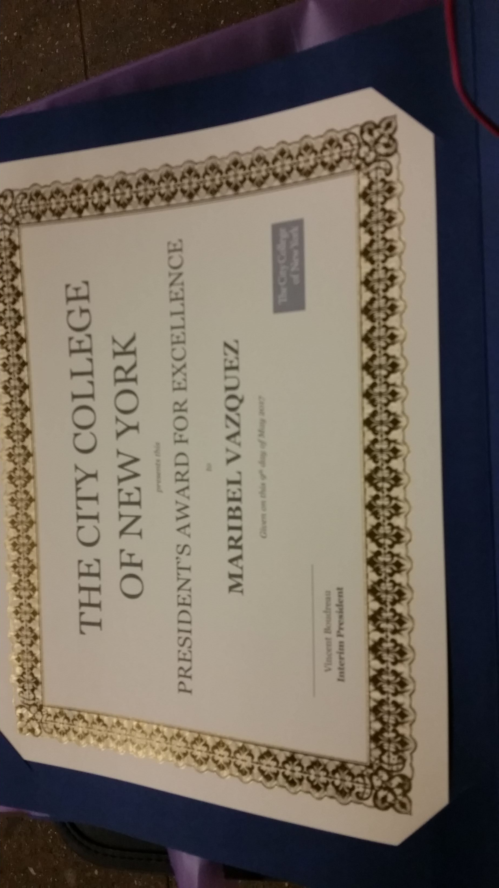

Remarks from Dr. Vazquez
The President’s Award for Excellence recognizes distinguished mentoring, research, teaching and scholarship at the City College of New York. But really it is so much more than that. It is a celebration of our community and of the mission of City College. I am a proud product of that mission! My mother enrolled in CCNY when I was a young girl, meaning I spent much of my childhood in the lecture halls of the NAC building trying hard to be quiet and not giggle while Mom was in class. She received her Bachelor of Arts degree the same year I graduated High School, and I remember thinking there was no way I would miss her ceremony even if it coincided to the minute with my own. I cannot describe the pride I felt as she walked onto the stage. Years later when I received my doctoral degree in Mechanical Engineering from MIT, my mother would ask me WHY I chose CCNY when I could go anywhere for my academic career. I remember saying, ‘MOM, there is no place else I want to BE because CCNY is like no other.’ CCNY is a place where anybody can come from anywhere and work hard to reach impossible dreams. I am deeply honored that my colleagues and my community feel I embody these principles in awarding me this recognition.

