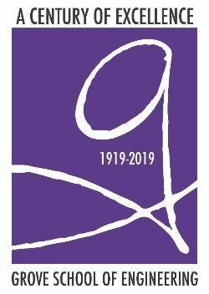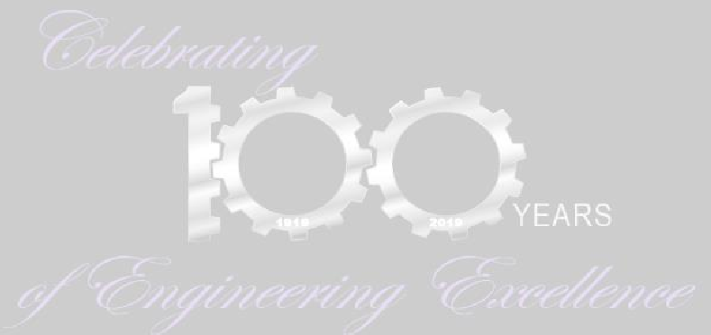

The Department of Mechanical Engineering and the Grove School of Engineering Community look forward to welcoming alumni to the Centennial Homecoming Celebration on September 20, 2019. See below for a partial list of Homecoming events.

ALUMNI HOMECOMING DAY CELEBRATING CENTENNIAL ANNIVERSARY OF MECHANICAL ENGINEERING
& GROVE SCHOOL OF ENGINEERING
Friday, September 20, 2019 (save the date)
Registration: Steinman Lobby 9:00 am to noon

Walking Tours of Campus & Mechanical Engineering Labs: 9:30 am to 10:30 am Welcome Back Remarks: Steinman Lecture Hall 10:30 am
Panel Discussions on Mentoring, Internships, & Employment: Steinman Lecture Hall
10:45 am to noon

Student-Alumni Luncheon-Mixer: Steinman Lobby 12:00 pm to 2:00 pm Poster & Exhibits Presentations: Steinman Lobby 10:00 am to 4:00 pm Alumni Research Presentations: Steinman Lecture Hall 2:00 pm to 4:30 pm
Boat Cruise with Buffet Dinner and Open Bar, Pier 81 NYC by 42nd Street 7:30 pm to 10:30 pm (ticket price: $168 per person)

All alumni and their families are welcome at Homecoming! Registration will open in late June.

