Department of Mechanical Engineering Seminar

2pm, 11/10/2022 Thursday
Steinman Hall Room 254 (Conference Room)
https://ccny.zoom.us/j/81357159148

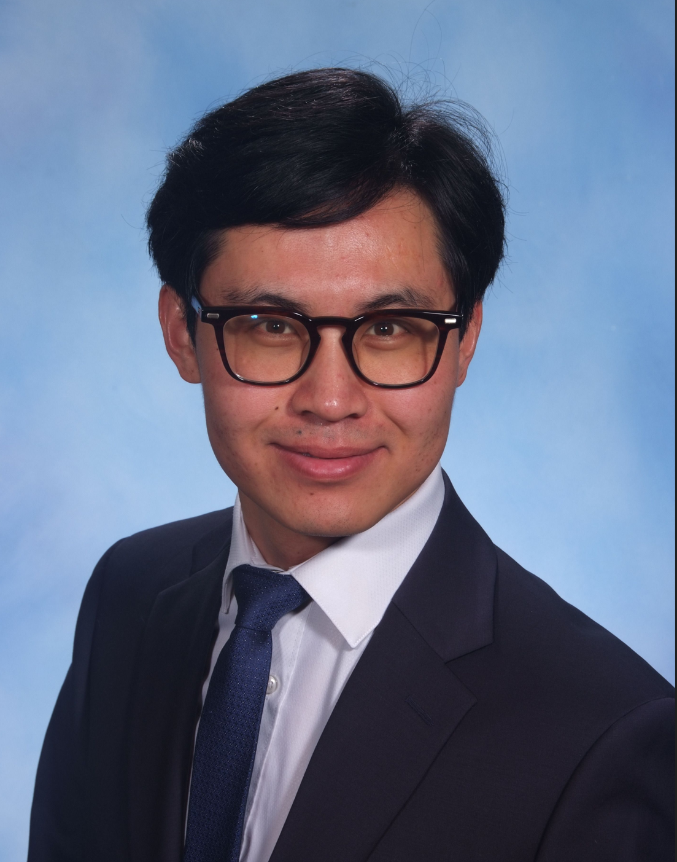
Modeling Transport of Soft Particles in Porous Media
Dr. Shuaijun Li
The City College of New York

ABSTRACT
Understanding transport of soft particles in porous media is important and imperative for many industries such as oil exploration, filtering, underground water pollution control and cell migration. In order to better regulate or control these processes, it is desirable to obtain a quantitative correlation between macroscale parameters such as total pressure drop and microscale parameters such as particle size, stiffness, concentration as well as flow properties and porous media properties. This talk will focus on building a quantitative relationship between these macro and microscale variables using Generalized Capillary Bundle Model. I will introduce two methods – direct method by analyzing the local pressure drop at a deformed particle in pore and energy method by analyzing total energy loss in the system. Both methods yield a pressure governing equation with identical mathematical structure and the same results. The results show that the total pressure drop is exponentially dependent on the particle concentration, the size ratio of particles to pore throat and porous media length. In addition, our model is also able to predict pressure-flow rate relation. Interestingly, different from single phase flow Darcy’s law where pressure increases linearly with flow rate, our model shows that the flow rate increasing rate is decreasing with flow rate. Comparing the model prediction with reported experimental data, with no more than two fitting parameters, our model captures a precise quantitative relationship between pressure drop, particle concentration, size ratio of particle to pore throat, porous media length, as well as flow rate. This work significantly enhances our understanding on transport of soft particles in porous media as well as benefits relevant industries.

BIO
Shuaijun Li is a postdoctoral researcher in Department of Mechanical Engineering at City College of New York. He received his Ph.D. in mechanical engineering under Prof. Jing Fan and Prof. Charles Maldarelli in May 2022 from CCNY. Prior to his Ph.D., he obtained a master’s degree in geotechnical engineering from University of Chinese Academy of Sciences and a bachelor’s degree in mining engineering from China University of Mining and Technology. His research interests range from multiphase flow in porous media, nanoparticles-stabilized foams and emulsions to microfluidics and rock mechanics. He has been a principal participant in several national key research projects and has over 10 publications. His research results have been applied to various key engineering applications. He is also a reviewer for several peer-reviewed journals and served as a Youth Editorial Board member for journal Capillarity.

