Biotechnology
Bachelor’s
Degree

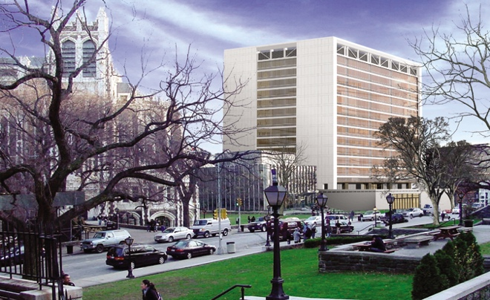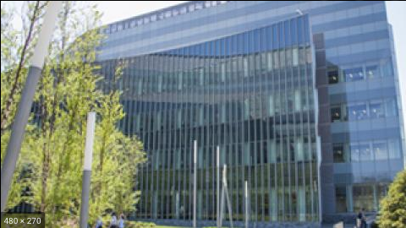

The degree in Biotechnology from the Division of Science at City College of New York aims to prepare students for careers in biotechnology, industry, or biomedical research. Students receive a thorough course foundation coupled with a one-year laboratory experience where the students perform original research.

Key Elements

- The program includes interdisciplinary coursework to provide a strong scientific foundation.
- Each student will gain research experience using cutting edge approaches as well as receiving individual advising and mentoring throughout the program.

Declaration of Major

To declare the major, students must have completed BIO 10100, BIO 10200, BIO 20600, CHEM 10301, CHEM 10401, and MATH 20500 or the equivalent. In addition, students must have an overall GPA of at least 3.0 and a GPA of at least a 3.0 in the Biotechnology major courses.

Course requirements
The program requires a total of at least 76-80 total course credits. At least 60% of these credits must be taken at CCNY.

Required core courses

BIOLOGY
BIO 10100 Biological Foundations I (4 cr)
BIO 10200 Biological Foundations II (4 cr)
BIO 20600 Introduction to Genetics (4 cr)
BIO 22900 Cell & Molecular Biology (4 cr)
BIO 48300 Laboratory in Biotechnology (5 cr)

CHEMISTRY
CHEM 10301 General Chemistry I (4 cr)
CHEM 10401 General Chemistry II (4 cr)
CHEM 26100 Organic Chemistry (3 cr)
CHEM 26200 Organic Chemistry Laboratory I (2 cr)
CHEM 26300 Organic Chemistry II (3 cr)
CHEM 32002 Biochemistry I (3 cr)

MATHEMATICS
MATH 20500 Elements of Calculus (4 cr)
MATH 20900 Elements of Calculus & Statistics (4 cr)
OR
MATH 201-203 series (total 12 cr)

PHILOSOPHY
PHIL 34905 Bioethics (3 cr)

PHYSICS
PHYS 20300 General Physics I (4 cr)
PHYS 20400 General Physics II (4 cr)
OR
PHYS 20700/20800 series (8 cr)

RESEARCH COURSES
BIO/CHEM/PHY 301-303 Honors I-III (maximum 6 cr towards major)
BIO/CHEM/PHY 310 Independent Study (1-3 cr/semester; maximum 6 cr towards major)

ADVANCED ELECTIVE COURSES from Biology, Chemistry, and/or Physics (11 cr)
Some possible electives include:

Biology
BIO 35000 Microbiology (4 cr)
BIO 35400 Introduction to Neurobiology (3 cr)
BIO 37500 Developmental Biology (3 cr)
BIO 37900 Developmental Neurobiology (3 cr)
BIO 38000 Eukaryotic Genetics (4 cr)
BIO 41000 Cell Development and Senescence (3 cr)
BIO 42000 Virology (4 cr)
BIO 42500 Cancer Biology (3 cr)
BIO 48000 Topics in Microbial Genetics (3 cr)
BIO 48100 Epigenetics (3 cr)

Chemistry
CHEM 33500 Physical Biochemistry (5 cr)
CHEM 40600 Environmental Chemistry (3 cr)
CHEM 48005 Biochemistry II (3 cr)
CHEM 48206 Journey to the Center of the Cell (3 cr)
CHEM 44200 RNA Biochemistry & Molecular Biology (3 cr)

Physics
PHY 31500 Medical Physics (3 cr)
PHY 42002 Biophysics (3 cr)
PHY 52200 Biomedical Physics (3 cr)

SCIENCE 28000 Bioinformatics and Biomolecular Systems (3 cr)

Participating Faculty at CCNY (list is not exhaustive)

Biology
Mark Emerson
Karen Hubbard
Shubha Govind
Anu Janakiraman
Chris Li
Mark Pezzano
Andrey Rudenko
Shireen Saleque
Tadmiri Venkatesh
Bao Vuong
Oseola Whitney

Chemistry
Zimei Bu
Amadee des Georges
Kevin Gardner
Ranajeet Ghose
George John
David Jeruzalmi
Daniel Keedy
Reza Khayat
Themis Lazaridis
Kevin Ryan
Ruth Stark

Physics
Marilyn Gunner
Ronald Koder

Partners at ASRC
Shana Elbaum-Garfinkle
Patrizia Casaccia
Pinar Ayata
Susana Mingote
Orie Shafer

Partners at CSOM
Andreas Kottmann
Itzik Mano
John Martin
Linda Spatz

For more information, contact: ScienceDean@ccny.cuny.edu

