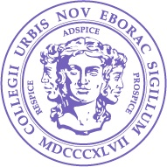

Biotechnology
Masters
Degree

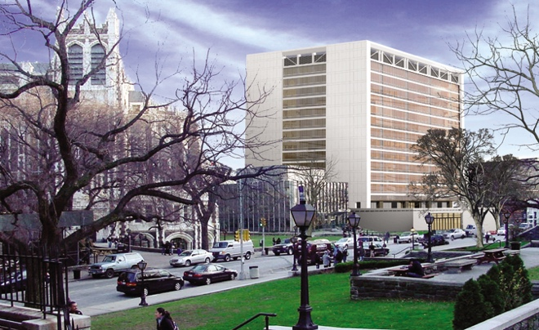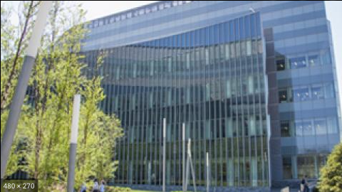

The degree in Biotechnology from the Division of Science at City College of New York aims to prepare students for careers in biotechnology, industry, or biomedical research. Students will receive training through coursework and research. A Master’s thesis is required.

Key Elements

- The program includes interdisciplinary coursework to provide a strong scientific foundation.
- Each student will gain research experience using cutting edge approaches as well as receiving individual advising and mentoring throughout the program.
- Students are required to perform two semesters of research, culminating in the writing and defense of a research thesis.

Entering Students

Students should have an undergraduate major in biological sciences (such as, biology, botany, zoology, and molecular biology), chemistry, or physics with a GPA of at least a 3.0. Chemistry or physics majors must have at least one year of appropriate biological sciences prior to admission. In addition, applicants should have one year of college physics, one semester of organic chemistry, and one year of calculus and/or statistics. Students who have not majored in the sciences should have taken foundational courses in the sciences and mathematics. GREs are highly recommended. Foreign students must have TOEFL scores with a minimum of 75th percentile on the exam.

Application

Apply online at: https://www.ccny.cuny.edu/admissions/graduate-studies

Course requirements
The program requires a total of 36 total course credits (cr).

Required core courses
Bio V1401 Cell Biology (4 cr)
Bio V0005 Genetics (4 cr)
Bio C0300 Molecular Biology (4 cr)
Bio A8300 Laboratory in Biotechnology (5 cr)
Phil 77900 Medical Ethics or equivalent (3 cr)
Bio V9100 Colloquium (2 cr)

Required research courses
Research culminating to a thesis is required. The research may be done at any laboratory in the Division of Science, CUNY School of Medicine, or affiliated institutions, such as the CUNY Graduate Center and Memorial Sloan-Kettering Cancer Center.
Bio B9901/Chem B9901/Phys B9901 (3 cr)
Bio B9902/Chem B9902/Phys B9902 (3 cr)

Required research thesis
Students must complete and defend a thesis based on original research.

Elective courses (8 cr)

Participating Faculty at CCNY (list is not exhaustive)
Biology
Mark Emerson
Karen Hubbard
Shubha Govind
Anu Janakiraman
Chris Li
Mark Pezzano
Andrey Rudenko
Shireen Saleque
Tadmiri Venkatesh
Bao Vuong
Oseola Whitney

Chemistry
Zimei Bu
Amadee des Georges
Kevin Gardner
Ranajeet Ghose
George John
Daniel Keedy
David Jeruzalmi
Reza Khayat
Themis Lazaridis
Kevin Ryan
Ruth Stark

Physics
Marilyn Gunner
Ronald Koder

For more information, contact: ScienceDean@ccny.cuny.edu

