Frequently Asked Questions (FAQs):

Animal Oversite ( IACUC)

Q1: What is Cayuse Animal Oversight?
Cayuse Animal Oversight is a web-based application used to draft, review, approve, and manage Institutional Animal Care and Use Committee (IACUC) protocols. All submissions can be accessed via the website on any device linked to the internet. Users will receive emails from the Cayuse system when action is required on a protocol, such as at the annual renewal or De Novo (3-year) renewal. Supported Browsers Chrome, Safari, and Firefox

Q2: How do I log in to Cayuse: Outside Interests?

Cayuse: Animal Oversite is accessible via the following: https://ccny-cuny.app.cayuse.com
The User ID and Password are the same as the CCNY email credentials. After a user log in, they are directed to the Cayuse Platform dashboard and their name should appear in the upper right-hand corner. The User should then select the down arrow adjacent to their name and select “Products.” Then “Animal Oversite”
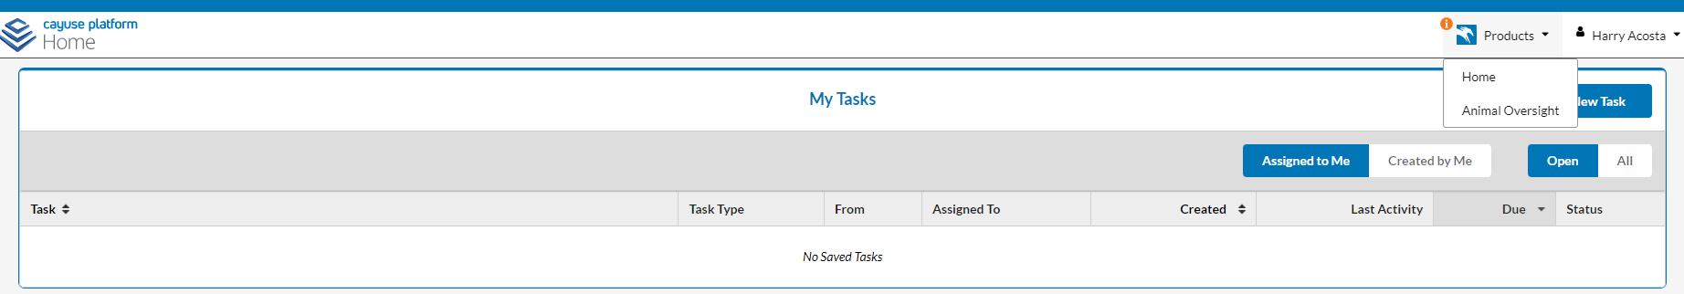

Q3: Who has access to Cayuse Animal Oversight?
Users will need to be granted access by the IACUC administrators. If you need to access the application, please reach out to your IACUC team for assistance.

Q4. "I can't find the staff member I am trying to add; what do I do now?"
New employees or guest users will need to be added by ADMIN/ICAUC Office. The information needed must include contact information and the type of role they will have in the lab. Will they enter protocols on behalf of the PI, etc.

Q5: How do I submit a new animal use protocol?
Before initiating a new protocol, make sure that the PI in the upper right-hand corner is correct. The name showing will be the PI on the IACUC protocol. If you are not part of another PI group, the system will only show your name.

Click on +Start a New Protocol Application from the Protocol Actions alert tab.

Q6. I tried to submit my protocol but got an error message.
If a section is missing a green checkmark, it means that you still need to answer a required question. If you try submitting without answering all the required questions, you will see this message:
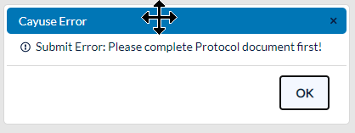

Q7. How do I receive updates regarding my Cayuse IACUC submissions?
The application will send users emails when action is required on submissions. For example, the Cayuse Animal Oversight application will send users notifications when a protocol has questions from the IACUC that need to be addressed or when a protocol is due for renewal. Note: emails will come from (Cayuse <no-reply@esirius.cayuse.com>) make sure to mark this as not spam/junk

Q8: Where can I get help with Cayuse Animal Oversight?
Training resources can be found on the Office of Research/ IACUC webpage https://www.ccny.cuny.edu/research/iacuc . Additionally Cayuse Animal Oversight offers an in-application resource center. Please click the question mark in the bottom right of your screen when you are in the Animal Oversight application. For additional resources, reach out to your IACUC team.

.

