Department of Mechanical Engineering Seminar
11AM, 3/21/2024 Thursday
Steinman Hall Room 254 (Conference Room)
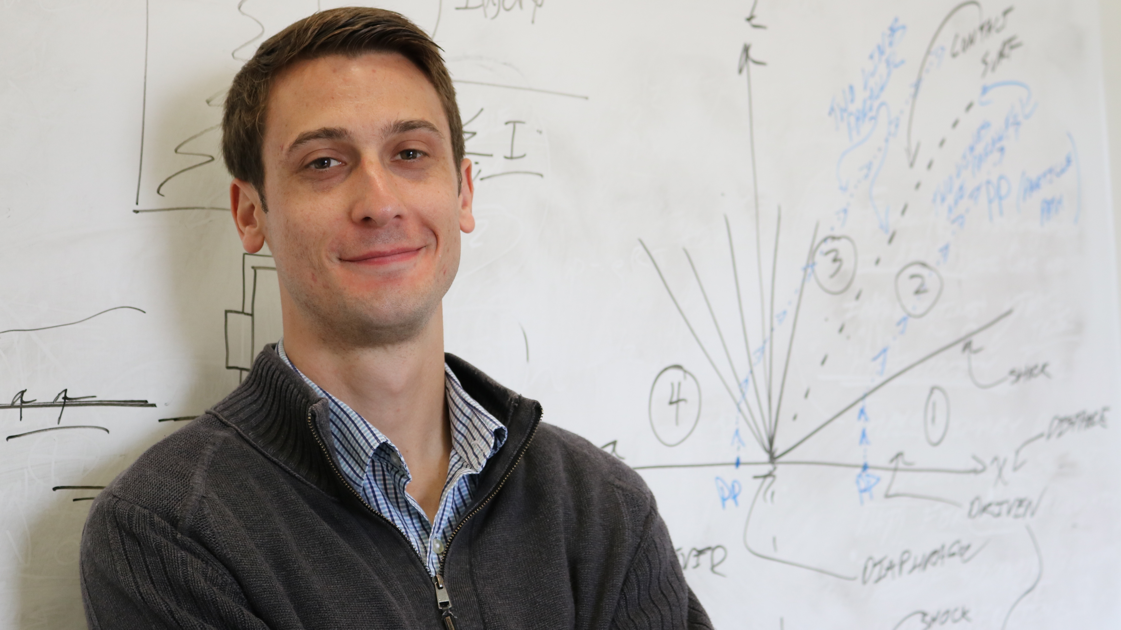
Hypersonic Turbulence Measurement and Observations of Drop Aerobreakup and Impact

Prof. Nick Parziale
Mechanical Engineering, Stevens Institute of Technology

ABSTRACT
Reacting/high-speed flow investigation with non-intrusive optical techniques permits researchers to probe fluid flows in harsh or otherwise previously inaccessible environments. New insight into the flow physics of the problems in supersonic and hypersonic flows can be had with the clever application of recent advances in laser, camera, and electronics technologies. In this talk, two examples of such efforts will be discussed. First, new data on hypersonic turbulence with tagging velocimetry will be presented. Then, new drop aerobreakup and impact data pertaining to the multiphase flow in high-speed-vehicle/weather interactions will be presented.

BIO
Nick’s current research interests include high-speed and reacting flows, chemical-thermodynamics, and heat transfer with applications in the fields of defense and energy/sustainability. Current projects include novel methods of high-speed flow velocimetry, hypersonic boundary-layer instability, shock-wave/boundary-layer interaction, multiphase flows, biomass to bio-oil conversion, and nitrogen-based fuels research. Nick received his BS in Mechanical Engineering from SUNY Binghamton in 2008, then received his MS and PhD degrees in 2009 and 2013 from the Caltech Graduate Aerospace Laboratories (GALCIT). In 2013, he was a PostDoc at Caltech and then a Visiting Assistant Professor at Stevens in the Mechanical Engineering Department at Stevens Institute of Technology in Hoboken, New Jersey. Nick was an Assistant Professor (2014-2020) and is currently an Associate Professor (2020-present). Nick spent four summers, from 2014-2017, as an Air Force Summer Faculty Fellow at AEDC White Oak in Silver Spring, MD.

IMAGES THAT SUPPORT SEMINAR TOPIC

