Faculty Tutorial – CUNY Accommodate Testing and Exams
- Student completes a request to take an exam with the Access/Ability Center.
  - This email will contain student name, date, time, course name, etc.
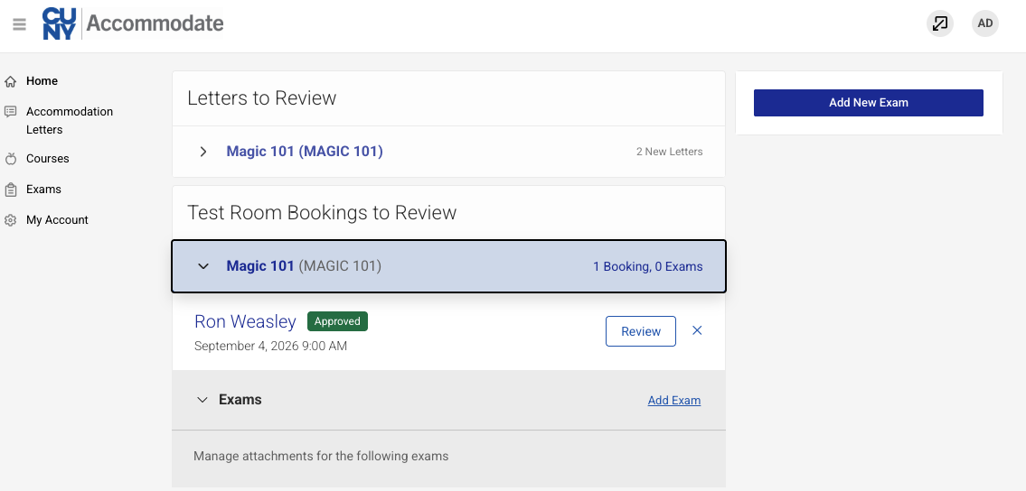
- Log in to CUNY Accommodate using your CUNYFirst credentials. All new requests for exams will appear on your front page.
- Review the student’s submission, including length of exam, dates, and times. If this information is accurate, scroll down to Exam Details and click “Enter Exam Details”
- Provide any relevant information about the exam, including length, how you would like it returned, and any additional materials (if any).
- Provide the “Exam Open Date” and “Exam Close Date”, which are usually the same day. Any additional students in your course who wish to test with us can now use the same exam booking information.
- Finally, upload your exam at the bottom. Additionally, feel free to drop it off in person, or email it to accessabilityexams@ccny.cuny.edu

If you have any questions, please reach out to:
- Accessabilityexams@ccny.cuny.edu
- Come to NAC 1/218A
- Call 212-650-5913

