Revised 3-24-16.

FIRE DEPARTMENT ● CITY OF NEW YORK

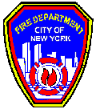

STUDY MATERIAL FOR THE EXAMINATION FOR CERTIFICATE OF FITNESS FOR

SUPERVISION OF STORAGE, HANDLING AND USE OF CHEMICALS IN NON-PRODUCTION LABORATORIES

C-14

© 12/2010 New York City Fire Department - All rights reserved ®

NOTICE OF EXAMINATION 1
INTRODUCTION 9
PART I 12
- DEFINITIONS 12
- CLASSIFICATIONS 17
  - Laboratory Unit Hazard Classification 17
  - Class of Flammable and Combustible Liquids 17
  - General Rule of Hazard Classes 18
  - NFPA Diamond Sign 19
  - Class of Organic Peroxide 21
- GENERAL FIRE CODE REQUIREMENTS 22
  - Fire Department Permit 22
  - General Operations, Housekeeping and Good Work Practices 23
  - Material Safety Data Sheets (MSDS) 28
- LABORATORY UNIT HAZARD CLASSIFICATION, DESIGN AND STORAGE 29
  - Flammable & Combustible Liquids Quantity Limitation for Different Laboratory Units 29
  - Other Laboratory Hazardous Material Quantity Limitations 30
  - Prohibitions 32
  - Laboratory Safety Requirement 33
- CHEMICAL STORAGE, HANDLING, AND WASTE DISPOSAL 42
  - Chemical Storage and Handling 42
  - Storage of Class I and Class II Liquids in Refrigerators 46
  - Liquid Dispensing 48
  - Waste, Handling and Disposal 48
- FIRE PREVENTION AND PROTECTION SYSTEMS 48
  - Fire Alarm Systems 49
  - Sprinkler System and Standpipe System 49
  - Portable Fire Extinguishers 50
- EMERGENCY PLANNING AND PREPAREDNESS 53
  - Emergency Procedures 53
  - Penalties for Non-compliance with Fire Code 53
PART III 54
- CORROSIVE MATERIALS 54
  - Storage and Use Requirements 54
- COMPRESSED AND LIQUEFIED GASES 54
  - General Requirement 55
  - Storing Containers 55
  - Cryogenic Liquid 57
PART IV 58
APPENDIX A 60
- COMPRESSED AND LIQUEFIED GASES 60
- FLAMMABLE SOLID 63
- CORROSIVE MATERIALS 63
- HIGHLY TOXIC AND TOXIC MATERIALS 64
- UNSTABLE REACTIVES (INSTABILITY HAZARD) 65
- OXIDIZERS AND ORGANIC PEROXIDES 66
- WATER-REACTIVE SOLID & LIQUIDS 69
- PYROPHORICS MATERIALS 70
APPENDIX B 71
APPENDIX C 75
APPENDIX D 78
APPENDIX E 79
APPENDIX F 80

NOTICE OF EXAMINATION

Title: SUPERVISION OF STORAGE, HANDLING AND USE OF CHEMICALS IN NON-PRODUCTION LABORATORIES (C-14).

Date of Exam: Written exams are conducted Monday through Friday (except legal holidays) 8:00 AM to 2:30 PM.

REQUIREMENTS FOR WRITTEN EXAM
Applicants who need to take the exam must apply in person and bring the following documents:
  - Applicants must be at least 18 years of age.
  - Applicants must have a reasonable understanding of the English language.
  - Applicant must provide two forms of identifications; at least one form of identification must be government issued photo identification, such as a State-issued Drivers’ License or Non Driver’s License or a passport.
  - Applicants must present a letter of recommendation from his/her employer. The letter must be on official letterhead, and must state the applicant’s full name, experience and the address where the applicant will work. If the applicants are self-employed or the principal of the company, they must submit a notarized letter attesting to their qualifications. For more info:
    - Sample of recommendation letter: http://www1.nyc.gov/assets/fdny/downloads/pdf/business/cof- samplerec-letter.pdf
    - Sample of self-employed letter: http://www1.nyc.gov/assets/fdny/downloads/pdf/business/cof- sample-selfrec-letter.pdf
  - Applicants must present a completed application for certificate of fitness (A-20 Form). http://www1.nyc.gov/assets/fdny/downloads/pdf/business/cof- application-form.pdf
  - Applicants not currently employed may take the exam without the recommendation letter. If the applicants pass the exam, FDNY will issue a temporary letter with picture for the job seeking purpose. The C of F card will not be issued unless the applicants are employed and provide the recommendation letter from his/her employer.
  - Special requirement for the C-14 Certificate of Fitness: Applicant must have one of the following:
    - A B.S degree in Chemistry, Biology, Biochemistry, Environmental or Health Sciences, Medical Technology and Chemical, Environmental, Mechanical or Biomedical Engineering, or related field or
    - An A.A.S or A.S degree in Chemistry, Biology, Biochemistry, Environmental or Health Sciences, Medical Technology and Chemical, Environmental, Mechanical or Biomedical Engineering, or related field

and a completion of a course on laboratory safety provided by the employer or
    - 60 credits with minimum of 21 credits in applicable science or engineering courses and a completion of a course on laboratory safety provided by the employer
    - NY State Permanent Certification as a Chemistry or Biology (7-12) Teacher.
    - Applicant must present evidence of academic degree(s) indicating specific course of study and/or transcript to verify college science courses.
    - Degree issued from outside USA or not in English shall be evaluated by an independent evaluation service accepted by NYC Department of Citywide Administrative Services.

http://www1.nyc.gov/assets/fdny/downloads/pdf/business/foreign- education-evaluation.pdf

  - APPLICATION FEE:
Pay the $25 application fee in person by one of the following methods:
    - Cash
    - Credit card (American Express, Discover, MasterCard, or Visa)
    - Debit card (MasterCard or Visa)
    - Personal or company check or money order (made payable to the New York City Fire Department)
For fee waivers submit: (Only government employees who will use their C of F for their work- related responsibilities are eligible for fee waivers.)
      - A letter requesting fee waiver on the Agency’s official letterhead stating applicant full name, exam type and address of premises; AND
      - Copy of identification card issued by the agency

A convenience fee of 2.49% will be applied to all credit card payments.

  - EXAM INFORMATION
The C-14 exam will consist of 50 multiple-choice questions, administered on a “touch screen” computer monitor. It is a time-limit exam. Based on the amount of the questions and reference material provided, you will have 76 minutes to complete the test. A passing score of at least 70% is required in order to secure a Certificate of Fitness.

Call (718) 999-1988 for additional information and forms.

Special material provided during the exam: The tables which appear in the booklet will be provided to you as a reference material when you take the exam at MetroTech, however, the booklet will not provide to you during the exam.

Please always check for the latest revised booklet at FDNY website before you take the exam.
http://www1.nyc.gov/assets/fdny/downloads/pdf/business/cof-c14-noe- study-materials.pdf

  - If all the requirements are meet and pass the exam a certificate will be issued the same day. Applicant who fails the exam will receive a failure report. To retake the exam applicants will need to submit a new application and payment.

ALTERNATIVE ISSUANCE PROCEDURE (AIP)
This certificate of fitness can be obtained by a training program that has been reviewed and approved by FDNY for an exemption. Applicants who qualify for AIP must apply online. For more detail information applicants must review the C-14 AIP information.
http://www1.nyc.gov/assets/fdny/downloads/pdf/business/cof-c14-aip.pdf RENEWAL REQUIREMENTS
This Certificate of Fitness must be renewed every THREE YEARS. The renewal fee is $15. FDNY also reserves the right to require the applicants to take a re- examination upon submission of renewal applications.

You will receive a courtesy notice of renewal 90 days before the expiration date. However, it is your responsibility to renew your Certificate. It is very important to renew your C of F before it expires. Renewals submitted 90 days (up to one year) after the expiration date will incur a $25 penalty in addition to the renewal fee. Certificates expired over one year past expiration date will not be renewed. New exams will be required.

To change a mailing address:
- Submit a letter requesting the change of mailing address and a copy of your C of F with $5.00 fee.

To change a work location,
- Submit a letter from your current employer (on company letterhead) confirming that you are an employee and stating your new work location with a copy of your C of F and a $5.00 fee
To request a replacement certificate:
- Submit a driver’s license or passport, social security number, mailing address and a $5.00 fee.
The certificate can be renewed On-line, by Mail or in Person.

- Renewal online
If you are an individual, make sure you have your 12 digit Certificate of Fitness Access ID. This can be found on your Renewal Notice. If you do not have your Renewal Notice, your Access ID is your 8 digit Certificate of Fitness number and the last four digits of your social security number. If you are submitting renewals on behalf of a company's employees, the company must be approved by FDNY and have an 8 digit Company Code. To request approval, email pubrenew@fdny.nyc.gov.

Renewal fee can be paid by one of the following methods:
  - Credit card (American Express, Discover, MasterCard, or Visa)
  - Debit card (MasterCard or Visa)
  - E-check
A fee exempted applicants cannot renew online only by mail or in person.

If all the requirements are met, the certificate of fitness will be mailed out within 10 days.

For online renewal go to: https://a836-citypay.nyc.gov/citypay/FDNYCOF

- Renewal by mail
Mail your Renewal Notice (or if you did not receive a Renewal Notice, a copy of your certificate), along with your fee payment, Personal or company check or money order (made payable to the New York City Fire Department)
For fee waivers submit: (Only government employees who will use their C of F for their work- related responsibilities are eligible for fee waivers.)
  - A letter requesting fee waiver on the Agency’s official letterhead stating applicant full name, exam type and address of premises; AND
  - Copy of identification card issued by the agency and if applicable, supporting documents to:

NYC Fire Department (FDNY)
Cashier's Unit
9 MetroTech Center, 1st Floor Brooklyn, NY 11201

If all the requirements are met, the certificate of fitness will be mailed out within four to six weeks.

- Renewal in person
Submit your Renewal Notice (or if you did not receive a Renewal Notice, a copy of your certificate), along with your fee payment by one of the following methods:
  - Cash
  - Credit card (American Express, Discover, MasterCard, or Visa)

  - Debit card (MasterCard or Visa)
  - Personal or company check or money order (made payable to the New York City Fire Department)
For fee waivers submit: (Only government employees who will use their C of F for his or her work-related responsibilities are eligible for fee waivers.)
  - A letter requesting fee waiver on the Agency’s official letterhead stating applicant full name, exam type and address of premises; AND
  - Copy of identification card issued by the agency and if applicable, your supporting documents to:
NYC Fire Department (FDNY)
Cashier's Unit
9 MetroTech Center, 1st Floor Brooklyn, NY 11201

If all the requirements are met, the certificate of fitness will be issued the same day.

A convenience fee of 2.49% will be applied to all credit card payments for original or renewal certificates.

EXAM SITE: FDNY Headquarters, 9 MetroTech Center, Brooklyn, NY. Enter through the Flatbush Avenue entrance (between Myrtle Avenue and Tech Place).
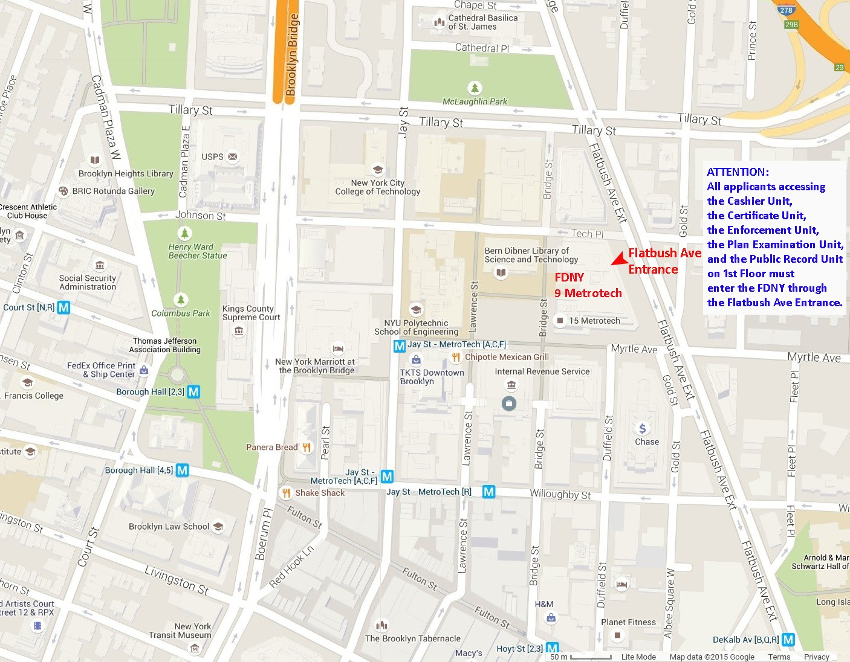

STUDY MATERIAL AND TEST DESCRIPTION

About the Study Material

These study materials will help you prepare for the written examination for the Certificate of Fitness for Supervising Non-production Chemical laboratories. The study materials include information taken from the Fire Code. The study materials do not contain all the information you need to know in order to work efficiently and safely when supervising a non-production Chemical laboratory. It is your responsibility to become familiar with all applicable laws, rules and regulations of the federal, state and city agencies having jurisdiction, even though such requirements are not included in this study material. You need to be familiar with the National Fire Protection Association(NFPA) 45, 2004 edition, and New Fire Code Section 2706, Fire Department Rules Section 4827-01(g)(1) which regulate the storage, handling and use of laboratory chemicals in a non-production laboratory in order to adequately prepare for the exam. It is critical that you read AND understand this booklet to help increase your chance of passing this exam.

About the Test

The C-14 test will consist of 50 multiple-choice questions, administered on a “touch screen” computer monitor. It is a time-limit test. You must pass a multiple choice test to qualify for the certificate of fitness. A score of 70% correct is required in order to pass the test. All questions have four answer options. Only one answer is correct for each question. If you do not answer a question, or if you mark more than one answer to a single question, your answer to that question will be scored as incorrect. Read each question carefully before marking your answer. You will be able to review all your answers before you finish your test. There is no penalty for guessing.

Sample Questions
- Which of the following are allowed to be used/displayed while taking a Certificate of Fitness examination at 9 Metro Tech Center?
  - cellular phone
  - study material booklet
  - reference material provided by the FDNY
  - mp3 player

- III only
- I, II, and III
- II and IV
- I only

Only reference material provided by the FDNY is allowed to be used during Certificate of Fitness examinations. Therefore, the correct answer would be A. You would touch “A” on the computer terminal screen.

- If you do not know the answer to a question while taking an examination, who should you ask for help?

- the person next to you
- the firefighters
- the examiner in the testing room
- you should not ask about test questions since FDNY staff cannot assist applicants

You should not ask about examination questions or answers since FDNY staff cannot assist applicants with their tests. Therefore, the correct answer would be D. You would touch "D" on the computer terminal screen.

- If the screen on your computer terminal freezes during your examination, who should you ask for help?

- the person next to you
- the firefighters
- the examiner in the testing room
- the computer help desk

If you have a computer related question, you should ask the examiner in the testing room. Therefore, the correct answer would be C. You would touch “C” on the computer terminal screen.

INTRODUCTION

The Fire Code and Fire Department rules regulating non-production laboratories date back to 1966. The 1966 rule regulated the storage and use of chemicals in college, university, hospital, and research and commercial laboratories, and required that such laboratories operate under the supervision of a certificate of fitness (C-14) holder.

In July of 2014, a new Fire Code was adopted in New York City. Similar to the former code, this code also regulated the storage and use of chemical in laboratories, and adopted with certain modifications, the requirements of National Fire Protection Association Standard (NFPA) 45, entitled "Fire Protection for Laboratories Using Chemicals". Unlike the former rule, the new Fire Code and NFPA Standard 45 are applicable to ALL non-production laboratories, including those in grade schools and high schools, not just those found in colleges, universities, hospitals, and research and commercial laboratories. Similar to the former rule, the 2014 Fire Code requires that ALL non-production laboratories be operated under the supervision of a certificate of fitness holder. For laboratories that were NOT previously required to operate their laboratories under the supervision of a certificate of fitness holder, such laboratories had until July 1, 2015 to have the responsible individuals obtain such certificate.

All new non-production laboratories established on or after July 1, 2008 are required to be in compliance with the 2014 Fire Code. Non-production laboratories approved by the Fire Department prior to July 1, 2008 do not have to, and in some case could not, comply the design and installation requirements of the 2014 Fire Code. Such laboratories are considered to be "pre-existing laboratories" and are required to comply with the design and installation requirements in effect at the time the laboratory was established. Throughout this study material you will see references and requirements that are applicable to "pre-existing laboratories". It is important that you understand what this means. Generally, original permits for laboratories issued by fire department prior to July 1 2008 would be subjected to compliance with the former rule requirement. Generally, original permits for laboratories issued after July 1 2014 would be subject to compliance with the new fire code. Therefore, it is possible that there can be two different kinds of non-production chemical laboratories in the same building, both supervised by one certificate of fitness holder. The certificate of fitness holder will have the responsibility of distinguishing and ensuring compliance with the different code requirements.

On the other hand, both new and pre-existing laboratories are required to comply with the operational and maintenance requirements of the 2014 Fire Code. Operational and maintenance requirements include such things as permits, certificate of fitness, signage, housekeeping, periodic testing and portable fire extinguishers.

In addition to the C-14 (non-production laboratory) certificate, the Fire Code requires, and the Fire Department administers, a variety of certificate of fitness exams that cover the types of hazardous materials generally found within a non-production laboratory. These include:

- C-91 (covers most hazardous materials with the exception of flammable liquids, combustible liquids, compressed gases and cryogenic gases).

- C-92 (covers flammable and combustible liquids).

- G-46 certificate (covers non-flammable gases).

- G-97 certificate (covers non-flammable cryogenic gases).

- G-98 certificate (covers flammable gases).

As you can see, it would be quite a hardship for most laboratories if their personnel were required to secure multiple certificates of fitness. For this reason, the Fire Code allows for a single certificate (C-14) that qualifies the person to provide supervision for all storage and use of hazardous materials within non-production laboratories. This certificate is required when the storage of flammable or combustible liquids within a laboratory or chemical storage room exceeds 1 gallon or flammable gas storage exceeds 75 SCF. If you operate a laboratory and store and/or use less than these amounts, you are not regulated by the Fire Code as a non-production laboratory.

For laboratories that store and/or use hazardous materials in quantities not regulated as a non-production laboratory, a different certificate of fitness may be required, if the threshold values established by the Fire Code for other types of hazardous materials are exceeded. For example, a laboratory, not regulated as a non-production laboratory, having; any amount of a highly toxic material (e.g. sodium cyanide); flammable solid (e.g. magnesium) in excess of 1 pound; or “class 3” oxidizer (e.g. nitric acid, fuming) in excess of 10 pounds would require supervision by a C-91 certificate holder.

The C-91 certificate of fitness examination has been specifically developed to cover the storage, handling and use of hazardous materials in industrial, manufacturing and maintenance type applications, not non-production laboratories. The C-14 exam has been developed to only address the specific fire safety concerns, and unique code requirements, associated with the storage, handling and use of hazardous materials in non-production laboratories.

At least one C-14 Certificate of Fitness holder shall be present on each of floor of the laboratory unit on which laboratory operations requiring a permit are being conducted. For example, if a group of laboratories on any particular floor is run by the same researcher or Department, then it is possible to have one person provide the required oversight (personal supervision) over all laboratories on that floor. It is also conceivable to have one person provide coverage of all laboratories on a floor even if those are operated by different researchers or Departments. However, if that person is not designed to assume responsibility for every lab on that floor, or if you have a situation where there are multiple researchers, Departments or different tenants on that floor, then more than one person holding a certificate of fitness would be required on that floor to adequately provide the required coverage. Furthermore, if there are laboratories on any particular floor that operate outside of normal business hours (typically, 8 am to 6 pm) or on weekends (Saturdays, Sundays and holidays), personnel holding certificates of fitness would be required to provide coverage (personal supervision) of those laboratories during these “off-peak” periods.

Irregardless of whether a Certificate of Fitness holder is designated by the owner to supervise the operations of a single laboratory or multiple laboratories, it is important to understand that each laboratory is required to be in compliance. The Certificate of Fitness holder, in conjunction to the building owner, is responsible to monitor the operation of such laboratories to help ensure compliance.

The C-14 Certificate of Fitness holders are responsible for making sure that all fire safety regulations and procedures are obeyed on the premises. All Permits and Certificates of Fitness shall be readily available on the premise for inspection by Fire Department representatives.

This booklet consists of four parts (i.e. Definition, Core fire safety requirements, Safety guide of two most common hazards, and Checklist), and six appendixes. For maintaining a safe laboratory environment, you should become knowledgeable with the entire booklet. The test covers the main body (the four parts) of the booklet and any tables. The tables which appear in the booklet will be provided to you when you take the test at Metrotech, however, the booklet will not provide to you during the test. Therefore, if you are successful on the test, you will be authorized to supervise a non-production chemical laboratory.

The operation of a non-production chemical laboratory is required to comply with the following fire department code and rule sections:

  - Non-production chemical laboratories: [Fire Code Section 2706]
  - Standard on fire protection for laboratories using chemicals: [NFPA 45, 2004 edition]
  - Flammable and combustible liquids: [Fire Code Chapter 34]
  - Flammable gases: [Fire Code Chapter 35]
  - Flammable solids systems and facilities: [Fire Code Chapter 36]
  - Compressed gases: [Fire Code Chapter 30]
  - Corrosive materials: [Fire Code Chapter 31]
  - Cryogenic liquids : [Fire Code Chapter 32]
  - Highly toxic and toxic materials systems and facilities: [Fire Code Chapter 37]
  - Organic peroxides storage and facilities: [Fire Code Chapter 39]
  - Oxidizer systems and facilities: [Fire Code Chapter 40]
  - Pyrophoric materials systems and facilities: [Fire Code Chapter 41]
  - Unstable (Reactive) materials systems and facilities: [Fire Code Chapter 42]
  - Water-reactive solids and liquids systems and facilities: [Fire Code Chapter 44]
  - Former laboratory rule for pre-existing laboratories [Rule Section 4827- 01(g)(1)]

PART I
- DEFINITIONS

BASEMENT: A story partly below the grade plane and having less than one-half its clear height (measured from finished floor to finished ceiling) below the grade plane.

BOILING POINT: The temperature at which the vapor pressure of a liquid equals the atmospheric pressure of 14.7 pounds per square inch (psia) or 760 mm of mercury. Where a boiling point is unavailable for the material in question or for mixtures which do not have a constant boiling point, for the purposes of this classification, the 20- percent evaporated point of a distillation performed in accordance with ASTM D 86 shall be used as the boiling point of the liquid.

CHEMICAL: An element, chemical compound or mixture of elements or compounds or both.

CHEMICAL NAME: The scientific designation of a chemical in accordance with the nomenclature system developed by the International Union of Pure and Applied Chemistry (IUPAC), the Chemical Abstracts Service rules of nomenclature, or a name that will clearly identify a chemical for the purpose of conducting an evaluation.

CLOSED CONTAINER: A container sealed by means of a lid or other device capable of preventing the escape of liquid, vapor or dusts in the ordinary course of storage, handling or use.

COMBUSTIBLE LIQUID: Any liquid that has a closed-cup flash point at or above 100°F, as determined by the standard test procedures.

CONTAINER: For solid and liquid hazardous materials, a vessel of 60 gallons or less in capacity used for storage or transportation. For compressed gases, a container, pressure vessel or tank designed for pressures greater than one atmosphere at 68°F. Pipes, piping systems, engines and engine fuel tanks associated with solid or liquid hazardous materials or compressed gases, shall not be deemed to be containers if in active use.

CORROSIVE MATERIALS: A liquid, solid, or gas that causes permanent injury (“full thickness destruction”) to human skin at a rate specified by the Department of Transportation (DOT) regulations. Or a liquid that can corrode ¼ inch of steel or aluminum within the course of a year.

DESIGN PRESSURE: The maximum gauge pressure that a pressure vessel, device, component or system is designed to withstand safely under the temperature and conditions of use.

DISPENSING: The pouring or transferring by other means of any material from a container, tank or similar vessel, which would release dusts, fumes, mists, vapors or gases to the atmosphere, unless such release is prevented by a device, equipment or system designed for that purpose.

EXCESS FLOW CONTROL: A fail-safe system or other approved device, equipment or system designed to shut off flow caused by a rupture in a pressurized piping system.

EXHAUSTED ENCLOSURE: A device, typically consisting of a hood equipped with a fan that serves to capture and exhaust fumes, mist, vapors and gases generated at a workstation or other local environment. An exhausted enclosure does not include a room provided with general ventilation.

EXPLOSION; An effect produced by the sudden violent expansion of gases, whether or not accompanied by a shock wave or disruption, of enclosing materials, including the effects of the following sources of explosion:
  - Chemical changes such as rapid oxidation, deflagration or detonation, decomposition of molecules and runaway polymerization (usually detonations).
  - Physical changes such as pressure tank ruptures.
  - Atomic changes (nuclear fission or fusion).

FACE VELOCITY: The rate of flow or velocity of air moving into the chemical fume hood entrance or face, as measured at the plane of the chemical fume hood face.

FIRE SEPARATION: A horizontal or vertical fire resistance-rated assembly of materials that have protected openings and are designed to restrict the spread of fire.

FLAMMABLE GAS: Any substance that exists in the gaseous state at normal atmospheric temperature and pressure and is capable of being ignited and burned when mixed with the proper proportions of air, oxygen, or other oxidizers.

FLAMMABLE LIQUID: Any liquid that has a closed-cup flash point below 100°F, as determined by the standard test procedures.

FLAMMABLE SOLID: A solid, other than a blasting agent or other explosive, whether in elemental or alloy form, that is capable of causing fire through friction, absorption of moisture, spontaneous chemical change, or heat retained from manufacturing or processing, or which has an ignition temperature below 212°F or which burns so vigorously and persistently when ignited as to create a serious hazard. Examples include Aluminum powder, Camphor, Magnesium, Matches, Naphthalene, Nitrocellulose, Phosphorus, Sulfur and Picric Acid (wetted with not less than 10% water).

FLAMMABLE VAPORS OR FUMES: The concentration of flammable constituents in air that exceeds 25 percent of their lower flammable limit (LFL).

FLASH POINT: The minimum temperature in degrees Fahrenheit at which a liquid will give off sufficient vapors to form an ignitable mixture with air near the surface or in the container, but will not sustain combustion. The flash point of a liquid shall be determined by appropriate test procedure and apparatus as specified in ASTM D 56, ASTM D 93 or ASTM D 3278.

GAS CABINET: A fully enclosed, noncombustible enclosure used to provide an isolated environment for compressed gas containers in storage or use, including any

doors and access ports for exchanging containers and accessing pressure-regulating controls.

GENERAL SUPERVISION: Supervision by the holder of any certificate of fitness who is responsible for performing the duties set forth in the Fire Code but need not be personally present on the premises at all times. The storage of any hazardous material in quantities requiring a permit shall be under the general supervision of a certificate of fitness holder.

HANDLING: The movement of a material in its container, the removal of the material from its container, or any other action or process that may affect the material, other than its storage or use.

HAZARDOUS LOCATIONS CLASSIFICATIONS DESCRIPTIONS FOR CLASS 1
DIVISION 2: Where ignitable concentrations of flammable gases, vapors, or liquids are present within the atmosphere under abnormal operating conditions.

HAZARDOUS MATERIALS: Those chemicals or substances that are physical hazards or health hazards as defined and classified in the Fire Code, whether the materials are in usable or waste condition.

HEALTH HAZARD: A classification of a chemical for which there is statistically significant evidence that acute or chronic health effects are capable of occurring in exposed persons. The term “health hazard” includes chemicals that are toxic, highly toxic and corrosive.

IMPAIRMENT COORDINATOR: The person designated by the owner and responsible for ensuring that proper notification and safety precautions are taken when a fire protection system is out of service.

INCOMPATIBLE MATERIALS: Materials that, if mixed or combined, could explode, generate heat, gases or other byproducts, or react in a way hazardous to life or property.

LABORATORY CHEMICAL: A material with a health, flammability and/or instability (reactivity) hazard ranking of 2, 3 or 4 as defined in NFPA 704.
LABORATORY UNIT: An enclosed space of a minimum one-hour fire rated construction, designed or used as a non-production laboratory. Laboratory units may include one or more separate laboratory work areas, and accessory storage rooms or spaces within or contiguous with the laboratory unit, such as offices and lavatories.

LABORATORY WORK AREA: a room of space for testing, analysis, research, instruction, or similar activities that involve the use of chemicals.

LC50: LC stands for "Lethal Concentration". A LC50 value is the amount of a gas, dust or mists that it takes to kill 50% of test animals (for example, mice or rats) in one dose. Like LD50 various tests and animals may be utilized. In addition the duration of exposure may vary. For the purposes of the Fire Code this is a one hour test utilizing rats.

LD50: LD stands for "Lethal Dose". A LD50 value is the amount of a solid or liquid material that it takes to kill 50% of test animals (for example, mice or rats) in one dose. It is a standard measurement of the short-term poisoning potential (acute toxicity) of a solid or liquid material. LD50 values are expressed in terms of the tests and animal used (i.e. LD50 (oral, rat), LD50 (skin, mouse)) other animals (dogs, hamsters, cats, guinea-pigs, rabbits, and monkeys) are sometimes utilized but the Fire Code is very specific regarding test species (oral-rats and skin-rabbets). The LD50 value is expressed as the weight of chemical administered per kilogram body weight of the animal, the test animal used and route of exposure. So, the example "LD50 (oral, rat) 5 mg/kg" means that 5 milligrams of that chemical for every 1 kilogram body weight of the rat, when administered in one dose by mouth, causes the death of 50% of the test group.

LECTURE BOTTLE: A small compressed gas container up to a size of approximately 2 in. X 13 in.

LIQUID: A material having a melting point that is equal to or less than 68°F and a boiling point that is greater than 68°F at 14.7 psia. When not otherwise identified, the term “liquid” includes both flammable and combustible liquids.

LOWER EXPLOSIVE LIMIT (LEL): See “Lower flammable limit.”

LOWER FLAMMABLE LIMIT (LFL): The minimum concentration of vapor in air at which propagation of flame will occur in the presence of an ignition source. The LFL is sometimes referred to as LEL or lower explosive limit.

MATERIAL SAFETY DATA SHEET (MSDS): A document prepared in accordance with the regulations of the United States Department of Labor, as set forth in 29 CFR Part 1910.1200 or a federally approved state OSHA plan which sets forth information concerning a hazardous material.

NON-PRODUCTION LABORATORY: A building or portion thereof wherein chemicals or gases are stored, handled or used on a non-production basis for testing, research, experimental, instructional or educational purposes.

NORMAL TEMPERATURE AND PRESSURE (NTP): A temperature of 70°F and a pressure of 1 atmosphere.

ORGANIC PEROXIDE: An organic compound having a double oxygen or peroxy (-O-O-
) in its chemical structure. Organic peroxides can present an explosion hazard (detonation or deflagration), can be shock sensitive, can be susceptible to decomposition into various unstable compounds over an extended period of time. The materials are divided in to six classes from Classes I through V and unclassified detonable class, with decreasing levels of hazard from Class I through Class V.

OUT OF SERVICE SYSTEM: This is a fire protection system that is not fully functional; or whose operation is impaired or is otherwise not in good working order.

OXIDIZER: A material that readily yields oxygen or other oxidizing gas, such as bromine, chlorine and fluorine, or that readily reacts to promote or initiate combustion

of combustible materials. The materials are divided in to 4 classes, with increasing level of hazard from Classes 1 through 4.

PERSONAL SUPERVISION: Supervision by the holder of any certificate of fitness who is required to be personally present on the premises, or other proximate location acceptable to the department, while performing the duties for which the certificate is required.

PHYSICAL HAZARD: A chemical for which there is evidence that it is a combustible or flammable liquid; a flammable solid or gas; an explosive; an organic peroxide; an oxidizer; a pyrophoric material; an unstable (reactive) material; a water-reactive solid or liquid; or a cryogenic liquid.

PYROPHORIC MATERIAL: A material that is so chemically unstable that it may ignite spontaneously at a temperature at or below 130˚F.

REDUCED FLOW VALVE: A valve equipped with a restricted flow orifice and inserted into a compressed gas container that is designed to reduce the maximum flow from the valve under full-flow conditions. The maximum flow rate from the valve is determined with the valve allowed to flow to atmosphere with no other piping or fittings attached.

SAFETY CAN: An approved container with a capacity of not more than 5-gallons and equipped with a spring-closing lid and spout cover designed to relieve internal pressure when exposed to fire.

SASH: A movable panel or panels set in the hood entrance.

SOLID: A material that has a melting point and decomposes or sublimates at a temperature greater than 68°F.

STANDARD CUBIC FEET (SCF): Cubic feet of gas at normal temperature and pressure (NTP).

STORAGE CABINET: A cabinet for the storage of flammable and combustible liquids constructed in accordance with section 6.3 of NFPA 30.

UNSTABLE(REACTIVE) MATERIAL: A material, other than an explosive, that will vigorously polymerize, decompose, condense or become self-reactive and undergo other violent changes, including explosion, when exposed to heat, friction or shock, or in the absence of an inhibitor, or in the presence of contaminants, or in contact with incompatible materials. The materials are divided in to 4 classes, with increasing level of hazard from Classes 1 through 4.

WATER-REACTIVE MATERIAL: A material (solid, liquid, or gas) that has a dangerous chemical reaction when reacting with water. Upon coming in contact with water, a water reactive material may explode, violently react, produce flammable, toxic, or other hazardous gases, and/or generate enough heat to cause ignition of the material or nearby materials. Water-reactive materials are divided in to Classes 1 through 3, with increasing levels of hazard from Class 1 to Class 3.

- CLASSIFICATIONS

- Laboratory Unit Hazard Classification

- Pre-existing laboratory
There are four types of laboratories and classified according to their fire rating and whether or not an automatic sprinkler system is installed. The four different classifications are shown in the table below.

Table I-1. Pre-existing Laboratory Type
Lab Type | Fire Rating | Fire Protection
I | 2 Hours | Sprinklers
II | 1 Hour | Sprinklers
III | 2 Hours | No Sprinklers
IV | 1 Hour | No Sprinkler

- New fire code
The modifications of the new fire code were primarily made to restrict the maximum allowable storage limitations for flammable and combustible liquids as permitted in NFPA 45. Following the new fire code, all non-production laboratories would be classified as Class “D” and Class “B” laboratories. For Class D laboratories, the new fire code keeps flammable and combustible liquid densities (in gallons per square foot) to a minimum while potentially allowing for up to 200 gallons of flammable and combustible liquids. For the Class B laboratories, the new fire code allows substantially increased flammable and combustible liquid densities (more gallons per square foot) but at the same time mirrors the maximum 30 gallon limit set forth in the old Rule.

Table I-2. Non-production Laboratory Classification in New Fire Code
Lab Class | Fire Rating | Fire  Protection* | Flammable & Combustible Liquid Density | Flammable & Combustible Liquid Limit
B | 1 or 2 Hours | Sprinklers | Up to 20 gal/100ft2 | Up to 30 gal
D | 1 or 2 Hours | Sprinklers | Up to 2 gal/100ft2 | Up to 200 gal
* In accordance with the new building code, laboratory units shall be provided throughout with an automatic sprinkler system.
Note: Educational and instructional labs and labs in health care occupancies shall comply with Class D requirement only.

- Class of Flammable and Combustible Liquids

For the pre-existing laboratory, there are only two categories of flammable and combustible liquids separated by their flash point, one is flammable liquids (flash point is below 100ºF) and the other is combustible liquids (flash point is at or above 100ºF). However, for the new fire code, the there are 3 classes of flammable liquids and 3 classes of combustible liquids defined as the following table.

Table I-3. Class of Flammable and Combustible Liquids
 |  | Flash point | Boiling point | Examples
 | Class IA | < 73ºF | < 100ºF | Acetaldehyde, Ethyl ether, Gasoline,  Methyl formate, Pentane
Flammable liquids (Class I liquids) | Class IB | < 73ºF | ≥ 100ºF | Acetone, Benzene, Carbon disulfide, Cyclohexane, Ethanol, Methyl alcohol, Toluene
 | Class IC | ≥ 73ºF but  < 100ºF | Not Applicable | Amylacetate,  Butyl alcohol, Hydrazine, Styrene, Xylene
 | Class II | ≥ 100ºF but  < 140ºF | Not Applicable | Acetic acid, Formaldehyde, Glacial acetic acid, Hydrazine, Naphtha, Stoddard solvent
Combustible liquids  (Class II & III liquids) | Class IIIA | ≥ 140ºF but  < 200ºF | Not Applicable | Cyclohexanol, Formic acid, Naphthalene, Nitrobenzene, Octyl alcohol
 | Class IIIB | ≥ 200ºF | Not Applicable | Formalin, Glycerine, Picric acid, Propylene glycol

- General Rule of Hazard Classes

Some hazard classes are assigned numerical designations based upon their hazard potential. For example, oxidizers and unstable (reactive) materials are classified as Class 1, 2, 3 or 4 materials; water –reactive solids and liquids are classified as Class 1,
2 or 3 materials; and organic peroxides are classified as Class I, II, III IV or V materials. The following chart explains the severity of each class:

Arabic Numeral |  | Roman Numeral
4 | HIGHEST HAZARD | I
3 |  | II
2 |  | III
1 |  | IV
0 | LOWEST HAZARD | V

- NFPA Diamond Sign

The sign provides a readily recognized for identifying specific hazards and their severity. The system is characterized by the "diamond shape". It identifies the hazards of a material and the degree of severity of the health, flammability, and instability (reactivity) hazards. In addition, a special precaution symbol may be used if necessary. Hazard severity is indicated by a numerical rating that ranges from 0 indicating a minimal hazard, to 4 indicating a severe hazard. The hazards are color coded (blue for health, red for flammability, and yellow for instability or reactivity) and arranged spatially as follows:
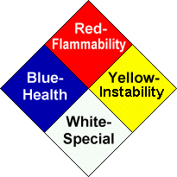
The six o'clock position on the symbol represents special hazards and has a white background. The special hazards in use are W, which indicates unusual reactivity with water and is a caution about the use of water in either fire fighting or spill control response, and OX, which indicates that the material is an oxidizer.

The followings are the detailed description of each categorization of the NFPA diamond sign (NFPA 704):
- Class of Health Hazard
  - Class 0. Materials that, under emergency conditions, would offer no hazard beyond that of ordinary combustible materials.
  - Class 1. Materials that, under emergency conditions, can cause significant irritation.
  - Class 2. Materials that, under emergency conditions, can cause temporary incapacitation or residual injury.
  - Class 3. Materials that, under emergency conditions, can cause serious or permanent injury.
  - Class 4. Materials that, under emergency conditions, can be lethal.

- Class of Flammability Hazard
  - Class 0. Materials that will not burn under typical fire conditions, including intrinsically noncombustible materials such as concrete, stone, and sand.
  - Class 1. Materials that must be preheated before ignition can occur. Materials in this degree require considerable preheating, under all ambient temperature conditions, before ignition and combustion can occur.
  - Class 2. Materials that must be moderately heated or exposed to relatively high ambient temperatures before ignition can occur. Materials in this degree would not under normal conditions form hazardous atmospheres with air, but under

high ambient temperatures or under moderate heating could release vapor in sufficient quantities to produce hazardous atmospheres with air.
  - Class 3. Liquids and solids that can be ignited under almost all ambient temperature conditions. Materials in this degree produce hazardous atmospheres with air under almost all ambient temperatures or, though unaffected by ambient temperatures, are readily ignited under almost all conditions.
  - Class 4. Materials that rapidly or completely vaporize at atmospheric pressure and normal ambient temperature or that are readily dispersed in air and burn readily.

- Class of Instability (Reactivity) Hazard
  - Class 0. Materials that in themselves are normally stable, even under fire conditions.
  - Class 1. Materials that in themselves are normally stable but that can become unstable at elevated temperatures and pressures.
  - Class 2. Materials that readily undergo violent chemical change at elevated temperatures and pressures.
  - Class 3. Materials that in themselves are capable of detonation or explosive decomposition or explosive reaction but that require a strong initiating source or must be heated under confinement before initiation.
  - Class 4. Materials that in themselves are readily capable of detonation or explosive decomposition or explosive reaction at normal temperatures and pressures.

- Special Hazard
Special hazards address water reactivity and oxidizing properties of the materials. The materials that react violently or explosively with water (water reactivity rating of 2 or 3) shall be identified by the label “W” and materials that possess oxidizing properties shall be identified by the letter “OX”. The severity of the hazard posed by an oxidizer can be divided in to 4 classes from Classes 1 through 4. The adding of the quantification of the oxidation helps to better define the hazard. For example, for the material categorized as a Class 2 oxidizer (e.g. calcium chlorite) can be marked “OX 2” to better define the hazard.

The descriptions of the class of water reactivity hazards and oxidizer hazards are listed as follows:

a.) Class of Water Reactivity Hazards
  - Class 0. The chemical is essentially non-reactive with water.
  - Class 1. The materials that react vigorously with water, but not violently.
  - Class 2. The materials that react violently with water, including the ability to boil water, or that evolve flammable or toxic gas at a sufficient rate to create hazards under emergency response conditions.
  - Class 3. The materials that react explosively with water without requiring heat or confinement.

b.) Class of Oxidizer
  - Class 1. An oxidizer that does not moderately increase the burning rate of combustible materials with which it comes into contact.
  - Class 2. An oxidizer that cause a moderate increase in the burning rate of combustible materials with which it comes in contact.
  - Class 3. An oxidizer that cause a severe increase in the burning rate of combustible materials with which it comes into contact.
  - Class 4. An oxidizer that can undergo an explosive reaction due to contamination or exposure to thermal or physical shock and that causes a severe increase in the burning rate of combustible materials with which it comes into contact.

Some chemicals in use already have these markings (or their equivalents) on the container. For those without classifications, determine the chemical hazard rating using the data available from the manufacturer-supplied MSDS.

- Class of Organic Peroxide
  - Class V. Organic peroxides that burn with less intensity than ordinary combustibles or do not sustain combustion and that pose no reactivity hazard.
  - Class IV. Organic peroxides that burn in the same manner as ordinary combustibles and that pose a minimal reactivity hazard.
  - Class III. Organic peroxides that burn rapidly and that pose a moderate reactivity hazard.
  - Class II. Organic peroxides that burn very rapidly and that pose a severe reactivity hazard
  - Class I. Organic peroxides that are capable of deflagration but not detonation.
  - Unclassified detonable: Organic peroxides that are capable of detonation and pose an extremely high-explosion hazard through rapid explosive decomposition.

PART II

- GENERAL FIRE CODE REQUIREMENTS

- Fire Department Permit

A permit is required to maintain or operate a non-production chemical laboratory or storage room in which more than 1 gallon of flammable or combustible liquid or 75 SCF of flammable gas are handled, stored, or used in testing, research, experimental or instructional work. This permit will be issued by the Fire Commissioner after the location has been inspected and approved as acceptable for such practices.

The certificate of fitness holder is responsible for ensuring that all required permits are secured in visible locations. The holder is responsible for complying with the requirements of the Fire code.

Permits are valid for 12 months only. Every permit or renewal shall require an inspection and shall expire after twelve months. Permits are not transferable and any change in occupancy, operation, tenancy or ownership shall require that a new permit be issued. Current permits (or a legible copy) shall be readily available for inspection by any representative of the department.

Fire Department Permit Sample (Pre-existing Laboratory):
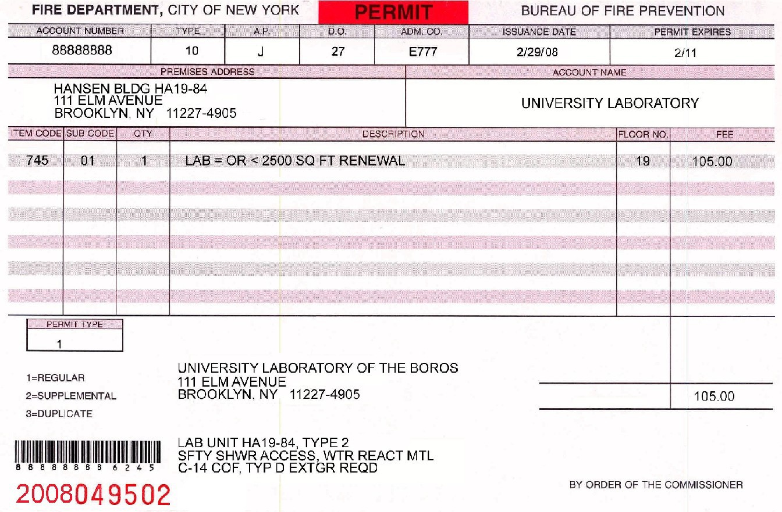

Fire Department Permit Sample (new fire code):
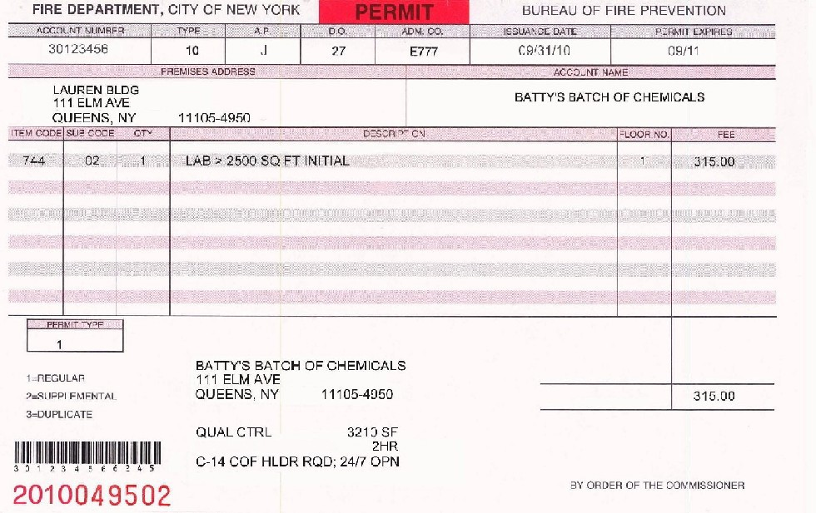

Generally speaking, the certificate of fitness holder can determine whether the laboratory is “pre-existing laboratory” or “new laboratory” by the information contained on the permit. If the description under the laboratory address mentions about “type” (e.g. type 2), then it is usually a pre-existing laboratory. If the description mentions about “laboratory size (e.g. 3210SF)” or “fire rating (e.g. 2HR), normally this laboratory needs to follow the new fire code. You should verify with the building fire safety personnel whether the laboratory you are responsible to supervise must comply with the new fire code or by the former regulations.

Enforcement action may be taken against the building owner, tenant and the certificate of fitness holder when the required permits are not secured. The enforcement actions may include fines and/or the revocation of the certificate of fitness. In addition to the requirements of Fire Code, all applicants for a permit must meet the requirements of the Department of Buildings. Other agencies such as NYCDOH, NYCDEP, NYSDEC, OSHA, and USEPA may have additional requirements.

- General Operations, Housekeeping and Good Work Practices

Poor operations, housekeeping & work practices are one of the leading causes of hazardous material incidents, work place accidents and fires. Before performing any chemical reaction, evaluation shall be made for hazards that can be encountered or generated during the course of the work. The evaluation must include (1) the hazards associated with the properties and the reactivity of the materials used and any intermediate and end products that can be formed; (2) the hazards associated with the

operation of the equipment at the operating conditions; (3) and the hazards associated with the proposed reactions, for example, oxidation and polymerization. Poor housekeeping can result in fire accidents, lost tools/supplies, damaged equipment and contribute to higher operating costs. Good housekeeping minimizes fire, accidents, reduces waste & disposal costs, increases efficiency and generally results in cheaper production costs. Areas kept in neat & organized condition provides a positive impression on inspectors. The following is some guidance on good practices.

- General Housekeeping and Standards:
  - Access doors, aisles and exit doors clear of obstructions. Keep storage of items out of hallways and stairwells. The Fire Code contains various requirements for aisle spacing depending upon stacking arrangements.
  - Secure storage areas to minimize liability and hazards of intrusion or dumping.
  - Be familiar with the use, limitations and location of emergency equipment such as emergency eyewashes, safety showers, fire alarms, exits and fire extinguishers.
  - Be aware of Fire Code storage requirements for permit and certificates of fitness.
  - Material Safety Data Sheet (MSDS) information should be readily available.
  - The following areas shall require special consideration:
    - Handling and storage of chemicals, flammable and combustible liquids, and gases
    - Open flame and spark-producing equipment hot work authorization
    - Arrangements and use of portable electric cords
- Work Areas:
  - Empty, but not clean, containers should be handled as having the same hazards as non-empty containers. In some cases, the residual vapors are more dangerous than the liquids. For example, gasoline vapors are more flammable than liquid gasoline.

  - Keep work areas clean and free of obstructions.
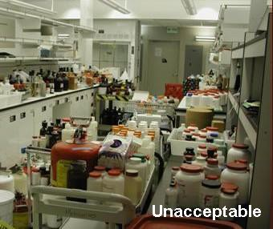
A messy laboratory is hazardous!
•
- Limit the amount of hazardous materials to the minimum needed for an operation and keep process containers covered when not being used.
- Clean surfaces (counter tops, bench tops, fume hoods and floors) of drips and residues.

  - Clean spilled chemicals immediately. Small spills can be cleaned up by properly trained employees with the appropriate spill response supplies and dispose of all wastes properly.
  - Any release of hazardous material into a sewer, water way, ground or atmosphere shall be subjected to comply with all requirement of federal, state, or local regulations.
  - Routinely inspect and address potential sources of leaks and spills including tanks, pipes, hoses and container storage areas. Spill control equipment & containment structures should be inspected periodically.
  - Code required signage must be provided on entrance to locations where hazardous materials are stored.
  - Good house keeping shall be maintained so as to avoid accumulations of the combustible dust.
  - Do not store, handle, or use of any liquid where the liquid may come in contact with any electrical receptacle, switch and control.
  - All furniture, casework, and equipment in laboratory units shall be arranged so that means of access to an exit can be reached easily from any point.

- Safety Procedures
Building owners are responsible for providing the periodic inspection, testing, and maintenance of the following systems, and the Certificate of Fitness should be aware of these requirements:
  - Utilities (Steam, gas, electrical)
  - Air supply and exhaust systems
  - Fire protection equipment
  - Detectors and alarms
  - Compressed gas regulators and pressure relief valves
  - Waste disposal systems
  - Fire doors
  - Emergency lighting and exit signs
  - Electrically operated equipment

If Certificate of Fitness is aware that any of the above system is not operational, they shall immediately notify the building owner or other designated building employee to fix the problem.

- Separation of incompatible materials
Incompatible materials, shall be separated while in storage except for stored materials in individual containers each having a capacity of not more than 5 pounds or 0.5 gallon. Separation shall be accomplished by:
  - Segregating incompatible materials in storage by a distance of not less than 20 feet.
Or
  - Storing liquid and solid materials in hazardous material storage cabinets. Materials that are incompatible shall not be stored in the same cabinet.
Or
  - Storing compressed gases in gas cabinets or exhausted enclosures in accordance with the Fire Code. Materials that are incompatible shall not be stored within the same cabinet or exhausted enclosure.

Or
- Isolating incompatible materials in storage by a noncombustible partition extending not less than 18 inches above and to the sides of the stored material.
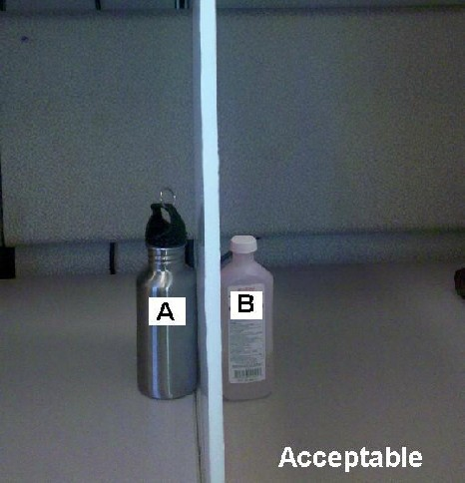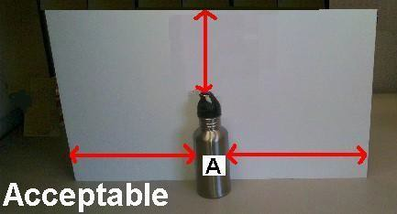
A and B are incompatible materials. They are both stored in individual containers each more than 0.5 gallons in size and are separated by a noncombustible partition.
At least 18 inches
Some examples of incompatible chemicals are shown in the table below. The chemicals in the right column should not be allowed to come in contact the chemicals in the left column. The MSDS’s should be consulted regarding specific incompatibilities. When you dilute corrosives, especially for concentrated strong corrosives, always add the corrosive material to water slowly while stirring; never the reverse. The exothermic reaction from the dilution can cause the water to flash to steam resulting in possible thermal and chemical burns due to splashing.

Table II-1. Examples of incompatible chemicals
SOURCE: Prudent Practices for Handling Hazardous Chemicals in Laboratories, National Research Council, Washington, D.C.,1995.
Chemical | Incompatibles
Acetic acid | Chromic acid, ethylene glycol, hydroxyl- containing compounds, nitric acid, perchloric acid, permanganates, peroxides
Acetone | Concentrated nitric and sulfuric acid mixtures
Acetylene | Bromine, chlorine, copper, fluorine, mercury, silver
Alkali and alkaline earth metals (lithium, sodium, potassium) | Carbon dioxide, carbon tetrachloride or other chlorinated hydrocarbons, halogens, powdered metals (e.g. aluminum or magnesium),water
Ammonia(anhydrous) | Bromine, calcium hypochlorite, chlorine, iodine, hydrofluoric acid (anhydrous),mercury (e.g. in manometers),

Table II-1. Examples of incompatible chemicals (continued)
Chemical | Incompatibles
Ammonium nitrate | Acids, chlorates, finely divided organic or combustible materials powdered metals, flammable liquids, nitrates, sulfur
Aniline | Hydrogen peroxide, nitric acid
Azides | Acids
Bromine | See Chlorine
Calcium oxide | Water
Carbon (activated) | All oxidizing agents, Calcium hypochlorite
Carbon tetrachloride | Acids, ammonium salts, chlorates, finely divided organic or combustible materials, powdered metals, sodium, sulfur,
Chlorine | Ammonia, acetylene, benzene, butadiene, butane, hydrogen, finely divided metals, methane, propane (or other petroleum gases), sodium carbide, turpentine
Chromic acid and chromium | Acetic acid, alcohol, camphor, flammable liquids in general, glycerol naphthalene
Cyanides | Acids
Flammable liquids | Ammonium nitrate, chromatic acid, halogens, hydrogen peroxide, nitric acid, sodium peroxide
Hydrofluoric acid (anhydrous) | Ammonia (aqueous or anhydrous)
Hydrogen peroxide | Acetone, alcohols, aniline, chromium, combustible materials, copper, iron, most metals or their salts, nitromethane, organic materials,
Hypochlorites | Acids, activated carbon
Mercury | Acetylene, ammonia, fulminic acid
Nitrates | Sulfuric acid
Nitric acid (concentrated) | Acetic acid, aniline, any heavy metals, brass, chromic acid, copper, flammable gases, flammable liquids, hydrocyanic acid, hydrogen sulfide

Table II-1. Examples of incompatible chemicals (continued)

Chemical Incompatibles
Nitrites Potassium or sodium cyanide.

Oxygen Flammable liquids, solids, or gases; grease, hydrogen, oils
Acetic anhydride, alcohol, bismuth and its alloys, grease, oils, paper, wood
Perchloric acid
Peroxides, Organic Acids (organic or mineral), avoid friction, store
cold
Phosphorus (white) Air, alkalis, oxygen, reducing agents
Phosphorus pentoxide Water
Potassium Carbon dioxide, carbon tetrachloride, water Potassium permanganate Benzaldehyde, ethylene glycol, glycerol,
sulfuric acid
Sodium See Potassium
Sodium nitrite Ammonium nitrate and other ammonium salts Acetic anhydride, benzaldehyde, carbon

Sodium peroxide
disulfide, Ethyl or methyl alcohol, ethyl acetate, ethylene glycol, furfural, glacial acetic acid, glycerin, methyl acetate

Sulfides Acids
Potassium chlorate, potassium perchlorate,

Sulfuric acid

Water
potassium permanganate (similar compounds of light metals, such as sodium, lithium)
Acetyl chloride, alkaline and alkaline earth metals, their hydrides and oxides, barium peroxide, carbides, chromic acid, phosphorous oxychloride, phosphorous pentachloride, phosphorous pentoxide, sulfuric acid, sulfur trioxide

- Material Safety Data Sheets (MSDS)

The material safety data sheet (MSDS) contains specific information about the health and physical hazards of the material used, as well as safe work practices and required protective equipment. It may also describe the material's physical characteristics and procedures that should be followed in case of an emergency. For example, the MSDS may list appropriate and inappropriate extinguishing agents. The Certificate of Fitness holder must refer to the MSDS when questions arise about how to handle, use, or

store hazardous chemicals or materials. The MSDS may also be requested by health care personnel to facilitate proper medical care in the event of chemical exposure. (See Appendix B for a sample of a “Material Safety Data Sheet”)
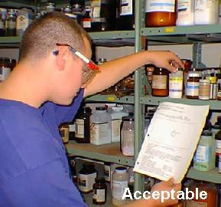

- LABORATORY UNIT HAZARD CLASSIFICATION, DESIGN AND STORAGE

- Flammable & Combustible Liquids Quantity Limitation for Different Laboratory Units

- Pre-existing laboratories
For the pre-existing laboratories, flammable and combustible liquids in each laboratory unit shall be maintained within the maximum allowable quantities specified in the following tables.

Table II-2. Quantity Limitation for Pre-existing Laboratory
Lab Type | Fire Rating (hr) | Fire Protection | Flammable liquids | Combustible liquids
I | 2 | Sprinklered | 30 Gallons | Not applicable
II | 1 | Sprinklered | 25 Gallons | Not applicable
III | 2 | Nonsprinklered | 20 Gallons | Not applicable
IV | 1 | Nonsprinklered | 15 Gallons | Not applicable
Schools K-12 | 1 or 2 | Sprinklered or  Nonsprinklered | 20 Gallons* | 5 Gallons*

* See appendix C for specific information (2) New fire code
In the new fire code, laboratories are classified either Class B or Class D. Moreover, educational and instructional labs and labs in health care occupancies shall comply with Class D requirement only. All laboratory units shall be separated from non- laboratory areas at least by 1-hour fire rated construction. Chemical inventories in each laboratory unit shall be maintained within the maximum allowable quantities specified in the following tables. Appendix D presents the maximum quantities for different laboratory sizes. It is the Certificate of Fitness holder’s responsibility to figure out what is the approximate maximum quantity that he/she can store or use in the laboratory according the laboratory class and size.

Table II-3. Quantity Limitation in the New Fire Codea
Excluding Quantities in Storage Cabinets or Safety Cans |  |  | Including Quantities in Storage Cabinets or Safety Cans
Laboratory unit hazard classification | Maximum Quantity Class I Liquids Alone per Lab Unit (gal) | Maximum Quantity Class I, II, IIIA Liquids per Lab Unit (gal) | Maximum Quantity Class I Liquids Alone per Lab Unit (gal) | Maximum Quantity Class I, II, IIIA Liquids per Lab Unit (gal)
Class B | 5 gals/100 ft2  25 (max) | 10 gals/100 ft2  25 (max) | 10 gals/100 ft2  25 (max)b | 20 gals/100 ft2  25 (max)b
Class D | 1 gals/100 ft2  75 (max)c | 1 gals/100 ft2  75 (max)c | 2 gals/100 ft2  150 (max)d | 2 gals/100 ft2  150 (max)d

  - Educational and instructional labs and labs in health care occupancies shall comply with Class D requirement only
  - Increased to 30 gallons with 2-hr laboratory fire rating
  - Increased to 100 gallons in the labs other than educational and instructional labs or labs in health care occupancies
  - Increased to 200 gallons with 2-hr laboratory fire rating in the labs other than educational and instructional labs or labs in health care occupancies
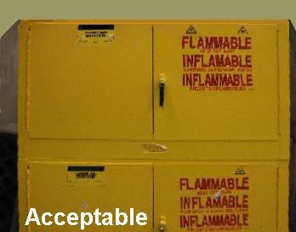
Acceptable storage cabinets

- Other Laboratory Hazardous Material Quantity Limitations

The following quantity limitations are independent of any hazardous materials that are stored in an approved chemical storage room:

- Pre-existing laboratories
For the pre-existing laboratories, other laboratory hazardous material quantity in each laboratory unit shall be maintained within the maximum allowable quantities specified in the following tables:

Table II-4. Laboratory Hazardous Material Quantity Limitations for Pre-existing Laboratories

Lab Type | I | II | III | IV | Schools K-12a
Flammable Solids | 15 Lbs | 10 Lbs | 6 Lbs | 3 Lbs | 50 Lbs
Oxidizing Material | 50 Lbs | 40 Lbs | 30 Lbs | 20 Lbs | 100 Lbs
Unstable Reactive Material | 12 Lbs | 6 Lbs | 3 Lbs | 2 Lbs | 30 Lbs
Corrosive Material | Not applicable | Not applicable | Not applicable | Not applicable | 50 Gals
Other Hazardous Material | Not applicable | Not applicable | Not applicable | Not applicable | 80 Lbs
a. See appendix C for specific information

Table II-5. Flammable Gases Quantity Limitations for Pre-existing Laboratories

Area of Laboratory |  | Maximum Capacity*
Up to 500 Sq. Ft. | Per additional 100 Sq. Ft.
9.24 Cu. Ft. | 1.54 Cu. Ft. | 15.4 Cu. Ft.
* Water container capacity

- New fire code
For those laboratory units following the new fire code, other laboratory hazardous material quantity in each laboratory unit shall be maintained within the maximum allowable quantities specified in the following tables:

Table II-6. Laboratory Hazardous Material Quantity Limitations in the New Fire Code

 | Maximum quantity in 1-hr fire rated lab | Maximum quantity in 2-hr fire rated lab
Water-Reactive Material | 2.5 Lbs. | 5 Lbs.
Pyrophoric Material | 0.5 Lbs. | 1 Lbs.
Highly Toxic Material | 5 Lbs. | 5 Lbs.
Toxic Material | 250 Lbs. | 250 Lbs.
Corrosive Material | 250 Gallons | 250 Gallons
Flammable Solids | 10 Lbs. | 15 Lbs.
Oxidizers/Org Peroxides | 40 Lbs.a | 50 Lbs.a
Unstable reactive material | 6 Lbs. b | 12 Lbs.b
- maximum 2 lbs of Class 3 oxidizers & 1 lb of Class I organic peroxides
- maximum 1 lb of Class 3 unstable reactive material

In addition, there are special quantity limitations for compressed gases. For those laboratory units following the new fire code, the total number of lecture bottle-sized containers of any type shall be limited to 25. However, for the educational or instructional laboratories, the total number of lecture bottle-sized containers of any type shall be limited to 10. For the containers other than the lecture bottles, the material quantity limitations are listed as the following table:

Table II-7. Hazardous Gases Quantity Limitations in New Fire Code (Non-Educational or Non-Instructional Labs)
Gas Type | Area of Laboratory |  | Maximum Capacity
Up to 500 Sq. Ft. |  | Per additional 100 Sq. Ft.
Flammable gases | 12 Cu. Ft.a,b | 2.4 Cu. Ft. a,b | Not applicable
Oxidizing gases | 12 Cu. Ft. a,b | 2.4 Cu. Ft. a,b | Not applicable
Liquefied flammable gases | 2.4 Cu. Ft. a,b | 0.36 Cu. Ft. a,b | Not applicable
Health hazard 3 or 4 gases | 0.3 Cu. Ft.a | 0.06 Cu. Ft.a | Not applicable
- Water container capacity
- The quantity limitations for flammable gases, oxidizing gases and liquefied flammable gases were doubled from what appears in sections 11.6.5(1) thru (3) of NFPA 45 as allowed by section A11.6.5 for sprinklered labs.

Table II-8. Hazardous Gases Quantity Limitations in New Fire Code (Educational and Instructional Labs)
Gas Type | Maximum Capacity
Flammable gases | 6 Cu. Fta
Oxidizing gases | 6 Cu. Fta
Liquefied flammable gases | 1.2 Cu. Fta
Health hazard 3 or 4 gases | 20 SCFb
  - The quantity limitation is limited by NFPA which uses water container capacity units
  - The quantity limitation is limited by Fire Code which uses SCF units (20 SCF is approximately equal to 0.10 cu ft).

Typical internal volume of common gas containers are listed in Appendix A (page 54). Appendix E presents the maximum quantities of gases for different laboratory sizes. It is the Certificate of fitness holder’s responsibility to figure out what is the approximate maximum quantity that he/she can store or use in the laboratory according the laboratory class and size.

In the test, examinees do not have to memorize the maximum quantity tables (Table II- 2 to Table II-8 or tables in Appendix D and E), but they need to know how to USE the tables in Appendix D and E to figure out the maximum quantity limitation of different chemicals under different condition. Appendix F provides an inventory table. Using this table, the Certificate of fitness (C-14) holder can monitor the hazardous materials and maintain compliance with the code requirements.

- Prohibitions

It shall be unlawful in any non-production laboratory or any accessory storage of laboratory chemicals in a storage room to use an open flame for heating or distilling any flammable solid, flammable liquid or flammable gas or to store, handle or use any following hazard materials:
  - Explosive;

  - unclassified detonable organic peroxide;
  - detonable pyrophoric material;
  - detonable unstable (reactive) material;
  - detonable water-reactive material;
  - Class 4 unstable (reactive) material;
  - Class 4 oxidizing material;
  - below grade any flammable gas.

For the pre-existing laboratories in the schools K to 12th grade, there are other prohibitions that must be complied with as follows

- It shall be unlawful to manufacture or store in a school any:
  - Acetylide of copper; or other metallic acetylide
  - Amide or amine explosive;
  - blasting powder
  - Chloride of nitrogen;
  - Colored fire in any form;
  - Cymogene or any volatile product of petroleum (except rhigoline) or coal tar having a boiling point lower than sixty degrees Fahrenheit;
  - Flashlight powders;
  - Fulminate or any fulminating compound (e.g. fulminate of mercury);
  - Guncotton;
  - Gunpowder in any form;
  - Liquid acetylene;
  - Liquefied chlorine;
  - Nitro-glycerine, except in official U. S. pharmacopoeia solution, or in the form of pills, tablets, or granules containing not more than one-fiftieth of a grain each;
  - Picrates;
  - Potassium chlorate in admixture with organic substances or with phosphorus or sulphur; provided that this restriction shall not apply to the manufacture or storage of tablets of chlorate of potash intended for use solely for medicinal purposes;
  - Smokeless powder.

- No more than five (5) gallons of volatile flammable oils derived from petroleum, shale oil or coal tar should be stored at any one time.

- No more than twenty-five (25) pounds of potassium and/or sodium chlorate is permitted to be stored.

- Laboratory Safety Requirement

- Hazard identification signs.
Unless otherwise exempted by the commissioner, hazard identification signs for the specific materials contained shall be conspicuously affixed on stationary containers and at entrances to locations where hazardous materials are stored, handled, used, or dispensing.

With the exception of educational facilities, pre-existing laboratories were required to be provided with a sign on the outside of each laboratory door indicating, “Laboratory
– Potentially Hazardous Substances”. A new Fire Department rule requires that all new laboratories be provided with a sign on the outside of each laboratory indicating, “Laboratory – Caution: Hazardous Materials”. All laboratories, including educational facilities, should be provided with the preferred new sign language, however the old sign language shall also be acceptable. Pre-existing laboratories were also required to provide signs on entrance doors whenever water reactive, radioactive and/or flammable or poisonous gases (e.g. DOT placards) or bio-hazardous materials (e.g.
OSHA sign) were in use.

In addition to the above signage requirements, NFPA Standard 45 also requires that all laboratories (both pre-existing and new) be provided with warning signs on entrance doors for laboratories that store or use materials that constitute an unusual or severe fire hazard, including unstable, toxic, radioactive, carcinogenic, pathogenic, water reactive or cryogenic materials. “Lettered” or “pictured” signs shall be acceptable to identify the laboratory as those that store and/or use materials that present an unusual or severe fire hazard.

The “Laboratory – Potentially Hazardous Substances” sign or the “Laboratory – Caution: Hazardous Materials” sign shall be constructed of metal or other durable material, with RED letters on a white background which shall be located in the area of the mid-point of the height of the door.

The sample pictures of different signs are presented below: a.) Fire Department Rule Section 4827-01(g)(1) Sign

1½”
1/4” stroke
5/16”
7/16”
1/16”

b.) New FC 2706-01 lab rule sign

1½”
1/4” stroke
5/16”
7/16”
1/16”

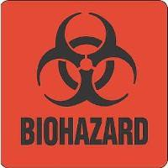
c.) OSHA biohazard sign

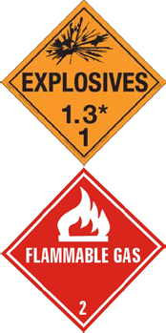
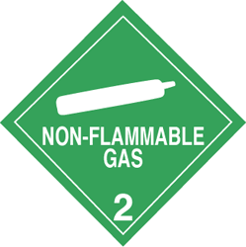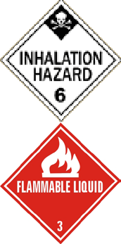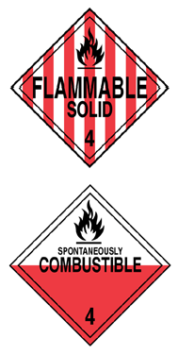d.) DOT
Table II-9. DOT placard.
Class | Label | Examples
Class 1 : Explosives |  | Ammonium nitrate; Hydrated picric acid which becomes explosive upon drying
Class 2 :Gases
Division 2.1 Flammable gases |  | Hydrogen; Methane
Division 2.2 Non- flammable, non-toxic compressed gases |  | Carbon Dioxide; Oxygen
Division 2.3 Gases toxic by inhalation |  | Diborane; Fluorine; Nitrogen dioxide
Class 3 : Flammable liquids |  | Methanol; Ethanol; Esters; Ethers; Ketones
Class 4: Flammable solids
Division 4.1 Flammable solids |  | Naphthalene;  Finely divided metal  (e.g., aluminum, cadmium, chromium, titanium, zinc)
Division 4.2 Spontaneously combustible materials |  | Acetic acid; Cumene; Phenol; Propionic acid

Table II-9. DOT placard.
Class | Label | Examples
Division 4.3 Dangerous when wet materials | 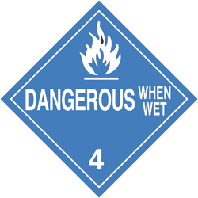 | Acetyl chloride; Aluminum; Calcium carbide;  Chloride (anhydrous); Chlorosulfonic acid; Magnesium;  Phosphorus pentatchloride; Sodium; Stannic chloride; Thionyl chloride
Class 5 : Oxidizers and Organic peroxides
Division 5.1 Oxidizers | 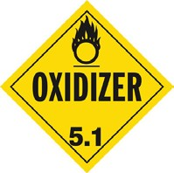 | Ammonium nitrate; Bromine; Calcium nitrate;  Chromic acid; Fluorine; Nitric acid; Oxygen; Peroxide; Perchloric acid;  Potassium chlorate; Potassium nitrate; Sodium dichromate;  Sodium nitrate; Sulfuric acid
Division 5.2 Organic peroxides | 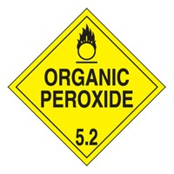 | Benzoyl peroxide; Hydrogen peroxide;  Ethyl methyl ketone peroxide
Class 6: Toxic materials and Infectious substances | 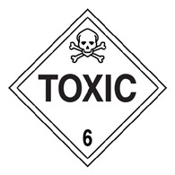 | Acrolein; Arsenic salts; Calcium cyanide; Nicotine; Hydrocyanic acid;  Organic mercury compounds
Class 7: Radioactive materials | 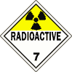 | Any material having a specific activity greater than  0.002 microcuries per gram (µCi/g)
Class 8: Corrosive materials | 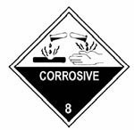 | Acids  (Acetic acid; Citric acid; Formic acid; Oxalic acid)  Bases  (Ammonium hydroxide; Calcium hydroxide; Potassium hydroxide; Sodium hydroxide)

In addition, “No Smoking” signs shall be required even in institutions that totally prohibit smoking. The signs shall be provided in English as a primary language and conspicuously posted in the following locations:
a.) In rooms or areas where hazardous materials are stored or used.
b.) Within 25 feet of outdoor hazardous material storage, handling and use areas, including dispensing areas.
c.) Facilities or areas within facilities in which smoking has been entirely prohibited.

The Fire Department has published an approved “No Smoking” sign. It is set forth in Fire Department rule (as the following figure). However, the Fire Department does not mandate that this design be used. Other legible, durable signs, clearly communicating the “no smoking” requirement, may be used, but are subject to Fire Department enforcement action if found to be inadequate.
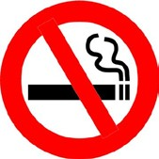

An example of acceptable sign on a laboratory door
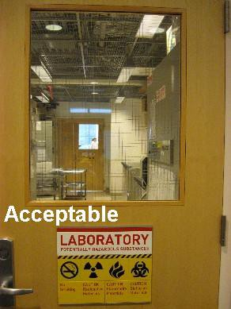

- All required signs are posted in the entrance of the laboratory.
- The “Laboratory – Potentially Hazardous Substances” sign posted in red letters
- “No Smoking” sign is posted
- “Radioactive”, “Biohazard” , “Flammable Material” placards are posted

- Fume Hoods and Exhaust Systems
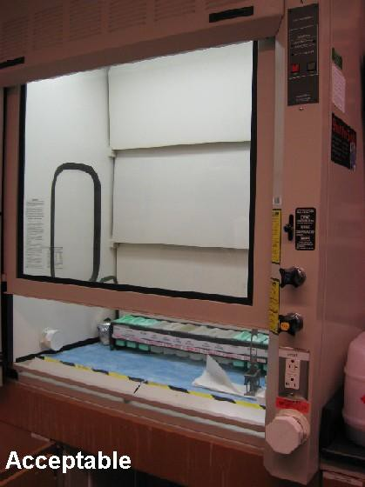

Approved fume hoods and exhaust systems which are installed to limit work place exposure to hazardous or noxious fumes, vapors or dusts. In general, fresh air is drawn in from the open side of the fume hood, and expelled outside the building (ducted type fume hood). Although commonly used outside N.Y.C., hoods made safe through filtration and fed back into the room are not allowed to be used in the city.

The hoods are designed for use when working with chemicals and must NOT be used for the storage of chemicals. Users should be periodically reminded to open hood sashes slowly and to allow hood sashes to be open only when needed. Chemical fume hoods shall be located in areas of minimum air turbulence, so people walking past the hood or place irrelevant activities should be minimized. The Certificate of Fitness holder must make sure that these systems are maintained in good working order and make sure that the face velocity of chemical fume hoods, exhaust systems, and laboratory special exhaust systems are inspected and tested annually by qualified inspectors.

With the exception of educational facilities, fume hood installations in pre-existing laboratories were required to provide a minimum average face velocity of 100 feet per minute (fpm) with a minimum face velocity at any point no less than 75 fpm. While no maximum face velocity or sash test height criteria was adopted, nationally recognized standards did recognize fume hoods with maximum face velocity limits ranging from 120 to 150 fpm and sash heights in the 12 to 18 inch range as acceptable. For new laboratories, NFPA 45 requires fume hoods to be evaluated using ASHRAE Standard 110, Method of Testing Performance of Laboratory Fume Hoods. ASHRAE Standard 15 indicates that face velocities of 80 to 120 fpm will generally provide the required containment. NFPA Standard 45, however, does not mention a required sash height that should be used when tested for face velocity.

In order to allow that pre-existing fume hoods be permitted to meet the lower minimum average fume hood face velocities specified in NFPA Standard 45, and for the sake of uniformity, fume hood installations in all laboratories would be required to meet an average face velocity range of 80 to 150 fpm at a sash height range of 12 to 18 inches. Fume hoods operating outside of this range would be required to be repaired, replaced, or otherwise altered to meet the required range, unless acceptable to the Fire Department based upon an evaluation by a qualified professional of the fume hood’s performance. Fume hoods failing to satisfy any of the above criteria should be removed from service until such time as a remedy is established. Fume hoods taken out of service should be marked as such (e.g. “DO NOT USE”).

The physical condition of the hood interior, sash, and ductwork need to be visually inspected if they are clean, dry, tight, and friction-free. An annual label (inspection record) for recording inspection interval, last inspection date, average face velocity, and inspector’s name shall be affixed to each hood.
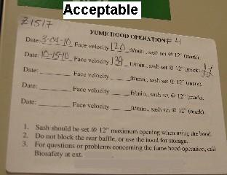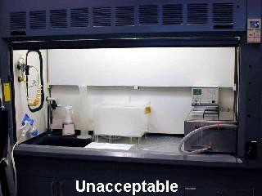
An annual inspection record with “Date”, “Face velocity” and “Inspector’s name”.
Keep the hood sash closed as much as possible when the fume hood is not in use.

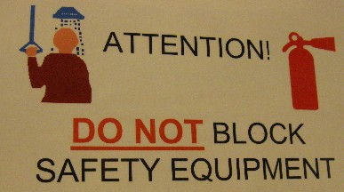
Special requirements for Chemical fume hood using perchloric acid:
When perchloric acid is heated above ambient temperatures, it will give off vapors that can condense and form explosive perchlorates. In order to decrease the potential hazard, the heating process must be only used in a chemical fume hood specially designed for percholoric acid operations or in a hood that the vapors can be trapped and scrubbed before they are released into the hood. The hood, exhaust ductwork, and fan shall be acid resistant, nonreactive, and impervious to perchloric acid. A water spray system shall be provided for washing down the hood interior behind the baffle and the entire exhaust system after each use, the effective washing down method has been recommended in the CRC Handbook of Laboratory Safety.

- Safety Showers, Neutralizing or Absorbing Agents and Curtains
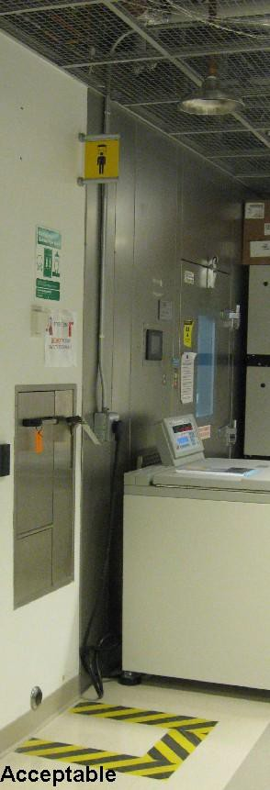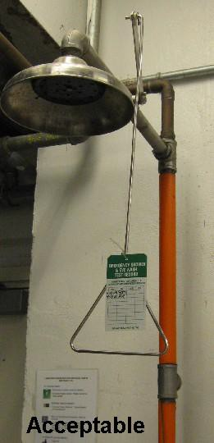Where more than 5 gallons of corrosive liquids or flammable liquids are stored, handled, or used, fixed overhead or flexible hand-held safety showers must be available in the laboratory, or outside the laboratory within 25 feet of laboratory/storage-room entrance door. Additionally, neutralizing or absorbing agents shall be provided. Safety showers shall be tested annually and a record of such maintenance must be maintained on the premise.
Keep the safety shower unblocked.
A record must be maintained.

Curtain and drapes used in laboratories must be documented as “flame proof” (chemically treated) or “inherently flame resistant”. Documentation must be provided by a person holding a “flame proofing certificate of fitness”.

- Ventilation and Oxygen Sensor
Occupied laboratories should operate at 8 room air changes per hour while ventilation rates in unoccupied labs can be reduced to 4 room air changes per hour. Storage room shall be equipped with a continuously operated ventilation system that provides at least 6 room air changes per hour and vents to the outside air. The location and configuration of fresh air intakes shall be chosen so as to avoid drawing in chemicals or products of combustion coming either from the laboratory building itself or from other structures and devices.
When the total cryogenic gas capacity in one fire area exceeds the permit limit of 60 gallons, an oxygen sensor equipped with an audible alarm shall be provided in cryogenic gas storage or used areas to continuously monitor the level of oxygen in the area. The alarm shall actuate when oxygen concentration drops below 19.5%.
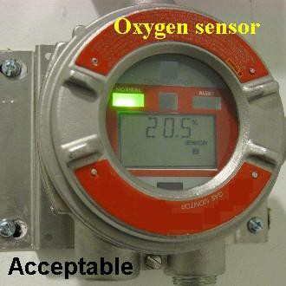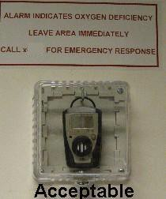
- Means of access to an Exit
It shall be unlawful to obstruct or impede access to any required means of egress. All required means of egress, including each exit, exit access and exit discharge, shall be continuously maintained free from obstructions and impediments to immediate use in the event of fire or other emergency. Emergency lighting facilities shall be provided for any laboratory work area requiring a second means of access to an exit.
- Storage room requirements
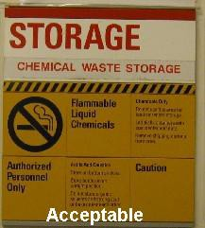

Each storage room must be constructed in a manner such that it has at least a 2-hour fire rating. Storage rooms shall be equipped with a continuously operated ventilation system that provides at least 6 room air changes per hour and vents to the outdoors.
A sprinkler system must be installed in each storage room. Electrical devices, equipment and systems installed in storage rooms in non-production laboratories shall comply with the Electrical Code requirements for Class I, Group D, Division 2 locations. Chemicals shall not be used and all incompatible materials must be separated within the storage room.

For the storage rooms which follow the new fire code, the capacity of each storage room shall not exceed a total volume of 300 gallons of chemicals or a liquid density of 5 gallons per square foot of floor area or 2,500 SCF flammable gas.

- CHEMICAL STORAGE, HANDLING, AND WASTE DISPOSAL

- Chemical Storage and Handling

General Storage Requirement:

  - Containers should be in good condition, stored in an upright position and closed when not in use.
  - Chemicals should be stored per manufacturer’s recommendations and in such a way to minimize the potential for tipping, tearing, puncture, or breakage.
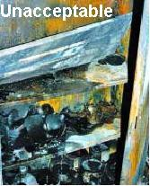
Unstable Shelves and Heavy Chemicals: The Cause of Explosion and Fire

A collapsed shelf in a solvent storage cabinet is implicated in the fire incident. The fire destroyed a university chemical laboratory completely including all of the research, laboratory notes, and other work by the supervisor and his students. The fire also damaged the adjacent laboratory.

  - Flammable/combustible material must be stored away from open flame or other ignition sources.
  - Don't stack equipment against containers.
  - Segregate incompatible materials/wastes by hazard category to prevent reactions (e.g. acids and bases). Organize chemicals first by COMPATIBILITY
— not alphabetic succession.
  - Know the characteristic of the material begin stored and possible interaction with other material stored.
  - No flammable gas is allowed be stored below grade.

- Under the new fire code, no Class I liquids, or flammable solids can be stored below the ground level. Additionally, Class II and Class IIIA liquids are only allowed in below grade sprinklered areas and Class IIIB liquids are allowed in below grade areas provided the areas are sprinklered.
- Safety cans should be considered for storage of flammable solvents instead of glass containers.
- Avoid storing any chemicals on the floor, especially chemicals stored in glass containers. If you must store containers of liquids on the floor, it is highly recommended that they should be away from pedestrian traffic and they are in secondary containments to control spills in case any container is accidentally broken.
- Piles of chemicals should be stacked in a secure manner, properly labeled in closed containers.
- Should not store chemicals above eye level.
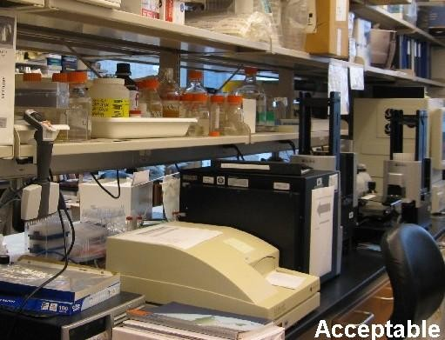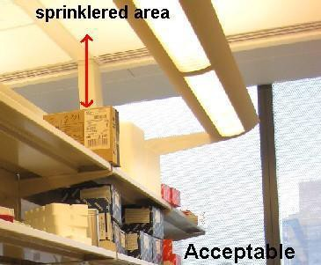
Keep chemicals under eye level
At least 18 inches

- Storage shall be maintained 2 feet or more below the ceiling in areas of buildings not protected by a sprinkler system, or a minimum of 18 inches below sprinkler head deflectors in areas protected by a sprinkler system.

  - 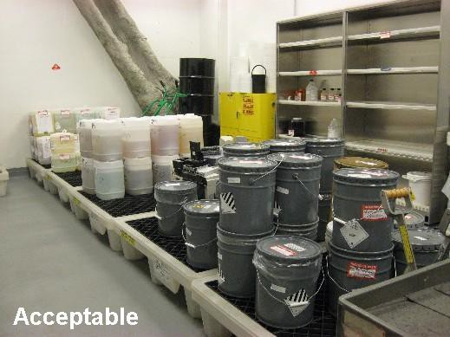Raise drums off floor to prevent corrosion from concrete "sweating" or storage in “wet” areas (i.e. pools).
•

Raise drums off floor.

- Storage area should be checked periodically for container integrity, leaks, older stock, faded/missing labels etc.

- Defective containers shall be promptly removed from service or disposed of in approved manner.
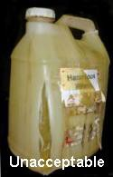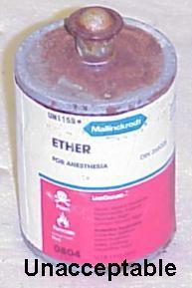
Rusty surface!
A leaking container
Handling and storage of chemicals shall conform to the manufactures’ recommendations and material safety data sheet (MSDS). The transportation of hazardous chemicals in laboratory buildings provides the greatest potential for chemical exposure to the building occupants. Spills occurring outside storerooms and laboratories may lead to hazardous concentrations of vapors and gases being distributed throughout the building. As a result, chemical quantities outside of storage shall be maintained at the lowest possible level necessary for the work performed and Class I liquids shall not be transferred from one vessel to another in any exit access corridor, and the spill scenario shall be limited to less than 5 gal for handling or storing all hazardous chemicals.

If the materials need to be transported between different floors, use of elevator for transport of hazardous materials should be accomplished by the minimum number of persons. In addition, it is not encouraged to use stairway to transport any amount of those materials.

Containers used to store chemicals and gases must be clearly labeled. These labels must indicate the container's contents. The containers of materials that might become hazardous during prolonged storage shall be dated when first opened. There are several chemicals that can increase in hazard potential if subjected to long-term storage. For example, exposure to air or light can cause the formation of peroxides (See Appendix A, Page 60). Another example is picric acid, which becomes highly shock-sensitive when its normal water content is allowed to evaporate. Reactive monomers that have been inhibited to reduce the chance of unintentional polymerization can become unstable when the inhibitor is consumed. At the end of 6 months, chemicals that can increase in hazard potential over time shall be evaluated (such as picric acid for dryness) or tested (such as isopropyl ether for peroxide formation) for continued safe use and can be re-dated and retained for an additional
- month period after it is found to be safe. The Certificate of Fitness holder must periodically check the labels to make sure that they are still legible. When the label on a container is not legible and its contents cannot be identified, the Certificate of

Fitness holder must treat its contents as hazardous waste. The Certificate of Fitness holder must then make arrangements to have the contents of the container disposed of in a safe manner according to the federal, state, and local regulations.
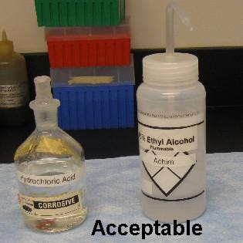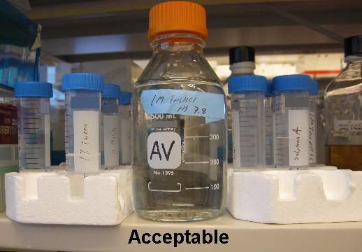
All containers on the working area must be clearly labeled.

The maximum allowable container capacity for flammable liquids and combustible liquids are listed as the following table.

Table II-10. The maximum allowable container capacity
Flammable Liquidsb |  |  |  | Combustible Liquidsb
Container Type | IA | IB | IC |  | II | IIIA
Glassa | 1 pt | 1 qt | 1 gal |  | 1 gal | 5 gal
Metal (other than DOT drums) or approved plastic | 1 gal | 5 gal | 5 gal |  | 5 gal | 5 gal
Safety cans | 2.6  gal | 5 gal | 5 gal |  | 5 gal | 5 gal
Metal container (DOT specification) | 1 gal | 5 gal | 5 gal |  | 60 gal | 60 gal
Polyethylene (DOT specification) | 1 gal | 5 gal | 5 gal |  | 60 gal | 60 gal
  - Break-resistant plastic coated glass containers as large as 1 gal shall be permitted to be used where the liquid would cause excessive corrosion or degradation of a metal or an approved plastic container.
  - In educational and instructional laboratory work areas, containers for Class I or Class II liquids shall not exceed the following capacity: Safety cans of 2.1 gallons and other containers of 1 gallon.

- Storage of Class I and Class II Liquids in Refrigerators

The flammable liquids stored in refrigerated equipment shall be stored in closed containers. Protection against the ignition of flammable vapors in refrigerated equipment is available through two types of laboratory refrigerators:
- Explosion-proof model: It is designed to protect against ignition of flammable vapors both inside and outside the refrigerated storage compartment.
- Flammable liquids storage refrigerator: The intent is to eliminate ignition of vapors inside the storage compartment by sources also within the compartment. And its design are intended to control or limit the damage should an exothermic reaction occur within the storage compartment and also reduce the potential for ignition of floor-level vapors.
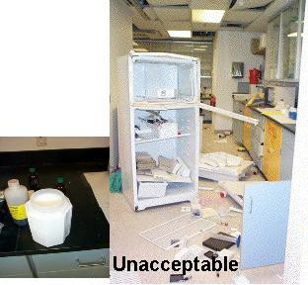
A liter of isopentane
Flammable Liquids and Domestic Refrigerators: An Explosive Combination.
A biomedical laboratory in one research facility were given an unexpected demonstration of what can happen when flammable liquids are stored in a domestic refrigerator.

Ordinary domestic refrigerators are allowed to be installed in chemical laboratories but are not permitted to store flammable liquids. The following signs shall be posted on all ordinary domestic refrigerators that are installed in chemical laboratories:

DO NOT STORE FLAMMABLE SOLVENTS IN THIS REFRIGERATOR.
OR
STORE NO FLAMMABLE LIQUIDS

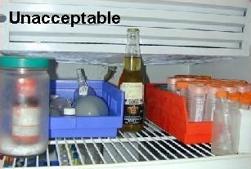
Do not store food with chemicals!
Examples of signs for different refrigerators

Domestic Refrigerator (Store No Flammables) | Laboratory-safe Refrigerator (Flammable Materials Storage)
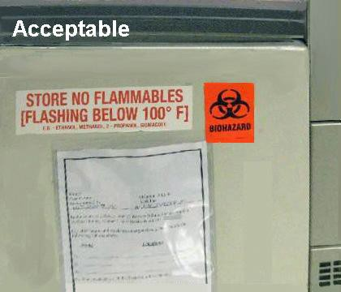 | 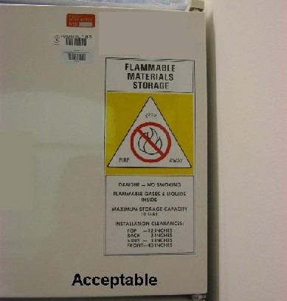
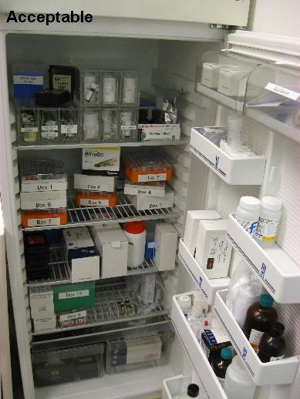
Well segregated chemicals in the refrigerator!

- Liquid Dispensing

Gases shall not be used to pressurize containers used to transfer Class I, II and IIIA liquids. Dispensing of Class I liquids to or from containers shall be performed either in a separate area outdoors or inside liquid storage areas specifically designed and protected for dispensing Class I flammable liquids. However, if the amount is less than or equal to 5 gal in capacity, it can also be performed in a chemical fume hood or in an area provided with ventilation adequate to prevent accumulations of flammable vapor/air mixtures from exceeding 25 percent of the lower flammable limit. Moreover, avoiding splashing or turbulence is also important for reducing ignition opportunity by using of a stirring rod or pouring liquids down the side of the container or using squeeze bottles. Smaller size containers, low flow rates during pouring/filling and good ventilation system could also reduce the risk.

- Waste, Handling and Disposal

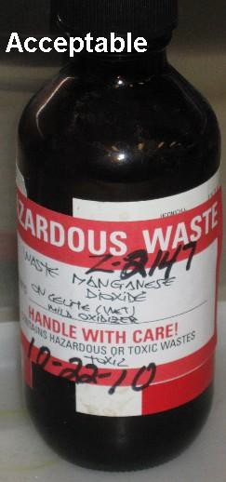
Before a chemical material is used, the user shall determine that information and facilities are available for safe disposal of hazardous materials and waste products. Waste chemicals shall not be combined or mixed with other waste chemicals unless they have been evaluated for compatibility by a qualified person. Hazardous waste chemicals containers shall be labeled as “Hazardous Waste” and the ones stored in laboratory work areas should not be allowed to accumulate. Waste quantities shall be subject to the maximum container sizes and type in accordance with the maximum allowable container capacity table mentioned before. Flammable chemical waste will count towards flammable storage limits. All hazardous waste shall be stored or handled or disposal of according to the federal, state, local regulations.

- FIRE PREVENTION AND PROTECTION SYSTEMS

Many storage areas and laboratories are required to have fire protection systems, including sprinklers and fire alarm systems. While it is not the responsibility of C-14 Certificate of Fitness holders to supervise the maintenance of fire protection systems, it is important to understand the importance of the systems for overall safety building occupants. In this regard, if you become aware of the need to repair or otherwise service of fire protection system, you should notify the building impairment coordinator.

The owner/managing agent/tenant of the premises is required to designate an impairment coordinator for the building/entity. It is important for the impairment coordinator to take immediate steps to notify the FDNY. You should know who has been designated at your location.

Any impairment to a life safety system poses safety risks to a building and its occupants. The impairment coordinator shall be responsible to ensure posting of a fire guard detail, notifications to onsite personnel, and posting out of service signage. Some of these systems are briefly described below.

- 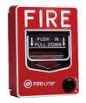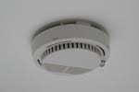Fire Alarm Systems

Manual fire alarm pull station

Smoke detector
Fire alarm systems are required in many premises as part of a fire protection system.
The new Fire Code has expanded the requirement for fire alarm systems which include but are not limited to the following buildings: hospitals, universities or as specified in New York City Building Code. The primary purpose of fire alarm systems within protected premises is to warn building occupants and transmit signals indicating a fire condition to the Fire Department via an approved central station company.

A fire alarm system is a system consisting of components and circuits arranged to monitor and annunciate the status of fire alarm and supervisory signal-initiating devices, and to initiate the appropriate response to these signals.

In general, a fire alarm system is classified as automatic, manually activated, or both. If a fire condition occurs, the alarm system warns the occupants within the premises by actuating loud sirens, gongs, bells, speakers, horns and flashing lights (strobes). A Certificate of Fitness for S95 for Supervision of Fire Alarm System is responsible for conducting inspections and ensuring maintenance.

- Sprinkler System and Standpipe System
A fire sprinkler system is an active fire protection requirement specified by FDNY regulations and laws. It consist s of a water supply system that provides adequate pressure and flows at a rate to a water distribution piping system, onto which fire sprinklers are connected. Its purpose is to control the fire or suppresses the fire.

Sprinklers are intended to control the heat release rate of the fire to prevent building structure collapse, and pre-wet the surrounding materials to prevent fire spread. The fire is only extinguished when the burning combustibles are exhausted or after manual extinguishment is done by Firefighters. Water reactive substances may pose special risks at locations.

A standpipe system is a fire protection system that is designed to provide rapid access to water in the event that a fire breaks out. Standpipes are installed as stand alone systems which act like building-specific fire hydrants. Standpipe systems can be combined with sprinkler systems. They can provide automatic or manual sprinklers as well as connection points for fire hoses.

These systems are most commonly installed in buildings which are tall, large, or highly specialized or in other buildings. Dry standpipe systems consist of a series of pipes which bring water to various points in a building when it is used by Fire fighters. The pipes are dry and empty whenever there is not a need. Wet systems are “charged,” meaning that they always are filled with water. Water reactive substances may pose special risks at locations.

- Portable Fire Extinguishers

Fire extinguishers must be provided in each laboratory and storage area. Generally, dry-chemical extinguishers are installed in laboratories and storage areas. Fire extinguishers must be conspicuously located where they are visible and readily accessible. They must be installed so that the top of the extinguisher is not more than 5 ft above the floor and the clearance between the bottom of the extinguisher and the floor is not less than 4 in. These extinguishers or extinguishers suitable for more than one class of fire are most effective when they are discharged at the base of the fire.
However, the Fire Commissioner may require other types of extinguishers depending on the nature of the chemicals used in the laboratory. Portable fire extinguishers are important in preventing a small fire from growing into a catastrophic fire, however, they are not intended to fight large or spreading fires. The Certificate of Fitness holder must be familiar with the different types of fire extinguishers that are present. He/she must know how to operate the extinguishers in a safe and efficient manner. He/she must know the difference between the various types of extinguishers and when they should be used. A description of the five classes of fires and the appropriate extinguishers are described below.

Class A fires occur when ordinary combustible materials are ignited. For example, wood, cardboard, and most plastics fires are Class A fires. Water type extinguishers should be used to extinguish these fires. The water type extinguishers cool the fire while quenching the flame.

Class B fires occur when flammable liquids such as gasoline, kerosene, grease and oil are ignited. These fires must extinguished by smothering the flame. The flame may be smothered using CO2, dry chemical or foam extinguishers. Water type extinguishers should not be used for class B fires. However, personnel should be aware that CO2 and dry chemical extinguishers are likely to be ineffective against oxidizer-based (e.g. oxidizer or organic peroxide) fires. All laboratories are required to have the minimum fire extinguisher rating of 20-B with maximum travel distance of 50 ft.

Class C fires occur when electrical equipment catches fire. These fires must be fought with fire extinguishers that do not conduct electricity. Fire extinguishers for the protection of delicate electronic chemical extinguishers must be used to extinguish electrical fires. Foam and water type extinguishers must not be used to extinguish electrical fires. After shutting off the electrical equipment, extinguishers for Class A or B fires may be used. As a result, the fire extinguisher shall be sized and located on the basis of the anticipated either Class A or Class B hazard.
Class D fires occur when they involve combustible metals, such as magnesium, titanium, potassium, sodium, and lithium. For metallic or pyrophoric material fires, do not use water, foam or carbon dioxide as an extinguishing agent. Dousing metallic fires with inappropriate extinguisher may generate flammable gas, an extremely dangerous explosion hazard, particularly if fire is in a confined environment. Use extinguishers designed for class D fires only.
Class K fires are kitchen fires in cooking appliances that involve combustible cooking media (vegetable or animal oils and fats). Fire extinguishers for the protection of Class K hazards shall b selected from types that are specifically listed and labeled for use on Class K fires.

The use of the markings to identify a fire extinguisher’s suitability is particularly important: the marking are shown in the table below.
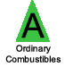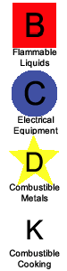Markings to Indicate Extinguisher Suitability According to Class of Fire:
 | Letter-Shaped Symbol Markings | Recommended Marking System
Class A: Ordinary Combustibles |  | 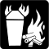
Class B: Flammable Liquids
Class C: Electrical Fires
Class D: Combustible Metals
Class K: Combustible Cooking

Symbols may also be painted on the extinguisher. The symbols with the shaded background and the slash indicate that the extinguisher must not be used for that type of fire. Examples of these symbols are shown on the following picture. The Certificate of Fitness holder must understand these symbols.
Examples of fire extinguishers
Class BC fire extinguisher Class ABC fire extinguisher Class D fire extinguisher
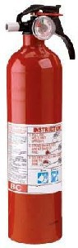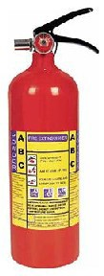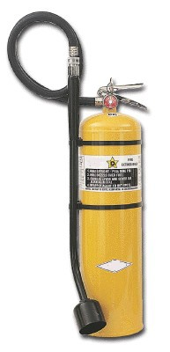
Note: Do not use an ammonium based dry chemical fire extinguisher on chlorine-
based oxidizers. The reaction between the chlorine, the oxidizer and the ammonium salts in the fire extinguishing agent may produce an explosive compound (NCL3).

Generally, operation instructions are clearly painted on the side of the fire extinguisher. They clearly describe how to use the extinguisher in case of an emergency. An example of these instructions is shown below.
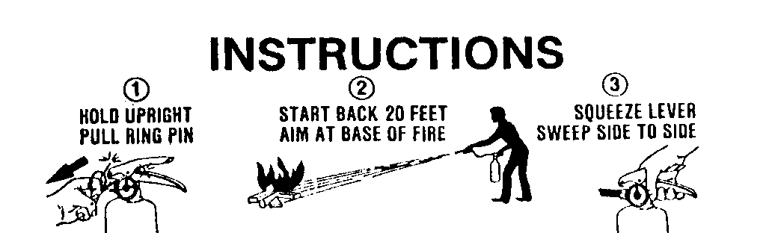
Operation Instructions for a Fire Extinguisher

Portable fire extinguishers must be kept in good working order at all times. The extinguishers are required to be inspected monthly. The building owner is responsible to designate a person to perform a monthly inspection, which may or may not be the C-14 Certificate of Fitness holders. This inspection is a "quick check" that a fire extinguisher is available and will operate. It is intended to give reasonable assurance
that the fire extinguisher is fully charged and operable. This is done by verifying that it is in its designated place, that it has not been actuated or tampered with, and that there is no obvious or physical damage or condition to prevent its operation. The information of the monthly inspection record must include the date the inspection was performed, the person performing the inspection, and those portable fire extinguishers found to require corrective action. Such recordkeeping must be either attached to the extinguisher or on an inspection checklist maintained on file. Labels or markings indicating fire extinguisher use or classification or both shall be placed on the front of the fire extinguisher. In addition, the required annual servicing tag shall include (1) the name and Certificate of Fitness number of the person who serviced the extinguisher; (2) The month and year the extinguisher was serviced; (3) The name, street address and telephone number of the extinguisher servicing company, if any, servicing the extinguisher.
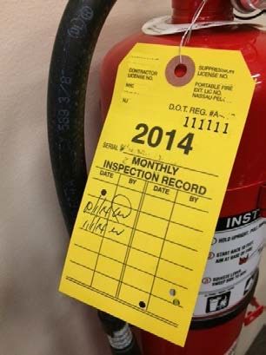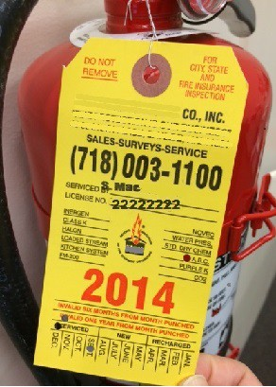
Annual servicing tag.
Monthly inspection tag.

- EMERGENCY PLANNING AND PREPAREDNESS
- Emergency Procedures
- Fire notification
Anyone becoming aware of an unwanted fire is required to immediately notify the emergency operator (911). The New York City Fire Department will respond. No supervisor or other person shall issue any directive or take any action to prevent or delay the reporting of a fire or other emergency to the department. You should also notify the building’s designated fire safety person who is familiar with the building and can meet the responding emergency units upon their arrival, and direct them quickly to the fire area.
The Certificate of Fitness holder must know the locations of manual fire alarm system pull stations and portable fire extinguishers and how to operate them. In addition to calling 911, you should also activate the fire alarm system manual pull station, only in the event of a fire emergency. Activation of the manual pull station will sound the alarm in the building and typically will notify the fire department.
The Certificate of Fitness holder should know how to respond when an individual's clothing has caught fire. The most important instruction for the case of clothing fires: immediately drop to the floor and roll. If the person is panicking and running, other people in the area should immediately knock that person to the floor and roll that person around to smother the flames. Most non-production laboratories are also required to have installed a safety shower. If the safety shower is near, the use of this shower would also be an effective way to smother the flames. If after smothering the fire, if the clothing that caught fire can be removed, remove it. If the clothes are burnt onto your skin, do not remove the clothes but soak with water and keep cool. In all cases, immediately seek medical attention.

- Spill notification
In case of a major spill, the Certificate of Fitness holder must notify the Fire Department by phone immediately. The Certificate of Fitness holder must know the telephone number of the Fire Department Borough Communication Office. The borough phone numbers are listed below. These phone numbers must be posted near the phones most likely to be used in case of an emergency.

Manhattan | 212-570-4300
Bronx | 718-430-0200
Brooklyn | 718-965-8300
Queens | 718-476-6200
Staten Island | 718-494-4296
- Penalties for Non-compliance with Fire Code
All applicants and certificate holders are required to promptly notify the Department of any change in the applicant's or certificate holder's residence address, any change in work location when such location is required for and/or indicated on such certificate or permit and such other information as the Department may require. Certificate of Fitness holders and permit holders must ensure that all requirements of the Fire Code and Fire Department Rules are met. Failure to comply with these provisions may subject Certificate of Fitness holder and/or permit holders to enforcement action, including violations, summonses and fines.

Part III

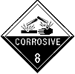
In this part, compressed gases and corrosive materials are covered. The Certificate of Fitness holder should know the proper storage, handling and use requirements associated with these chemicals.

  - CORROSIVE MATERIALS

    - Storage and Use Requirements

Special care needs to be taken when storing acids. Minor spills and acid fumes can quickly corrode standard metal storage cabinets or soapstone countertops, for example. The best choice for storing acid containers is a chemically-resistant cabinet designed for that purpose, with polyethylene construction being the best choice. Polyethylene spill trays are also a very good idea, whether acids are stored on a bench top or in a cabinet. Containers of sodium bicarbonate or other suitable neutralizing or absorbing agents must be provided where more than 5 gallons are stored or used per laboratory or storage room and accessible in these storage areas at all times. Corrosives, if exposed to incompatible materials, can lead to dangerous reactions such as explosions, release of toxic gas, or extreme fire conditions. Compressed gas containers and systems should not be exposed to corrosive chemicals or fumes that could damage containers, valves or valve-protective caps. Acids and bases should not be stored or used near each other as their accidental combination could generate a huge amount of heat and energy, possibly resulting in an explosion.

When corrosive liquids are stored in excess of 5 gallons, special emergency showers must be installed in the laboratory/storage-room, or outside the laboratory within 25 feet of laboratory/storage-room entrance door. Store containers at a convenient height for handling, below eye level if possible. High shelving increases the risk of dropping containers and the severity of damage if a fall occurs. The showers are designed to quickly drench the individual in case of emergency. The Certificate of Fitness holder must make sure the showers remain accessible and unobstructed at all times.

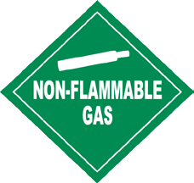
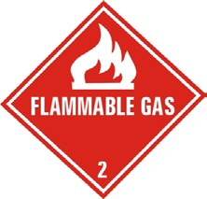
Handling and use of corrosive materials shall be located in accordance with the distances and exposures noted for storage.

  - COMPRESSED AND LIQUEFIED GASES

ADDITIONAL PERMITS AND CERTIFICATES OF FITNESS

Quantities requiring a permit AND Supervision by a G-97 certificate of fitness holder: When there are more than 60 gallons cryogenic containers in a storage area outside of the laboratory, permits and a G-97 Certificate of Fitness (Supervision of Commercial

Cryogenic Systems and for Storage and Handling of Cryogenic Liquids) holder must be present.

    - General Requirement

Compressed gas containers are often used in the laboratory. All compressed gases are potential hazards because of the pressure within the container, their flammability, and/or their toxicity. The chemical is in gaseous form and pressurized, it can quickly contaminate a large area in the event of a leak.

- Labeling all compressed gas container clearly
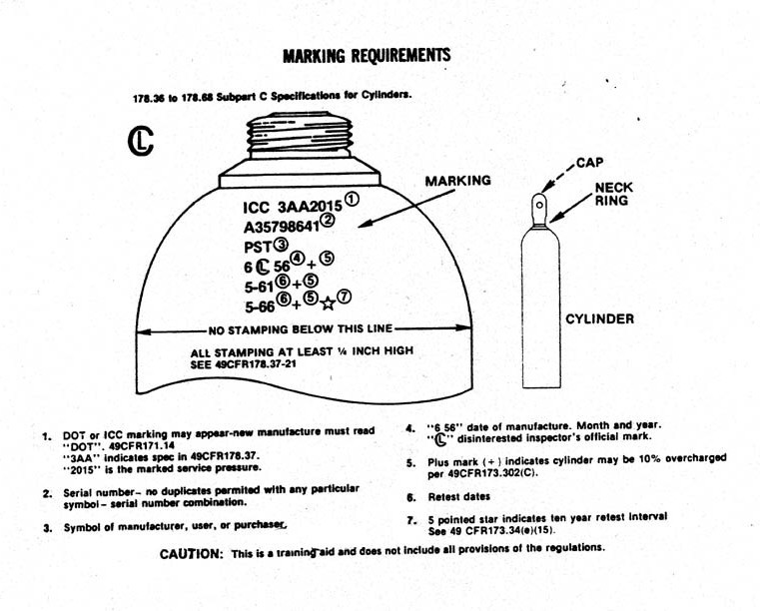
The contents of any compressed gas container must be clearly identified. Gas identification should be stenciled or stamped on the container or a label which shall be marked to show the authorizing code and its working pressure at 70°F. Do not rely solely on the color of the container to identify the contents. Reject any container that is unmarked or has conflicting marking or labels.

- Refilling container
The practice of transferring compressed gases from one commercial container to another is not permitted.

    - Storing Containers

- Upright position
All containers must be secured from tipping over and shall be stored in an upright position and be equipped with a pressure regulator designed for the specific gas and marked for its maximum container pressure. You can use appropriate material, such

as chain, plastic coated wire cable, commercial straps, etc., to secure containers. The only exception for storing the compressed gas containers in a horizontal position is those containers with an internal volume is less than 0.174 Cu. Ft. (e.g. lecture bottles).
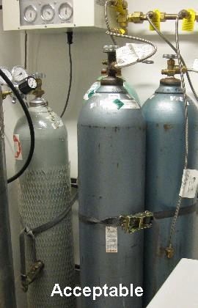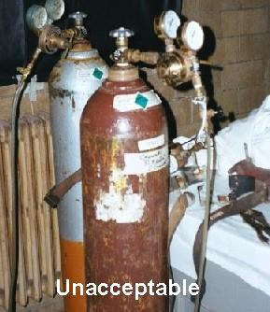
Containers should be secured!
Containers are secured by straps.
- Well-ventilated areas
Containers of all gases that have health hazard ratings of 3 or 4; or have a health hazard rating of 2 without physiological warning properties; or are pyrophoric gases shall be kept in a continuously mechanically ventilated hood or enclosure. The containers that are greater than lecture bottle size shall be kept in continuously mechanically ventilated gas cabinets.

- Separation from hazardous conditions
All compressed gas containers and systems in storage or use shall be away from materials and conditions that present potential hazards to them or to which they present potential hazards. Those containers shall be segregated in hazard classes while in storage, especially be separated from incompatible materials. It is recommended to group containers according to the type of gas (e.g. flammable, oxidizer, toxic or corrosive) or whether containers are full or empty, if they are stored at the same location. Combustible waste shall be kept a minimum of 10 feet from compressed gas containers and systems. Generally, corridors are not designed for storage of compressed gases. However, there are circumstances when the Department may allow this. Any corridor storage of compressed gases should be approved by the Department prior to commencing such storage. Oxidizing gases shall not be stored/used or come in contact with oil, grease, or other petroleum base.

Generally, the compressed gas containers shall be kept away from
  - Sources of ignition
  - Temperature extremes (Above 125 degrees F or less than mean low atmospheric temperatures)
  - Corrosive chemicals or fumes
  - Falling objects
  - Ledges, unprotected platforms, and elevators or other areas where the container could drop a distance exceeding one-half the height of the container

    - Cryogenic Liquid

- Safety Practices
Always handle cryogenic/refrigerated liquids carefully. At their extremely low temperatures, they can produce frostbite on the skin and exposed eye tissue. When spilled, they tend to cover a surface completely, cooling a large area. Delicate tissues, such as those of the eyes, can be damaged by exposure to these cold vapors, even when the contact has been so brief to affect the skin of the hands or face. Boiling and splashing always occurs when charging a warm container, or when inserting warm objects into a liquid. Always perform the operations slowly to minimize boiling and splashing. Never allow any unprotected part of the body to touch uninsulated pipes or vessels which contain cryogenic/refrigerated fluids. Even nonmetallic materials are dangerous to touch at low temperatures. Use tongs to withdraw objects dipped in a cryogenic/refrigerated liquid. Objects that are soft and pliable at room temperature, such as rubber or plastics, are easily broken because they become hard and brittle at extremely low temperatures. Carbon steels also become brittle at low temperatures and will easily break.
If severe spraying or splashing may occur, a face shield or chemical goggles should be worn for additional protection. Insulated gloves should always be worn when handling anything that comes in contact with cold liquids and vapors. Gloves should be loose fitting so that they can be removed quickly if liquids are spilled into them. Trousers should be left outside of boots or work shoes.

In the event of unlikely contact with a cryogenic/refrigerated liquid, a cold-contact burn may occur, which means that the skin tissue freezes. If this should occur, remove any clothing that may restrict the blood circulating to the frozen area. Do not rub frozen parts because the tissue may become damaged. Immerse the affected parts in warm water (105°F to 115°F). Never use dry heat. If possible, put the victim in a warm room. Obtain medical assistance as soon as possible.
Persons who work with cryogenic/refrigerated liquids, including handling, storage, and transfer operations should be trained in the:
- nature and properties of cryogenics in both liquid and gaseous phases;
- specific instructions on the equipment to be used;
- approved materials that are compatible with the cryogens;
- use and care of protective equipment and clothing;
- safety, first aid, and self aid when first aid and/or medical treatment is not available;
- handling emergency situations such as fire, leaks, and spills;
- good housekeeping practices are essential for the safety of personnel.
- Ventilation
All gases should be used and stored in well-ventilated areas. All of the gases except oxygen can cause a person to suffocate by replacing breathable air in an enclosed workplace. However, workers will not be aware of the presence of such gases without a tool to help them detect the gases. Therefore, an oxygen sensor equipped with an audible alarm must be installed to monitor the level of oxygen in the area when the total cryogenic gas capacity exceeds 60 gallons. In addition, all entrances to such areas should have prominent durable signs indicating danger due to extreme cold and possibility of rapid suffocation.

Part IV
Summary Checklist of the most common requirements
Date: C of F Holder’s Name:

Signature: C of F # : Exp Date:
 | Business name: Address: City & State: Phone #: | Supervising Chemical Laboratories
SECTION A.
General Requirement |  |  | Responses |  | Recommended Action
1. Is there a valid fire permit for the laboratory? |  |  |  Yes No |  | If No, discontinue use and remove from site and obtain a permit.
2. Is there a person in your laboratory unit responsible for supervising laboratory who holds a C- 14 C of F as required by code? |  |  |  Yes No |  | If No, correct and comply.
SECTION B.
Laboratory Safety |  |  | Responses |  | Recommended Action
1. Have you checked if all portable fire extinguishers are available, unobstructed and clearly marked? |  |  |  Yes No |  | If No: correct and comply
2. Have you checked whether the owner has designated an Impairment Coordinator? |  |  |  Yes No |  | If No: correct and comply
3. Have you checked if all exit ways are free and unobstructed? |  |  |  Yes No |  | If No: correct and comply
4. Have you checked if the emergency phone numbers and the evacuation plan are updated and clearly posted in appropriate locations? |  |  |  Yes No |  | If No: correct and comply
5. Have you checked if the MSDS sheets are maintained correctly and are readily available to lab staff and emergency personnel? |  |  |  Yes No |  | If No: correct and comply
6. Have you checked if the electrical cords are in good condition? |  |  |  Yes No |  | If No: correct and comply
7. Have you checked if the inspection record is affixed to each hood, and each fume hood is maintained in good working order? |  |  |  Yes No |  | If No: correct and comply
8. Have you checked if the inspection record is affixed to each safety shower and each shower is unobstructed and can work properly? |  |  |  Yes No |  | If No: correct and comply
9. Have you checked if neutralizing or absorbing agents are provided at all areas used for the storage of acids? |  |  |  Yes No |  | If No: correct and comply
10. Have you checked if your work areas neat; Food/drink absent? |  |  |  Yes No |  | If No: correct and comply

SECTION C.
Signs and Warning Placards | Responses | Recommended Action
1. Have you checked if the appropriate warning signs are properly posted on exterior entrances to laboratory areas? |  Yes No | If No: correct and comply
2. Have you checked if the no smoking sign is posted on exterior entrances to storage and laboratory areas and within such areas? |  Yes No | If No: correct and comply
3. Have you checked if non-explosion proof refrigerators and cold room are clearly labeled? |  Yes No | If No: correct and comply
SECTION D.
Chemical Storage and Handling | Responses | Recommended Action
1. Is there any prohibited hazardous material stored/used in the laboratory? |  Yes No | If Yes: correct and comply
2. Have you checked if the maximum storage limit is complied? |  Yes No | If No: correct and comply
3. Have you checked if all chemical containers are properly labeled? |  Yes No | If No: correct and comply
4. Have you checked if all containers are in good conditions? |  Yes No | If No: correct and comply
5. Have you checked if all chemicals are properly safety segregated? |  Yes No | If No: correct and comply
6. Have you checked if all gas containers are properly secured and clearly labeled? |  Yes No | If No: correct and comply
7. Have you checked if peroxide forming chemicals not expired or tested after expiration date? |  Yes No | If No: correct and comply
8. Have you checked if the water-reactive chemicals are stored in suitable receptacles, properly identified and away from any possible fuel sources and water? |  Yes No | If No: correct and comply

Additional Comments:
Section/Item # | Description of Deficiencies

Appendix A
In this appendix, the supplementary information of common hazardous materials in non-production chemical laboratory is covered.

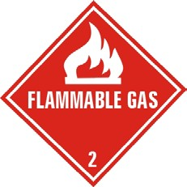
- COMPRESSED AND LIQUEFIED GASES
  - Containers in Use 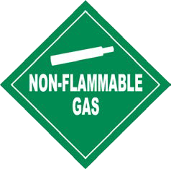
(1) Train Users
Before attempting to connect a container to a system, be certain that the personnel handling the containers are trained and knowledgeable regarding the product, container, fittings, equipment, and proper connection procedures.

- Regulator use
Containers, when in use, must be connected to gas delivery systems and a regulator instrument. The regulator system shall be equipped with two gauges installed so as to show both the pressure in the container and the pressure in the system.
Container Pressure

Delivery Pressure Gauge

Pressure
Gauge
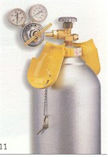Container Valve
Container Connection

Valve

Adjusting Screw
Protection Cap

- Valves
Valves utilized on compressed gas systems shall be suitable for the use intended and shall be accessible. Valve handles or operators for required shutoff valves shall not be removed or otherwise altered to prevent access or hinder operation. Always open the valves slowly and only with the proper regulator in place. Valve protection caps should remain in place until ready to withdraw gas, or connect to a manifold. Before removing the regulator from the container, close the container valve first and release all pressure from the regulator.

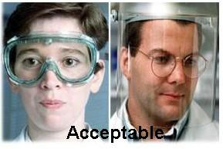
- Eye protection
Always wear eye protection when working on or near compressed gas systems. Never let anyone without eye protection into any area where compressed gas are used or stored.

- Containers not in use
In order to decrease the potential hazards for the laboratory personnel, all not “in use” containers, except nominal 1lb propane containers made for consumer use, shall be removed from the laboratory unit to a storage facility (“ in use” can include connected to a regulator; connected to a manifold; or an unconnected reserve stored alongside a connected container). Always shut off and have a container cap on any container that is not in use or is being stored.

  - Typical Internal Volume of Cylinders

The following table provides information on the typical internal volume of cylinders:

Model | Nominal Dimension (Diameter x Length*, inch) | Internal Volume (Water volume, Cu. Ft.)
TYPE | STANDARD CYLINDER SIZES AND CAPACITIES (NFPA 45)
Lecture Bottle | 2 x 15 | 0.016
D | 4.5 x 18 | 0.08
E | 4.5 x 31 | 0.164
M | 7 x 43 | 0.77
G | 9 x 55 | 1.54
H | 9 x 60 | 1.75
LPG WEIGHT | COMMON LPG CONTAINER SIZES AND CAPACITIES
16.4 oz. | 4¼ x 6¼ | 0.051
5 lbs. | 9 ⅜ x 12½ | 0.192
20 lbs. | 12 ⅛ x 20⅛ | 0.769
TYPE | COMMON ACETYLENE CONTAINER SIZES AND CAPACITIES
B (40 SCF) | 6 x 25 | 0.278
WC (110 SCF) | 8½ x 33½ | 0.885
WK (330 SCF) | 13 x 42 | 2.414
* Includes valve and cap

  - Compressed Gas Container Disposal or Return

It is dangerous to empty a compressed gas container completely, a container is considered empty when the container pressure is at atmospheric pressure or 15 psia (pounds per square inch absolute) remaining. The empty containers shall be labeled

with the word “empty” or the abbreviation “MT and the date”. Always handle empty containers as carefully as full ones; residual pressure can be dangerous.

Examples of the gas container tag
Container before use | Container in service | Empty container
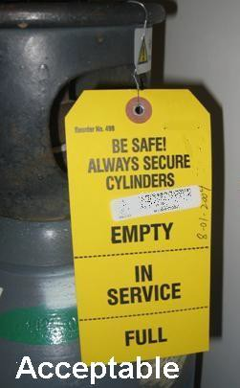 | 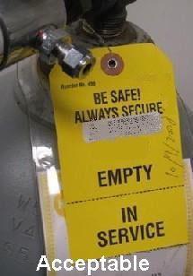 | 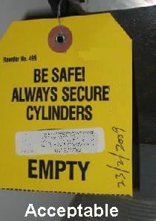

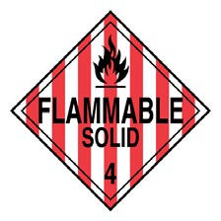
- FLAMMABLE SOLID

  - General Description

Many flammable solids may react violently or explosively on contact with water including water applied for extinguishment purposes (i.e., water fire extinguishers). They may also be ignited by friction, heat, sparks or flame. Some of these materials will burn with intense heat. Dusts or fumes may form explosive mixtures in air. Containers may explode when heated. Materials may re-ignite after fire is extinguished.

Fires may produce irritating, corrosive and/or toxic gases. Some of these materials may also be pyrophoric – spontaneously reacting with oxygen in air to ignite. Many flammable solids are metals. Oxides from metallic fires are a severe health hazard, inhalation or contact with substance or decomposition products may cause severe injury or death. Cutting some flammable solids can initiate a fire. For example, using a torch to cut titanium tubing will generate sufficient heat to ignite the material. Dry sand can usually be used to smother a fire involving flammable solids. Keep a container of sand near the work area.

- CORROSIVE MATERIALS

  - General Description

Corrosives act either directly, by chemically destroying the part or indirectly by causing inflammation. Acids and bases are common corrosive materials. Information on pH can often be found in the MSDS. It is important to know the pH of substances because they may be corrosive or react with incompatible materials. For example,

acids and bases should not be stored or used near each other as their accidental combination could generate a huge amount of heat and energy, possibly resulting in an explosion. Personal protective equipment (PPE) should be worn to prevent possible harm. PPE includes gloves, respiratory protection, eye protection, and protective clothing. The need for PPE is dependent upon the nature and quantity of the materials in use and shall be based on risk assessment.

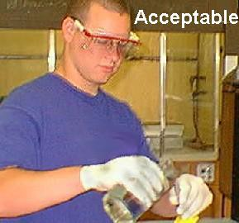
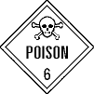
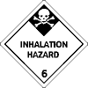
It is also important to know the pH in case you get the material on your skin or in your eyes. And in order to prevent any corrosive materials enters eyes, always wear eye protection when working with corrosives. Adequate safety glasses must be worn at all times when handling corrosive chemicals (ordinary glasses do not provide adequate protection). Whenever a substance enters the eye, flush with water for 15 minutes and get prompt medical attention.

- HIGHLY TOXIC AND TOXIC MATERIALS

  - General Description

Toxic chemicals are chemicals that can produce injury or death when inhaled, ingested, or absorbed through the skin. While damage may be acute or chronic the Fire Code is only concerned with acute lethality. The extent of lethality depends on the dose and duration of exposure. Exposure may enter the body through three routes: inhalation, ingestion, or contact with the skin and eyes.

For the purposes of the Fire Code, Toxic & Highly Toxic Material are defined in terms of LD50 values as follows.

Summary Definitions Toxic & Highly Toxic

 | Toxic | Highly Toxic
Oral LD50 (albino rats) | 50-500 mg/kg | <50 mg/kg
Skin Contact LD50 (albino rabbits) | 200-1000 mg/kg | <200 mg/kg
Inhalation LC50 (albino rats) gas | 200-2000 ppmv/air | <200 ppmv/air
Inhalation LC50 (albino rats) mists/dust | 2-20 mg/L | <2 mg/L

For the purposes of Fire Code compliance, it is important to have supporting documentation regarding the toxicity of the specific materials being stored, handled or used. Generally this would be MSDS’s. Care should be exercised when changing material vendors as the MSDS information may be different. It is the facility storing, handling or using these chemicals to know their toxicity and be able to demonstrate to an inspector that the appropriate classification and handling procedures are being used.

The level of toxicity of Highly Toxic and Toxic Materials may be reduced by diluting such materials with other materials, such as water, to a degree that the resulting mixture may no longer be Highly Toxic or Toxic. For the purposes of Fire Code compliance, a mixture containing any amount of Highly Toxic and/or Toxic material is presumed to be a highly toxic or toxic material, as applicable, unless it is otherwise certified and labeled by the manufacturer.

Highly Toxic and Toxic Materials that are compressed gases can be referred to the section of this study guide, Part III-1 [COMPRESSED AND LIQUEFIED GASES], which follows requirements of the NFPA 45 and the New Fire Code Chapter 30 [Compressed Gases]. Additionally Highly Toxic and Toxic Materials that meet the definition of other hazard classes shall comply with those requirements also including New Fire Code Chapters 35 (Flammable Gases), 37 (Highly Toxic and Toxic Materials), 40 (Oxidizers) and 41 (Pyrophoric), as applicable.

  - Storage and Use Requirements (liquids/solids)

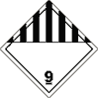
The indoor and outdoor storage, handling or use of Highly Toxic and Toxic solids or liquids in amounts that do not exceed the maximum allowable quantity per control area shall be in accordance with the general provisions for hazardous materials and with the general previsions for Highly Toxic & Toxic Materials.

- UNSTABLE REACTIVES (INSTABILITY HAZARD)

  - General Description
In storing unstable reactive materials, care must be taken to ensure that the materials do not encounter any incompatible materials or conditions that could cause a reaction. Storage of temperature-sensitive materials requires the use of temperature controls. Whenever the chemical manufacturer or MSDS specifies a maximum/minimum storage temperature, the storage area must also have an emergency alarm that notifies personnel whenever the temperature falls below or exceeds the set point. These personnel must ensure notification to the fire department.

There are different storage considerations for “deflagrating” unstable reactives, as opposed to those for “non-deflagrating” unstable reactives. To determine whether or not a material is considered deflagrating, one must consult an MSDS or the chemical manufacturer.

Additionally, one must determine the class of unstable reactive by consulting an MSDS or by contacting the chemical manufacturer. The classes of unstable reactives are ordered in incrementally increasing hazard. A Class 4 unstable reactive, therefore, must be handled more carefully than a Class 1 unstable reactive.

  - Storage and Use Requirements

The storage and use of these materials near incompatibles such as heat sources must be avoided. Material must be kept away from any possible fuel sources. Proper personal protective equipment must be worn at all times while handling these materials.

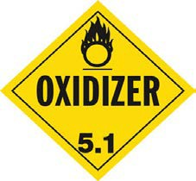
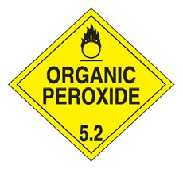
Many unstable materials possess other hazards such as flammability, corrosivity, and toxicity. Be sure to reference MSDS’s or manufacturer’s information for all materials prior to working with material. All hazards should be investigated prior to use and handling and steps taken to reduce the potential for problems, in accordance with the Fire Code. In the event of an uncontrolled spill or release of material, the area should be evacuated and notification made to 911 as soon as possible.

- OXIDIZERS AND ORGANIC PEROXIDES

  - General Description
- Oxidizers
Oxidizers are chemicals that release large amounts of oxygen. Because this class of compounds can act as an oxygen source, they can be unpredictable and dangerous during fire situation. Inorganic oxidizers can increase the danger of fire around flammable or combustible materials, while organic oxidizers are flammable in themselves. Oxidizers and organic peroxides are both considered “oxidizing materials” in that they provide oxygen to chemical and physical reactions. Some organic oxidizers can even explode when they are exposed to heat, shock or friction. Most oxidizer are corrosive and can irritate skin or lungs. In general, oxidizers shall be kept away with organic or combustible materials.

- Organic peroxides
Organic peroxide is a compound having a double oxygen or peroxy (-O-O-) in its chemical structure. The oxygen-oxygen linkage (-O-O-), a thermally sensitive and energetic bond, makes organic peroxides become relative unstable compounds which can decompose spontaneously and sometimes explosively. For example, if one liter of liquid with 100 ppm peroxides is distilled down to dryness and the residue explodes, the energy is roughly equivalent to good firecracker or a .22 caliber bullet charge (i.e., one kilo-Joule). This is the same energy as a 280 pound weight falling from a 30-inch height onto the floor or a change of two degrees Fahrenheit in a cup of water. Moreover, the decomposition of organic peroxide generally produces heat and by- products (e.g. free radicals, gases, mists) which can becomes uncontrolled and violent. Improper storage or handling could lead to an uncontrolled decomposition. All materials in the vicinity of organic peroxides should be investigated for compatibility, and segregated if necessary.

Solid oxidizers and organic peroxides are less likely to pose problems than liquids and gases due to their physical characteristics. However, special attention must be paid to the class of oxidizer and organic peroxides that may be found on the label

accompanying the material, it’s MSDS (Material Safety Data Sheet), or through a phone call 1-800-CHEMTREC or to the manufacturer. For instance, greater care must be used in the storage of Class 4 oxidizers than with Class 1 oxidizers. Similarly, greater care must be used in the storage of Class I organic peroxides than with Class IV organic peroxides.

  - Storage and Use Requirements

Solid oxidizers are less likely to pose problems than liquids and gases due to their physical characteristics. However, great care must be used in the handling and use of all oxidizing materials. In some respects, the hazard during handling may be significantly increased due to the potential absence of a suitable container. The use of these materials near potential fuels must be avoided. Fuels include paper, wood, and flammable liquids. Also of concern is the use of oxidizing materials near some acids, as a dangerous reaction may occur when these materials are mixed. All materials in the vicinity of oxidizers and organic peroxides should be investigated for compatibility, and segregated if necessary.

All potential sources of ignition must be removed from the vicinity of oxidizers in use. “No smoking” signs must be posted prominently and no open flames – such as those associated with boilers or water heaters – are permissible where oxidizers and organic peroxides are used or stored.

- Oxidizers
It is important to understand that the conditions of acceptable storage for oxidizing materials are based upon their ability to cause combustible and flammable materials to ignite and burn, or explode. The fundamental and general rule is to keep fuels (including wood, paper, cardboard, flammable liquids and gases, metals, etc…) and sources of ignition away from the stored oxidizing materials.

Many oxidizing materials possess other hazards such as flammability, corrosivity and toxicity. Chlorine, for instance, is an oxidizer that is also both corrosive and toxic. Strong oxidizing materials, such as perchloric acid, shall not be heated by gas flames or oil baths. Adequate safety glasses must be worn at all times when handling oxidizing chemicals (ordinary glasses do not provide adequate protection). All hazards should be investigated prior to use and handling and steps taken to reduce the potential for problems, in accordance with the Fire Code.

In the event of an uncontrolled spill or release of a liquid, solid or gaseous oxidizing material, the area should be evacuated and notification to 911 made as soon as possible.

- Organic Peroxides
In general, great care of temperature and contamination must be used in handling or storing organic peroxides. The most important one is the control of the temperature. Whether handling or storing organic peroxides, if the temperature is maintained below its Self-Accelerating Decomposition Temperature, most uncontrollable reaction are avoided. In addition, where the required storage temperature range, as specified by the manufacturer, extends beyond normal ambient temperatures, high or low temperature limit switches, as applicable, shall be provided in addition to normal temperature

controls. These limit switches shall actuate an alarm in a supervised area to ensure reporting to the fire department. In addition, contamination can lead to rapid decomposition too. Organic peroxides shall be stored in their original DOT shipping containers. Organic peroxides shall be stored in a manner to prevent contamination.

For any containers holding a peroxide-forming compound, label it with the words “Date received”, “Date opened” and “Expiration date”. Laboratory chemicals known to form peroxides have been categorized into three groups (Group A, Group B, Group C) based on their susceptibility to peroxide formation. The chemicals in Group A can form explosive peroxide levels even in an unopened container, and severe peroxide hazard after prolonged storage, especially after exposure to air. All have been responsible for fatalities. The chemicals in Group B have peroxide hazards on concentration. The chemicals in Group C, which are hazardous due to, peroxide initiation of autopolymerization. The peroxide-forming potential increases for liquids of Group C, especially for butadiene, chloroprene and tetrafluoroethylene, such that these materials should be considered as a peroxide hazard. The sample chemicals in each group are listed in the following table.

Table. Peroxide-Forming Chemicals
SOURCE: Clark, D.E., Peroxides and Peroxide - Forming Compounds, Chemical Health and Safety, 2001, 8 (5), 12-21
Group A
Butadienea | Isopropyl ether | Sodium amide
Chloroprene a | Potassium amide | Tetrafluoroethylene a
Divinyl acetylene | Potassium metal | Vinylidene chloride
Group B
Acetal | Diacetylene (butadiyne) | Methyl-isobutyl ketone
Acetaldehyde | Dicyclopentadiene | 4-Methyl-2-pentanol
Benzyl alcohol | Diethylene glycol dimethyl ether (diglyme) | 4-Penten-1-ol
2-Butanol Dioxanes | Diethyl ether | 1-Phenylethanol
Chlorofluoroethylene | Ethylene glycol ether acetates (cellosolves) | 2-Phenylethanol
Cumene (isopropylbenzene) | Furan | Tetrahydrofuran
Cyclohexene | 4-Heptanol | Tetrahydronaphthalene
2-Cyclohexen-1-ol | 2-Hexanol | Vinyl ethers
Cyclopentene | Methyl acetylene | Other secondary alcohols
Decahydronaphthalene (decalin) | 3-Methyl-1-butanol
Group C
Butadiene b | Styrene | Vinyl chloride
Chlorobutadiene | Tetrafluoroethylene b | Vinyl pyridine
Chloroprene b | Vinyl acetate | Vinyladiene chloride
Chlorotrifluoroethylene | Vinyl acetylene
- When stored as a liquid monomer.
- Can form explosive levels of peroxides when stored as liquid. When stored as gas, peroxide accumulation may cause autopolymerization.

- WATER-REACTIVE SOLID & LIQUIDS

  - General Description

Water-Reactive chemicals react with the hydrogen and oxygen in water to create new combinations of chemicals and produce energy, resulting in an exothermic reaction. Water reactive materials often produce byproducts that may be ignited by the heat generated, thereby producing a flame or explosion. Water-reactive materials are often elemental metals in either whole or powder form. Examples include Potassium, calcium, and sodium.

The chemical equation below shows the reaction of elemental potassium with water. The heat generated by the reaction ignites the hydrogen gas, creating a bright flame.

2 K + 2 H2O → 2 KOH + H2
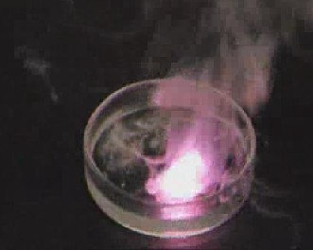

A reaction of potassium metal with water.

Water-reactive materials are divided in to Classes 1 through 3, with increasing levels of hazard from Class 1 to Class 3. To determine the class of the water-reactive material, one should consult the MSDS or call the chemical manufacturer.

  - Storage and Use Requirements
In storing water reactive materials, care must be taken to ensure that the materials do not come in to contact with any water or other incompatible materials.

The hazards presented by these materials in storage also exist during the use of these materials. The use of these materials near incompatibles such as heat sources and water must be avoided. Material must be kept away from any possible fuel sources. All water reactives should be managed under solvent or in an inert atmosphere.

Many water reactive materials possess other hazards such as flammability, corrosivity and toxicity. Be sure to reference MSDS’ or manufacturer’s information for all materials prior to working with material. All hazards should be investigated prior to use and handling and steps taken to reduce the potential for problems, in accordance with the Fire Code.

- PYROPHORICS MATERIALS

  - Storage and Use Requirements

The handling and use of pyrophoric materials near incompatibles such as heat sources and water must be avoided. Material must be kept away from any possible fuel sources. All pyrophorics should be managed under inert gases, solvent or in an inert atmosphere. Compressed pyrophoric gas systems shall have approved emergency shutoff valves that can be activated at each point of use and each source. Proper personal protective equipment must be worn at all times while handling these materials.

Many pyrophorics possess other hazards such as flammability, corrosivity and toxicity. Be sure to reference MSDS’ or manufacturer’s information for all materials prior to working with material. All hazards should be investigated prior to use and handling and steps taken to reduce the potential for problems, in accordance with the Fire Code.

Appropriate fire extinguishing equipment must be present in each in areas where these materials are handled. Extinguishing agents include a Class D fire extinguisher and Metal X for metal fires.

In the event of an uncontrolled spill or release of material, the area should be evacuated and notification made to 911 as soon as possible.

Manufacturing, storing, handling and/or using of detonable pyrophoric materials is prohibited in most cases. Always consult the Fire Code prior to conducting any activities with any of these materials.

Pyrophoric materials will often have very specific storage or handling requirements due to the volatile nature of the chemicals. It is important to consult the MSDS or to contact the chemical manufacture for specific guidelines. Some examples of pyrophoric materials include diethylaluminum chloride, lithium metal or silane gases.

Appendix B
Sample Material Safety Data Sheet (MSDS)

SECTION 1: PRODUCT IDENTIFICATION

PRODUCT NAME: Squeaky Clean Solution

MANUFACTURER: Batty’s Batch of Chemicals ADDRESS: 111 Elm Ave
Astoria, NY 11105

EMERGENCY PHONE: 1-800-555-5555 CHEMTREC PHONE:
OTHER CALLS:
FAX PHONE:

PRODUCT USE: Cleaning Solution

SECTION 2: COMPOSITION/INFORMATION ON INGREDIENTS

INGREDIENT:
Methanol 90%

CAS NO. 67-56-1

INGREDIENT:
Acetic Acid 10%

CAS NO. 64-19-7

SECTION 3: HAZARDS IDENTIFICATION

EMERGENCY OVERVIEW: Corrosive! Flammable liquid and vapor. May be fatal or cause blindness if swallowed. Causes respiratory tract irritation. Causes eye and skin irritation. May be absorbed through intact skin. May cause central nervous system depression. May cause liver, kidney, and heart damage.
ROUTES OF ENTRY: Inhalation, Ingestion, Absorption. POTENTIAL HEALTH EFFECTS
EYES: May cause conjunctivitis and corneal damage. Mild eye irritation. May cause disruption of vision, possibly leading to blindness.

SKIN: May cause irritation

INGESTION: May be fatal if swallowed or cause blindness. May cause central nervous system depression, characterized by excitement, followed by headache, dizziness, drowsiness, and nausea.

INHALATION: Heavy, dense vapors may quickly collect and may be easily inhaled. Symptoms of poisoning by inhalation include visual effects and increased sensitivity to light, blurred, double, impaired vision, and/or blindness.
ACUTE HEALTH HAZARDS: May cause death, blindness, or severe health reactions within 24 hours of ingestion or inhalation of particles.

CHRONIC HEALTH HAZARDS: May cause effects similar to acute inhalation or ingestion. Methanol may accumulate in the body as a poison.

CARCINOGENICITY
ACGIH: Not listed NTP: Not listed IARC: Group 1 carcinogen OTHER: Carcinogen in California

SECTION 4: FIRST AID MEASURES

EYES: Flush with water for at least 30 minutes. Immediate medical aid.

SKIN: Remove any clothing and flush skin with water. Immediate medical aid. INGESTION: Do NOT induce vomiting. Call poison control and get medical aid.
INHALATION: Remove from exposure and get medical aid immediately. If breathing is impeded, give oxygen. Do NOT administer mouth-to-mouth resuscitation when substance inhaled or ingested.

NOTES TO PHYSICIANS OR FIRST AID PROVIDERS: Effects may be delayed. Ethanol may inhibit methanol metabolism.

SECTION 5: FIRE-FIGHTING MEASURES

FLASH POINT: 52˚F
AUTOIGNITION TEMPERATURE: 867˚F NFPA HAZARD CLASSIFICATION
HEALTH: 2 FLAMMABILITY: 3 REACTIVITY: 0
Note: ratings are estimated

EXTINGUISHING MEDIA: Use water spray, dry chemical, carbon dioxide, or chemical foam. Use water to cool containers. For extinguishing flames; use fog, or alcohol-resistant foam. Do NOT use straight streams of water.

SPECIAL FIRE FIGHTING PROCEDURES: None

General: Use self-containe breathing apparatus, or approved respiratory gear in the case of a fire.

SECTION 6: ACCIDENTAL RELEASE MEASURES

ACCIDENTAL RELEASE MEASURES: Promote proper ventilation. Absorb the spill with non- combustible absorbents such as soil, sand, or vermiculite (do NOT use sawdust). Collect material with nonsparking tools and place in containers for disposal. Use water spray to disperse vapors.

SECTION 7: HANDLING AND STORAGE

STORAGE: Keep away from heat, sparks, and flame. Store away from incompatible substances. Store in a cool, dry place in closed container. Do not get in eyes, skin, or clothing. Do not store in metal containers due to risk of corrosion.
HANDLING: Use only in well-ventilated areas. Ground and bond containers when transferring materials. Observe proper PPE to avoid exposure. Keep containers tightly closed when in use. Keep away flames and ignition sources.

SECTION 8: EXPOSURE CONTROLS/PERSONAL PROTECTION

ENGINEERING CONTROLS: Eyewash facility and safety shower. Use only in chemical fume hood.

RESPIRATORY PROTECTION: Follow the OSHA respirator regulations found in 29 CFR 1910.134 or European Standard EN 149. Use a NIOSH/MSHA or European Standard EN 149 approved respirator if exposure limits are exceeded or if irritation or other symptoms are experienced.

EYE PROTECTION: Wear appropriate safety eye protection per OSHA 29 CFR 1910.133 SKIN PROTECTION: Wear appropriate safety gloves
SECTION 9: PHYSICAL AND CHEMICAL PROPERTIES

APPEARANCE: Clear, Colorless ODOR: alcohol and vinegar smells PHYSICAL STATE: liquid
pH: 2.1
BOILING POINT:Not available MELTING POINT: not available FREEZING POINT: not available SPECIFIC GRAVITY (H2O = 1): 0.89
Molecular Formula: Solution

SECTION 10: STABILITY AND REACTIVITY

STABLE UNSTABLE

STABILITY: Hygroscopic

CONDITIONS TO AVOID (STABILITY): High temperatures and ignition sources

INCOMPATIBILITY (MATERIAL TO AVOID): Strong oxidizing agents, strong bases

HAZARDOUS DECOMPOSITION OR BY-PRODUCTS: Carbon monoxide, carbon dioxide, formaldehyde

HAZARDOUS POLYMERIZATION: Will not occur

SECTION 11: TOXICOLOGICAL INFORMATION

TOXICOLOGICAL INFORMATION:

Oral, mouse: LD50=7300 mg/kg Oral, rat: LD50=5600 mg/kg

SECTION 12: ECOLOGICAL INFORMATION

ECOLOGICAL INFORMATION: Degrades in water and land through biodegradation.

SECTION 13: DISPOSAL CONSIDERATIONS

WASTE DISPOSAL METHOD: Consult federal and state regulations for proper disposal guidance.

SECTION 14: TRANSPORT INFORMATION

  - DEPARTMENT OF TRANSPORTATION
PROPER SHIPPING NAME: Flammable Liquids, Corrosive, n.o.s. HAZARD CLASS: 3(8)
ID NUMBER: 2924 PACKING GROUP: II

Appendix C
Storage and Use of Limited Quantities of Chemicals, Acids, and Flammables for Instruction Purposes in [Public High] Schools Through the Twelfth Grade

    - The storage of dangerous chemicals, volatile flammable oils and liquids shall be confined to metal cabinets vented at top and bottom. A cardholder should be provided for a visible record of the contents and maximum amount stored therein; also, a caution sign, if applicable to read: "In case of fire do not use water."

    - Listed below are the maximum quantities of combustibles and dangerous chemicals which may be stored in [public high]schools through the twelfth grade:

Hazardous materials | Maximum Quantities
Explosives
Picric acid | 1 lb.
Carbon bisulphide | 10 lbs.
Carbon Dioxide | 1 lb.
Anhydrous Ammonia | 1 lb.
Sulphur Dioxide | 1 lb.
Nitrous Oxide | 1 lb.
Oxygen | 1 lb.
Volatile Flammable Liquids (Insoluble)
Crude Petroleum | 2 lbs.
Benzine, Benola or Naphthas of any kind | 2 lbs.
Ether, Sulphuric | 10 lbs.
Varnishes, Lacquers, etc. | 2 lbs.
Volatile Flammable Liquids (Soluble)
Acetone | 1 lb.
Alcohol, Denatured | 5 gals.
Aylcohol. Methyl | 5 gals.
Non-Volatile Flammable Liquids (Insoluble)
Amyl Acetate | 2 lbs.
Amyl Alcohol | 2 lbs.
Aniline Oil | 1 lb.
Kerosene | 2 lbs.
Turpentine | ½ gal.
Tuluol | 1 gal.
Xylol | 1 gal.
Essential Oils | 2 lbs.
Non-Volatile Flammable Liquids (Soluble)
Glycerine | 5 lbs.

Hazardous materials | Maximum Quantities
Combustible Solids
Phosphorous | ¼ lb.
Phosphorous, Red | 5 lbs.
Sulphur | 15 lbs.
Metallic Magnesium | 1 lb.
Gums, Resins, Pitch, Etc.
Camphor | 1 lb.
Resin | 11 lbs.
Venice Turpentine | 1 lb.
Naphthaline | 1 lb.
Shellac | 1 lb.
Combustible Fibers and Powders (Vegetable)
Pulverized Charcoal | 5 lbs.
Cotton, Absorbent | 5 lbs.
Lampblack | 2 lbs.
Lycopodium | 1 lb.
Dangerously corrosive Acids
Glacial Acetic Acid | 5 gals.
Hydrofluoric Acid | 1 lb.
Hydrochloric Acid | 12 gals.
Sulphuric Acid | 12 gals.
Carbolic Acid | 1 lb.
Acids
Acid, Chromic | 1 lb.
Acid, Nitric | 12 gals.
Peroxides
Hydrogen Peroxide, U.S.P. | 0 lbs.
Sodium Peroxide | 2 lbs.
Barium Peroxide | 2 lbs.
Other Hydrogen Peroxides over 3 percent, not to exceed 15 percent | 5 lbs.
Chlorates
Potassium Chlorate | 15 lbs.
Permanganates
Potassium Permanganates | 1 lb
Nitrates
Barium Nitrate | 1 lb.
Stontium Nitrate | 1 lb.
Cobalt Nitrate | 1 lb.
Copper Nitrate | 1 lb.
Iron Nitrate, Ferric Mercury Nitrate (mercuric) | 1 lb.
Mercury Nitrate (mercurous) | 1 lb.

Hazardous materials | Maximum Quantities
Potassium Nitrate | 10 lbs.
Silver Nitrate | 5 lbs.
Sodium Nitrate | 15 lbs.
Other Metallic Nitrates | 5 lbs.
Metallic Oxides
Lead Oxide (red) | 5 lbs.
Lead Oxide (Litharge) | 10 lbs.
Oxide of Mercury red precipitate (mercuric) | 10 lbs.
Oxide of Mercury; yellow precipitate (mercurous) | 5 lbs.
Substances Made Dangerous by Contact with Other Substances
Calcium Carbide | 5 lbs.
Metallic Potassium | ½ lb.
All other Metals of the Alkalies or Alkaline Earths | 2 lbs.
Metallic Sodium | ½ lb.
Zinc Dust | 5 lbs.
Slaked Lime | 25 lbs.

Appendix D
Table D1. The maximum quantity limitation of flammable and combustible liquids for all Class D laboratories (Gallons)
 | Exclude Cabinet Class I, II, IIIA liquids(total) |  | Include Cabinet Class I, II, IIIA liquids(total)
Lab Size (Sq. Ft.) | Educational/ Instructional Laboratory | 1 HR or 2 HR  Fire Rating, Other Class D Laboratory | Educational/ Instructional Laboratory | 1HR Fire Rating Other Class D Laboratory | 2HR Fire Rating Other Class D Laboratory
100 | 1 | 1 | 2 | 2 | 2
200 | 2 | 2 | 4 | 4 | 4
300 | 3 | 3 | 6 | 6 | 6
400 | 4 | 4 | 8 | 8 | 8
500 | 5 | 5 | 10 | 10 | 10
1000 | 10 | 10 | 20 | 20 | 20
1500 | 15 | 15 | 30 | 30 | 30
2000 | 20 | 20 | 40 | 40 | 40
2500 | 25 | 25 | 50 | 50 | 50
3000 | 30 | 30 | 60 | 60 | 60
3500 | 35 | 35 | 70 | 70 | 70
4000 | 40 | 40 | 80 | 80 | 80
4500 | 45 | 45 | 90 | 90 | 90
5000 | 50 | 50 | 100 | 100 | 100
5500 | 55 | 55 | 110 | 110 | 110
6000 | 60 | 60 | 120 | 120 | 120
6500 | 65 | 65 | 130 | 130 | 130
7000 | 70 | 70 | 140 | 140 | 140
7500 | 75 | 75 | 150 | 150 | 150
8000 | 75 | 80 | 150 | 150 | 160
8500 | 75 | 85 | 150 | 150 | 170
9000 | 75 | 90 | 150 | 150 | 180
9500 | 75 | 95 | 150 | 150 | 190
≥10000 | 75 | 100 | 150 | 150 | 200
Table D2.The maximum quantity limitation of flammable and combustible liquids for all Class B laboratories (Gallons)
Lab Size (Sq. Ft) | Exclude Cabinet |  | Include Cabinet
 | Class B |  | 1HR Class B |  | 2HR Class B
 | Class I Liquid | Class I,II,IIIA  Liquid (total) | Class I Liquid | Class I,II,IIIA  Liquid (total) | Class I Liquid | Class I,II,IIIA Liquid (total)
100 | 5 | 10 | 10 | 20 | 10 | 20
150 | 7.5 | 15 | 15 | 25 | 15 | 30
200 | 10 | 20 | 20 | 25 | 20 | 30
250 | 12.5 | 25 | 25 | 25 | 25 | 30
300 | 15 | 25 | 25 | 25 | 30 | 30
350 | 17.5 | 25 | 25 | 25 | 30 | 30
400 | 20 | 25 | 25 | 25 | 30 | 30
450 | 22.5 | 25 | 25 | 25 | 30 | 30
≥500 | 25 | 25 | 25 | 25 | 30 | 30

Appendix E

Table E1.The maximum quantity limitation of gases for pre-existing laboratories (Water container capacity, Cu.Ft.)
Lab Size (Sq. Ft.) | Flammable Gases
≤ 500 | 9.24
600 | 10.78
700 | 12.32
800 | 13.86
≥900 | 15.4

Table E2.The maximum quantity limitation of gases for new laboratories other than educational or instructional laboratories (Water container capacity, Cu.Ft.)
Lab Size (Sq. Ft.) | Flammable Gases | Oxidizing Gases | Liquefied Flammable Gases | Health Hazard Rating 3 or 4
≤ 500 | 12 | 12 | 2.4 | 0.3
600 | 14.4 | 14.4 | 2.76 | 0.36
700 | 16.8 | 16.8 | 3.12 | 0.42
800 | 19.2 | 19.2 | 3.48 | 0.48
900 | 21.6 | 21.6 | 3.84 | 0.54
1000 | 24 | 24 | 4.2 | 0.6
1500 | 36 | 36 | 6 | 0.9
2000 | 48 | 48 | 7.8 | 1.2
2500 | 60 | 60 | 9.6 | 1.5
3000 | 72 | 72 | 11.4 | 1.8
3500 | 84 | 84 | 13.2 | 2.1
4000 | 96 | 96 | 15 | 2.4
4500 | 108 | 108 | 16.8 | 2.7
5000 | 120 | 120 | 18.6 | 3
5500 | 132 | 132 | 20.4 | 3.3
6000 | 144 | 144 | 22.2 | 3.6
6500 | 156 | 156 | 24 | 3.9
7000 | 168 | 168 | 25.8 | 4.2
7500 | 180 | 180 | 27.6 | 4.5
8000 | 192 | 192 | 29.4 | 4.8
8500 | 204 | 204 | 31.2 | 5.1
9000 | 216 | 216 | 33 | 5.4
9500 | 228 | 228 | 34.8 | 5.7
10000 | 240 | 240 | 36.6 | 6

Appendix F
Maximum Allowance Quantities of Chemicals

- Pre-existing laboratory
Lab Type : |  |  | Lab Size: Sq. Ft.
Chemical | Maximum Allowance | Current Inventory | Chemical | Maximum Allowance | Current Inventory
Flammable Liquids | Gals | Gals | Unstable Reactive Material | Lbs | Lbs
Flammable Solids | Lbs | Lbs | Flammable Gases | SCF | SCF
Oxidizing Materials | Lbs | Lbs

- New fire code
Lab Class : |  |  | Fire Rating: HR
Lab Size: Sq. Ft.
Chemical | Maximum Allowance | Current Inventory | Chemical | Maximum Allowance | Current Inventory
Class I Liquids (Excluding Cabinets) | Gals | Gals | Corrosive Material | Gals | Gals
Class I, II, IIIA  Liquids (Excluding Cabinets) | Gals | Gals | Flammable Solids | Lbs | Lbs
Class I Liquids (Including Cabinets) | Gals | Gals | Oxidizers/Org Peroxides | Lbs | Lbs
Class I, II, IIIA  Liquids (Including Cabinets) | Gals | Gals | Unstable Reactive Material | Lbs | Lbs
Water-Reactive Material | Lbs | Lbs | Flammable Gases | SCF | SCF
Pyrophoric Material | Lbs | Lbs | Oxidizing Gases | SCF | SCF
Highly Toxic Material | Lbs | Lbs | Liquefied Flammable Gases | SCF | SCF
Toxic Material | Lbs | Lbs | Gases with Health Hazard rating 3 or 4 | SCF | SCF
Storage Room
 | Maximum Allowance (Total) | Current Inventory |  | Maximum Allowance (Sq. Ft.) | Current Inventory
All Chemicals | 300 Gal | Gal | All Chemicals | 5 Gal | Gal
Flammable Gas | 2,500 SCF | SCF

