Assessment Report: Chemistry 110: June 20, 2014
Dr. David Gosser, Chemistry

Course Description and Evaluation Goals
Chemistry 110 is a course to introduce Chemistry primarily to non­science majors. This course was restructured from a similar course to introduce more active learning. The course is time is split between lecture and a student led workshop/laboratory component. Last semester, the active learning of the student led workshop/laboratory was evaluated positively, In the spring 2014, a new element was introduced to improve student engagement in the lecture time for the topic of Nuclear Chemistry. This was the assignment to students to watch an animated lesson created using the program POWTOON and to take notes. During lecture time, students participated in problem solving in Nuclear Chemistry. The success of this approach was evaluated according to student feedback and by performance on exam questions in Nuclear Chemistry compared to other topics.

Survey on animated lesson (Nuclear Chemistry)

Students were emailed the YOUTUBE video (appx. 4 minutes) Nuclear Chemistry the night before class and asked to take at least 1 page of notes. The video was produced with the free program POWTOON, which is capable of making animated lessons with accompanying soundtracks. In class they were asked to provide a free form comment evaluating the video.

Summary of Comments:

44 out of 49 responses (class size = 65) were positive or very positive. 5 were neutral, and no response was directly negative.

Very Positive (used words like: Extremely useful, very useful, very informative): 19

Postive (used words like useful, helpful, interesting): 25 Nuetral (no better than lecture, no better than pdf, ok): 5 Selected Comments
Very Positive

- I think the animation … really helped me learn the steps of uranium alpha and beta decay.

- The video was very helpful in explaining step by step.
- I feel that the video Nuclear Chemistry was very informative, easy to understand, but short. By the end of the video I wanted to know more so that I could understand nuclear decay and half lives.
- I liked the fact that it was short, concise, yet so full of information. It honestly helped me sum up everything we have learned.
- The video was very helpful to me because it provided the material in a simple way that was easy to understand. Itisveryconvenienttobeabletopauseandrewindthevideoinorder to betterunderstand. I appreciate that the video is short, making it easier to remember than a long lecture.
- I found it quite helpful becauseIwasabletorewinditseveraltimestobesureIunderstand the material. It was also somehow entertaining to see it in this format.
- The video is very helpful, even though it isn’t very long.Itcontainsalotofinformationinashort and concise time span. Taking notes in a lecture hall is tougher … the notes from the video) were much more precise the lecture.
- I believed the video was super helpful.Iallowedmetostudyathomeandhaveinstantaneous explanations.
- I believe the video idea worked great, It simplified in a way that is easy to understand.
- The video is very educational. I learned about a female nuclear physicist who didn’t receive credit for her work.
- The video is very helpfultobetterunderstandthematerialatmyownpace.

Positive

- Taking notes (on the video) definetely made a difference, I retained more.
- You are on the right track but there are some issues with your key frames (followed by suggestions for improvement).
- The video was helpful because it provided a visual which is easier for me to learn.
- Comparing the video and lecture ­ it is easier to learn watching the video.
- It was too short, but so informative.
- Iappreciatedhowconvenientthevideowas. I was able to comprehend what a beta particle was and the history behind Becqeurel nd Meitner. I would recommend more science professors to utilize this.
- I prefer the video to taking notes in class.
- Ifoundtakingnotesonthevideohelpedcontextualizeandmakesenseofthework we did in class.
- Ifounditeasiertolearnandtakenotesfromthevideo. I like it because I can stop, rewind, to learn something I may have missed. I hope to see more video notes in the future.
- Looking back at the video I remember more information. I remember the historical background about Meitner who was forgotten.Itwasalsoeasytopauseandlearnatmyown pace.

- IprefertakingnotesviathevideobecauseIcanstopitandtakenotesandaskmytutor to explain.

Neutral

- In watching the video I found it informative but limiting … it would be useful as a good primer for the lecture.
- The video was a useful history lesson. It would have been better if more of nuclear chemistry had been presented.
- They are no different than regular sheet notes (pdf). You might as well mail us a pdf.

Summary of Survey Comments

The feedback is generally very positive. Specific feedback regarding the difference between taking notes from the video and from the lecture is very interesting. I have highlighted the many comments in this vein. The material on the video is very condensed and is equivalent to one lecture (the lecture would give more examples).

Performance on Exam by Topic

The feedback on the animated lesson was very positive. It is of interest to examine whether this increased engagement of students with material had any correlation with performance on exams.
Six Topics were selected for tracking on exams: Lewis Dot Structures, Nuclear Chemistry, Climate Change, Atomic Structure, Compounds, and Chemical Reactions. Analysis of 76 exams resulted in the following % correct on each question type:

1.Lewis Dot Structures | 65%
2. Nuclear Chemistry | 89%
3. Climate Change | 68%
4. Atomic Structure | 73%
5. Compounds | 54%
6. Chemical Reactions | 24%

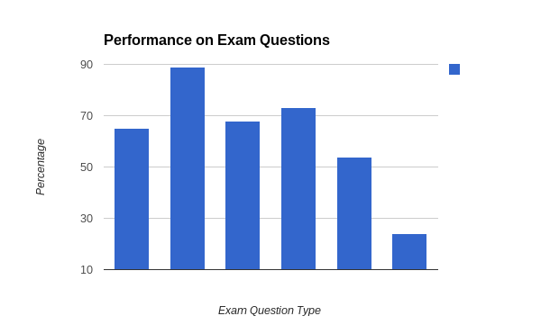

Conclusions and Plans for Next Semester

The animated powerpoint and the student led workshops have been shown to dramatically increase student engagement in the material, and preliminary analysis of exams indicates improved performance. However, the design of the laboratory component needs to be improved to go beyond “demonstration” to allow for more detailed exploration and report writing, and the assessment will focus on this aspect of the course as well as a complete set of animated
lessons that will be used for all topics and further assessment on performance on exams.

