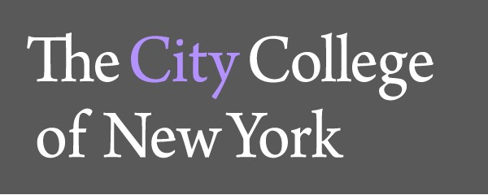North Academic Center, Room 6/219
160 Convent Ave
New York, New York 10031

TEL: 212.650.5407
DEPARTMENT OF ENGLISH FAX: 212.650.5410
www.ccny.cuny.edu

Digital Portfolio Assessment

Fall 2016-Spring 2017
September 12, 2017
Submitted to: Doris Cintrón, Senior Associate Provost for Academic Affairs Erec Koch, Dean, Division of Humanities and the Arts
Renata Miller, Deputy Dean, Division of Humanities and the Arts Liz Mazzola, Chair, Department of English
Kathy Powell-Manning, Learning Assessment Director Ana Vasovic, Director of General Education
Joshua Wilner, Chair, General Education Committee
Submitted by: Thomas Peele, Director, First-Year Writing Program

Table of Contents
Introduction 2
Summary of Results 3
CUE and Title V Funded Faculty Development 4
Factors Affecting Writing Trait Scores 5
Implications for the 2017-2018 Academic Year 5
Scoring Process and Rationale 6
Scoring Guide and Trait Guidelines 7
Individual Writing Trait Scores by Course 8
Overall Portfolio Scores 8
Information Literacy Scores 9
Citation Scores 10
Drafting Scores 11
Collaboration Scores 12
Synthesis Scores 13
Audience Scores 14
Technology Scores 15
Reading Scores 16
Appendix A 17
Appendix B 18

Introduction
This portfolio assessment covers the 2016-2017 academic year. It builds upon the Fall 2015 pilot portfolio assessment. This is the first year that the portfolio assessment has been at full scale: each instructor of English 110, FIQWS Writing, English 210.01, .02, .03, and .07 was required to include a portfolio assignment on their syllabus and to use, with no more than minor variations, a standard portfolio assignment. In the spring of 2017, approximately 72% of the instructors participated in this project.

Year-to-Year Portfolio Assessment
 | Fall 2015 | Fall 2016 | Spring 2017
Number of Sections | 24 (FIQWS WS and | 42 (FIQWS WS) | 4 (FIQWS WS)
 | ENG110) | 20 (ENG110) | 7 (ENG110)
 |  | 5 (ENG21001) | 1 (ENG21001)
 |  | 5 (ENG21002) | 7 (ENG21002)
 |  | 7 (ENG21003) | 15 (ENG21003)
 |  | 9 (ENG21007) | 14 (ENG21007)
 | 24 Total | 88 Total | 48 Total
Number of Students  in Assessment Pool | 494 | 2295 | 1367
Number of Portfolios  Assessed | 176 | 235 | 240
Confidence Level | 90% | 89.4% | 91.1%

Confidence levels apply only to program-wide portfolio scores. Individual course confidence levels are lower because of the relatively small sample size. The random selection of portfolios was facilitated by Random.org, a random number generator. Portfolios were selected from a master list (generated by the Office of Institutional Research) of all students enrolled in composition.

Portfolios were scored on a scale of 1-6: 1=Failing
2=Attempted
3=Minimally Proficient 4=Proficient 5=Advanced 6=Highly Advanced

Every portfolio was scored twice; portfolios whose overall scores were not identical or adjacent were scored a third time. After the portfolios were scored, the individual scores were added together to create a twelve-point scale. For example, a portfolio with a score of 8 received a score of 4 from each rater (4+4=8). In the spring of 2017, portfolio evaluators achieved an inter- rater reliability score of approximately 94.2%.

Summary of Results
This study of student writing at CCNY, based on a set of 651 writing portfolios collected over three semesters, while preliminary, suggests that the Department’s CUE and Title V funded faculty development workshops have had a positive impact on student performance. In the aggregate, the number of portfolios scored minimally proficient or above has increased from 58.5% in the fall of 2015 to 70.39% in the spring of 2017.

English 110, FIQWS WS, English 210
Minimally Pro9icient or Higher Portfolio Scores

80.00%

70.00%

60.00%

50.00%

40.00%

30.00%

All Sections

20.00%

10.00%

0.00%

FA15 FA16 SP17

All Sections 58.50% 63.76% 70.39%

CUE and Title V Funded Faculty Development
During the 2016-2017 academic year, the Department of English hosted several CUE and Title V funded faculty development events, all of which directly or indirectly supported the portfolio project:

- New Instructor Orientation (two days, August, 2016)
- Introduction to WordPress Portfolios (two half-days, August 2016)
- Portfolio Assessment (January 2017)
- Instructional Strategies for Information Literacy, Citation, Drafting, and Collaboration (January 2017) (Appendix B: The CCNY Writing Program: Curricular Goals was distributed to instructors during the writing traits workshop and used as a guiding document.)
- Portfolio Assessment (June 2017)

The table below shows the change in the number of minimally proficient portfolios from Fall 2106 to Spring 2017. With the exception of English 110, which showed some decline, the semester-over-semester trends are positive.

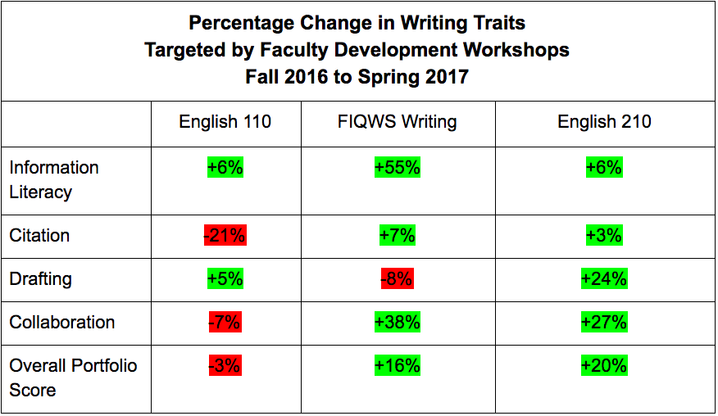

- Information literacy proficiency scores improved by 6% in English 110 and English 210 and by 55% in FIQWS Writing sections.
- Citation proficiency scores decreased in English 110, but improved by 7% in FIQWS Writing and 3% in English 210.
- Drafting proficiency scores declined in FIQWS writing by 8%, but improved in English 110 by 5% and English 210 by 24%
- Collaboration proficiency scores declined in English 110 by 7%, but improved in FIQWS Writing sections by 38% and in English 210 by 27%
- The Overall Portfolio proficiency score declined by 3% in English 110, but improved by 15% in FIQWS Writing Sections and 20% in English 210.

Factors Affecting Writing Trait Scores

While these results are encouraging, an additional year of portfolio assessment at scale will provide a more comprehensive view of the First-Year Writing Program. Some limitations of the current study include

- the small number of English 110 (7) and FIQWS (4) sections that we offer in the spring semester. With such a small number of sections, the data from just one or two classes can have an outsized impact on the final assessment results
- the high number of College Now courses (four of the seven English 110 sections) in which only high school students enroll
- the distribution of students in various sections of composition: undesignated sections of English 110 are populated almost exclusively by Engineering students, while most of the students interested in the humanities are enrolled in FIQWS sections
- the number of transfer students who begin the CCNY composition sequence with English 210
- the length of time that students wait between enrolling in English 110/FIQWS Writing and English 210
- the distribution of instructors who attend the faculty development workshops
- the length of time an instructor has been teaching composition (beginning instructors are most often assigned to English 110; more experienced instructors are assigned to FIQWS WS and English 210)

Implications for the 2017-2018 Academic Year

As the tables on pages 9-17 show, students in every section scored at or near target levels in the areas of Audience Awareness, Synthesis, and Technology, which suggests that we should continue our focus on Information Literacy, Citation, Drafting, and Collaboration in the 2017-2018 academic year. The portfolio assessment shows significant gains in all targeted areas. The First-Year Writing Program will build on these successes by continuing its focus on these traits in faculty development workshops.

Scoring Process and Rationale

Raters, all experienced CCNY composition instructors, scored each trait and the overall portfolio based on our norming session on the morning of the portfolio assessment as well as their years of teaching experience. While instructors will not always agree on the evidence or particular traits, this assessment model allows the First Year Writing Program to take advantage of our instructors’ deep knowledge of our program’s context. In addition, all of the instructors in the classes whose portfolios we assessed used the same set of course learning objectives from which the scoring traits are derived. Thus, in our view, the assessment was fair since the aims of the course were made clear to the students, the information that portfolios were going to be collected and scored was known both by instructors and students, and the portfolios were scored by instructors experienced with teaching composition at CCNY.

The aim of portfolio assessment is to assess the writing program itself rather than individual instructors or students. When we read the portfolios for traits, we look for evidence of the traits in the portfolios since the portfolio assignment asks students to write about each of these traits. If there is no evidence of the trait in the portfolio, this does not necessarily mean that the trait was not covered by the instructor. Rather, it means that the student showed no evidence of the trait in the portfolio and, thus, no awareness of the trait. This lack of evidence provides the Writing Program with direction for faculty development. Our aim is not only to have students develop these aspects of their writing, but also to reflect on these traits to increase their meta- awareness of writing. In portfolio assessment, metacognition of writing practices (process and content knowledge) is as important as the practices themselves.

Scoring Guide and Trait Guidelines
The Scoring Guide was drawn from the Course Learning Outcomes (see Appendix A). We isolated eight learning objectives to frame our assessment and to provide direction for faculty development in the 2016-2017 academic year. Portfolio raters used the following trait guidelines to rate portfolios:

Information Literacy and Citation

Information Literacy. There is evidence that students used the library's databases to find research materials. Discussion of databases in reflective essay; citations that include the names of the library’s databases

Citation. There is evidence that students practiced systematic application of citation conventions. Both in-text citations and works cited entries are consistently well constructed

Writing Processes

Drafting. There is evidence that students wrote at least one draft to prepare for the final writing assignment. Discussion of drafting in the reflective essay; drafts included in the portfolio

Collaboration. There is evidence that students engaged in collaborative writing processes. Discussion of collaboration in the reflective essay, including responding to feedback on drafts; inclusion of collaborative texts (peer reviews, discussion board entries, email exchanges, social media posts)

Synthesis. There is evidence that students composed texts that integrated their ideas with appropriate sources. Discussion of synthesis in reflective essay; textual evidence of links between student’s thinking and sources

Audience Awareness, Technology, and Reading Practices

Audience. There is evidence that students wrote to a range of audiences. Discussion of audience in reflective essay, including instructors and classmates; textual evidence (change of tone, vocabulary, voice, syntax); mention of audience in essay

Technology. There is evidence that students used multiple technologies to complete writing assignments. Discussion of technology in reflective essay both for research (videos, sound clips, images) and delivery; evidence of Bb use, WordPress use, other Web 2.0 use, evidence of the use of Word, .pdf, or other software packages

Reading. There is evidence that students applied multiple reading strategies. Discussion of reading strategies in reflective essays or in essays submitted in response to assignments

Individual Writing Trait Scores by Course

Overall Portfolio Scores

As with the aggregate, portfolio scores for each course have improved over the last two years. More than 85% of FIQWS Writing Section portfolios received a score of minimally proficient or higher. English 210, too, made significant gains, and English 110 decreased slightly from Fall 2106 to Spring 2017. During the current academic year, it seems likely that more instructors will assign the portfolio, and that instructors who assigned it last year will be more proficient with the assignment this year. We should anticipate that both fall and spring proficiency scores will be higher.

Overall Portfolio Scores by Course Minimally Pro9icient or Higher

100.00%
 | FA15 |  |  | FA16 |  |  |  |  | SP17
ENG110 | 58.50% |  |  | 64.91% |  |  |  |  | 61.90%
FIQWS WS |  |  |  | 71.15% |  |  |  |  | 87.50%
ENG210 |  |  |  | 51.47% |  |  |  |  | 71.58%

90.00%
80.00%
70.00%
60.00%
50.00%
40.00%
30.00%
20.00%
10.00%
0.00%

ENG110 FIQWS WS ENG210

Information Literacy. There is evidence that students used the library's databases to find research materials. Discussion of databases in reflective essay; citations that include the names of the library’s databases

These scores, while improving significantly across all sections of composition, remain low with the exception of FIQWS Writing. The likely reason for this is the narrowness of the measure—as dictated by style guides, students must name a database on their works cited sheet in order to achieve a high score on this trait. While there is substantial evidence that students are using a wide variety of peer reviewed and popular sources, there is little evidence that they are accessing it from our databases. This specific outcome remains important, however, since the naming of a database in a citation remains the single most accurate measure of whether or not a student has used the database. Students are resistant to any research practice that requires a login procedure, but it’s crucial that they be at least familiar with how to use databases early in their academic careers. Without this measure, we have no evidence that they’ve used the databases.

Informa(on Literacy Minimally Proﬁcient or Higher

80.00%
70.00%
60.00%
50.00%
40.00%
30.00%
20.00%
10.00%
0.00%

FA15 FA16 SP17

ENG110 FIQWS WS ENG210

ENG110 23.60% 23.26% 29.27%
FIQWS WS 20.93% 75.00%
ENG210 16.13% 22.41%

Citation. There is evidence that students practiced systematic application of citation conventions. Both in-text citations and works cited entries are consistently well constructed

Citation practices improved considerably in FIQWS WS and somewhat in English 210, but declined in English 110. Both in-text and end-of-text citations are difficult to consistently execute well, and the College Now high school students in English 110 in the spring of 2017 would necessarily have had less experience with citation practices.

Coupled with information literacy, this outcome remains important since it is among the least abstract measures of writing and since with some practice with the library’s citation generator a higher percentage of students can improve their proficiency in this area.

Cita(on Minimally Proﬁcient or Higher

80.00%

70.00%

60.00%

50.00%

40.00%

30.00%

20.00%

10.00%

0.00%

FA15 FA16 SP17

ENG110 FIQWS WS ENG210

ENG110 64.80% 60.42% 39.47%
FIQWS WS 64.44% 71.43%
ENG210 57.14% 60.87%

Drafting. There is evidence that students wrote at least one draft to prepare for the final writing assignment. Discussion of drafting in the reflective essay; drafts included in the portfolio

This area, which the department specifically targeted in its faculty development workshops, shows significant improvement in both English 110 and English 210 but a decrease in FIQWS Writing. As with the other traits, this is likely based on the small number of sections available for this study, but the increase in the English 210 scores suggest that the department’s ongoing discussion of the importance of reflection is having an impact on how instructors teach, and how students think about, drafting.

Dra9ing Minimally Proﬁcient or Higher

70.00%

60.00%

50.00%

40.00%

30.00%

20.00%

10.00%

0.00%

FA15 FA16 SP17

ENG110 FIQWS WS ENG210

ENG110 65.00% 55.32% 60.61%
FIQWS WS 58.43% 50.00%
ENG210 31.48% 55.86%

Collaboration. There is evidence that students engaged in collaborative writing processes. Discussion of collaboration in the reflective essay, including responding to feedback on drafts; inclusion of collaborative texts (peer reviews, discussion board entries, email exchanges, social media posts)

Collaboration scores went up dramatically for FIQWS Writing and English 210, but fell somewhat for English 110. The significant number of high school students in English 110 likely had a negative impact on this writing trait.

Collabora(on Minimally Proﬁcient or Higher

90.00%
80.00%
70.00%
60.00%
50.00%
40.00%
30.00%
20.00%
10.00%
0.00%

FA15 FA16 SP17

ENG110 FIQWS WS ENG210

ENG110 49.30% 52.38% 45.16%
FIQWS WS 42.68% 80.00%
ENG210 45.28% 72.59%

Synthesis. There is evidence that students composed texts that integrated their ideas with appropriate sources. Discussion of synthesis in reflective essay; textual evidence of links between student’s thinking and sources

Raters gave the portfolios high scores in this area, with both FIQWS WS and English 210 scoring above 80%. As with Collaboration, Citation, and Audience, however, the score for English 110 fell from the fall to the spring semesters. Even with this lower score, however, achievement in these three areas is at or near target outcomes of 80% achievement.

Synthesis Minimally Proﬁcient or Higher

120.00%

100.00%

80.00%

60.00%

40.00%

20.00%

ENG110 FIQWS WS ENG210

0.00%

FA15 FA16 SP17

ENG110 67.60% 84.91% 73.33%
FIQWS WS 86.32% 100.00%
ENG210 85.48% 88.08%

Audience. There is evidence that students wrote to a range of audiences. Discussion of audience in reflective essay, including instructors and classmates; textual evidence (change of tone, vocabulary, voice, syntax); mention of audience in essay

All of the FIQWS Writing portfolios received scores of minimally proficient or higher—an encouraging result, even based on such a small number of classes. The FIQWS Writing scores increased from an already strong 86.05% in the fall of 2016. The English 210 scores, already strong, remained relatively flat, while the English 110 scores fell. Since part of the evidence that the portfolio team looks for is built into the assignment sequence—essays that by definition change tone, vocabulary, voice, and syntax—it seems likely the students in English 110 did not describe in their self-reflections the impact of audience on their writing.

Audience Minimally Proﬁcient or Higher

120.00%

100.00%

80.00%

60.00%

40.00%

20.00%

ENG110 FIQWS WS ENG210

0.00%

FA15 FA16 SP17

ENG110 71.60% 79.63% 60.61%
FIQWS WS 86.05% 100.00%
ENG210 81.82% 82.76%

Technology. There is evidence that students used multiple technologies to complete writing assignments. Discussion of technology in reflective essay both for research (videos, sound clips, images) and delivery; evidence of Bb use, WordPress use, other Web 2.0 use, evidence of the use of Word, .pdf, or other software packages

Technology scores remain high across all sections of composition, with English 110 outperforming FIQWS Writing. As the portfolios are digital documents, the technology scores are generally high since the portfolio itself demonstrates a certain level of proficiency with technology.

100.00%
90.00%
80.00%
70.00%
60.00%
50.00%
40.00%
30.00%
20.00%
10.00%
0.00%

Technology Minimally Proﬁcient or Higher

FA15 FA16 SP17

ENG110 FIQWS WS ENG210

ENG110 77.50% 94.34% 87.80%
FIQWS WS 88.00% 83.33%
ENG210 81.82% 91.08%

Reading. There is evidence that students applied multiple reading strategies. Discussion of reading strategies in reflective essays or in essays submitted in response to assignments

As in several other areas, FIQWS Writing showed significant improvement in this area, while English 110 and 210, though still stronger than in the fall of 2015, showed slight declines. Even with these declines, however, all scores are significantly improved since the Fall 2015 pilot, which suggests that instructors and students are making stronger connections between reading and writing in their self-reflections.

Reading Minimally Proﬁcient or Higher

120.00%

100.00%

80.00%

60.00%

40.00%

20.00%

ENG110 FIQWS WS ENG210

0.00%

FA15 FA16 SP17

ENG110 45.20% 68.18% 60.61%
FIQWS WS 72.60% 100.00%
ENG210 67.35% 63.01%

Appendix A

FIQWS WS and English 110 Course Learning Outcomes

- Explore and analyze, in writing and reading, a variety of genres and rhetorical situations.
- Develop strategies for reading, drafting, collaborating, revising, and editing.
- Recognize and practice key rhetorical terms and strategies when engaged in writing situations.
- Engage in the collaborative and social aspects of writing processes.
- Understand and use print and digital technologies to address a range of audiences.
- Locate research sources (including academic journal articles, magazine and newspaper articles) in the library’s databases or archives and on the Internet and evaluate them for credibility, accuracy, timeliness, and bias.
- Compose texts that integrate your stance with appropriate sources using strategies such
as summary, critical analysis, interpretation, synthesis, and argumentation.
- Practice systematic application of citation conventions. English 210 Course Learning Outcomes
- acknowledge your and others' range of linguistic differences as resources, and draw on
those resources to develop rhetorical sensibility
- enhance strategies for reading, drafting, revising, editing, and self-assessment
- negotiate your own writing goals and audience expectations regarding conventions of genre, medium, and rhetorical situation
- develop and engage in the collaborative and social aspects of writing processes
- engage in genre analysis and multimodal composing to explore effective writing across disciplinary contexts and beyond
- formulate and articulate a stance through and in your writing
- practice using various library resources, online databases, and the Internet to locate sources appropriate to your writing projects
- strengthen your source use practices (including evaluating, integrating, quoting, paraphrasing, summarizing, synthesizing, analyzing, and citing sources

Appendix B

CCNY First-Year Writing

CONTACT

Tom Peele
Director of First-Year Writing
NAC 6/333C (212) 650 6328
tpeele@ccny.cuny.edu

- Information Literacy and Citation Practices
- Drafting and Collaboration
- Reading Strategies
Curricular Goals

Spring 2017
- Assessment of Rhetorical Moves: A Big Data Study

Information Literacy and Citation Practices

Goal
Students should use and correctly cite CCNY’s academic databases. Consider directing them towards Opposing Viewpoints in Context, which includes various genres of research materials (newspapers, magazine, peer reviewed articles, popular sources, audio and video recordings).

Why this goal?
The course learning outcomes specify that students should leave our courses knowing how to use the online databases. The 2015 assessment showed that only 24% of students showed at least minimal proficiency in this area. Understanding the basics of our extensive database collection will be enormously helpful to students going forward. Searching the open web as a part of the research process is an excellent strategy, but students will get significantly more credible sources from database searches.

How do we know students have used the databases?
In MLA format, the name of the database is included in the citation. In APA format, the name of the database’s owner appears in the URL. You can tell by looking at the citation whether or not students found the source in a database.

How do I teach this citation practice?
Show students how to use the Citation Tools in the toolbar on the right hand side of the source page.

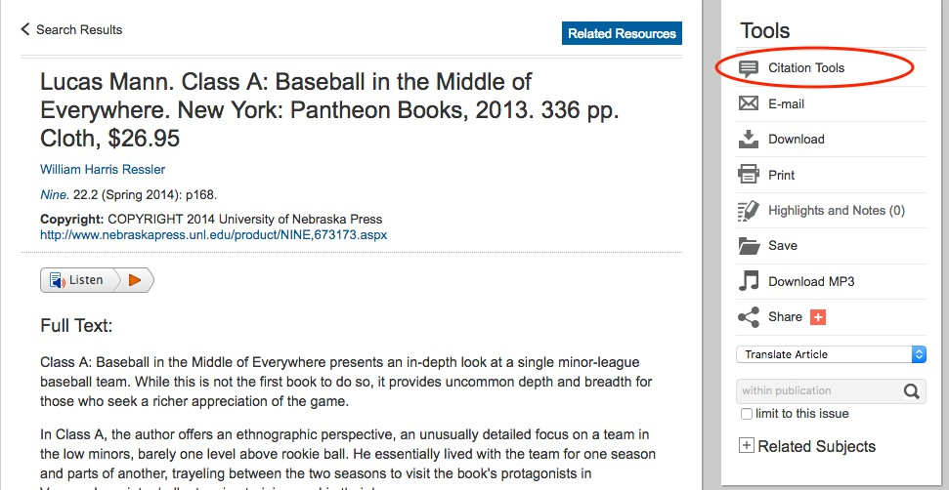

Drafting and Collaboration

Goal
In their self-reflections, students should describe their collaborative writing activities and the impact they’ve had on their drafting processes.

Why this goal?
Instructors spend an enormous amount of time on collaboration and drafting. Many would describe these practices as at the heart of a composition classroom. The 2015 assessment report shows, however, that fewer than half the students demonstrate that they’ve collaborated in their writing process. Significantly more students (73%) describe or otherwise demonstrate their drafting processes, but as these two activities are highly correlated it makes sense to focus on them at the same time.

How can I get students to reflect more on these activities?
After each assignment, have a brief discussion with students about the course learning outcomes. They’ll come up with a lot of examples of collaboration and drafting, and the impact these activities had on their work. They include peer review, web-based discussion, instructor feedback, collaborative writing assignments, and many other activities. Make sure these areas are discussed and documented (with screen-shots of conversations, examples drawn from drafts, and so on) in their final self-reflections.

Reading Strategies

In the faculty development workshops, we discussed the need to focus on reading strategies. We know students are accessing and incorporating secondary sources (62% of students were ranked as at least minimally proficient in this area in last year’s assessment report) but we don’t know if they’re reading and understanding the entire source. Instructors offered numerous activities to develop students’ reading strategies.

Students (in groups or individually) focus on sections of the text then collaborate to develop a full reading. | Read an article aloud and annotate it collectively. Demonstrate how you work through the questions that a text presents.
Use the discussion board feature of Blackboard to facilitate general discussion about the text before the class meets. | Ask students to write progressively more concise summaries (of five sentences, then of three, then of one).
Use Blackboard’s discussion board for guided discussions; ask student to:  - articulate the main point of the  essay  - describe their response to the essay  - present evidence from the essay for their response | Ask students to summarize individually, then compare their summaries in small groups. Provide students with previously written summaries for comparison.
Ask students to use different colored highlighters to annotate various parts of the text (main idea in blue, supporting evidence in red, for example). | Ask students to reflect on the reading process itself in addition to the essay.
Provide a difficult article with your annotations to demonstrate your method. | Repeat the annotation process, raising students’ awareness of how a second reading might answer questions raised in the first reading.
Use a model annotated essay from the textbook. | Provide a guided activity chart:  what do I know about this subject already? what do I want to learn?  what did I learn when I read the article? what more do I want to learn?
Assign short quizzes at the beginning of the class period that ask students to identify components of the essay. | Use short pieces that the class can go over several times.

Combine one dense, academic article with articles written in response to it, so that students are repeatedly exposed to the concepts. | Scaffolding: discuss key works and concepts before students read the essay.
Identify the specific rhetorical moves that writers use to make claims, introduce evidence, entertain objections, make concessions, and make counter arguments.

Assessment of Rhetorical Moves: A Big Data Study

A preliminary study of 548 research essays written by City College students in the fall of 2015 showed that while our students are likely to entertain objections in their essays (that is, introduce an opposing point of view) they are not very likely to offer concessions (admit that the opposition may have a point) or to offer counter arguments. This pattern suggests that students are not engaging with other viewpoints as extensively as we’d like them to.

The study of large numbers of essays, made possible by computers, while telling only a partial story of student writing, is revealing. In addition to focusing on reading strategies as noted above, I also want to encourage instructors to focus on specific rhetorical moves that writers use to include other voices in their essays. To conduct this study, I need your help. If you want to participate, you’ll be asked to do the following:

  - Use the “rhetorical moves” assignment (attached). Feel free to alter it to suit your teaching style; just be sure that the emphasis remains on both identifying rhetorical moves in assigned essays and on students practicing their use in their own essays. I’ll collect your version of the assignments at the end of the semester.

  - Send a copy of your students research essays to me.

At the end of the semester, a faculty development team will assess the essays.

This study is motivated by many factors. Primarily, we want our students to engage with viewpoints with which they do not agree because it both expands their perception and it strengthens their arguments.

Please send me an email to let me know if you’d like to participate in this study.

