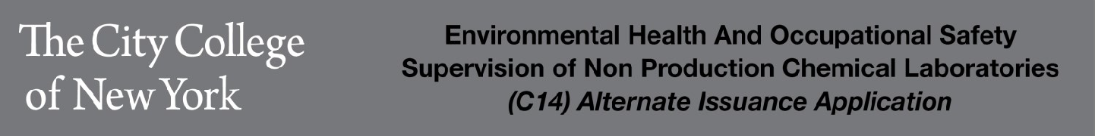
Applicant Information
First Name: |  |  | Last Name:
Social Security Number (required by FDNY
Email Address:
Date of Birth (mm/dd/yyyy): |  |  | Gender: |  | Male ☐ Female ☐
Weight (pounds): |  |  | Height (ft./ins.): |  | /
Applicant Mailing (Home) Address: |  |  |  |  | Phone:
Street: |  |  |  |  | Apt No:
City: |  | State: |  |  | Zip Code:
Borough: Bronx ☐Brooklyn☐ Manhattan ☐Queens ☐Staten Island ☐Outside NYC
Work Address(Location where C14 COF holder will be working:
Street: 160 Convent Avenue | Lab Room #
City : New York | State: NY |  |  | Zip Code: 10031
Borough: Bronx Brooklyn Manhattan ✔ Queens Staten Island Outside NYC
Applicant Education and Training Qualifications
(select the most appropriate choice and provide copy of license, degree, or other proof of qualifications)
□ Clinical Laboratory Director license issued by the New York State Department of Health.
□ Doctor of Medicine (MD) OR Doctor of Dental Surgery (DDS)
□ Master's or Doctoral degree in Chemistry, Biology, Biochemistry, Environmental or Health Sciences,
□ Medical Technology, Chemical or Environmental Engineering, or related field.
□ Bachelor’s degree in Chemistry, Biology, Biochemistry, Environmental or Health Sciences, Medical Technology, Chemical or Environmental Engineering, or related field AND two years of Post-baccalaureate experience in an operating chemical laboratory.

Experience Years Months
Signature:
The above information is true to the best of my knowledge
Applicant Name - Print (above) Signature Date
Supervisor Name - Print (above) Signature Date

AIP form 1/2016

