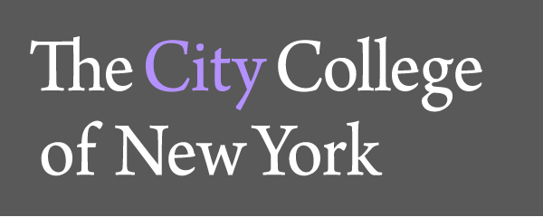
Admin. 218C
160 Convent Avenue
New York, NY 10031
TEL: 212.650.8066
FAX: 212.650.6425

Office of General Education

FIQWS Description – Fall 2013 and after

The cornerstone of City’s General Education experience, FIQWS combines a focused and immersive introduction to academic inquiry in a particular subject area with the intensive writing instruction offered by more traditional freshman composition courses. Each FIQWS offering is made up of two parts: 3 hours of the seminar are spent exploring the specific topic and 3 hours in a writing workshop organized around the subject matter studied in the topic seminar.

Under Pathways General Education curriculum 3 credits of FIQWS are allocated to an area of the Flexible Core (topic section) and 3 credits are allocated toward the English Composition requirement (writing section). The Flexible Core variations are:

FIQWS 10003 – World Cultures and Global Issues (Cultural/Historical Emphasis)
FIQWS 10005 – World Cultures and Global Issues (Literary)
FIQWS 10008 – Individual and Society
FIQWS 10011 – Scientific World
FIQWS 10013 – Creative Expression
FIQWS 10015 – US Experience in its Diversity

The matching English Composition sections are:

FIQWS 10103 – Composition for World Cultures and Global Issues (Cultural/Historical Emphasis)
FIQWS 10105 – Composition for World Cultures and Global Issues (Literary)
FIQWS 10108 – Composition for Individual and Society
FIQWS 10111 – Composition for Scientific World
FIQWS 10113 – Composition for Creative Expression
FIQWS 10115 – Composition US Experience in its Diversity

For transfer purposes, students should be awarded 3 credits in English Composition and 3 credits in a category corresponding to an area of the Flexible Core.

Sincerely,

Ana Vasovic
Director of General Education
avasovic@ccny.cuny.edu
212-650-8066



