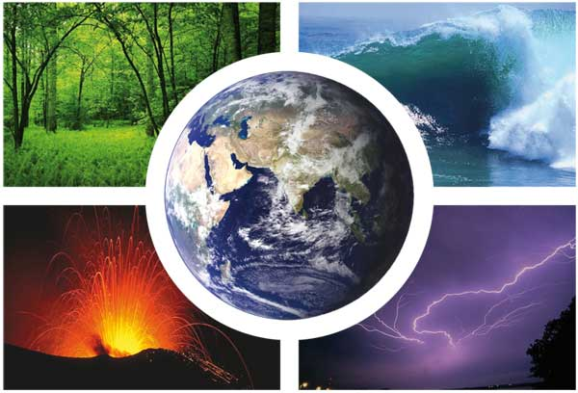
Spring 2018

Perspectives of Global Warming

EAS 104

Instructor’s information:

Name: Dr. Diomaris Padilla
"The important thing in science is not so much to obtain new facts as to discover new ways of thinking about them."
- William Lawrence Bragg
Mailbox location: MR925
E-mail: dpadilla@ccny.cuny.edu
Office hours: By Appointment only

Course information:

Term and date: Spring 2018, 01/29/2017 - 05/18/2017
Course number and section: EAS-104; ND, ND2, ND3, ND4, ND5, ND6, HNR Credits: 3.00
Meeting times (Lecture): Mon/Fri: 12:30PM - 1:45PM, meets in MR2
Meeting times (Labs): Once a week meets for 50 min., meets in MR 044

Required Materials:

READER: Dessler, Andrew E. Introduction to Modern Climate Change. (2012).
Cambridge University Press. ISBN-13: 978-0521173155; Paperback Online Price: $46.34

App: Tophat app for smart phones and laptops. Join Code: 248966
Course description:

This course is designed to foster an interest in global environmental issues by informing the student of both the anthropogenic and natural causes for climate change. While focusing on the scientific aspects of climate change, a broader study will include issues pertaining to global policy and economics in order to engage the student in public policy debates. Course objectives include:
- Obtaining basic content-knowledge associated with climate studies:

- Developing an understanding of a scientific process and fostering a scientific approach to the world (quantitative reasoning skills, problem solving skills and critical thinking skills).

Unlike a typical science course, this course aims to engage students in new ways of thinking. The course is interdisciplinary and interactive.

List of learning outcomes for the course:

As part of the College’s General Education Curriculum, this course is designed to enhance your
understanding of science. Students successfully completing this course will be able to:
- Identify and apply the fundamental concepts and methods of a life or physical science.
- Apply the scientific method to explore natural phenomena, including hypothesis development, observation, experimentation, measurement, data analysis, and data presentation.
- Use the tools of a scientific discipline to carry out collaborative laboratory investigations.
- Gather, analyze, and interpret data and present it in an effective written laboratory or fieldwork report.
- Identify and apply research ethics and unbiased assessment in gathering and reporting scientific data.
Assessment & Grading formula:

- Daily Blackboard Assignments 20 %
- In Class Participation 20 %
  - Contributing to discussions
  - In-class assignments

- Lab Participation 20 %
- Midterm Exam 20 %
- Final Exam 20 %
Notes relevant to the Assessment:

All assignments (weekly readings, TopHat/Blackbaord assignments, etc.) will be posted on a weekly basis on the TopHat/Blackboard site, under folder “Assignments”. Therefore, you are responsible to check this folder every week. Late Assignments Not Accepted.

Attendance policy: Attendance at all class sessions and labs is required. Labs are highly participatory and interactive. If you are absent on a given day, you will receive a zero for any activities completed in lab that day; large numbers of absences will undoubtedly hurt your grade.

Academic integrity and plagiarism policies:

Cheating on exams or plagiarizing someone else’s work constitutes as a violation of the rules of CUNY-CCNY academic integrity policies.

For rules on academic integrity please visit: http://www1.ccny.cuny.edu/current/integrity.cfm

CLASS SCHEDULE:

Dates | Course Topic | Chapter
1/30/2018 | Introduction to Course | n/a
2/2/2018 | Introduction to the Climate Problem: What is climate? | Ch. 1
2/6/2018 | Introduction to the Climate Problem: What is climate? | Ch. 1
2/9/2018 | Is the Climate Changing? | Ch. 2
2/13/2018 | Is the Climate Changing? | Ch. 2
2/16/2018 | Radiation and Energy Balance | Ch. 3
2/20/2018 | No Classes (Classes follow Monday Schedule)
2/23/2018 | Radiation and Energy Balance | Ch. 3
2/27/2018 | “The Science Behind Global Warming” | n/a
3/2/2018 | Introduction to Climate Models & the Greenhouse Effect | Ch. 4
3/6/2018 | Finish Climate Models & Midterm Review | Ch. 4
3/9/2018 | Midterm Exam (Online via Blackboard)
3/13/2018 | The Carbon Cycle: Greenhouse Gases and Atmosphere | Ch. 5
3/16/2018 | The Carbon Cycle: Atmosphere-Land-Ocean Exchange | Ch. 5
3/20/2018 | The Carbon Cycle: Atmosphere-Land-Ocean Exchange | Ch. 5
3/23/2018 | The Carbon Cycle: Human Influence | Ch. 5
3/27/2018 | Carbon Film | n/a
3/30/2018 | Spring Recess
4/3/2018 | Spring Recess
4/6/2018 | Spring Recess
4/10/2018 | Forcing, Feedbacks, and Climate Sensitivity | Ch. 6
4/11/2018 | Wednesday: Classes follow a Friday Schedule; Future of Climate | Ch. 6
4/13/2018 | Exponential Growth: Population Growth | Ch. 7
4/17/2018 | Exponential Growth: Ecosystems | Ch. 7
4/20/2018 | Population Film | Ch. 8
4/24/2018 | Climate Impacts | Ch. 8
4/27/2018 | Climate Impacts | Ch. 9
5/1/2018 | Fundamentals of Climate Policy | Ch. 10
5/4/2018 | Fundamentals of Climate Policy | Ch. 10
5/8/2018 | Green Living | n/a
5/11/2018 | Green Living | n/a
5/15/2018 | Mitigation Policies -Last Day of Classes, Final Exam Review | Ch. 11
5/18 or 5/22 | Final Exams Week

