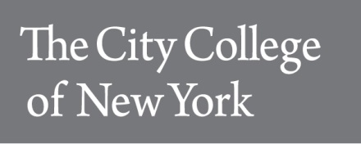
Department of Earth and Atmospheric Sciences
City College of New York, CUNY
160 Convent Avenue, Marshak 106
New York, NY 10031

Course Syllabus Spring 2018
Phase II Environmental Site Assessments
EAS 33400-H (23363) / EAS B3400-2HJ (23362)

Days & Times Mondays/Wednesdays 9 am – 10:15 am
www.ccny.cuny.edu/eas/
p. (212) 650-6452
f. 212.650.6482
Room Marshak 107
Instructor Angelo Lampousis, Ph.D., Lecturer
Email alampousis@ccny.cuny.edu
Office Marshak 717
Office Phone (212) 650-7590
Office Hours Right after class or by appointment

Course Bulletin Description: The purpose of this course is to introduce students to good commercial and customary practices in the United States of America for conducting Phase II environmental site assessments (ESA). A Phase II ESA is an evaluation process for confirming and quantifying the presence of hazardous substances or petroleum products in environmental media (i.e., soil, rock, groundwater, surface water, air, soil gas, sediment) throughout a contaminated site. A Phase II ESA typically includes a determination through field screening and chemical testing of the geological, hydrogeological, hydrological, and engineered aspects of the site that influence the presence of hazardous substances or petroleum products (e.g., migration pathways, exposure points) and the existence of receptors and mechanisms of exposure. Students are automatically enrolled in the 40-hour OSHA HAZWOPER (Hazardous Waste Operations and Emergency Response Standard) certification program, which applies to employees who are engaged in clean-up operations that are conducted at uncontrolled hazardous waste sites.
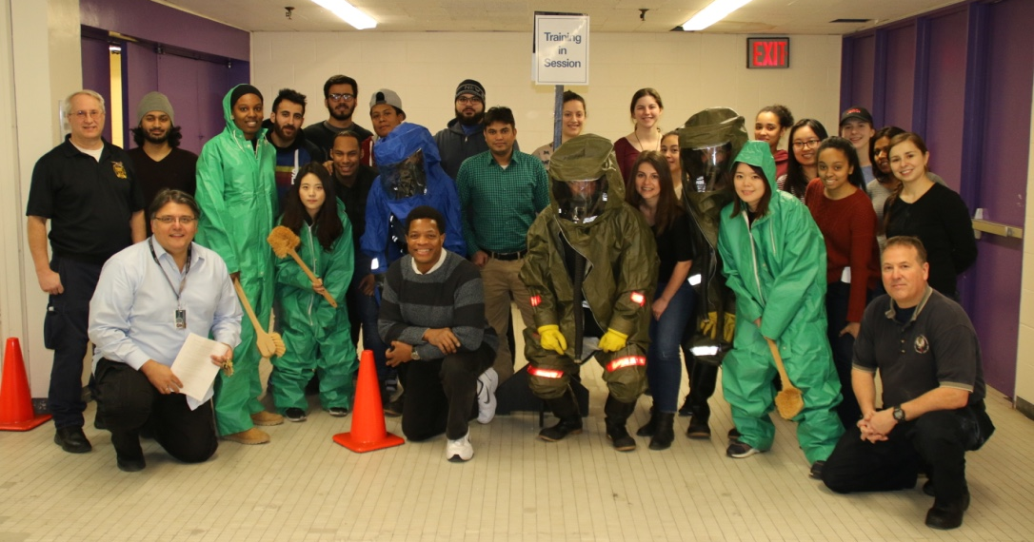
Prerequisites: EAS 33300 Phase I Environmental Site Assessments, or permission of instructor. 3 hr./ wk. 3 cr. Non-matriculated students may register if they hold a current Professional Engineer’s or Professional Geologist’s license and have the equivalent of three (3) years of full-time relevant experience.
Learning outcomes
• Develop and apply expertise from a wide range of fields, including environmental science and engineering as well as public health, law, civics, economics, and business management
• Gain an appreciation of the complexity, ambiguity, and risk involved in investigating and remediating environmental problems
• Ability to define technical and business practices to streamline environmental investigation and cleanup activities
• Develop confidence in project and site decision-making. Students will be introduced to best industry practices on how to maximize investigation project effectiveness and going beyond site assessment with existing resources. Special emphasis will be placed on achieving cleanup goals faster and at less cost.

Spring 2018 ASTM Standards for Phase II Environmental Site Assessments – Required
{Cost: $10 - Credit Card payment required – instructions to follow}
- ASTM E1903 Standard Practice for Environmental Site Assessments: Phase II Environmental Site Assessment Process

- ASTM E1739 Standard Guide for Risk-Based Corrective Action Applied at Petroleum Release Sites

- ASTM E2081 Standard Guide for Risk-Based Corrective Action

- ASTM E2600 Standard Guide for Vapor Encroachment Screening on Property Involved in Real Estate Transactions

- ASTM E2091 Standard Guide for Use of Activity and Use Limitations, Including Institutional and Engineering Controls

- ASTM E2790 Standard Guide for Identifying and Complying With Continuing Obligations

- ASTM E2137 Standard Guide for Estimating Monetary Costs and Liabilities for Environmental Matters

- ASTM E2173 Standard Guide for Disclosure of Environmental Liabilities

- ASTM E2718 Standard Guide for Financial Disclosures Attributed to Climate Change

- ASTM E1527 Standard Practice for Environmental Site Assessments: Phase I Environmental Site Assessment Process
Grading
- 45% Class assignments [Phase II case studies and other]
- 5% ANSI 2018 Student Paper Competition
- Draft due via Blackboard on April 9, 2018
- Final draft due directly to 5 pm ET on April 27, 2018, to lrajchel@ansi.org
(need to save copy of email acknowledgment and upload receipt on Blackboard)
- 10% Attendance and extended participation
  - Summer Volunteer Student Internship U.S Environmental Protection Agency
  - Other projects in consultation with the instructor
- 20% Midterm exam
- 20% Final exam
TENTANTIVE COURSE CALENDAR & CONTENT
Week | Day | Date | Topic
1 | Monday | 29-Jan | Transition from Phase I to Phase II Investigations
 | Wednesday | 31-Jan | Site Characterization: Non-Dynamic vs. EPA's Triad Approach
2 | Monday | 5-Feb | New York Water Environment Association Conference*
 | Wednesday | 7-Feb | New York Water Environment Association Conference*
 | Monday | 12-Feb | CCNY CLOSED Lincoln’s Birthday
3 | Wednesday | 14-Feb | Site Characterization: EPA's Triad Approach (continued)
 | Monday | 19-Feb | CCNY CLOSED Presidents’ Day
 | Tuesday | 20-Feb | Classes to follow a Monday schedule
4 | Wednesday | 21-Feb | NY State DER-10 Guidance: Site Investigation & Remediation
 | Monday | 26-Feb | NJ DEP Preliminary Assessment Technical Guidance
5 | Wednesday | 28-Feb | Continued
 | Monday | 5-Mar | The revision of ASTM E1903-11 on Phase II ESAs
6 | Wednesday | 7-Mar | Guest Speaker: Christopher P. McCormack, Esq., ASTM Task Group Chair on the revision of ASTM E1903-11 on Phase II Environmental Site Assessments
 | Monday | 12-Mar | HAZWOPER training compensation - NO CLASS
7 | Wednesday | 14-Mar | Best Management Practices (BMP), Planning and Logistical Considerations Transition from Investigation to Remediation
 | Monday | 19-Mar | Midterm Exam
8 | Wednesday | 21-Mar | Site Remediation Overview: Implications of Site Characterization on Remedy Design and Implementation
 | Monday | 26-Mar | Continued
9 | Wednesday | 28-Mar | Estimating and Disclosing Environmental Liabilities  ASTM E2137, E2173, E2718
 |  |  | Spring Recess March 30 - April 08
 | Thursday | 5-Apr | EPA-CCNY DAY - Mandatory
 | Monday | 9-Apr | HAZWOPER training compensation - NO CLASS
 | Wednesday | 11-Apr | Classes to follow a Friday schedule
10 | Monday | 16-Apr | Field activities – NYC Brownfields
 | Wednesday | 18-Apr | Field activities – NYC Brownfields
11 | Monday | 23-Apr | Field activities – NYC Brownfields
 | Wednesday | 25-Apr | Field activities – NYC Brownfields
12 | Monday | 30-Apr | Field activities – NYC Brownfields
 | Wednesday | 2-May | Using Consensus Based Environmental Standards to Assess, Remediate, and Transfer Ownership of a Contaminated Property by Tripp Fischer, P.G., Principal Hydrogeologist, BSTI
13 | Monday | 7-May | Remediation Basics: Cleanup Technologies
 | Wednesday | 9-May | Remediation Basics: Common Remedies by Primary Media
14 | Monday | 14-May | Overview and closing thoughts
 | Wednesday | 16-May | Overview and closing thoughts
 |  | TBA | Final Exams May 18 – 24
CCNY Spring 2018 Academic Calendar
https://www.ccny.cuny.edu/registrar/spring-2018-academic-calendar
* TIME SENSITIVE: Attendance at the New York Water Environment Association Conference is free for NYWEA members. You will need to join NYWEA as a student for $5. Contact Agata Bugala, the president of CCNY NYWEA Club at abugala000@citymail.cuny.edu or ccny.nywea@gmail.com
Definition of Grades:
All grades will be based on a scale of 100 with A+ = 97-100, A = 95-96, A- = 90-94, B+ = 87-89, B= 84-86, B- = 80-83, C+ = 77-79, C = 74-76, C- = 70-73, D = 60-69, and F<60.
- A+ = Rare performance. Reserved for exceptional achievement.
- A = Excellent work. Outstanding achievement.
- A- = Excellent work that exceeds course expectations.
- B+ = Very good work. Solid achievement (expected of CCNY undergraduates) that meets all course expectations.
- B = Good work. Acceptable achievement that meets almost all course expectations.
- B- = Satisfactory work. Acceptable achievement that meets major course expectations.
- C+ = Fair achievement just above that which is minimally acceptable.
- C = Fair achievement but only minimally acceptable.
- C- = Barely acceptable achievement.
- D = Very low performance. Unsatisfactory work. Lowest achievement to still allow for a passing grade. This grade may not be counted toward the major or minor option.
- F = Failure
Special note on “A” letter grades: For a student to receive an “A” in this course, the expectation is that she/he will score consistently grades of equal or higher than 94% in all assignments, quizzes, and exams, WITHOUT the assistance of points assigned after a curve. In addition, an “A” student is expected to attend every single class meeting from beginning to end, and also invest time in preparing for the lecture in advance of every lecture. The assumption is also that the student will perform similarly in the laboratory component of the course.
Classroom Etiquette: Every few years the behavior of several students compels me to remind the whole class of what may seem obvious to most: a) Talking during lecture is inconsiderate and disconcerting to me as well as to those trying to listen, think, and take notes.b) It is rude to walk in front of class (between the lecturer and the class) after class has begun. If you come in late quietly take a seat in the back half of the room.
Make-up Quizzes: No make-up quiz will be given without advance notification of at least one week before any absence due to religious observance. No make-up quiz will be given except for bonafide emergencies or illness. Except in the most unusual circumstances advance notification is required. An email or letter from your Academic Dean or your doctor is required before the scheduling of any make-up quiz. Also, except in the most unusual circumstances requiring special permission, the make-up quiz must be taken within one week of the missed quiz.
Extra credit: Since there are many opportunities in this course to academically perform, there will be no extra credit assignments.
Academic Integrity: Academic integrity governs all aspects of academic work. Academic dishonesty is prohibited in the City University of New York, and is punishable by failing grades, suspension and expulsion. If a violation should arise, it will be reported for appropriate action. For more information, visit https://www.ccny.cuny.edu/about/integrity
Please read the summary below of “What behaviors constitute academic dishonesty?” (shared by Professor Peter Bower, Senior Lecturer, Barnard College, Columbia University).

What behaviors constitute academic dishonesty?
- Cheating on examinations, quizzes, tests, or other assignments: the giving of assistance to another or the receiving of assistance from another person, another examination paper, other written material, or any source not explicitly permitted by the instructor, is cheating. Thus, you may not look at another’s paper or answers; you may not show your paper or answers to another or leave your paper or answers around for others to look at; and, you may not verbally read or reveal your answers to another in any way. It is also cheating to have access, without the instructor’s approval, to examination, quiz, or test questions prior to the administration of the examination, quiz, or test.

- Plagiarism: the submission or presentation of ideas or work in any form that are not one’s own without appropriate acknowledgement of the source(s). Even with the acknowledgement, close paraphrasing can constitute plagiarism. You may quote the work of others if properly attributed. Close paraphrasing also requires attribution; close paraphrasing is, however, a gray area on a slippery slope, and the slope tends to become steeper and more slippery with the length of the paraphrase.

- Submission of the same work for more than one course without the explicit permission of the instructors involved.

- Falsification or misrepresentation of data in any coursework.

- Altering, defacing, or concealing library materials.

- Participating in the academic dishonesty of another student by offering assistance or advice that encourages such behavior.

- Misrepresentation of one’s sate of health or personal situation to gain deferrals of examinations or extensions of academic deadlines.

- Forgery of a signature on any document or form related to a student’s academic life, including the adviser’s signature on a program, drop/withdrawal slip, or petition.
Accommodations for students with disabilities: The AccessAbility Center (AAC) facilitates equal access and coordinates reasonable accommodations and support services for City College students with disabilities. Visit: http://www.ccny.cuny.edu/accessability/ for more information.
Email Policy: The instructor reserves the right to not answer email communications that do not meet the following criteria:
(a) The student last name and course number must appear in the email subject line,
(b) Messages need to be signed with the full student name, department and major information,
(c) spell-check your messages and avoid language abbreviations common in online chatting and text messaging,
(d) use your CCNY email account in all communications.
Syllabus Change Policy: Except for changes that substantially affect implementation of the evaluation (grading) statement, this syllabus is a guide for the course and is subject to change with advance notice. Students will be informed promptly of any change through in-class announcements, Blackboard, and email communications.

