CCNY Review Committee Formatting Guidelines
For Tenure/CCE/Promotion Dossiers
(Handout Version of “E. Fermi Mock tenure/Promotion Dossier”)
August 13, 2019

Mock Tenure/Promotion File: Professor Enrique Fermi

This document is intended as a guide to formatting for administrative staff involved in uploading tenure/CCE and/or promotion cases. Where content is mentioned, it is usually with the intent to clarify some common questions or formatting issues. For complete information, always refer to the CCNY Policies and Guidelines for Reappointment, Tenure and Promotion (updated Summer 2019) on the Academic Affairs web site.

The guiding principles of this format are consistent file names and individual files for each document, grouped in subfolders if there is more than one file per item type.

The CCNY CV format is accessible on the Academic Affairs web site (“Forms”).

Folder Name = Faculty Name Action Semester Year: Fermi E. Tenure Promotion Fall 2019

Sample Folder View

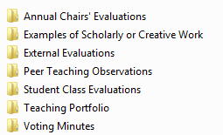

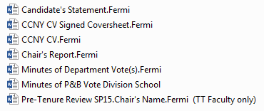

Subfolders

Annual Chairs’ Evaluations Subfolder

Sample Subfolder View

Instructions for the Annual Chairs’ Evaluations Sub-Folder

- Include the Chair’s evaluation for each year of service toward tenure/CCE. For tenure-track faculty, except the third-year, or Pre-Tenure Review.* The Pre-Tenure Review is placed at the top level of the folder.

- Any faculty responses to the documents above must be included.

- Any gaps between evaluation years or evaluations for more than the required years of continuous service should be explained in a document labeled as such, i.e. “2013-14 Chair’s Evaluation.Fermi.Explanation.”

*See CUNY’s Pre-Tenure Review policy for Spring of the 3rd year of continuous service:
https://www.ccny.cuny.edu/sites/default/files/academicaffairs/upload/RevisedPre-TenureReviewPolicy(CUNY)_2017.10.23.pdf

Examples of Scholarly and Creative Work Subfolder

Sample Subfolder View

Instructions for Examples of Scholarly and Creative Work Subfolder

Content
The texts and artifacts that accompanied the request for external review letters whenever feasible. Items that cannot be uploaded (ie books) should be brought by the Dean to the RC meeting when the case will be voted.

Format
Please upload each item in a separate file. Avoid long file names.

External Evaluations* Subfolder

Sample Subfolder View

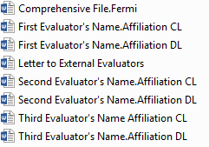

Instructions for the External Evaluations Subfolder

I. Format
External letters of evaluation should be uploaded in a separate sub-folder within the dossier folder. For ease of reference, the “External Evaluations” folder should consist of:

- One comprehensive document entitled “Comprehensive File” that contains:

--the candidate’s Advisory Panel member names and titles

-the list of all external evaluators with titles and affiliations

- Each external evaluation in a separate file, with the evaluator’s name, institutional affiliation and “CL” (Candidate List) or “DL” (Department List) or “CLDL” (both) in the document file name. Ideally, each letter will also bear a stamp indicating “Candidate’s List” or “Department List” or both if applicable.

- The “Letter to External Reviewers” is a sample of the Chair’s letter sent to each external review soliciting their evaluation letters.

*External letters of evaluation are not required for CCE or CLT tenure cases.

II. General
There must be a minimum of six (6) respondents, at least three (3) of whom appear only on the Panel's list.

All responses solicited should be included, including responses declining to write an evaluation.

III. Letters of Evaluations for Tenure and Promotion
If a faculty member is being recommended for both tenure and promotion, all evaluations should speak separately to his qualifications for each, as requested by the Chair in her/his letter of solicitation:

-For recommendations regarding tenure, the solicitation letter should request an evaluation of the potential for continued growth and performance, as well as for an appraisal of the quality of the candidate’s work to date.

-For recommendations regarding promotion, the solicitation letter should ask if the candidate is now, or shortly will be, performing at the teaching, research, scholarship, or administrative level appropriate to the rank for which he/she is being considered.

IV. Letters of Evaluation from CCNY or CUNY Faculty (Tenure Track faculty only)
Whereas the CCNY Policy and Guidelines for reappointment, Tenure and Promotion states that “Evaluators should be external to the College, except in cases such as where the candidate's college-wide service has been of an extraordinary nature, and other situations as appropriate,” the Review Committee also discourages letters of evaluation from CUNY faculty on the same basis. In case of promotion to full professor, letters from CCNY and CUNY faculty will not be accepted.

Peer Teaching Observations (Tenure Track Faculty and CCE* only)

Sample Subfolder View

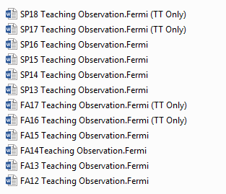

*For CCE cases there will only be four years of peer teaching observations.

If evaluations are not available for all semesters or are provided for more than the required years of service, an explanation should be provided.

Student Class Evaluations (TT Faculty and CCE only)

Sample Subfolder View
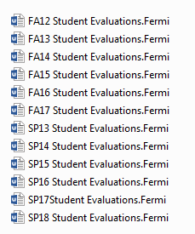

Instructions for the Student Class Evaluations Subfolder

- Include statistical summaries only.*
- Aggregate all class evaluations for a semester in one file.
- If evaluations are not available for all semesters or are provided for more than the required years of service, an explanation should be provided.

*Complete evaluations with student comments may be included in the Teaching Portfolio.

Teaching Portfolio (TT Faculty and CCE only)

Sample Subfolder View

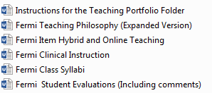

Instructions for the Teaching Portfolio Subfolder

Format: Each item in the Teaching Portfolio should be saved in a separate file within the Teaching Portfolio folder. Please avoid long file names.

Content:
Any additional items detailed in Section 9 of the City College CV (including comments from student Class Evaluations):
- Clinical instruction
- Innovative instructional activities, including curriculum and program development

- Development of online/hybrid or service learning courses

- Any additional material, produced by the candidate that constitutes clear evidence of the candidate’s caliber and accomplishment as a teacher

Voting Minutes Subfolder

Each File Name = Committee Name/Action/Candidate’s Name

Sample Subfolder View

Instructions for the Voting Minutes Subfolder

Include Minutes of all votes related to the action. Minutes should be on department letterhead and include:

- Meeting Date
- Faculty Candidate’s Name
- Faculty Member’s Title
- Action Voted
- Voting Results
- Meeting Attendance (Present/Absent)
- Signature of Committee Chair if Applicable

Top Level Files

Candidate’s Statement (TT Faculty and CCE only)

- 3 page limit

- The statement should put all the candidate’s activities and accomplishments into a framework that makes a case for the pending tenure and/or promotion action.

- Include separate sections covering research and future research agenda, teaching, and service.

CCNY CV Signed Coversheet (Parts I –III)

Please make sure all signatures are present. Effective dates of initial appointment and tenure/promotion if applicable may be obtained from the Office of Human Resources is if needed.

CCNY CV Curriculum Vitae (Sections 1-11)

Notes on Part 1: Effective date of tenure is Sept. 1 of the following year. Effective date of promotion is the first day of the following fall semester. “Salary” may be left blank.

Chair’s Report (TT Faculty and CCE only)

Please make sure this is signed and dated.

The Chair's Report should be written after the Executive Committee’s/Promotion Committee’s vote and before presentation to the P&B Committee.

The Chair’s report usually includes a summary of the results of departmental committee votes on the proposed actions.

The Chair's Report should thoroughly address all aspects of the qualifications of the candidate. It is typically 2-3 pages in length. The Chairperson should comment on such things as:

1. ability to contribute to the department’s curricular offerings;

2. teaching effectiveness;

3. student evaluations;

4. value of service to the Department and/or College as a whole;

5. value of service to the discipline;

6. status of journals in which publications appear;

8. candidate’s impact on the discipline;

9. effects of collaboration with other faculty; and

10. any other issues which the Chairperson believes will illuminate the candidate for the various personnel bodies.

Pre-tenure Review (TT faculty only)

Note that this file is placed at the top level instead of in the Chairs’ Reports subfolder.

See the City University of New York Pre-Tenure Review Policy (Revised October 2017).
https://www.ccny.cuny.edu/sites/default/files/academicaffairs/upload/RevisedPre-TenureReviewPolicy(CUNY)_2017.10.23.pdf

