CATERING MENUS

WELCOME TO THE CITY COLLEGE OF NEW YORK
Centerplate is a leading global event hospitality company, and we are thrilled to be your exclusive hospitality partner at The City College of New York. Our style is collaborative, and our New York team is delighted to work with you to ensure your experience here is smooth, successful and enjoyable. We are committed to delivering the finest foods, amenities, and service to impress your guests.
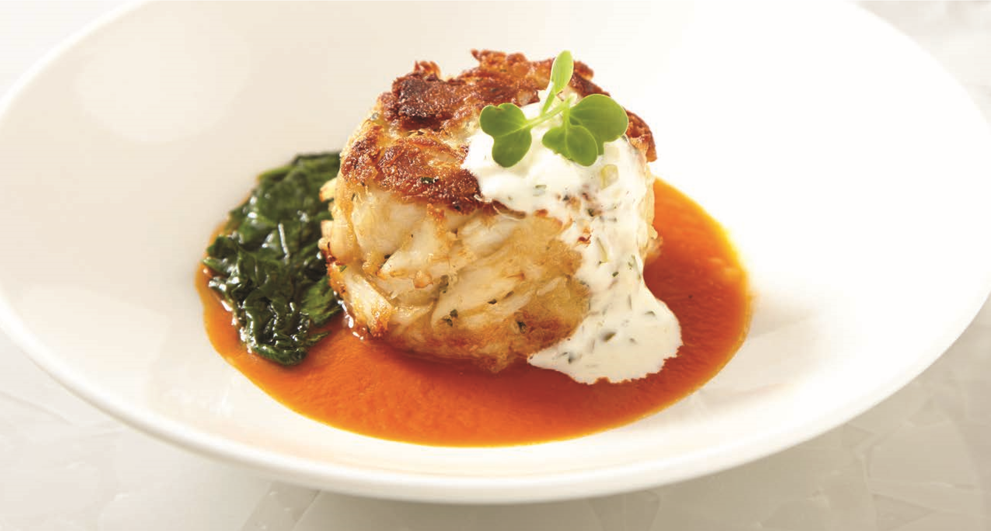
Much of our success comes from our attention to the important details that create truly welcoming experiences. From fresh, locally sourced, and quality ingredients to crisp, sincere, and attentive service, our goal is to provide world-class hospitality for each of our guests.
Whether hosting a reception, supplying convenient meals for your team, or creating custom menus for unique occasions, we are dedicated to helping you achieve extraordinary results. Please give us a call to start the planning process today.
Centerplate
160 Convent Ave
New York, NY 10031
NAC Building, 2nd Flr
P: 917-407-3300
O: 212-650-7203
E: sharmon@ccny.cuny.com

CONTENTS PAGE
Á la Carte ........................................................................................................................ 4-6
Boxed Lunches ...................................................................................................................7
Break Packages .................................................................................................................8
Sandwich/Wrap Platters .................................................................................................9
Salad Platters ....................................................................................................................10
Breakfast .........................................................................................................................11-13
Lunch Buffets ..............................................................................................................14-15
Hors D’oeuvres .................................................................................................................. 16
Dinner Buffets .............................................................................................................17-18
Beer & Wine ...................................................................................................................... 19
General Information ................................................................................................20-23

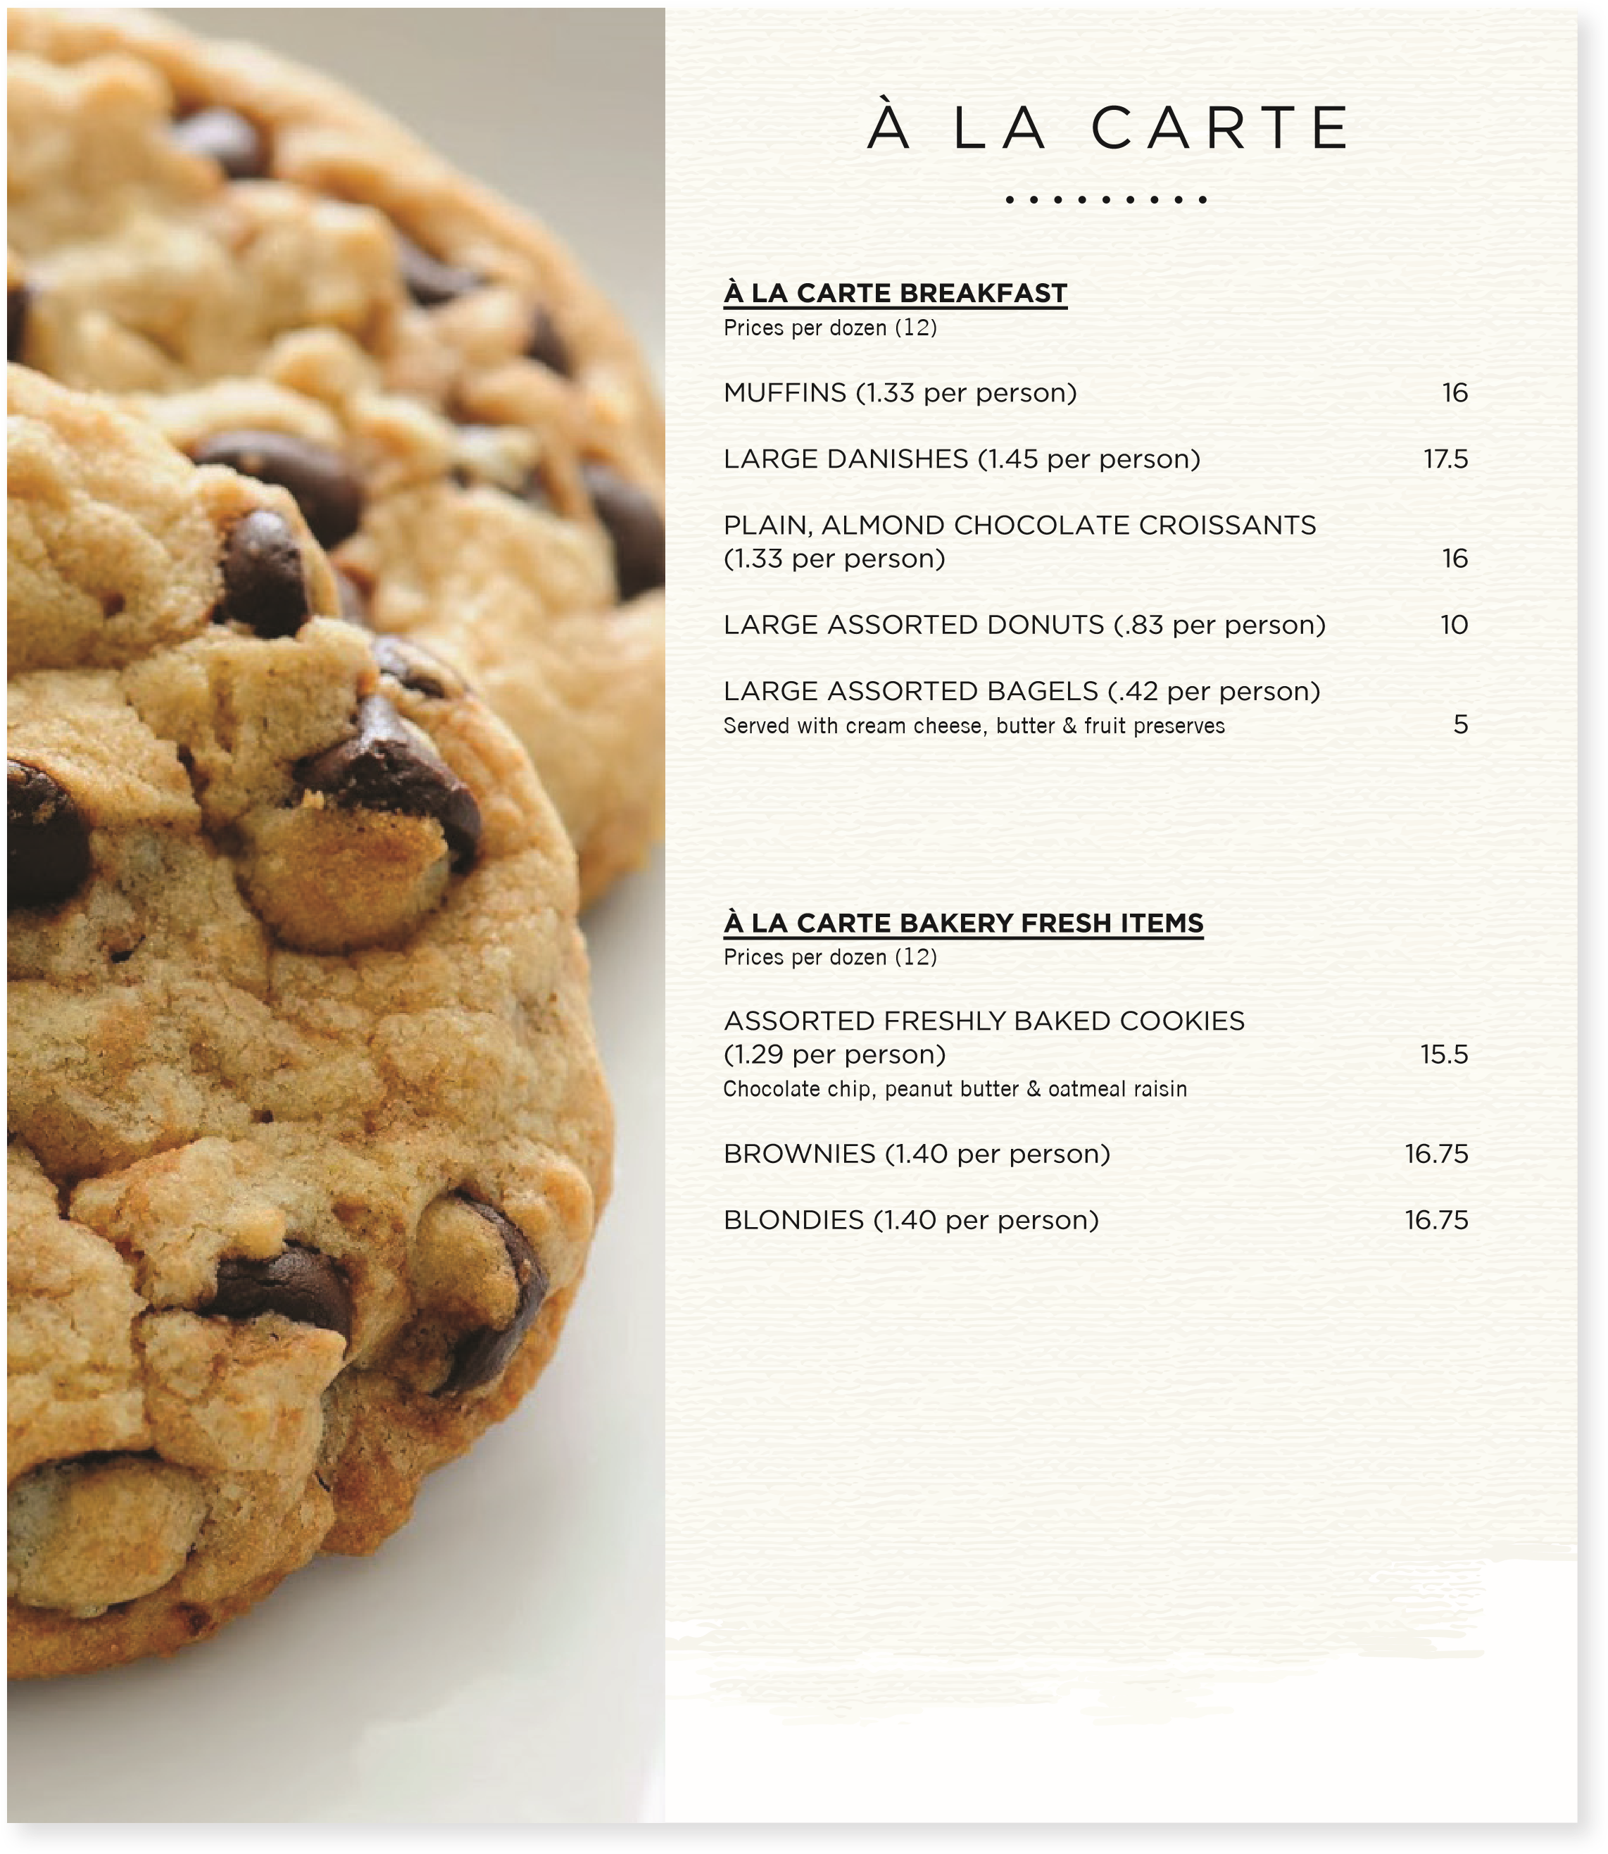
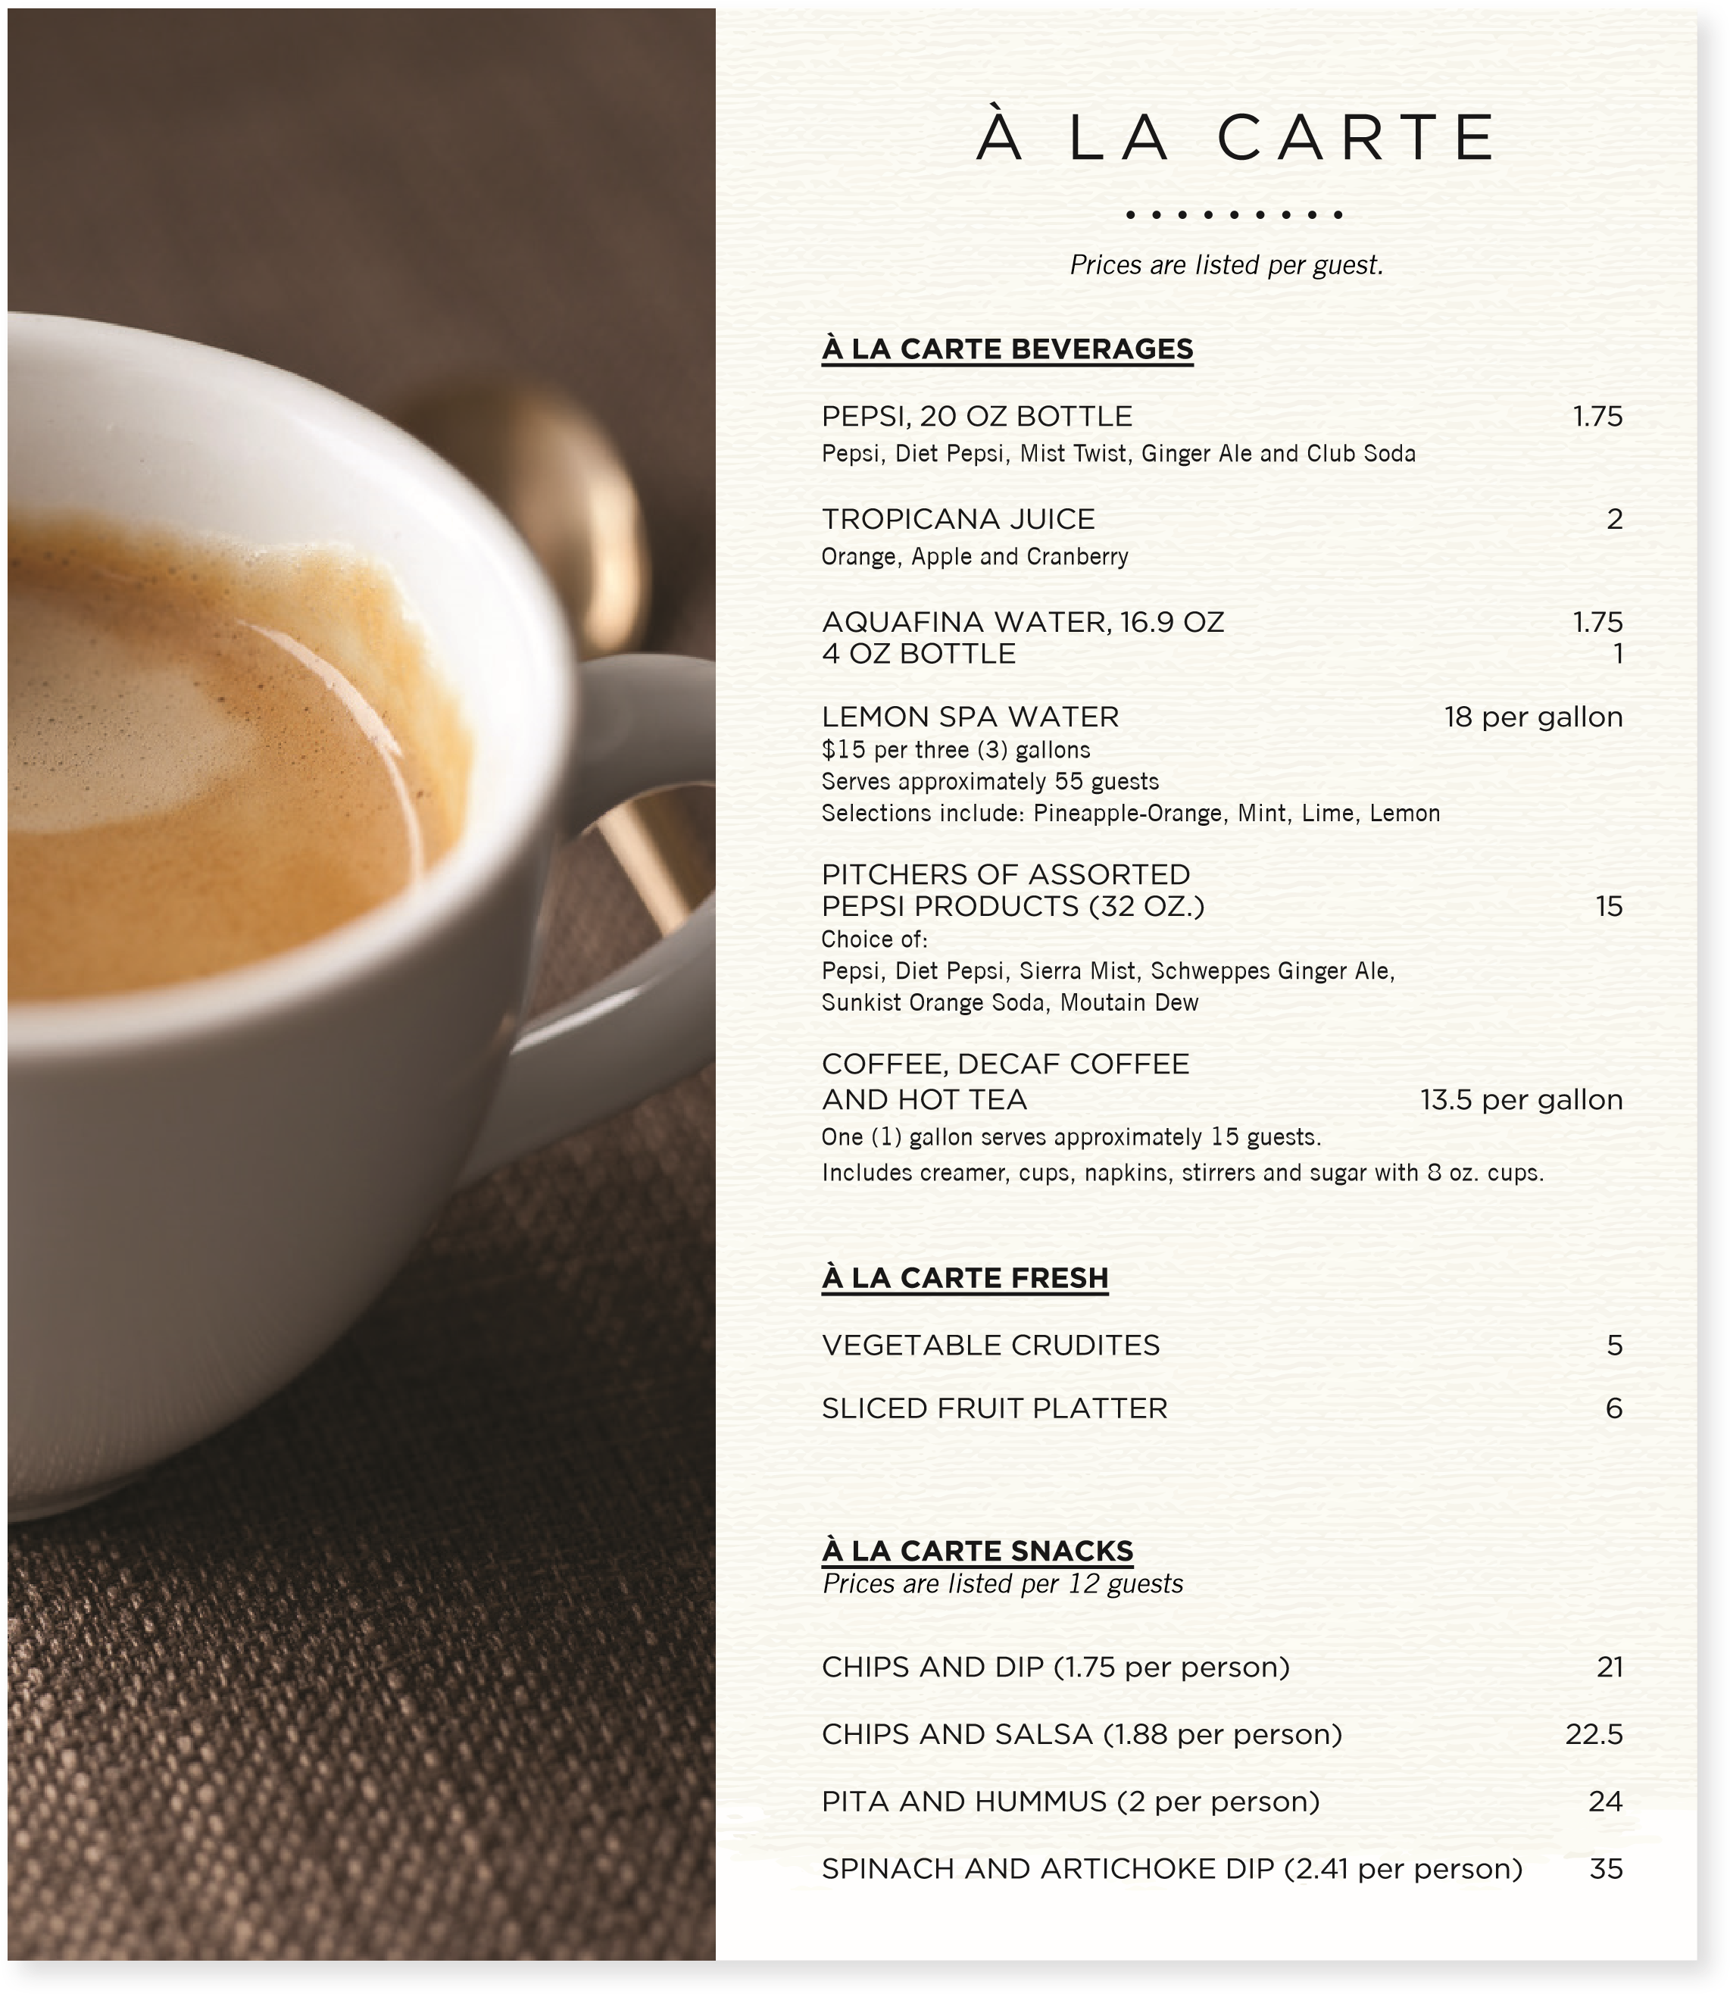
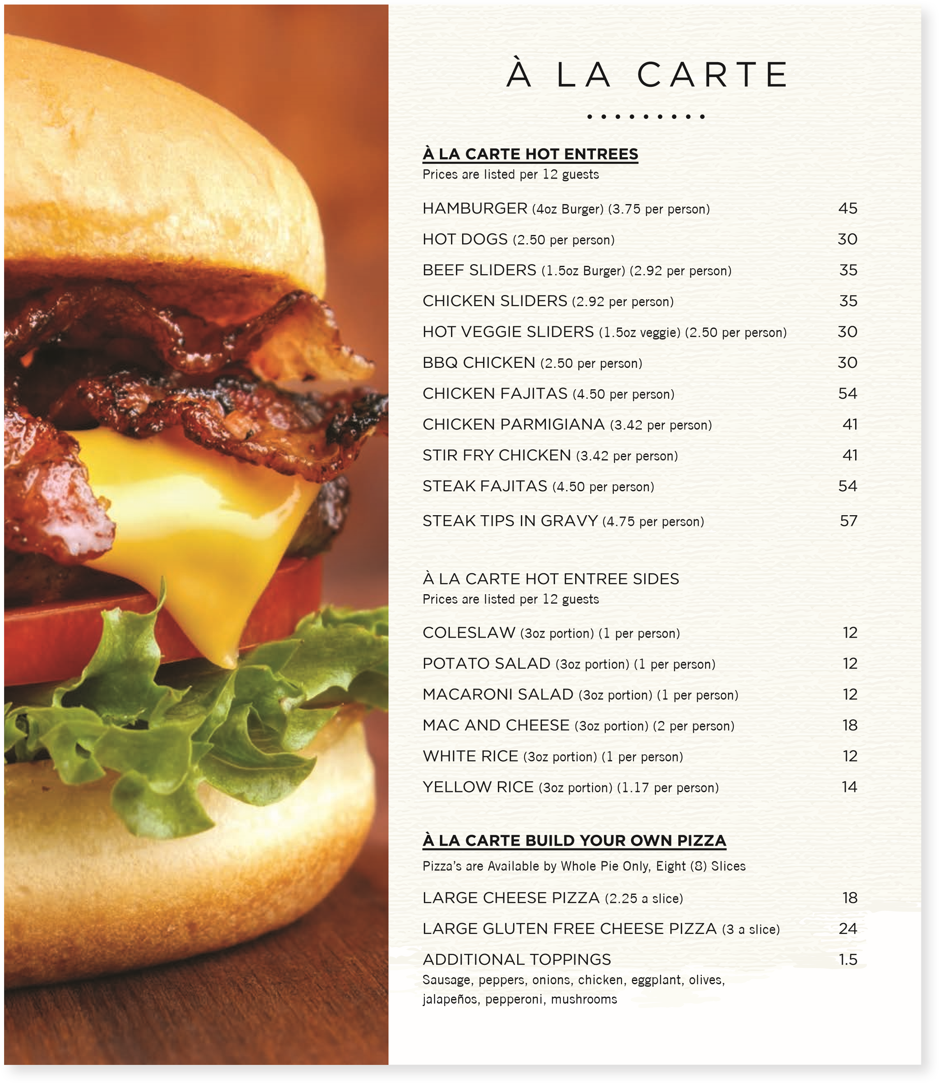

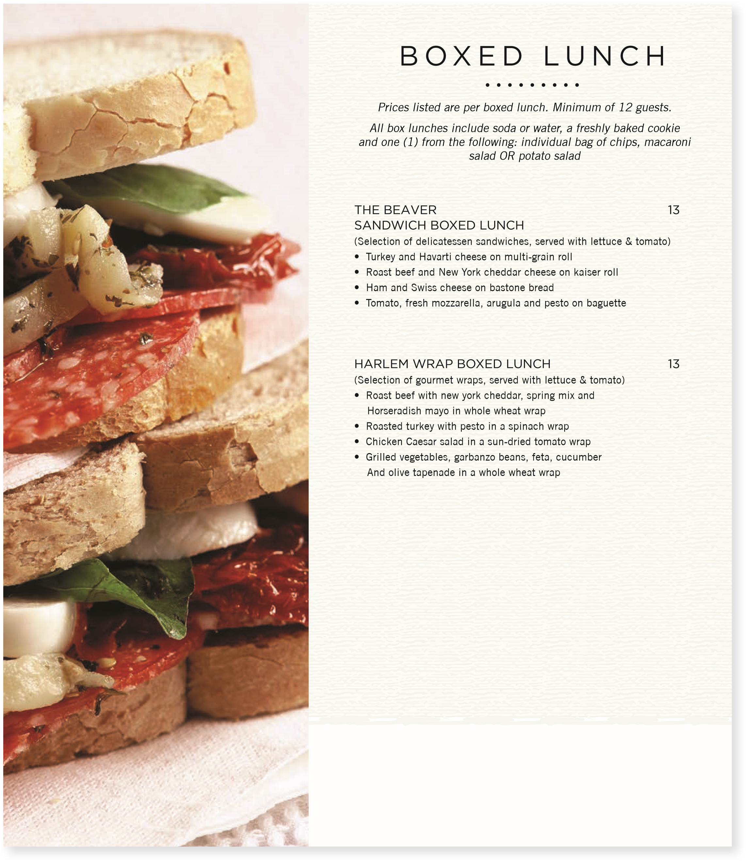
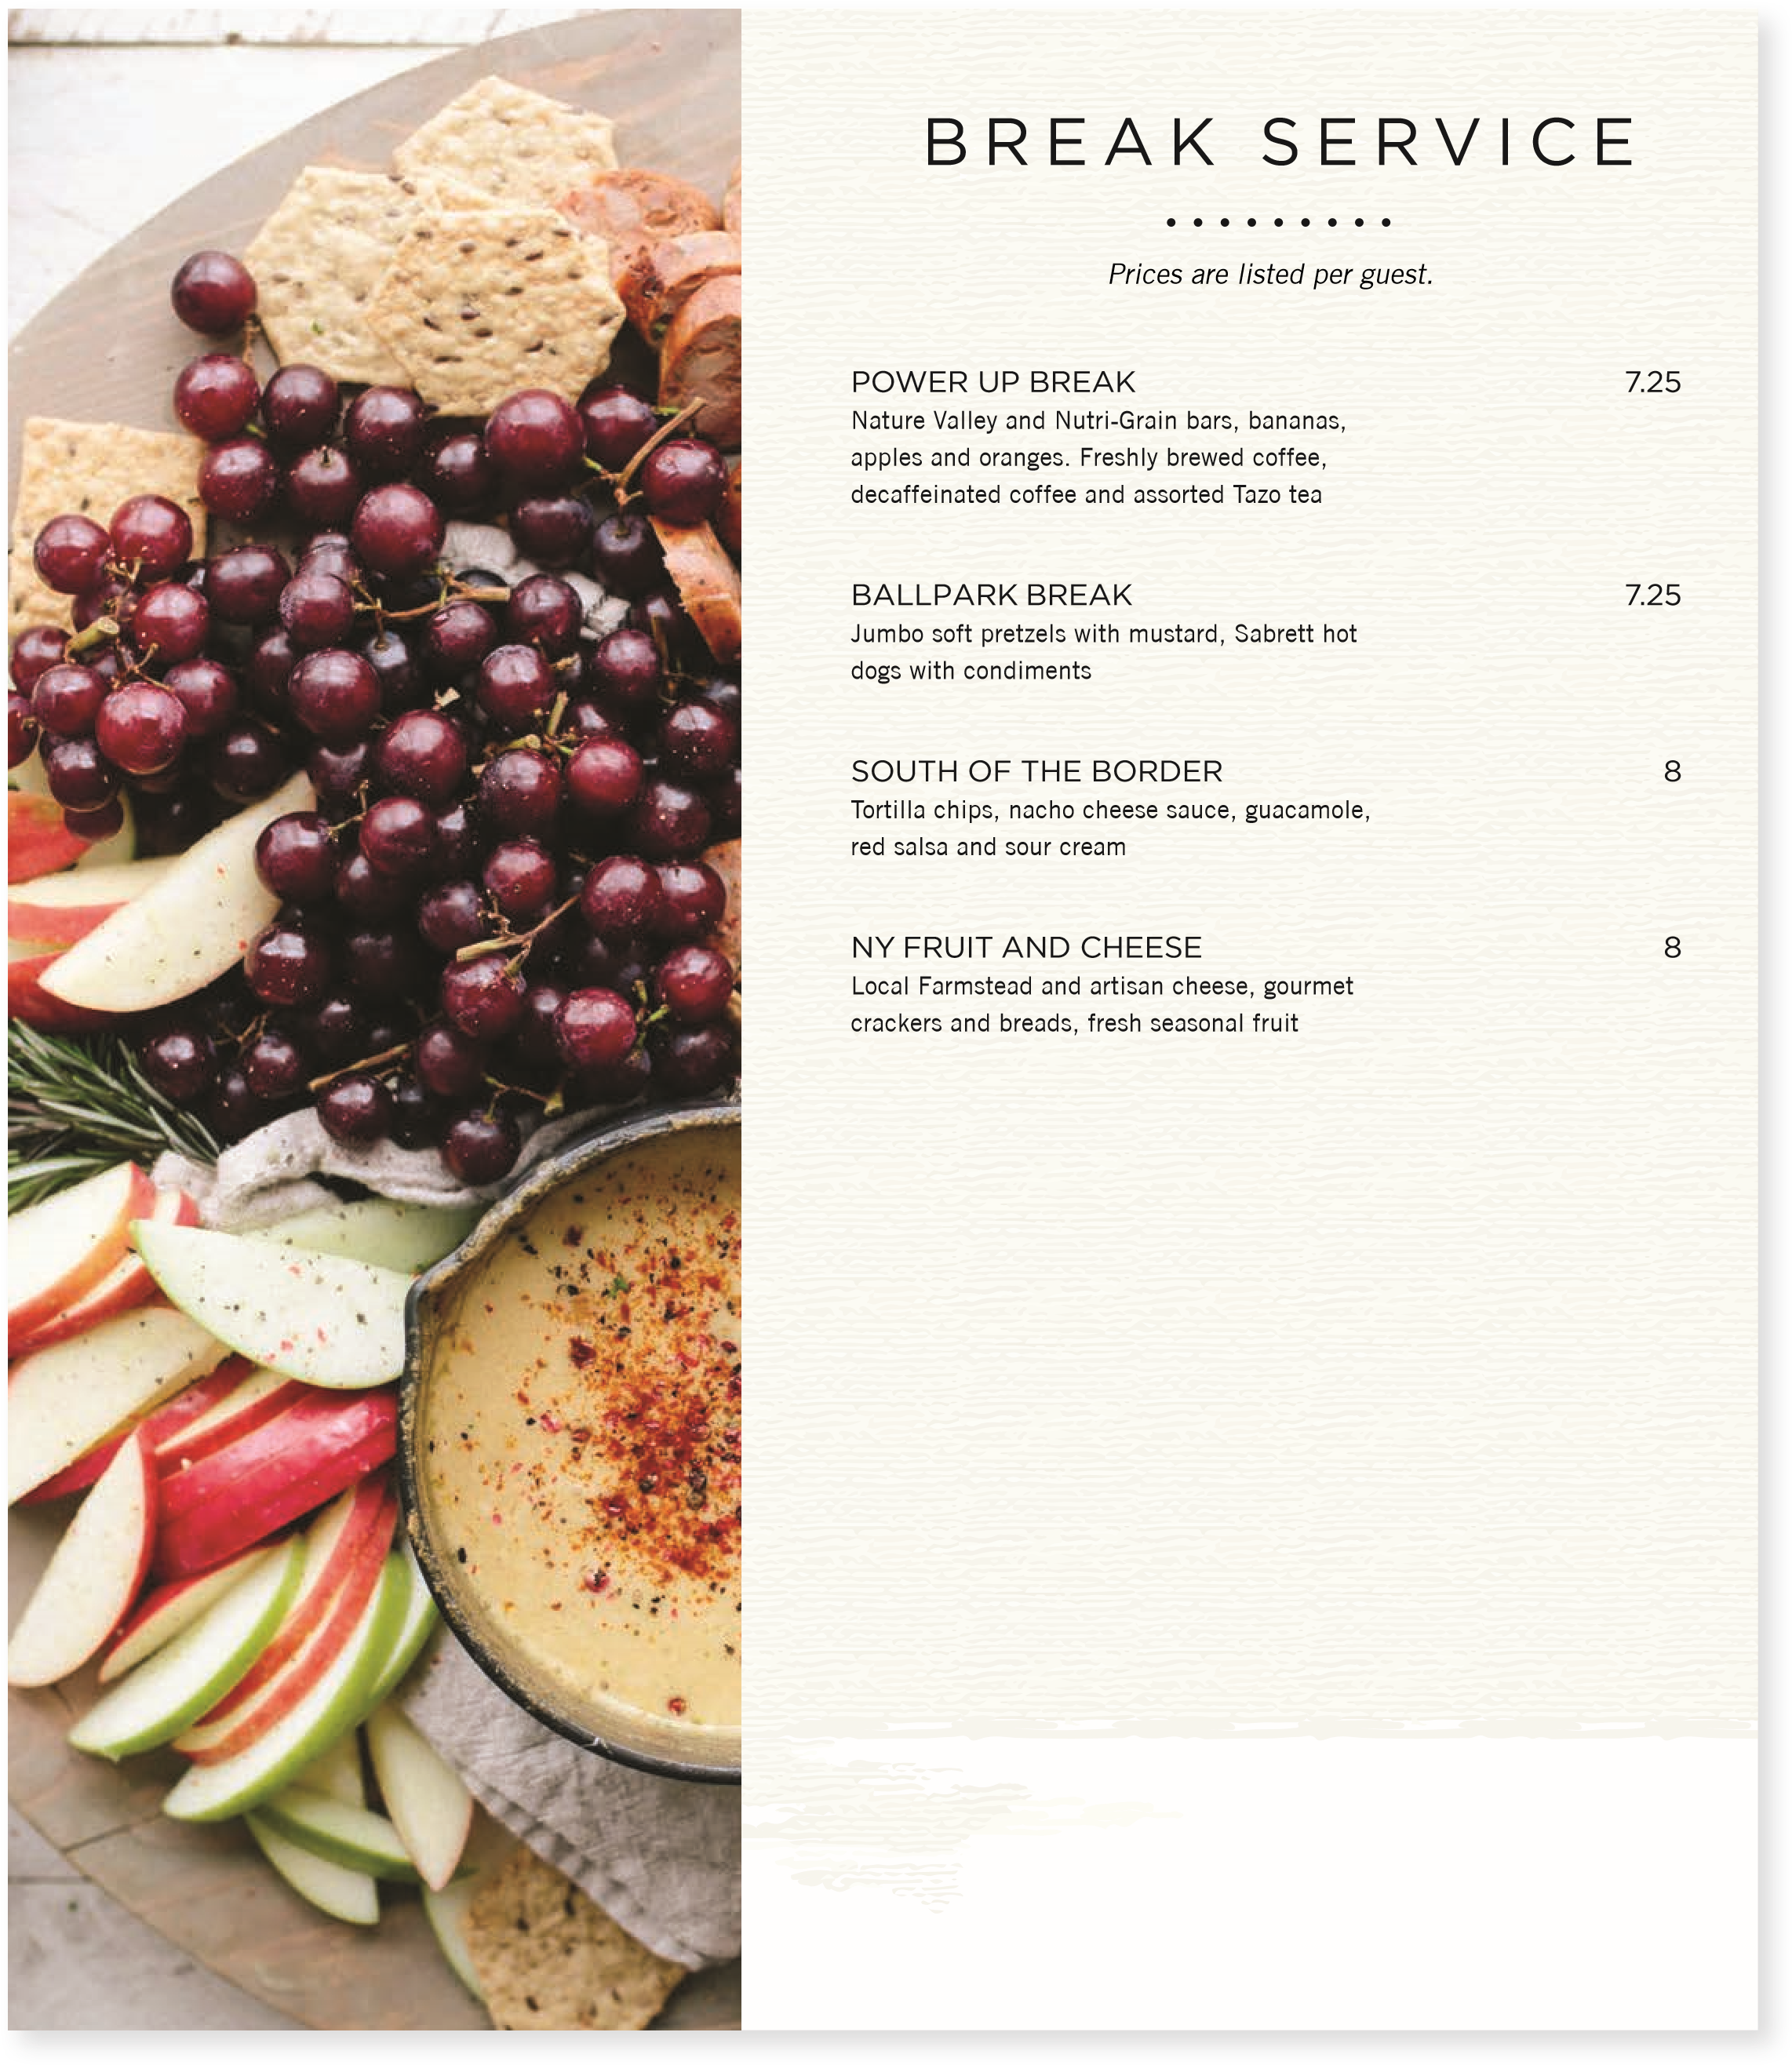
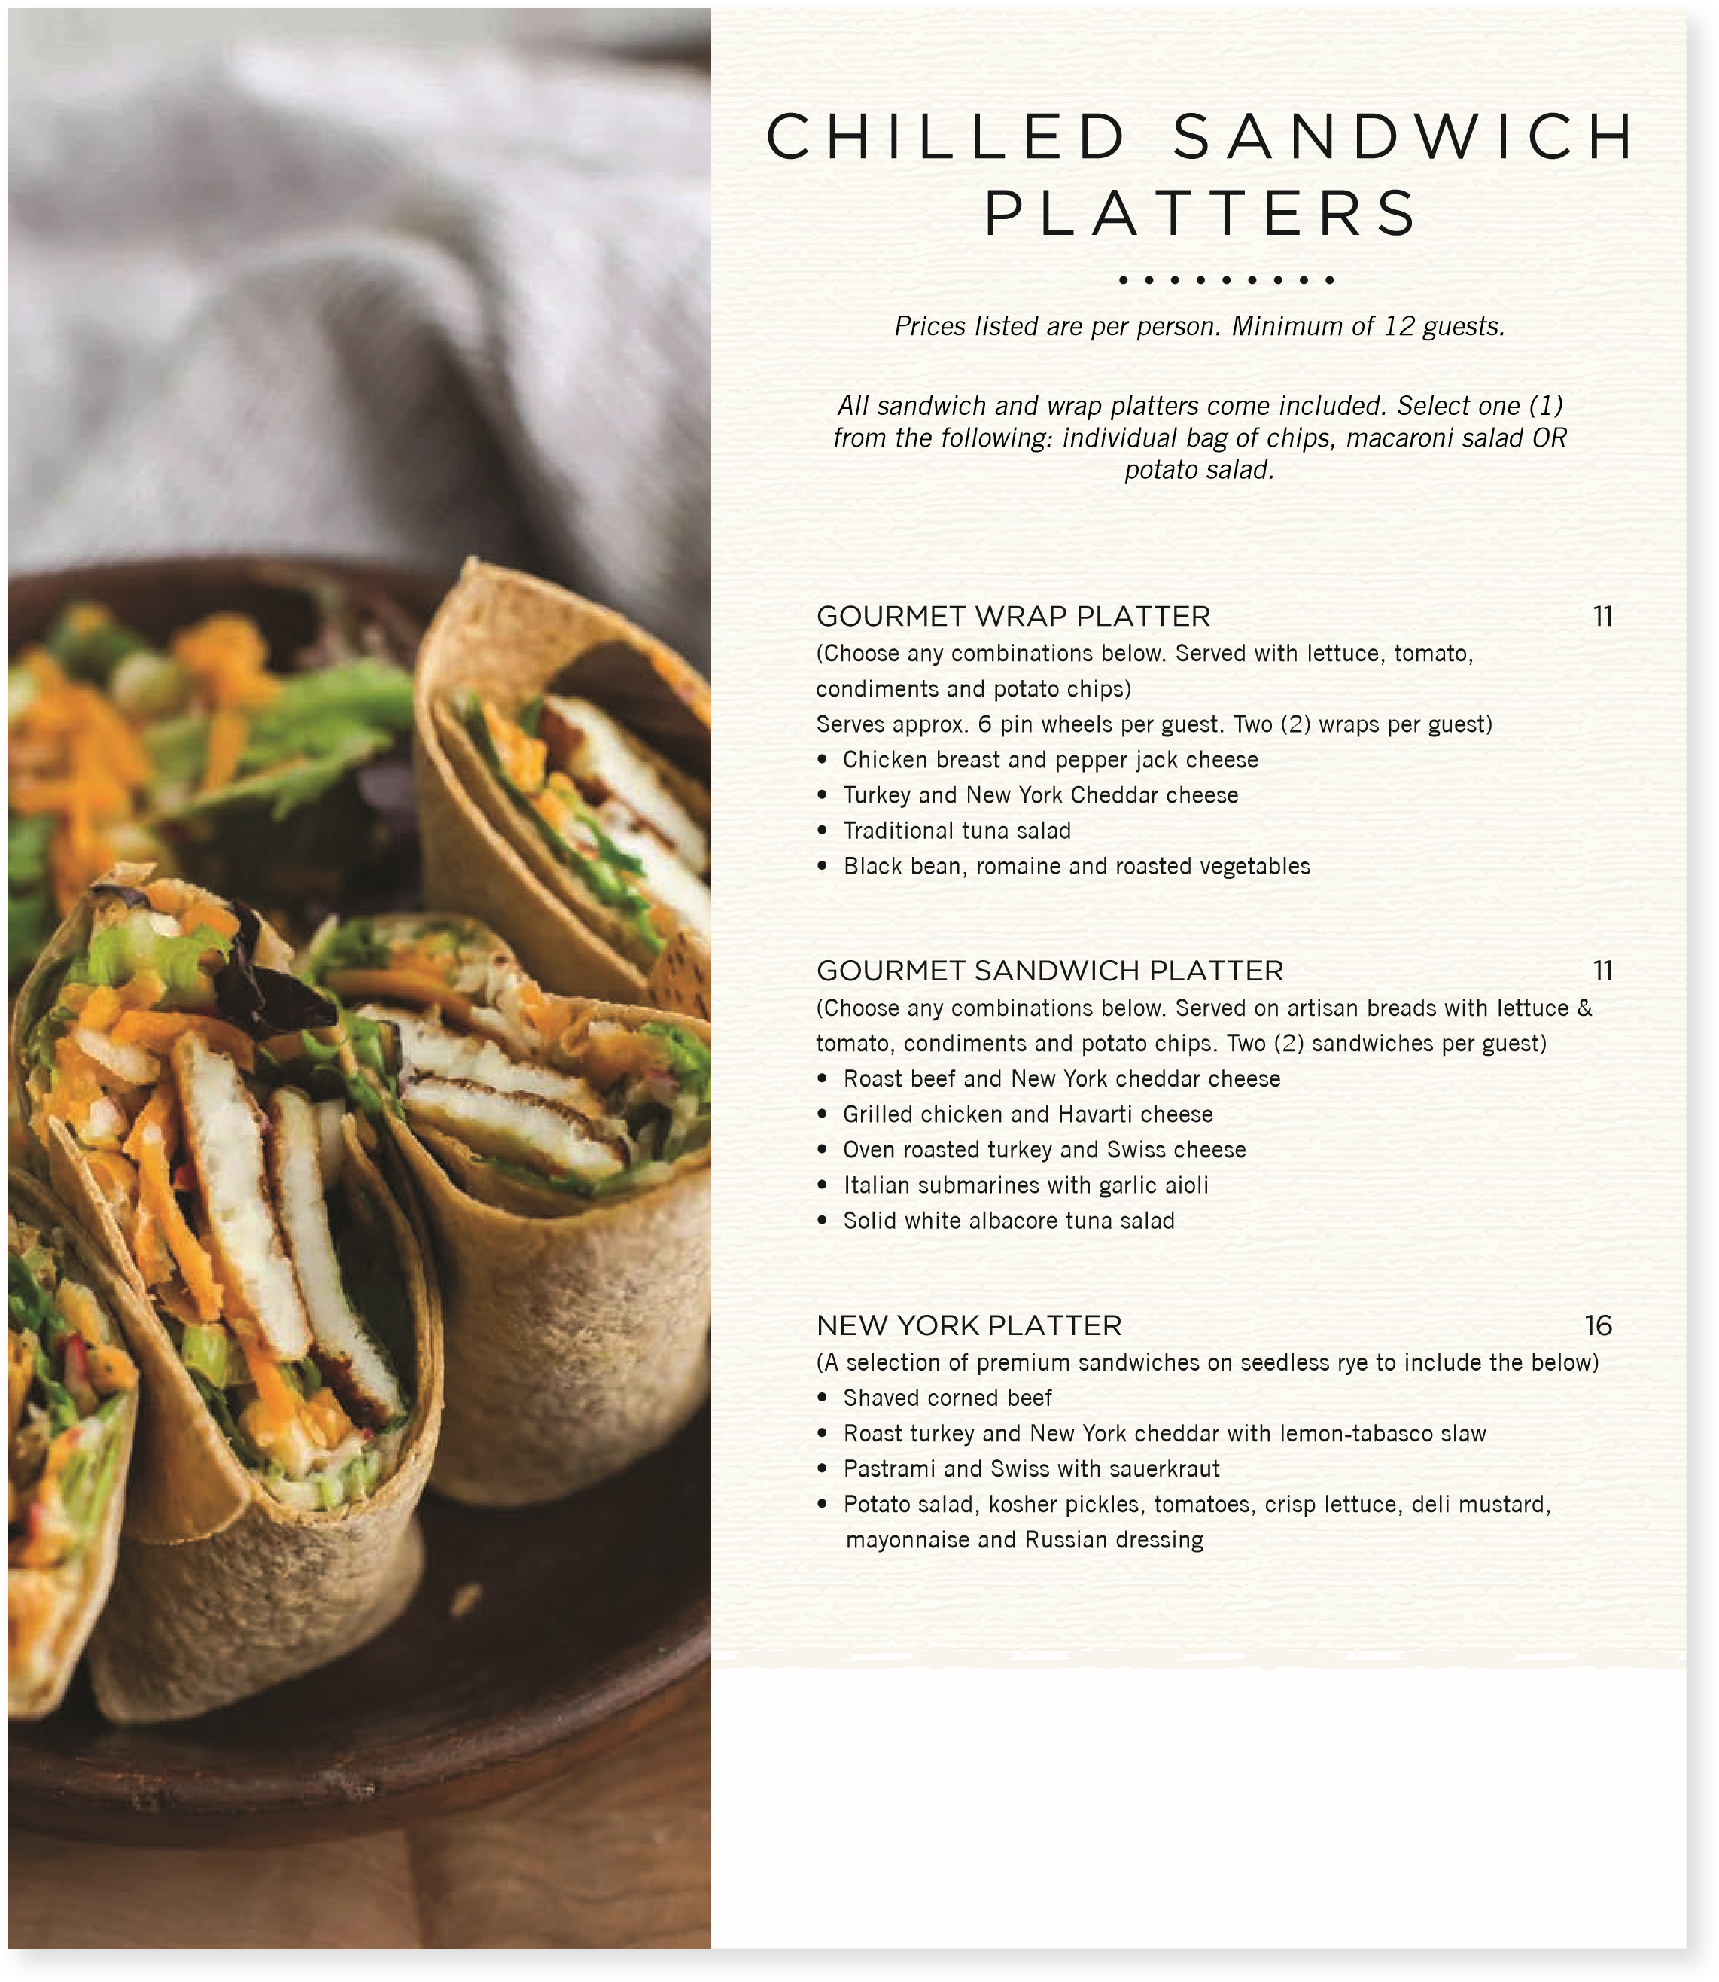

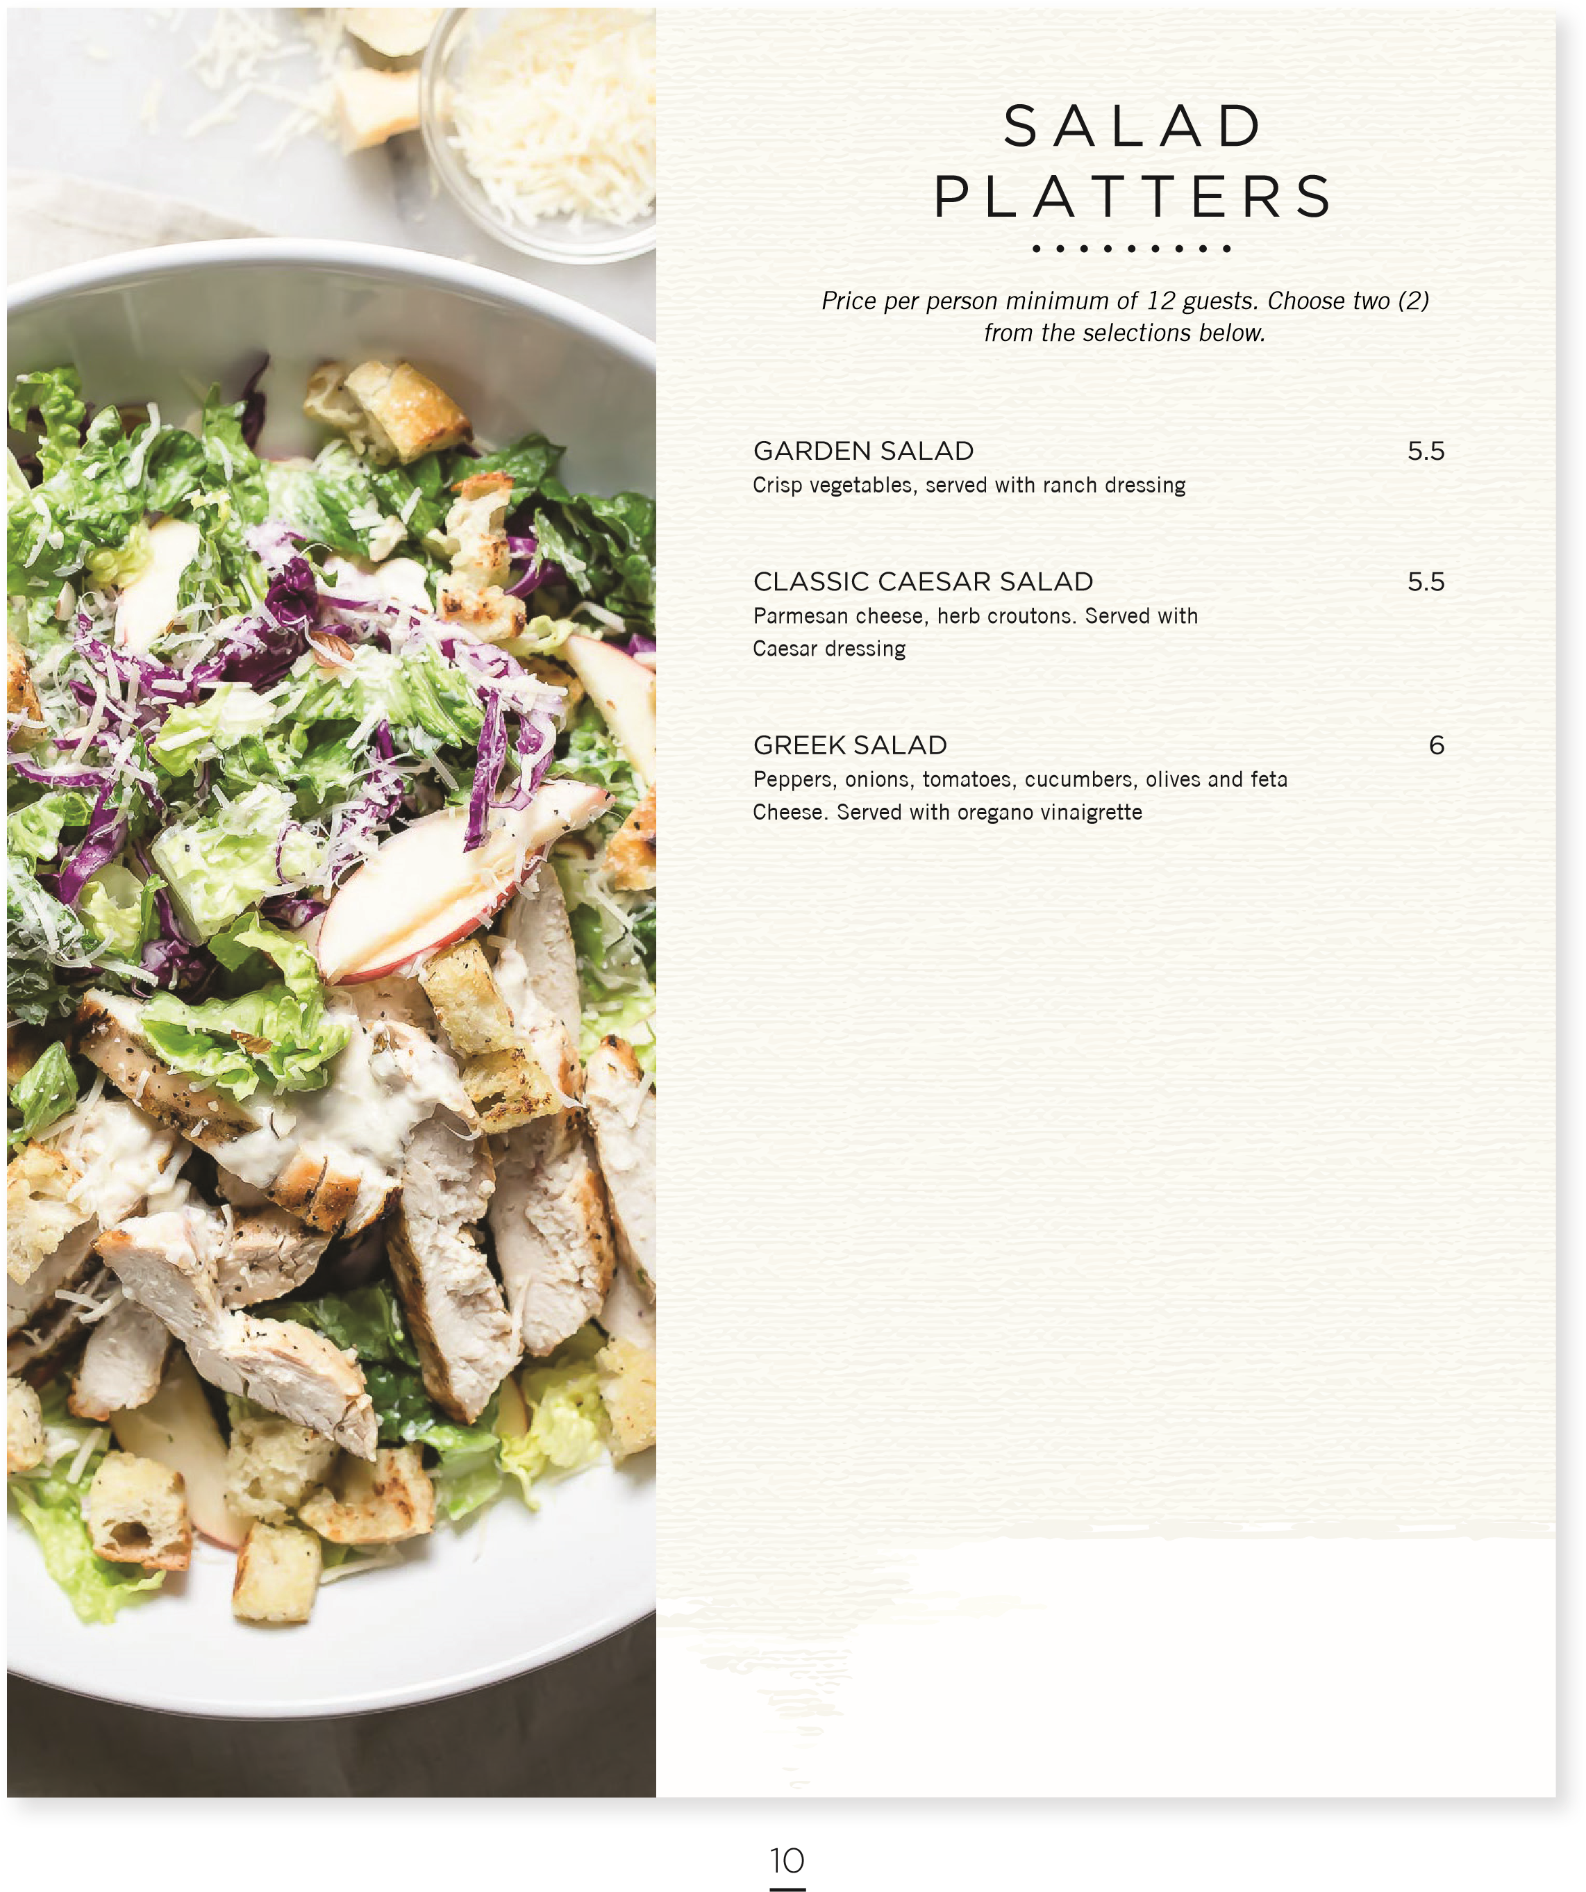
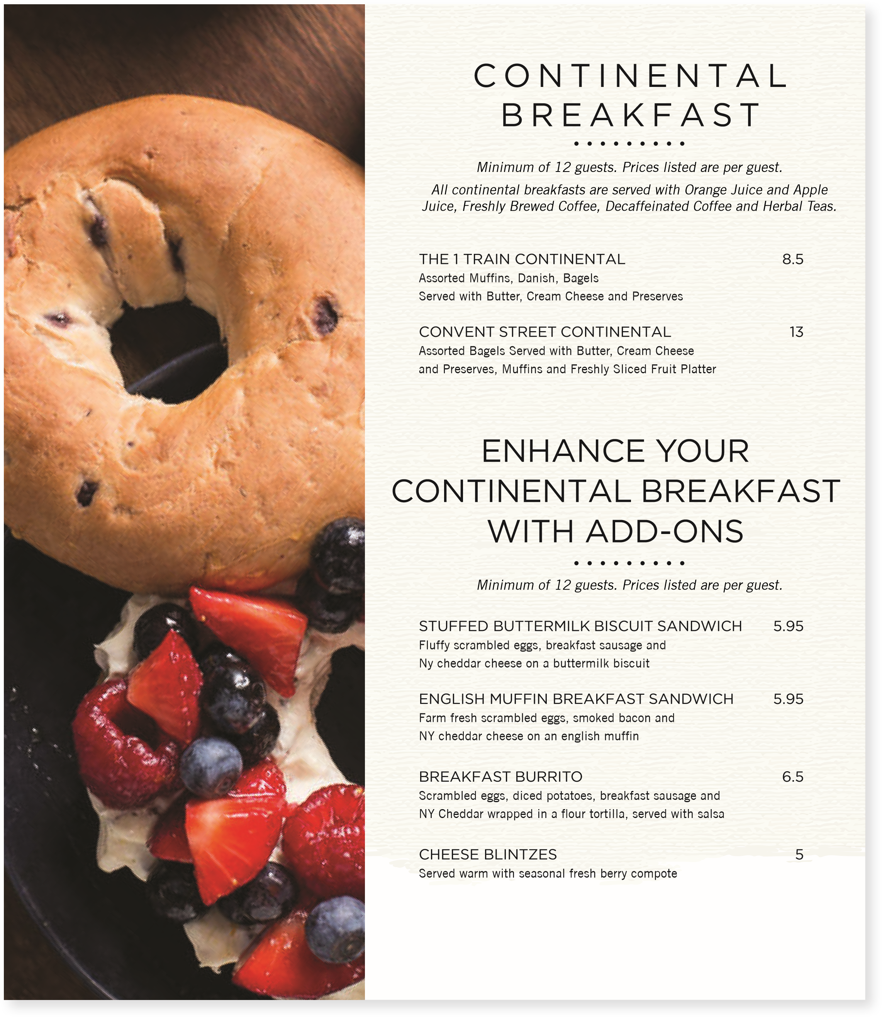
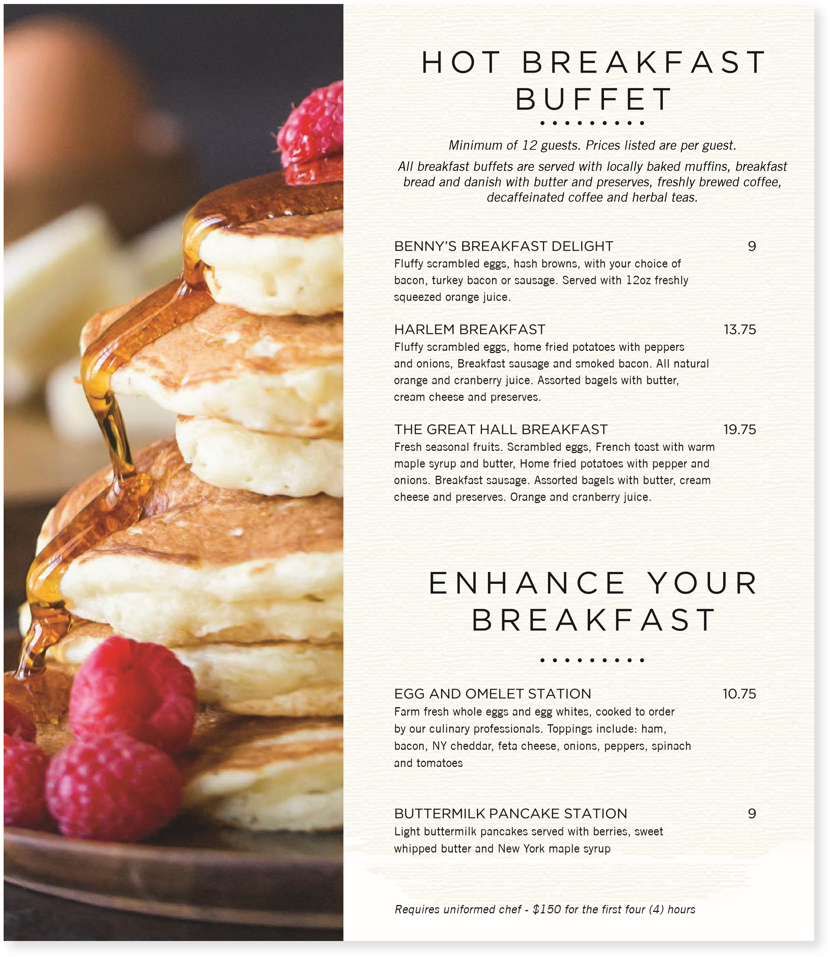

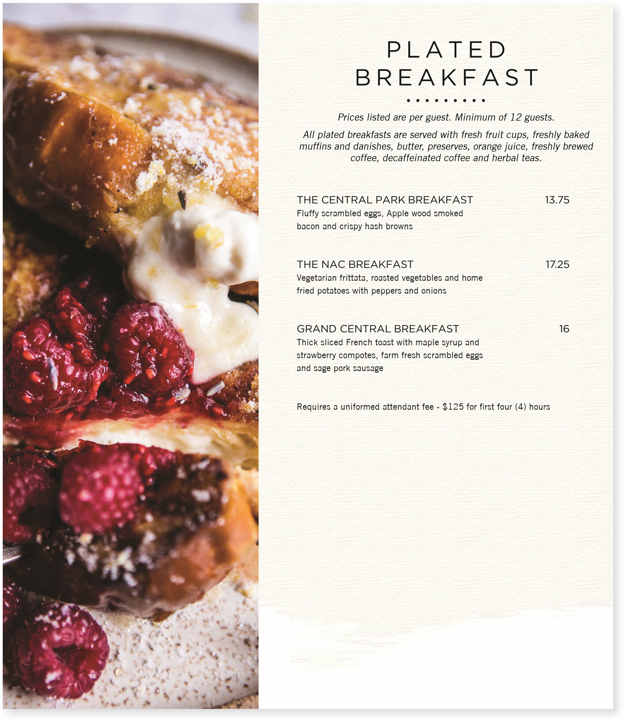
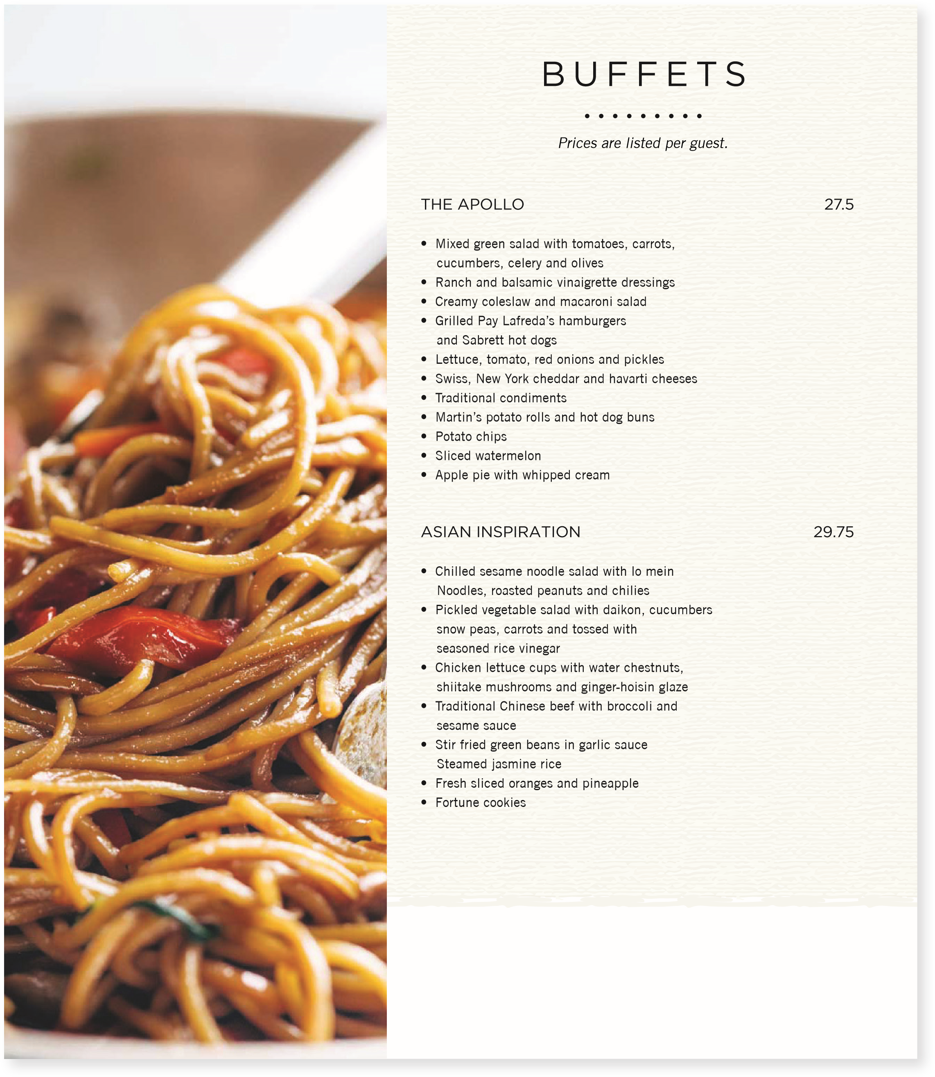
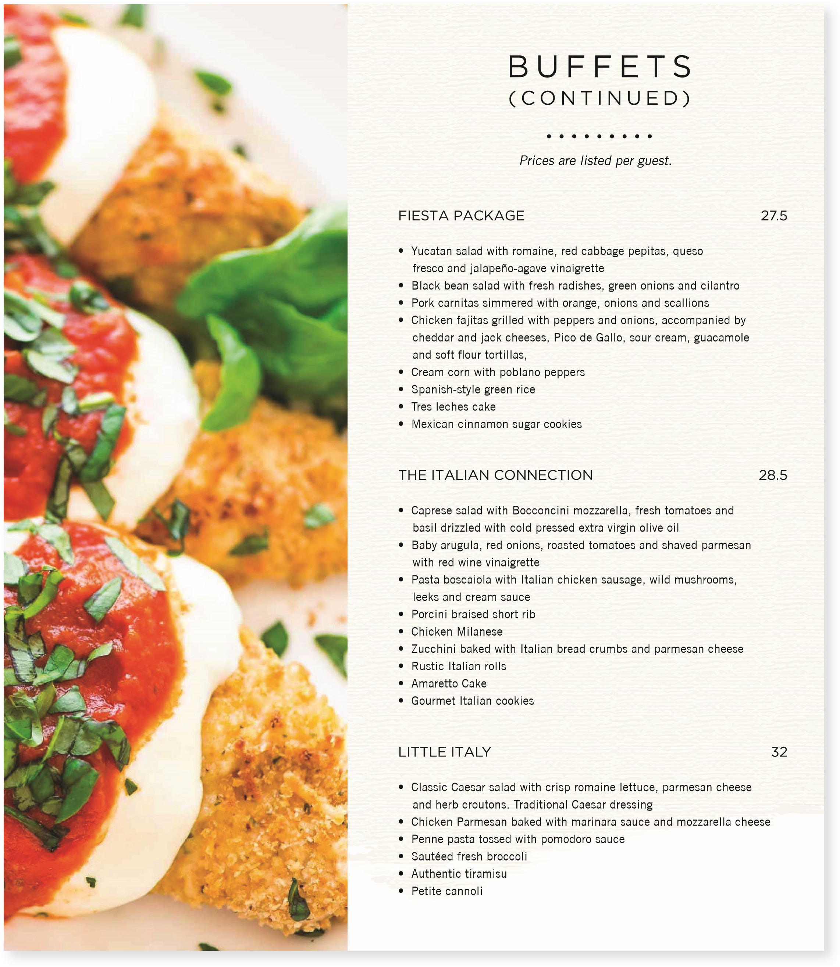
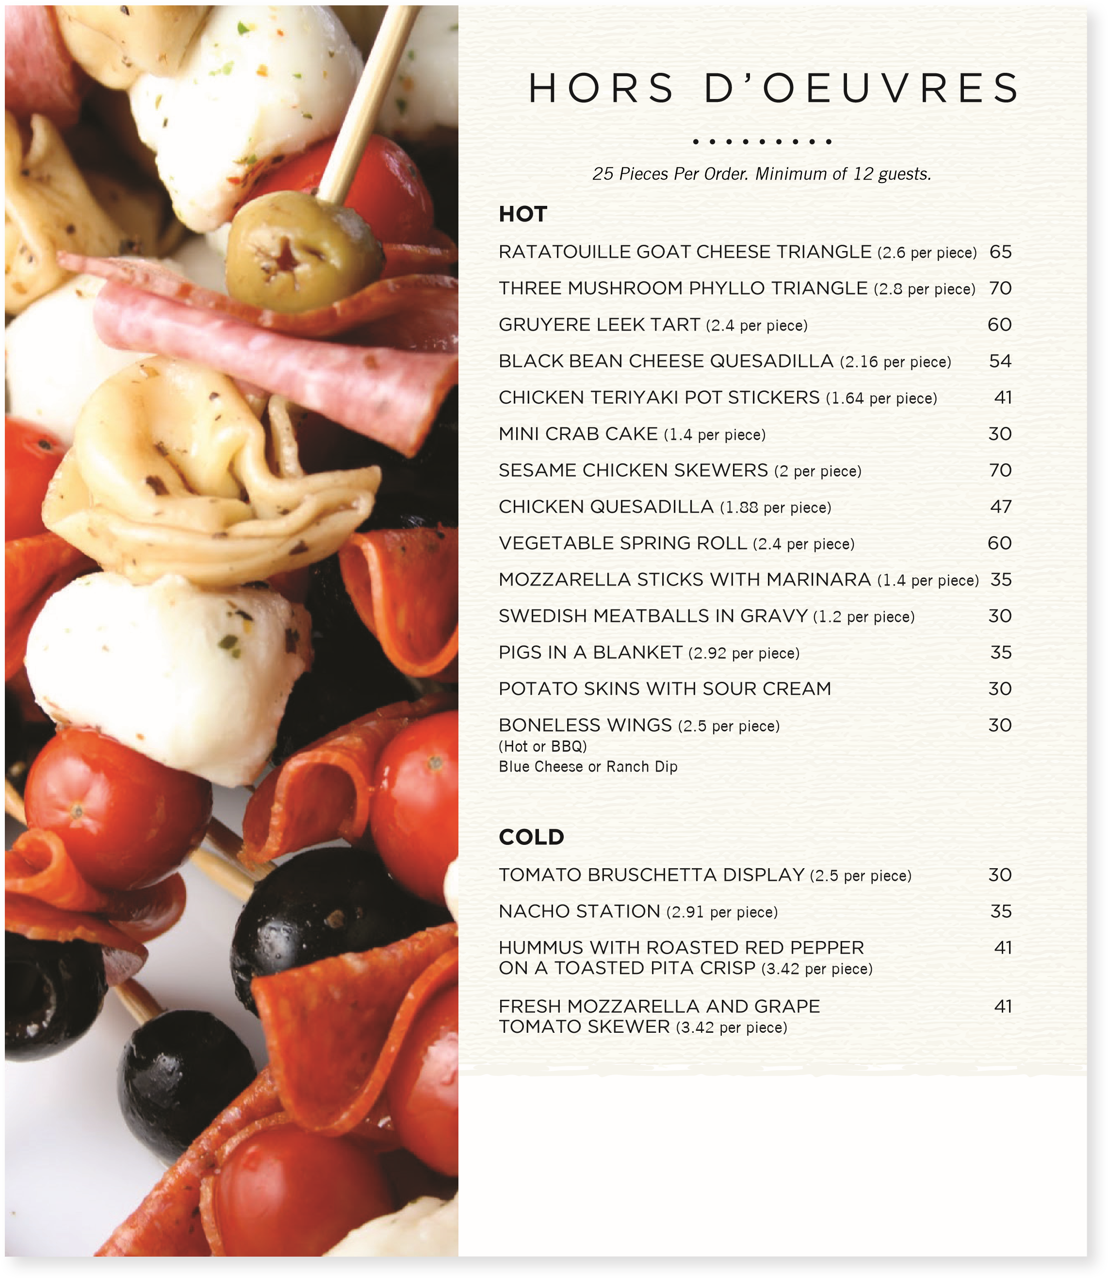

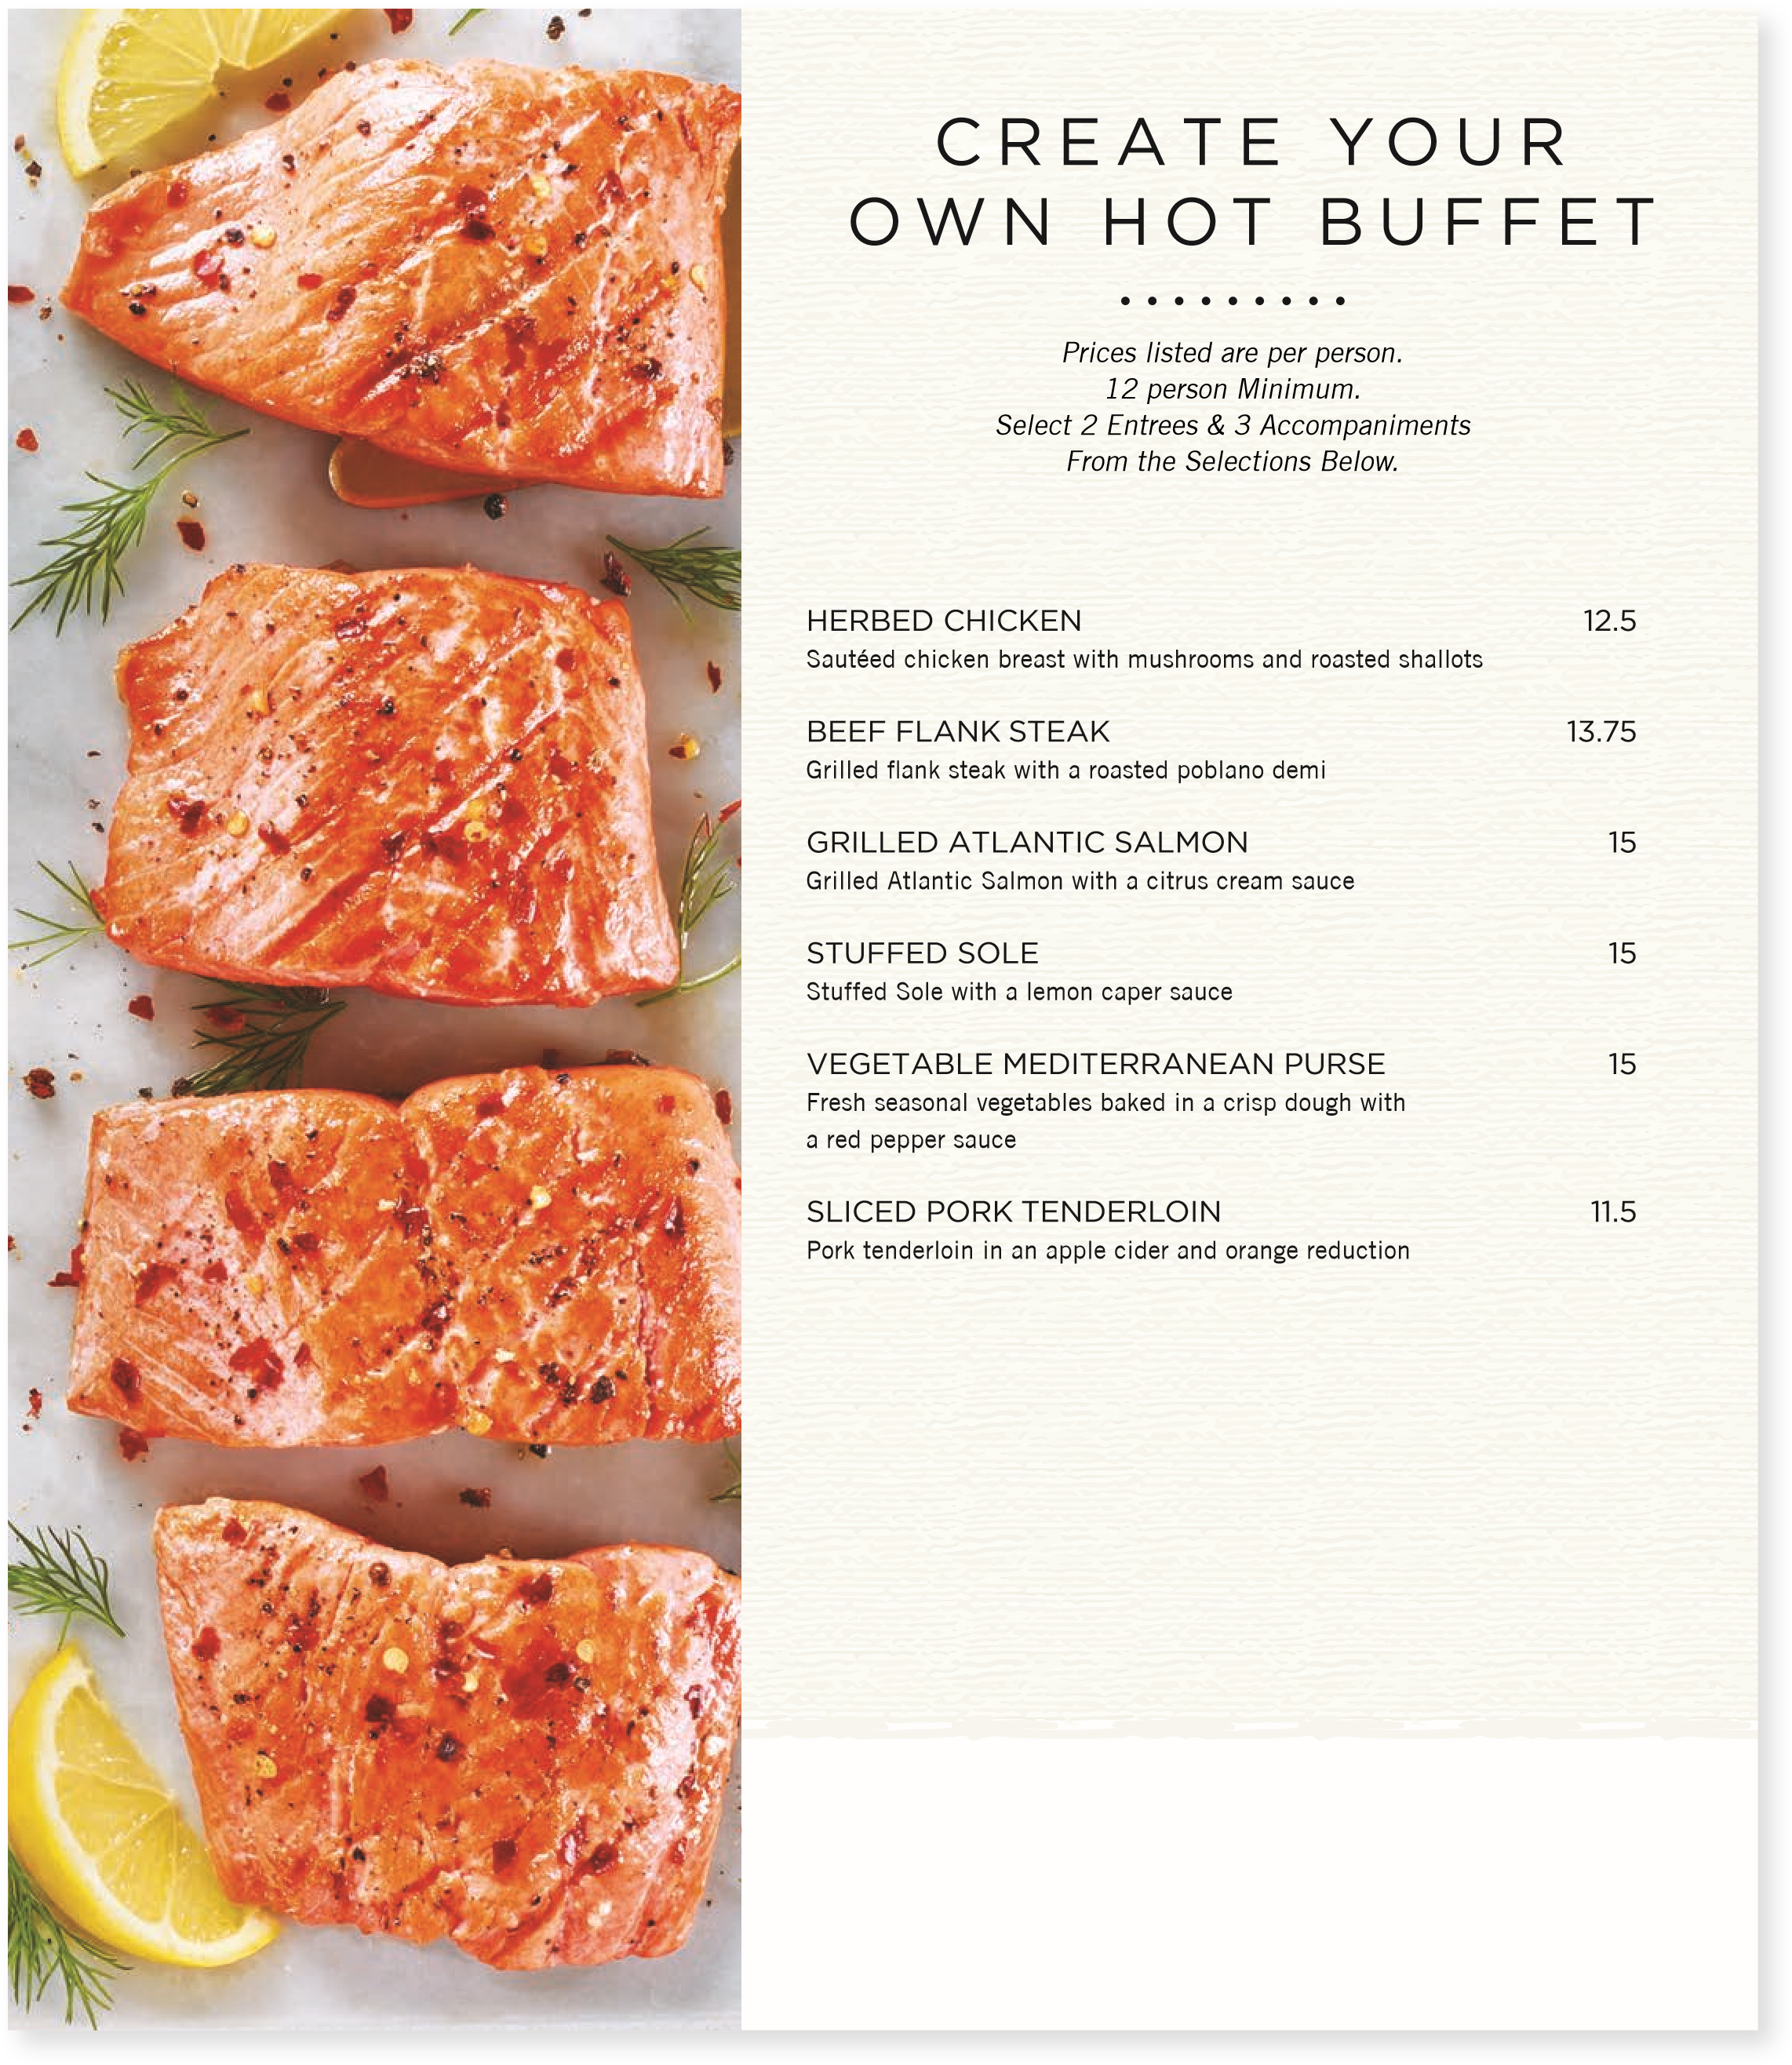
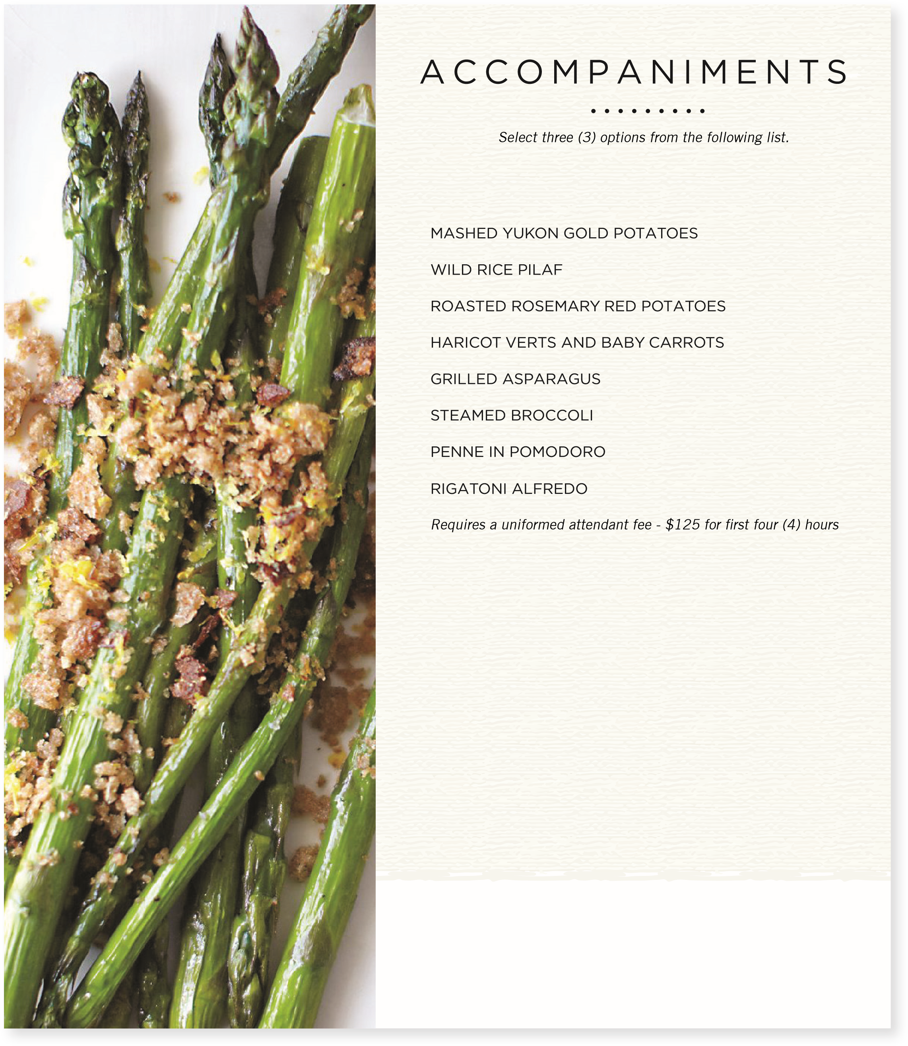
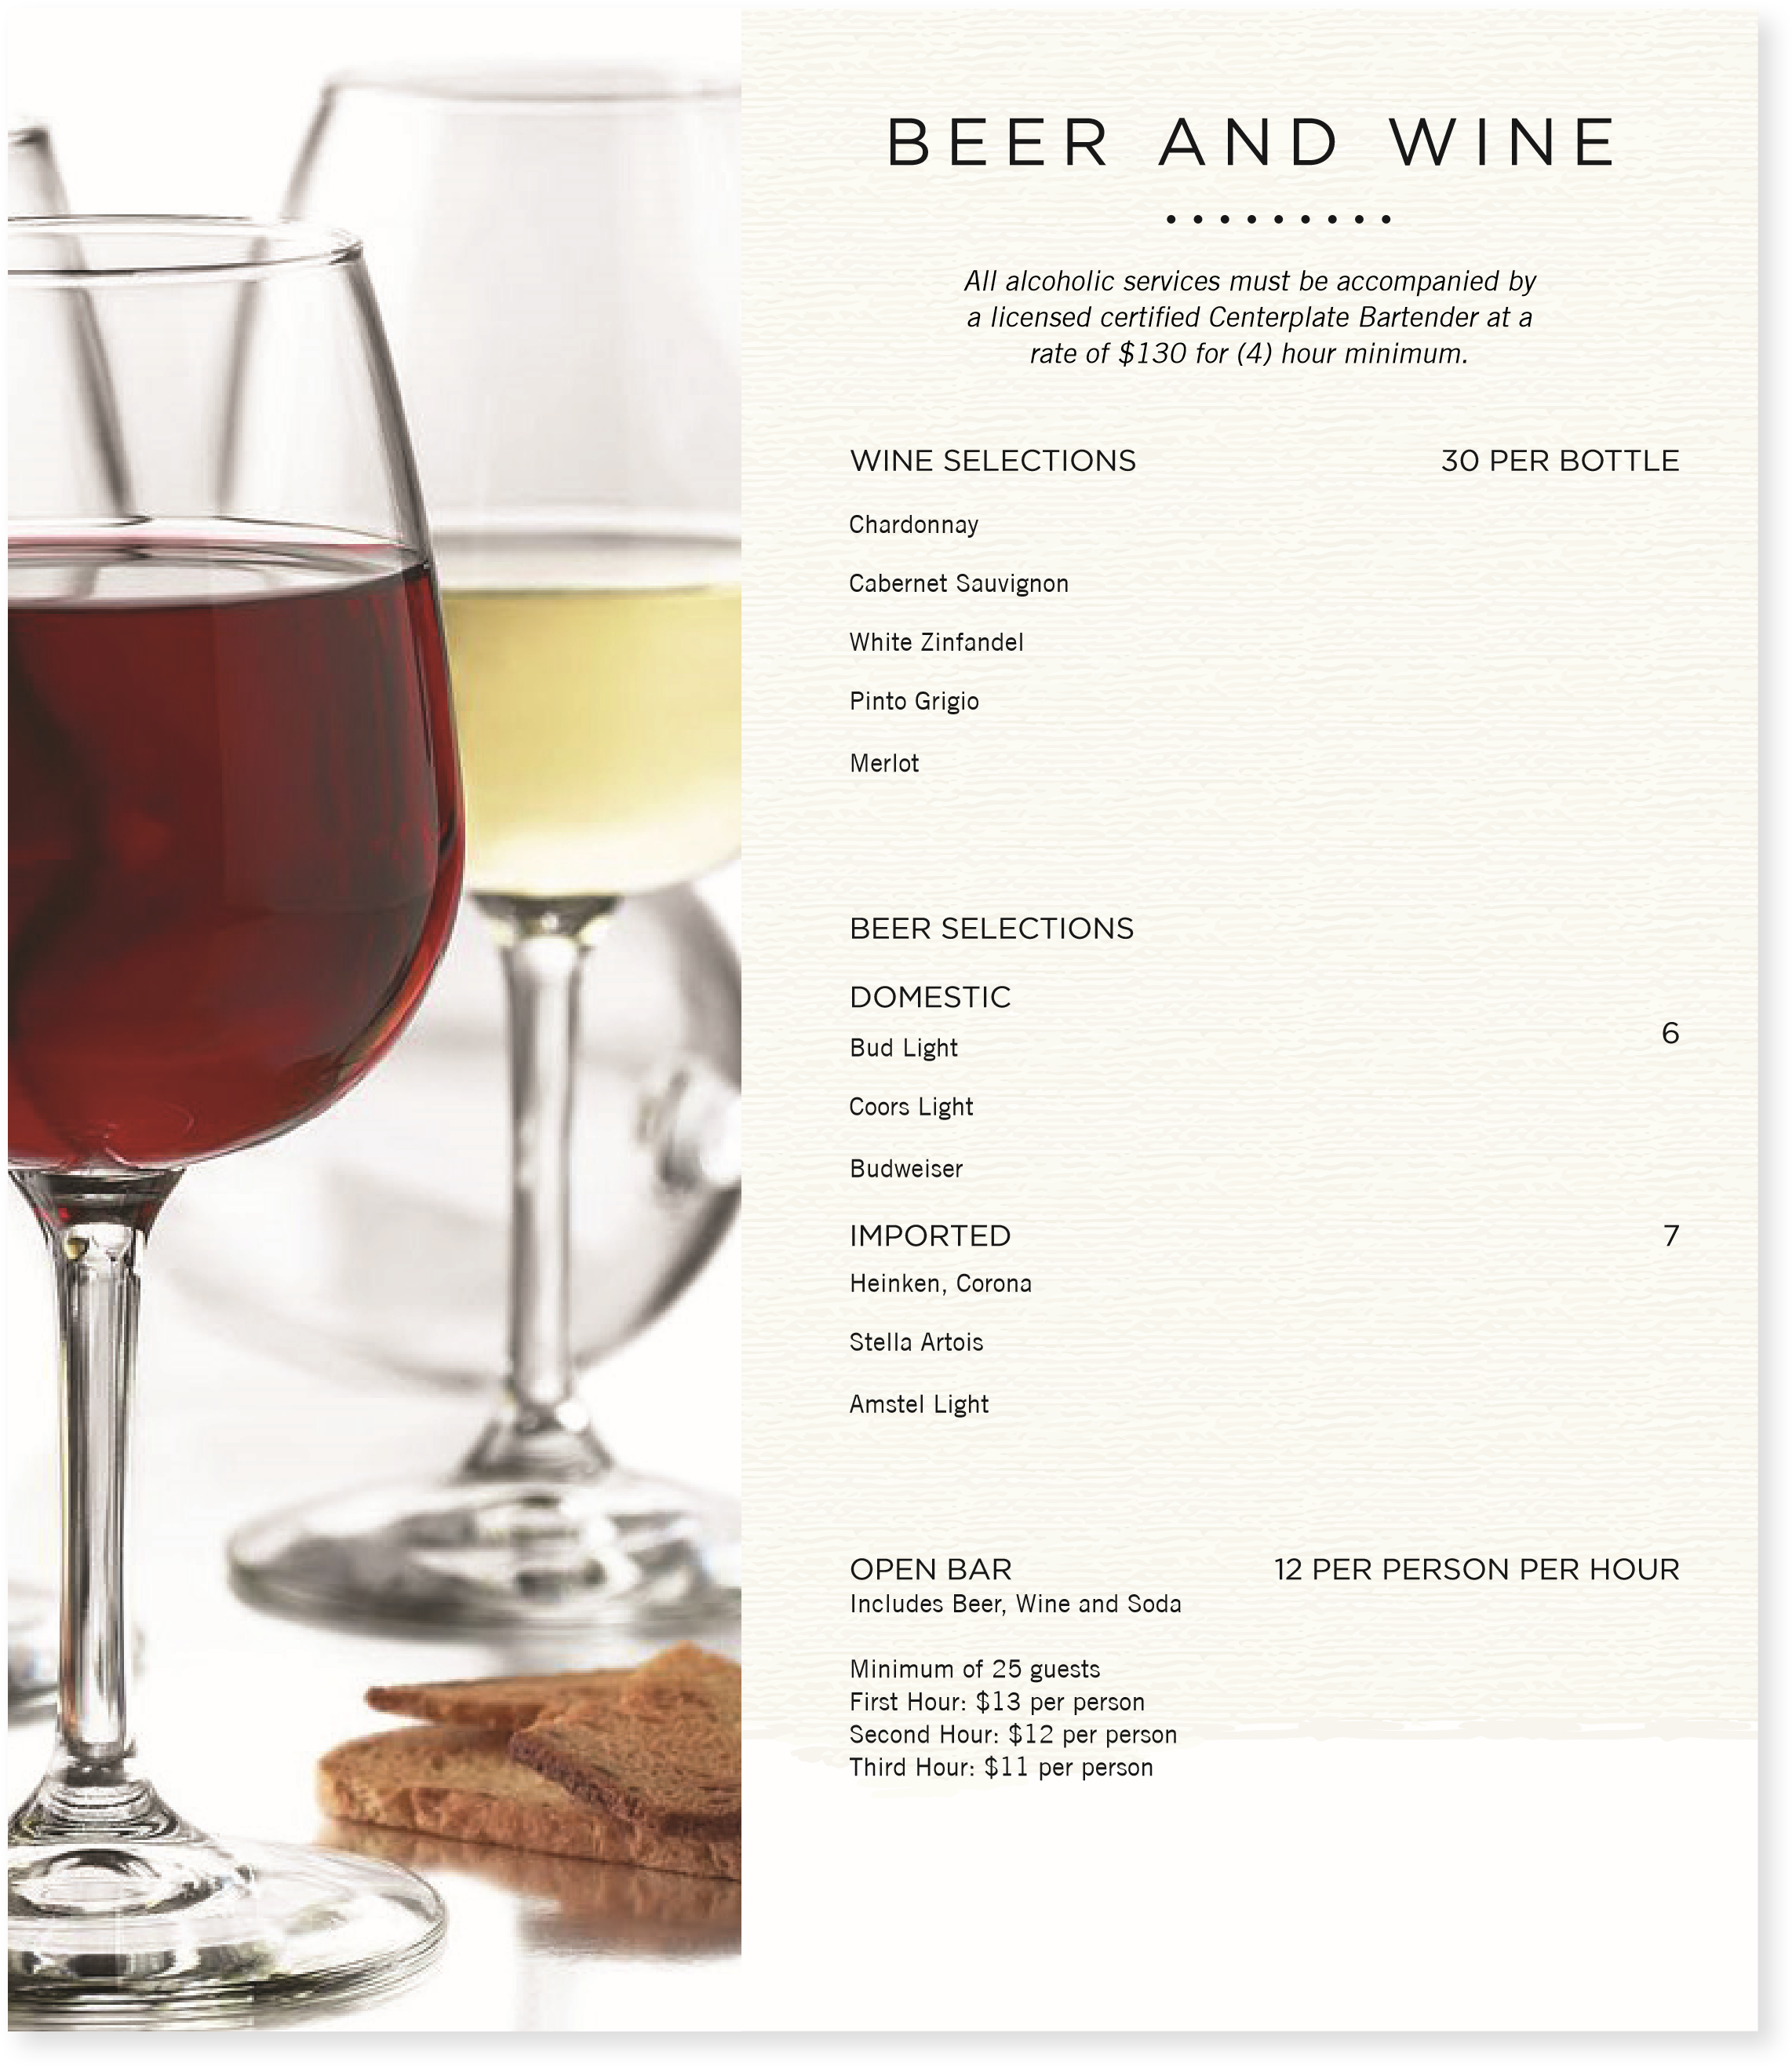

GENERAL INFORMATION

POLICIES AND SERVICES
Exclusivity:
Centerplate maintains the exclusive right to provide all food & beverage at The City College of New York.
Food & Beverage Pricing:
A good faith estimate of food & beverage prices will be provided upon request, up to 45 days in advance of the event;s start date and will be confirmed at the signing of the contract. Due to fluctuating market prices, however, we reserve the right to make product substitutions based on specific commodity price increases.
All menu prices listed are subject to change without notice.
Menu Selection:
Our knowledgeable Catering Sales Team is eager to assist you with your event planning, menu selection and to answer any questions or concerns. Even though our menus offer a wide variety from which to choose, your Catering Sales Manage, together with the Executive Chef, will be happy to design menus to suit your special occasion.
Contracts:
In order to execute your event, a signed copy of the Banquet Contract & Banquet Event Order (BEO) must be returned to Centerplate prior to any services being provided. The Signed contract, with its stated terms, constitutes the entire agreement between the client and Centerplate. In addition, full payment for all services must be received in advance of your first event.
Payment Policy:
The balance is required to be paid in full 30 days after rendered service. Open balances after the 30 days will be subject to a monthly interest rate of 1.5%. Please provide a credit card or check as the payment methods.
Linen Service:
Centerplate provides plastic in house linen for all meal functions with our compliments. Additional linen fees will apply for specialty cloth linens or linens required for meeting functions for events without food and/or beverage service. Your Catering Sales Manager will be happy to offer suggestions for your consideration and quote corresponding linen fees.
20

GENERAL INFORMATION

POLICIES AND SERVICES...CONTINUED
Holiday Service:
There will be an automatic additional labor fee for food and beverage service or preparatory days on the following federal holiday: New Year’s Eve and Day, Martin Luther King Jr. Day, Memorial Day, Independence Day, Labor Day, Thanksgiving Day, & Christmas Day. At the time of booking event(s), Centerplate will notify the customer of estimated labor fees based on the information supplied by the customer .
Delayed or Extended Service:
On the day of your event, if the agreed upon beginning or ending service time of your meal changes by 30 minutes or more, an additional labor charge will apply. Should you event require extended pre or post service or stand by time, often necessitated by high volume functions, an additional labor charge will apply.
Service Times:
In the event that the service period exceeds the above time frame, an additional labor charge of $25.00 per hour per wait staff will be applied. Should your event require extended pre or post service or stand by times or deviation from the standard set, an additional labor charge may apply.
Supplemental Staffing Fees:
Unless indicated otherwise, charges for the staffing of your function are included in the contract. Please note that a (4) hour minimum, per staff member applies. Rates are between 6:00AM and 6:00PM. Your catering sales manager will quote rates for events before 6:00AM and after 6:00PM.
Uniformed Attendant - $125.00 per four hours per attendant
Uniformed Bartender - $130.00 per four hours per bartender Uniformed Chef - $120.00 per four hours per chef
Sustainability:
Centerplate sources and utilizes the finest and freshest ingredients to create first class dining experiences. Centerplate supports regional based vendors and farms to incorporate local, seasonal items whenever possible. Centerplate partners with community based organizations to minimize the waste of leftover items that provide for New York’s underserved. Centerplate offers full china service or appropriate compostable and recyclable service ware at every food and beverage event. Certain parameters shall apply for specific event locations, including additional costs if necessary.

GENERAL INFORMATION

POLICIES AND SERVICES
Alcoholic Beverage Guidelines:
Please ask your Catering Sales Manager.
Cancellation Policy:
For cancellation of contracted services less than one (1) week prior to the event, Centerplate is reimbursed for any and all labor and unrecoverable product expenses incurred in conjunction with planning for the event. Any event cancelled less than seventy two (72) business hours prior to the event will forfeit the 100% deposit.
Guarantees:
The Customer shall notify Centerplate, no less than five (5) business days (excluding holidays and weekends) prior to the Event, with the minimum number of persons the Customer guarantees will attend the Event (the “Guaranteed Attendance”). There may be applicable charges for events with minimal attendance based on the service selected. If Customer fails to notify Centerplate of the guaranteed attendance within the time required, Centerplate shall prepare for and provide services to the persons attending the Event on the basis of the estimated attendance specified in the BEO’s, and such estimated attendance shall be deemed to be the Guaranteed Attendance. Centerplate will be prepared to serve five percent (5%) above the Guaranteed Attendance, up to a maximum of 30 meals (the Overage).
22

OUR PROMISE TO YOU

MAKING IT BETTER TO BE THERE®
As a leader in event hospitality, Centerplate is committed to welcoming guests to moments that matter at more than 300 premier sports, entertainment, and convention venues worldwide. From Super Bowl 50, to the U.S. Presidential Inaugural Ball, to the winning of the Triple Crown, we are committed to making the time people spend together more enjoyable through the power of authentic hospitality, remarkably delivered.
Thank you for giving us the opportunity to be a part of your next favorite story.

