Amount Only Requisition Lines

To make a line on a requisition an Amount Only line, click on the Line Details icon, place a check mark on the Amount Only check box, click Ok and finally click on Yes.

REMEMBER: Amount Only Lines on a requisition are for services only. E.g. telephone bills, maintenance
services, Etc.

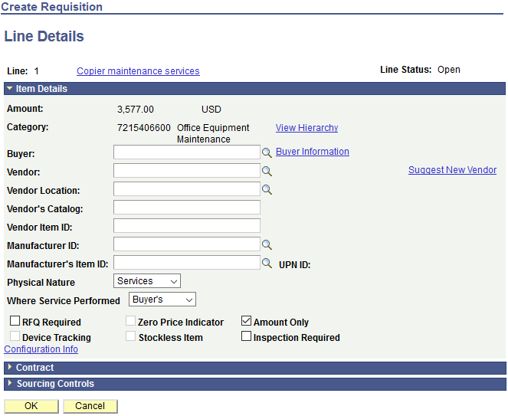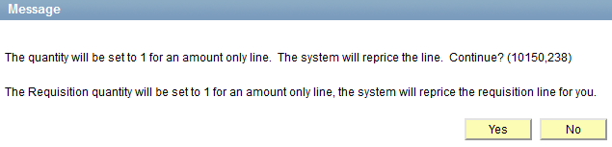Making an Amount Only requisition line offers flexibility to the requester when creating receipts

Last Updated: 6.7.19 | Page 22 of 29

