Budget Overview Query

BUSINESS OBJECTIVE: Requesters must run the Budget Overview query in CUNYfirst to confirm the general availability of funds prior to creating a requisition. This query provides summarized budgetary data required for acquiring goods or services. It also enables colleges to manage their budgets effectively throughout the year and at year-end.

STEP#1: From the Enterprise Menu, click on the Financials Supply Chain link. Navigate to: Reporting Tools >

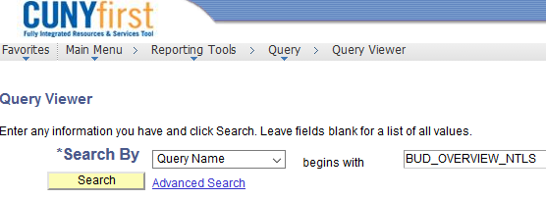Query > Query Viewer. Search for Query Name ‘BUD_OVERVIEW_NTLS’ and click on Search.

STEP#2: Click Run to Excel link.

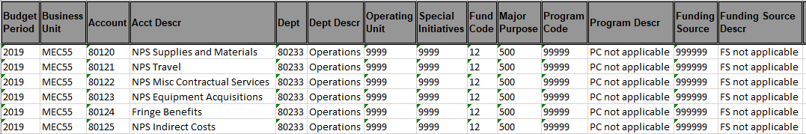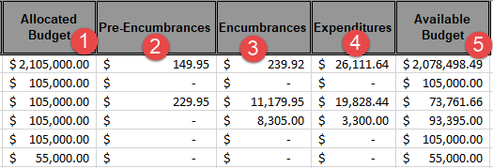

STEP#3: Enter applicable parameters and click on View Results, see example below:

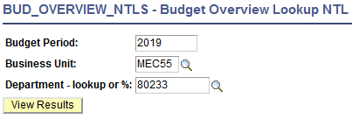STEP#4: Open the query output file with MSFT Excel. Sample Data:

Allocate Budget – Funds assigned to a department.

Pre-Encumbrances – The sum of all fully approved and successfully budget checked requisitions. Encumbrances – The sum of all successfully budget checked Purchase Orders.
Expenditures – The sum of all successfully paid expenses (ex. vouchers, expenses reports). Available Budget – remaining funds available to a department.

