Canceling Receipts

BUSINESS OBJECTIVE: At times, receipts need to be canceled due to entering incorrect information or making a mistake.

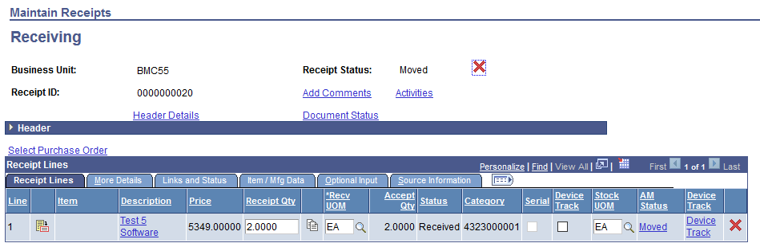STEP#1: Navigate to Purchasing>Receipts>Add/Update Receipts> Find an Existing Value. Enter business unit and receipt number or PO number.

STEP#2: Click on the red ‘X’ next to ‘Receipt Status’

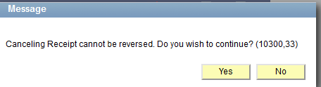STEP 3: A message will pop up to confirm the cancelation. Click on ‘Yes’ and click on the button to save the receipt.

A receipt cannot be canceled if a voucher has been entered against the receipt. If the voucher has not been paid, the voucher would need to be deleted before canceling the receipt. Work with your Accounts Payable Office.

