Creating Inspections

BUSINESS OBJECTIVE: Receipts are required for all goods and services. Some goods and services may require an additional inspection (Information Technology, Facilities/Furniture, Hazardous Materials, and others as designated by the University).

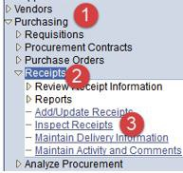STEP#1: Navigate to Purchasing>Receipts>Inspect Receipts.

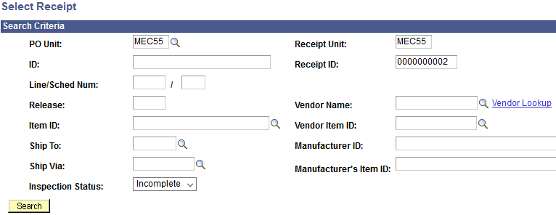STEP#2: Enter as much information to select the Receipt to be inspected. Make sure the Correct PO Unit and Receipt Unit are displayed. If you do not know the Receipt Number, you may search by Purchase Order Number as well. Click on Search.

STEP#3: Purchase Order displays all applicable lines. Check the box to the left of PO Unit to select the line and

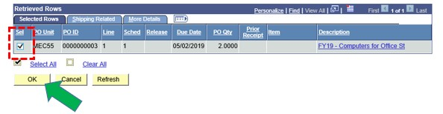click OK

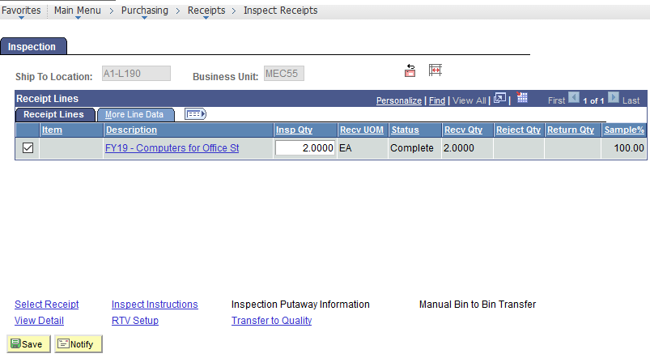STEP#4: Purchase Order is for a quantity of 2 computers. Enter “2” in the Insp Qty. If the quantity inspected is less than the number on the purchase order, enter the correct number inspected in the Insp Qty box and click on Save.

NOTE: If the goods fail inspection or if a portion of the goods fail inspection the inspection receipt should indicate only the quantity of goods that passed inspection. In either case, contact purchasing who will contact the vendor for resolution/replacement.

