Creating Receipts

BUSINESS OBJECTIVE: Requesters will need to create a receipt in CUNYfirst for all goods and services received. Requesters ARE NOT to create receipts prior to the satisfactory verification of goods and/or services received.

Prior to entering a receipt in CUNYfirst, requesters must review and verify the following:

1. A valid Purchase Order Number must be printed on the invoice by the vendor (or written by the requestor.)

2. Invoices should be sent to the Accounts Payable Department. In the event that the invoice is sent to the requestor, the invoice must be scanned and attached to the receipt in CUNYfirst.
3. The requestor should also scan and attach documents to the receipt that demonstrate that the goods have been received (e.g. packing slips) or that the services have been performed (detailed description of services provided by the vendor).

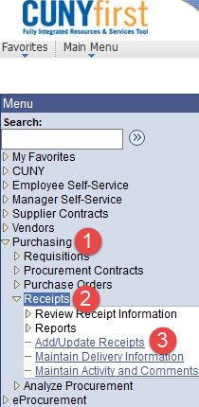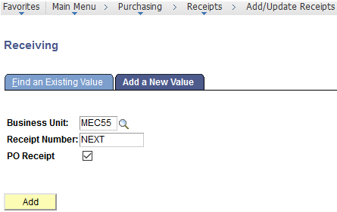STEP#1: Navigate to Purchasing>Receipts>Add/Update Receipts. Select your Business Unit and click on Add

STEP#2: Enter as much information to select the Purchase Order to be received. If you do not know the PO

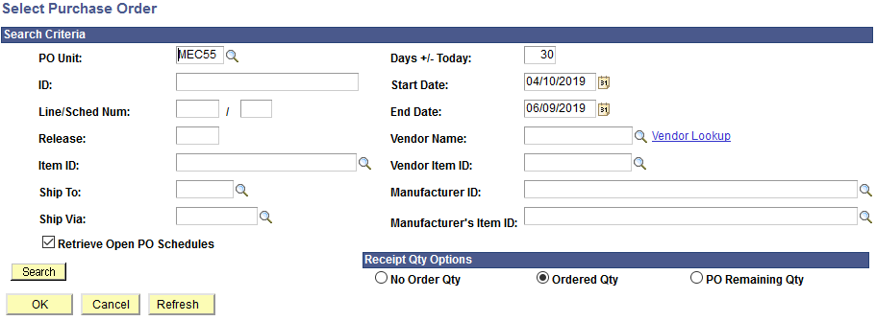number, you may search by Vendor Name. Click on Search.

Enter PO # here

STEP#3: Purchase Order displays all applicable lines. Check the box to the left of PO Unit to select the line and

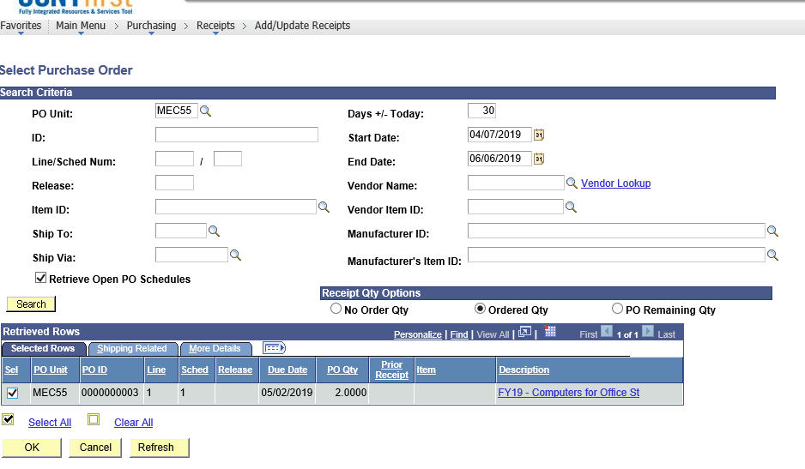click OK

STEP#4: Purchase Order is for a quantity of 2 computers. Enter “2” in the Receipt Qty. If the quantity received is
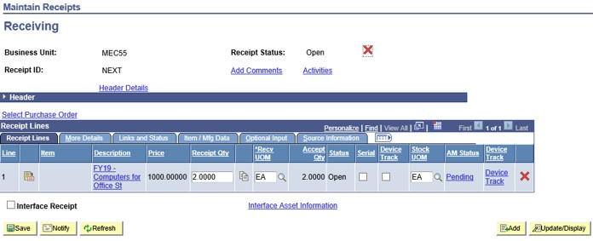less than the number on the purchase order, enter the correct number received in the Receipt Qty box.

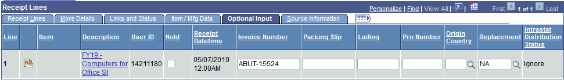STEP#5: Click on Optional Input tab. Enter the Invoice Number as it appears on the actual invoice if available.

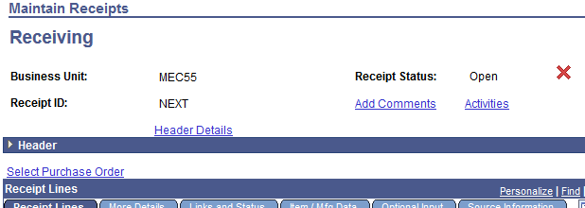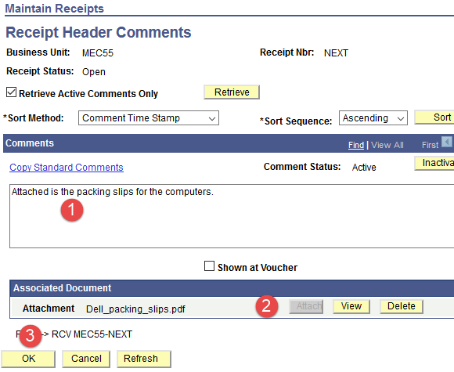STEP#6: Click on Add Comments link. Add a comment, attach documents to the receipt that demonstrate that the goods have been received and click OK.

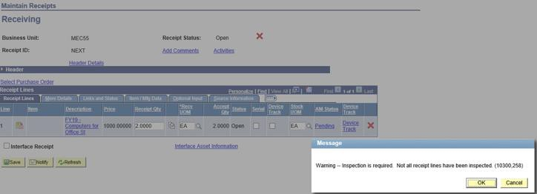STEP#7: Click on Save. In this case an inspection is also required because computers have been purchased. An inspection receipt will also be required before the vendor can be paid. Click Ok. The receipt will be assigned a number and the Status will be “Received”.

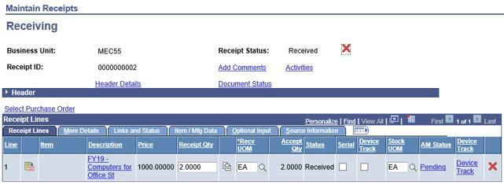STEP#8: Please make note of your CUNYfirst Receipt ID.

