Purchase Orders

BUSINESS OBJECTIVE: The Procurement Department also known as Purchasing Office finalizes purchase orders thru an extensive due diligence and compliance process. The Procurement Department is the only university authority that will send a fully executed Purchase Order to the vendor and shall copy the requestor.
NOTE: Requestor or department personnel must not provide vendor with Purchaser Order number prior to the receipt of a fully executed Purchase Order from their Procurement Department.

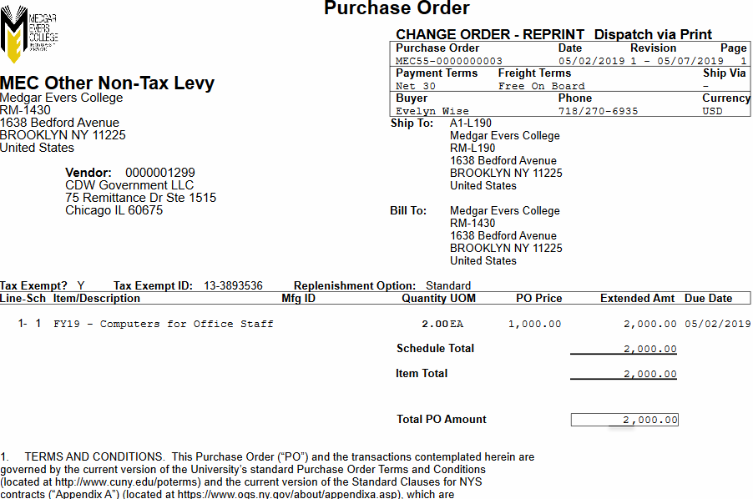SAMPLE PURCHASE ORDER:

Last Updated: 6.7.19 | Page 15 of 29

