City University of New York
Fall 2012
CHEM 21000: Applied Chemistry for Biomedical Engineers
Section: P (course code 0467)

Prerequisite: CHEM 10300 General Chem I & CHEM 10400 General Chem II or equivalent; A grade of C or higher is required in the prerequisite courses.
Meeting Place and Time: Marshak MR 1307, 2:00 PM – 3:15 PM Tuesdays and Thursdays
Instructor: Dr. Sean Boson
Office: Marshak 1018 Telephone: (212) 650-8386 E-mail: sboson@ccny.cuny.edu

Office Hours: Wed 4:00 – 6:00 PM, Thu 11:00 AM – 12:00 PM, Thu 4:00 – 5:00 PM; others by appointment

Textbook: General, Organic and Biochemistry, 7th Edition, Denniston, Topping and Caret McGraw-Hill (for sale and for rent in the bookstore and available on the internet ISBN 978-0-07-340262-8)

This course is intended to introduce biomedical engineering majors to key concepts in organic chemistry and biochemistry, and to describe the significant connections between these topics and health, disease and the molecular treatment of disease. The course will balance theoretical and practical chemistry, while emphasizing material that is relevant to health-related studies. The material will be taught at a level intended for students whose professional goals do not include a mastery of chemistry, but for whom an understanding of the principles of chemistry and their practical applications is a necessity. The pre-requisite for this course is Chem 10401 (with a minimum grade of C); Biomedical Engineering majors only.

How to maximize your grade: Read the chapter carefully before class. Attend class. Re-read the chapter after class. Be able to do and understand all of the problems at end of the chapter. Strive to understand both the concepts and the details.

Grading

Exams 1 and 2 60%
Quizzes 10%
Final 30%
TOTAL 100%

There will be two regular 75-minute exams. A make-up exam will be given for these only if you are absent for a documentable medical reason. All instructional activities are planned for working days during class hours as indicated by City College. Exams 1 & 2 will contribute 60% to your course grade. The final exam will contribute 30% to your course grade. The final exam will be on material covered after Exam 2 and will also cover important cumulative concepts from Exams 1 & 2 material. (Policy for missing the Final exam is described by the Science Division INC policy.) Unannounced quizzes will account for the remaining 10%. Quizzes are given in the first 10 minutes of class and cover the assigned reading material for that day. The quiz average may be modified by student academic attitude and class participation, at the instructors’ discretion.

Note on 2011 INC grade policy (Science Division only):
Makeup exams for INC grades in Chemistry courses will be completed no later than two weeks after the end of classes. INC may only be assigned to students who have a “passing grade” in the course and who are unable to take the final examination. A “passing grade” is computed by averaging all examinations, including grades that might otherwise be dropped in normal final grade calculations. A student must have a legitimate reason for requesting an INC grade, such as a conflict with another scheduled examination, a death in the family, or a serious injury sustained in an accident. Proof is required in all cases. If a reason is not provided, then a letter grade of F will be given. An INC Grade Agreement Form must be signed by the Instructor before the student is allowed to take the makeup exam. Payment of a fee at the Bursar's office is required in order to take the makeup examination. The Registrar will waive the fee if the reason for granting an INC grade is conflict with another scheduled examination. Grades for a makeup exam will be submitted within one week of the administration of the exam.

Please note: Students who do not meet the course pre-requisite will be de-registered.

Tentative Lecture/Exam Schedule

Month / Day Chapter in Text Exam

Aug 28, 30 Ch 10. An Introduction to Organic Chemistry: Saturated Hydrocarbons
Sept 4, 6 Ch 11. Unsaturated Hydrocarbons: Alkenes, alkynes, and Aromatics
Sept 11, 13, 20 Ch 12. Alcohols, Phenols, Thiols, and Ethers
Sept 27 Chapter 10 - 12 Exam 1
Oct 2, 4 Ch 13. Aldehydes and Ketones

Oct 9, 11 Ch 14. Carboxylic Acids and their Derivatives
Oct 16,18 Ch 15. Amines and Amides
Oct 23 Chapters 13 - 15 Exam 2
Oct 25, 30 Ch 16. Carbohydrates

Nov 1, 6 Ch 17. Lipids and their Functions in Biochemical Systems
Nov 8, 13 Ch 18. Protein Structure and Function
Nov 15, 20 Ch 19. Enzymes
Nov 27, 29 Ch 20. Introduction to Molecular Genetics
Nov 29, Dec 4 Ch 21.1 – 21.4 Carbohydrate Metabolism
Dec 6 Ch 22.1 - 22.4, 22.6 Aerobic Respiration & Energy Production
Dec 11 Ch 23.1, 23.2 Fatty Acid Metabolism

Dec 20 Chapters 10 – 23 (more emphasis on Ch 16 – 23) Final Exam
(1:00 – 3:15 PM

Blackboard will be used. Please make sure that your correct email address is registered with blackboard through CUNY Portal.

A tip for understanding organic chemistry and biochemistry: “Like everyday macroscopic objects, molecules have 3-dimensional structures that determine their properties:

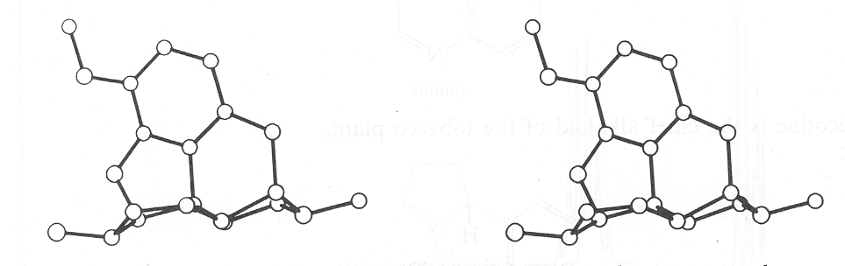

Stereo projection of codeine

To view: Hold page in front of you, but focus your eyes on the horizon beyond the page. Then, without refocusing, look at the projection.
OR
While looking at the projection, relax your eye coordination as if you were tired. One image will drift into the other.
OR
Use a stereoviewer

Academic Integrity: The CCNY policy on academic integrity will be followed, as per the document posted on the CCNY website (CUNY policy on academic integrity—link is at the bottom of the home page). Make sure you have read the details regarding plagiarism and cheating, in case you are not clear about the rules of the college. Cases where academic integrity is compromised will be prosecuted according to these rules.
***********************************************************************************************************
Official Learning Outcomes for Chemistry 21000:

After completing this course, students should be able to: | Dept. Outcome letters
1. Understand and explain the common structural motifs found in carbonaceous compounds, including carbon allotropes. | a
2. Understand and explain chemical bonding in organic molecules, including the distinction between covalent and non-covalent bonding, and between single and multiple bonds. | a
3. Understand and explain simple physico-chemical trends in a homologous series of organic compounds, such as the boiling or melting points of the linear alkanes or alcohols. | a,d
4. Understand and draw models of conformational isomers of linear and cyclic alkanes. | a
5. Recognize and predict simple physico-chemical properties of the common organic functional groups based on their structure-based non-covalent interactions. | a,d
6. Write balanced chemical reactions for the most basic reactions characteristic of the common organic functional groups, such as alkenes, alcohols, aldehydes, ketones, carboxylic acids, esters, amines and amides. | a
7. Plan a short chemical synthesis of monofunctional compounds containing the major functional groups listed above. | a
8. Understand the relationship between polymer molecular structure and the fundamental physical properties of polymeric materials. | a
9. Understand acid-base equilibria of amino acids as described by the pKa. | a,b,e
10. Distinguish between primary, secondary, tertiary and quaternary structures in biopolymers. | a,b
11. Analyze the reaction coordinate for an enzyme catalyzed metabolic reaction. | a,b,d
12. Explain using a diagram the Central Dogma of Molecular Biology. | a,b
13. Understand and explain how cells burn organic molecules and trap some of the energy in the chemical bonds of ATP | a,b,e
14. Follow a specific glucose carbon through glycolysis. | a,b
15. Follow a specific Acetyl-CoA carbon through the Krebs Cycle. | a,b
16. Follow a specific fatty acid carbon through beta oxidation | a,b
17. Qualitatively describe Oxidative Phosphorylation and explain why aerobic organisms require oxygen to live. | a,b

Topics covered:
Saturated Hydrocarbons | Lipids
Unsaturated Hydrocarbons | Protein Structure and Function
Alcohols, Phenols, Thiols and Ethers | Enzymes
Aldehydes and Ketones | Introduction to Molecular Genetics
Carboxylic Acids and Derivatives | Carbohydrate Metabolism
Amines and Amides | Aerobic Respiration and Energy Production
Carbohydrates | Fatty Acid Metabolism

