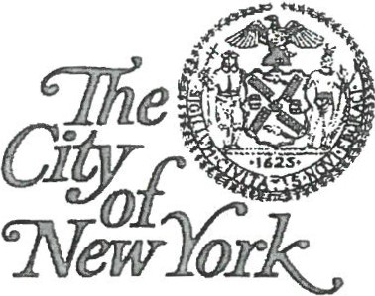
FIRE DEPARTMENT
9 METROTECH CENTER BROOKLYN, NY 11201-3857

Supervising Non-Production Chemical Laboratories

C-14
Renewal Form

Date

I hereby certify that I have fully read the new C-14 examination study material and understand its content. I understand that the rules and regulations have changed since I was first issued my certificate of fitness and I understand that non-production laboratories must be regulated in accordance with these new rules and requirements.
I also understand that the Department reserves the right to require me to take a re-examination upon submission of renewal applications, and that failure to submit this document with my renewal application may require me to retake the examination.

Name (Print) Certificate of Fitness Number Signature

