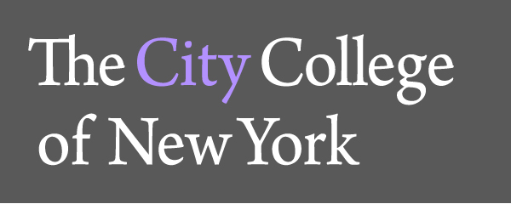

The Department of Foreign Languages and Literatures of

The City College of New York

cordially invites you to attend a lecture by

Ana Isabel González Támara

on

“Tratamiento de la variación del español en textos para estudiantes bilingües en Estados Unidos”
(in Spanish)

Date: Wednesday, April 30, 2014

Hour: 11:00 am-12:15 pm

Place: NA 4/108

Ana Isabel González Támara received her B.A. in Modern Languages from the Universidad del Atlántico (Barranquilla, Colombia), and her M.A. in Spanish Linguistics from the Instituto Caro y Cuervo (Bogotá, Colombia). She is currently a doctoral student in Hispanic Linguistics in the Ph.D. Program in Hispanic and Luso-Brazilian Literatures and Languages at the Graduate Center, CUNY, and an adjunct lecturer of Spanish at Hunter College and Hostos Community College. Her areas of investigation are language variation and change, Spanish in contact, acquisition of Spanish as a second language, and linguistic ideologies.

For information please call: 212.650.6731

