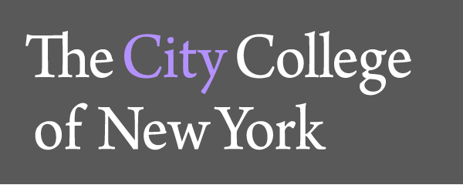
160 Convent Ave. at 138th Street

The Department of Foreign Languages and Literatures

The Cátedra Mario Vargas Llosa
and
Colonial Latin American Review

Cordially invite you to celebrate Hispanic Heritage Month
and the inauguration of the seminar ¿Cómo leer a Mario Vargas Llosa? with a lecture by

J. J. Armas Marcelo
“Mario Vargas Llosa: una vida de novela”

Date: Tuesday, 21 October
Time: 6: OO pm.
Place: Shepard Hall, Room 95

Reception will follow

For information please call 1212-650-6731. Event open and free to the public.

J.J. Armas Marcelo is the General Director of the Cátedra Mario Vargas Llosa in Madrid. A columnist, essayist and novelist, he is a corresponding member of the Royal Spanish-American Academy of Cádiz and the Academia Peruana de la Lengua. Translated into more than ten languages, Armas Marcelo’s novels have received numerous prizes, among them the International Plaza Janés for Los dioses mismos in 1989 and the International Ciudad de Torrevieja for Casi todas las mujeres in 2003. Armas Marcelo’s writings are marked by a Latin American bent evident in his fiction taking place there or treating the history of the region such La noche que Bolívar traicionó a Miranda. His most recent novel is Réquiem habanero por Fidel (Alfaguara, 2014).

