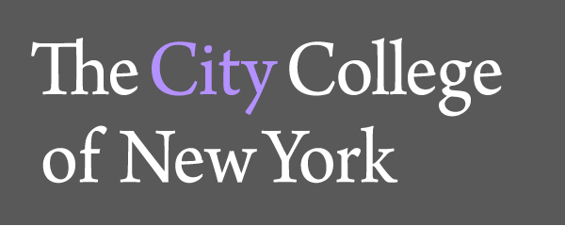

The Department of Foreign Languages and Literatures of

The City College of New York

and the Simon H. Rifkind Center for the Humanities

cordially invite you to a lecture by

Prof. Amr Kamal

on

A Mediterranean House: Saint-Simonian Utopianism and the Creation of Egyptian Political Economy

Monday, May 5
12:30-1:45 pm
The Rifkind Center Seminar Room, NAC 6/316

Amr Kamal is Assistant Professor of French and Arabic at The City College of New York-CUNY. In 2013, he received his PhD in Comparative Literature from the University of Michigan, Ann Arbor. He is currently working on his book manuscript based on his dissertation entitled “ Empires and Emporia: Fictions of the Department Store in the Modern Mediterranean.” His work studies the writings of Emile Zola, Huda Sha’arawi and Jacqueline Kahanoff on the department stores in France and Egypt and the role of these texts in critiquing French and Egyptian social relations and national identity within the context of the Suez Canal Project. His research interests include 19th and 20th century French literature, Francophone literature from the Mashreq (especially Egypt, Lebanon and Syria), Mediterranean Studies, Human Geography and material culture.

For information please call: 1212.650.6731

