CLINICAL PSYCHOLOGY @ CITY COLLEGE 2017-2018 COLLOQUIA SERIES

Judy Roth, PhD.

GRASPING EXPULSION: ENGAGING PEOPLE LIVING WITH  
HISTORICAL AND CONTINUOUS SOCIAL CRISIS

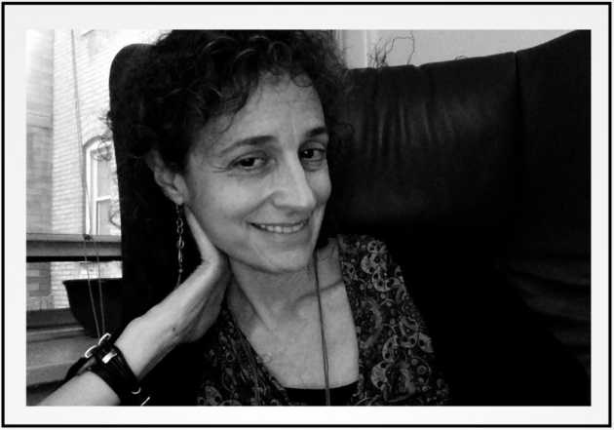

TUES 13 MARCH, 2018 AT 11:30 AM-12:50 PM

SHEPARD HALL RM 107

\*

TALK ABSTRACT

This presentation addresses the question of why it is so hard to see and know expulsion and its legacy overtime and relational space. What kind of presence and accompaniment are needed to identify and respond to ongoing social catastrophe? And what is needed conceptually, clinically, and ethically to grasp these realities earlier? We will explore these questions drawing from the voices of 'dwellers at the threshold'—people who are particularly attuned to the ways in which injustices tear at the fabric of their community. This includes people who bear the brunt of the harm; those who first respond; those able to step through the looking glass of disavowal and public dissociation risking vilification; and those of us at the edges, struggling to see, grasp, and truly know.