CLINICAL PSYCHOLOGY @ CITY COLLEGE 2017-2018 COLLOQUIA SERIES

Kevin Nadal, PhD

"LET'S GET IN FORMATION": ON BECOMING A PSYCHOLOGIST-ACTIVIST IN THE 21st CENTURY

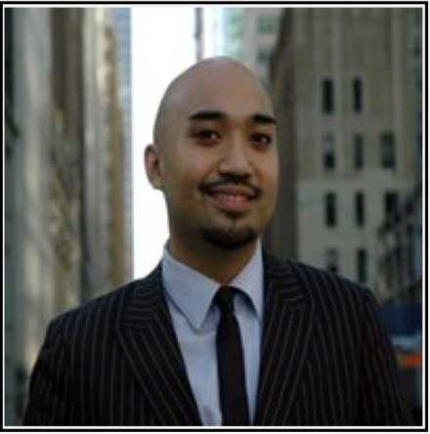

TUESDAY 14 NOVEMBER, 2017; 11:30 AM-12:45 PM

SHEPARD HALL RM 107

\*

TALK ABSTRACT

Throughout the history of the United States, there have been many social movements that have resulted in an array of historic societal outcomes - ranging from the end of racial segregation to women’s voting rights to the legalization of same-sex marriages. Despite the positive outcomes derived from political activism, many psychologists have struggled with how to advocate for social justice, while maintaining their professional responsibilities and ethical boundaries. The current paper will review the historical ways that psychologists have participated in political movements- from the use of psychological research in landmark U.S. Supreme Court cases to psychologist-led pushes for policy changes in psychology, medicine, and other mental health related fields. Next, a critical review will be provided of some of the major controversies or dilemmas regarding psychology, social justice, and political participation - including: (a) ethical concerns and professional boundaries, (b) the utility of political neutrality in psychology, (c) psychologists’ balance and self-care, (d) psychologists’ lack of advocacy training, and (e) beliefs of the role of social justice advocacy in psychology. Finally, the presentation will conclude by discussing the concept “psychologist-activist” - highlighting the many ways that psychologists across various subfields and institutions can combat oppression on individual, interpersonal, group, and institutional levels.