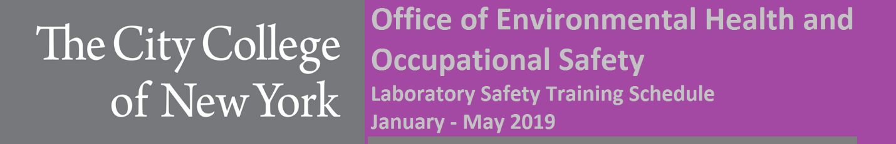
General Information
Environmental Health and Occupational Safety (EHOS) offers monthly safety training sessions as required for all lab personnel (but not limited to): principal investigators, laboratory technicians, graduate students, post-doctoral fellows, researchers or any visiting personnel working in a lab. It is MANDATORY that any individual who has not received initial training MUST attend EHOS safety training, BEFORE working in a lab on campus. Information on the respective safety trainings are presented below. Please contact EHOS at (212) 650-5080 or email ehos@ccny.cuny.edu if you have any additional questions or concerns.
Certificate of Fitness C-14
The City of New York Fire Department requires that all non-production chemical laboratories have a Certificate of Fitness for Non-Production Chemical Laboratories (C-14) holder to be present at all times during operation. The certificate is site specific to the City College campus and for the respective certificate holder. City College requires C-14 training to be completed once, as long as renewals of the certificates are maintained. For more information about applying for a Certificate of Fitness visit: https://www.ccny.cuny.edu/facilities/fdny-certificate-fitness
OSHA Lab Safety Standard
This training includes information on lab standards and regulations set forth by OSHA. It includes potential hazards associated with the lab environment, along with applicable exposure control measures. City College requires the training to be completed every three years.
Hazardous Waste Management
Hazardous Waste Management (HazWaste) Training includes information pertaining to EPA regulations governing proper disposal of waste generated during research or experiments. City College requires this training to be completed annually as per EPA regulations.
Laser Safety and Blood Borne Pathogen
Blood Borne Pathogen (BBP 29 CFR 1910.1030)) training is available to all CCNY employees with a reasonable anticipated exposure to blood, tissues, cell lines and other potentially infectious materials (OPIM). Laser Safety training is also available for all lab personnel who own or operate lasers in campus laboratories.

DATE | TYPE | ROOM | TIME | INSTRUCTOR
Tuesday, January 29, 2019 | OSHA | MR 1027 | 12:30 – 2:30 PM | Tom Dickson
Thursday, February 7, 2019 | HazWaste | MR 801 | 12:30 – 2:30 PM | Nick Rienzi
Wednesday, February 20, 2019 | C-14 | MR 801 | 10:00 AM – 12:00 PM | Graciano Matos
Monday, March 4, 2019 | Blood Borne | MR 1027 | 2:00 – 4:00 PM | N. Rienzi/G. Matos
Wednesday, March 13, 2019 | HazWaste | MR 801 | 10:00 AM – 12:00 PM | Tom Dickson
Tuesday, March 26, 2019 | C-14 | MR 1027 | 12:30 – 2:30 PM | Graciano Matos
Thursday, April 4, 2019 | OSHA | MR 1027 | 10:00 AM – 12:00 PM | Tom Dickson
Tuesday, April 9, 2019 | Laser Safety | MR 1027 | 2:00 – 4:00 PM | N. Rienzi /G. Matos
Monday, April 15, 2019 | C-14 | MR 1027 | 2:00 – 4:00 PM | Nick Rienzi
Wednesday, May 1, 2019 | OSHA | MR 1027 | 12:30 – 2:30 PM | Graciano Matos
Monday, May 6, 2019 | HazWaste | MR 1027 | 12:30 – 2:30 PM | Nick Rienzi
Thursday, May 9, 2019 | C-14 | MR 1027 | 2:00 – 4:00 PM | Tom Dickson

