Interim Report

Facilities and Infrastructure Technology Task Force

Submitted to:

President Boudreau

Submitted by:

FIT Task Force

Ken Ihrer – Information Technology, Chairperson

Committee Members

Gordon Gebert - Architecture

Gilda Barabino – Engineering

Rose Wesson – Engineering

Umit Uyar – Engineering

David Robinson – Facilities

Vatthana Chin – Facilities

Khadesha Maxim – Facilities

Laurent Mars – Science

Kevin Gardner – Science

Carol Huang – Education

Moe Liu Dalbero – Colin Powell School

Justin Williams – CWE

Otto Marte – Information Technology

May 10, 2018

**Summary and Recommendations**

This Interim Report represents the work product developed by the Facilities and Information Technology (FIT) Task Force to-date. The report represents the cumulative efforts of the FIT Task Force members for the analysis of the facilities and IT infrastructure/operation on the CCNY campus as well as preliminary findings that will be used to shape the FIT Task Force’s recommendations in the Final Report.

This Interim Report includes discussions in the following areas:

* Conditions that limit the delivery of Facilities and Information Technology services to the campus community;
* The evolution of preventative maintenance on the CCNY campus and the impact that preventative maintenance has to the campus community;
* A comparison of past personnel and OTPS budgets together with a recommended four (4) year projection for funding to meet the Facilities and Information Technology campus needs;
* A discussion of Research on the CCNY campus relative to the special maintenance and support that is required to meet their needs;
* The importance of Space and Capacity Planning towards the effective utilization of campus buildings and grounds;
* The importance of Facilities and Information Technology modernization as it relates to the level facilities and technology needed to deliver teaching and learning excellence;

The reader needs to understand that points referenced above are preliminary in nature. Information and findings presented in this Interim Report are still under study and represent the findings of the FIT Task Force to-date. These points, as well as additional points still under study, will be further expanded by the FIT Task Force for inclusion in the final report.

Preliminary recommendations at this time are as follows:

**Staffing:**

* Balance Facilities and IT staffing levels to the workload and needs of the campus;
* Increase Custodial Assistant levels to 130 over the next 4-years;
* Add the position of Oilers with a staffing level of eight (8) over the next 4-years;
* Increase the Facilities Staffing from 253 to 329 persons over the next four (4) years
* For the IT Department, determine the support model for the divisions and add staff appropriately

**Preventative Maintenance:**

* Institute a plan to counter the deferred maintenance that has been pervasive on the CCNY campus for the past 15-years;
* Recognize the level of preventative maintenance needed to maintain operations on the CCNY campus and fund the maintenance accordingly;
* Recognize that the maintenance needs for spaces such as Research varies compared to the maintenance needs for classrooms. As such, one must not fit maintenance into a broad category but instead customize and support campus maintenance relative to the diversification of uses on-campus;

**OTPS Budget:**

* Establish a four (4) year budget for the Facilities and IT Departments that will be used as a guide to implement non-capital improvement initiatives across the campus.
* Retain a purchasing agent specific for the Facilities Department to facilitate Facilities purchases;
* Establish authorizations for the Facilities and IT Departments to purchase from the NYS OGS eMarketplace portal;
* Set-up preventative maintenance contracts for a 5-year term so that they are available to the Facilities Department at the beginning of the fiscal year;
* Establish a list of M/WBE and Veteran Owned Businesses to aid in the facilitation of purchases;
* Establish an equipment replacement plan to insure IT hardware does not become obsolete;

**Research:**

* Provide for transparency in use of indirect costs for academic research; establishing separate overhead budgets for FIT that will be earmarked for research infrastructure support;
* Enhance communication between FIT and researchers:
  + implement ongoing feedback mechanisms to gauge customer satisfaction (e.g., forumCures);
  + Identify physical space and IT needs specific to cutting-edge research (e.g, networking speeds and bandwidth); and,
  + open, two-way discussions to determine cost sharing between university and faculty;
* Improve communication and cooperation between CCNY and CUNY ASRC; and,
* Provide for transparency in criteria applied to optimizing utilization of research space across campus.

**Space:**

* Future designs should incorporate materials that are low in maintenance;
* Recognize those spaces on-campus that need expedited upgrades/renovations; and
* Move towards the development of a new Master Plan for the CCNY campus.

**Modernization:**

* Establish a program for modernization needs to be established and maintained to insure that classrooms, lecture halls, music rooms, arts and sciences laboratories, theatrical spaces, libraries and all student spaces will provide for spaces for excellence in teaching and learning.

1. **Introduction**

Studies undertaken in higher education institutions over the course of the past 10-years show direct relationships between the quality and condition of campus infrastructure and facilities to the ability of colleges to attract and retain new students, the caliber of education that can be delivered in classrooms, the test scores achieved by students, the ability to attract research, the satisfaction for research facilities and the overall quality of campus life.[1] These same studies show that campuses with clean well-functioning facilities versus the converse have one thing in common…campus culture.

The FIT Task Force Committee is comprised of a cross-section of campus employees with strong focus in the fields of administration, academia and research. Together the Task Force members have been working towards consensus on the importance of sound campus facilities, the condition of the current campus facilities and the limiting factors towards bettering the facilities and infrastructure on-campus. The interim report that follows illustrates some of the issues that have been deliberated by the Task Force, research that has been undertaken to assemble evidence for the current infrastructure conditions and topic points that are in-progress for inclusion in the final report.

1. **What We Have Learned:**

In 2013 and again in 2015 the Faculty Council solicited academic departments asking for input on information technology, adjunct budgets and infrastructure of learning spaces relative to the impact they pose to teaching excellence. One takeaway from these surveys is the importance to understand the paradigm of others for the services needed to support academic program deliveries. From the perspective of the users contributing to these surveys, information technology and facilities infrastructure that did not support their academic needs was seen as a reflection of negative customer service. To the provider, the inability to deliver services is a reflection of inadequate resources. The FIT Task Force committee deliberated these points and finds that each needs to be taken seriously in their own context and that each forms the touchstone for being able to inspire institutional advancements.

The diversity of the FIT Task Force lent important insight and conversation towards the different information technology and facilities infrastructure needs on-campus. Simply put, the FIT needs for a classroom are different than a research lab, than an office, than a library. To that end, the optics for each user needs to be understood and supported. In some cases this means a higher level of cleaning services while in others it means a higher level of financial support for the repair and maintenance of specialty equipment. In either case, the inability to deliver these resources represented the same metrics of negative customer service.

Lastly, The FIT Task Force finds their role and mission as an opportunity to research the FIT attributes that impact the quality of life on the CCNY campus for students, teachers, research scientists and administration alike and, to present facts and propose findings that can be used by the college to equitably improve the quality of life for all. Both Facilities and IT recognize the need to continually solicit input from its customers and the development of a standing advisory board for each area should help focus these departments on what is most important to the user community.

1. **Limiting Conditions:**

The mission of the Facilities and Infrastructure Technology (FIT) Task Force is to understand the current state of FIT infrastructure on the CCNY campus, to relate the impacts, positive or negative, that the condition of the FIT infrastructure has on the campus community and to understand the causal factors that pose limiting conditions towards advancing improvements to the campus FIT infrastructure.

The FIT Task Force has done a considerable level of research and is continuing to do more in an effort to understand the FIT service needs of the diversified customer population on campus. Along with this work comes insights towards the customer’s paradigms and initiatives to improve the services that meet the customer’s needs. While Task Force work continues, some of the limiting conditions to-date that have been identified includes but is not limited to: personnel and staffing, budget and OTPS, space management, preventative maintenance and modernization. A summary of these follows.

**Facilities Personnel and Staffing**

Recognized industry organizations as well as comparisons to fellow CUNY institutions were used to gauge the standings of the Department of Facilities Management and the Department of Information technology against generally accepted standards and peer colleges. Results of this exercise suggests two things: 1) the aggregate number of employees to provide the level of services customers need is greater than currently employed; and, 2) the job titles currently employed do not include titles that are needed to satisfy customer needs. Examples of this can be seen in the Department of Facilities Management wherein the total number of custodians are less than needed to provide the level of service for campus cleaning. Attrition was also found to illustrate the need for positions that currently are not employed. A discussion of both is shown below.

Custodial Assistants:

The title of Custodial Assistant incurs high levels of attrition, resulting in both performance based and economic based impacts to the college. In 2015 the Facilities Department evaluated all spaces on-campus and developed a plan for Custodial Assistant Post Assignments. This exercise evaluated every space on-campus using the Archibus system and then assigned the spaces for cleaning either in the day shift, afternoon shift or evening shift. A fourth shift was developed to address cleaning needs over the weekends due to weekend events that are hosted on-campus so that the campus would be clean on Monday mornings. These Shifts are identified as the A, B, C and D shifts respectively.

Prior to the development of the Post Assignment schedules in late 2015, which was a first of its kind for the college, the cleaning department carried approximately 62 cleaners. The 2015 Post Assignment schedule that was developed called for 79 post assignments, requiring an increase of 17-Custodial Assistants. The 2015 post assignment was purposively narrowed so as not to induce a large hiring demand on the College but at the same time to increase the low level of staffing that existed at that time. This still represented approximately 23 less Custodial Assistant positions in comparison to the levels carried in 1991-1994, even though the campus building gross area square feet (GASF) increased ±400,000 sf with the addition of the ASRC/CDI campus in 2015.

While the Facilities Department has authorization to carry 79 Custodial Assistant positions, attrition causes the number to regularly be in the range of 69-positions. Coupled with a 15% to 18% daily attrition rate, the daily count of Custodial Assistants is in the range of 57. That means that the 79 post assignments need to be covered by 57 Custodial Assistants, resulting in an average of ±48,000 square feet /Custodial Assistant.

The Association of Physical Plant Administrators (APPA) is an industry standard for higher educational institutions to use in gauging the number of cleaners needed for a facility. Using the APPA guidelines, if cleaning activities are accomplished with decreasing frequency, appearance will suffer. Accordingly, the APPA has identified five levels of appearance together with a corresponding an assignable cleanable square feet (CSF) per custodian or FTE. Information relative to the five (5) levels of appearance together with the CSF/FTE that is needed to meet each of the five (5) appearance levels is also included in Appendix A.

Appendix B includes survey information from Oakland University relative to campus cleaning and APPA’s five (5) levels of cleanliness. From Appendix B the survey results obtained by Oakland University shows that 88-percent of respondents reported that a lack of cleanliness becomes a distraction at APPA Level 3 (causal inattention) and Level 4 (moderate dinginess). 85-percent reported that they want APPA Level 2 (Orderly Spotlessness) or Level 1 (Orderly Tidiness) standard of cleanliness to create a good learning environment.

From Appendix A and B it can be understood that there is a direct correlation of the amount of resources and the cleanliness of a building. The appearance factors for each level of cleanliness are also included in both Appendix A and B.

Appendix C includes information relative to the number of FTS’s needed to obtain a desired level of cleanliness. From Appendix C one can see that the number of FTE’s needed to obtain a given level of cleanliness is a function of the space being cleaned with a higher number of FTE’s (more resources) yielding a higher level of cleanliness and a lower number of FTE’s (less resources) yielding a lower level of cleanliness. Based upon Appendix C, to obtain a Level 2 standard of cleanliness the CSF/FTR ratio needs to be in the range of 20,000 CSF/FTE. Using our current staffing levels of 69 and a campus wide average cleanable square footage of 75-percent or 2.6M sf, the average CSF/FTE is equal to 37,681. Taking into consideration an 18-percent daily attrition, the CSF/FTE is reduced to 45,614 CSF/FTE, which is equal to an APPA Level 3 to 4 standard of cleanliness (casual inattention to moderate dinginess).

As identified by the Oakland University survey and so many other studies that are available for cleanliness at college campuses, one needs to strive for a Level 1 standard of cleanliness for bathrooms and food service areas and no less than a Level 2 standard of cleanliness for most other spaces. In order to obtain these levels of cleanliness on the CCNY campus the level of resources (FTE’s) needs to be increased from the staffing level of 79 (69 currently on-staff due to attrition) to a staffing level of 130 (2.6M sf / 20,000 CSF/FTE). Taking into consideration an 18-percent daily attrition rate and the high turn-over rate for the position of Custodial Assistant, one would need a staffing level of 153 FTE’s to maintain a daily FTE count of 130.

Oilers:

Until 2015 the campus carried 4-6 FTE’s in the title of Oiler. In 2015 the number of FTE’s in this position was reduced to 1 through attrition and thereafter left unfilled. The reason for having a discussion about the position of Oilers is because personnel in this title are the ones on the front line of maintenance for campus mechanical equipment. In addition, persons with this title are generally versed in the troubleshooting and maintenance of refrigeration equipment, such as cold rooms that support much of the science research that occurs on campus. Having these positions helps to reduce deferred maintenance, increases the level of preventative maintenance for campus mechanical equipment and reduces the response time for corrective maintenance due to equipment failure. Not having persons in this title leaves the campus devoid the mechanical aptitude and skill-sets needed to maintain and repair the large amount of mechanical equipment that is throughout the campus. It is recommended that the position of Oiler be re-instated within the ranks of the Facilities Department with no less than three (3) hired for FY’19 and increasing to eight (8) by 2022.

The current staffing levels for the Facilities Department is shown in table 1. A proposed 4-year staffing plan for the Facilities department is shown in Table 2.

Table 1

Historic Staffing Levels

CCNY Facilities Department



**Table 2**



**OIT Personnel and Staffing**

The Office of Information Technology employs 40 fulltime staff and 11 tax-levy part-time staff and 53 Tech Fee staff. The department reaches across all areas of the campus to supply services to students, administration and faculty. Some of our services are provided by CUNY, such as Blackboard (Learning Management System) and CUNY First (Enterprise Resources such as Student Information System, Electronic Procurement, and soon, Human Resources). Even with these centralized services, local OIT staff support the users of these centralized services, provide for their security and interface with CUNY when issues arise.

Services provided directly by OIT include Infrastructure Services, Frontline Services, Application Services and Academic Services. Each of these areas has a Director that oversees personnel and operations.

Infrastructure Services

The Infrastructure Services area reports to the Deputy CIO and has three (3) working managers that oversee Networking, Telecommunications and System Administration. Total headcount for Infrastructure Services is three (3) FTEs in Networking, four (4) FTEs and three (3) part-time in telecommunications, three (3) FTEs and two (2) part-time in Systems Administration.

The support model for Infrastructure Services is currently a hybrid model whereby many services are provided campus wide but others are split among centralized IT and the Divisions. For example, email and our network are campus-wide services. However, some Divisions support their own servers and in the case of Research, central IT is rarely involved with the support of those systems.

As far as personnel recommendations, the biggest need is for a Senior-level information security engineer. This position has been posted and we are hopeful that it will be filled shortly. Other staffing needs will depend on how the College wants to support the Divisions. If a decision is made to provide centralized support for Researchers and Divisional labs, additional system administrators will be needed. The number of additional staff will depend on the level of support desired/required by the Divisions. Even if the decision is made to keep this support decentralized, it is important that we ensure that the Divisions are adequately staffed.

Telecommunications handles our phone systems and our data wiring throughout the campus. The current staff is only capable of supporting smaller wiring jobs and much of our data wiring projects are contracted out. Between FY 16 & FY 17 we spent $274,179 on contractors for wiring jobs and about $24,140 in cable materials for job done in-house. By hiring 2 additional cable specialists at a cost of $(66,710) per year, our overall costs will go down plus we will reduce the load on procurement to fill these contracts.

Frontline Services

The Frontline Services area reports to a director and has four (4) managers that oversee the Help Desk, Client Services, OIT Labs and Divisional Support. The Help Desk has one (1) FTE, and 6 part-time employees and 180 hours/week of Tech Fee employees. Client Services has three (3) FTEs, 4 part-time employees and 128 hours/week of Tech Fee employees. OIT Lab Services has two (2) FTEs, 19 part-time employees (404 hours/week) of Tech Fee employees. Divisional Support has eight (8) FTEs, 1 part-time employees and 5 Tech Fee employees.

Our Help Desk operates 12 hours per day, five days per week. Currently, the only FTE is the manager. The staff primarily consists of student Tech Fee employees. This arrangement is beneficial to students who are wanting to learn about IT but disadvantageous when it comes to continuity and level of support. While we recommend that some of the Help Desk staff continue to come from Tech Fee, we should consider adding three (3) more FTEs with higher skill levels that are capable of resolving more problems on the first call instead of needing to pass the issue to Client Services.

Client Services is the OIT area that is sent out in the field to repair or solve user issues with technology. This includes problems in the classrooms with AV equipment. In addition to administrative staff, Client Services supports the schools and divisions that do not have a dedicated Divisional Support technician. Personnel changes to this area will depend on how we decide to support the Divisions and Research. One area that could use additional resources regardless of the support model is in the area of classroom support. We currently have one technician that is trained to support the 180 smart classrooms on campus.

OIT Labs consists of the two main computer labs on campus (City Tech Center and Fishbowl). While there are at least 58 additional computer labs on campus, central OIT is fully responsible for just these two. These labs are open seven days per week and operate between the hours of 7:00AM until Midnight Monday through Friday, 9AM to 6PM on Saturday and Noon to 6PM on Sunday. The overwhelming majority of support for this area comes from student Tech Fee employees. This seems to work well, although schedules can be hard to fill around midterms and finals. Table 3 shows the numbers of computer Labs by school/division. Some of these labs are also used for teaching.

|  |  |
| --- | --- |
| **Table 3**  **Computer Labs by School/Division** |  |
| **School/Division** |  |
| School of Architecture | 2 |
| School of Education | 2 |
| Division of Science | 12 |
| Grove School of Engineering | 20 |
| Humanities and the Arts | 9 |
| Colin Powell School | 3 |
| Center for Work Education (CWE) | 2 |
| College Libraries | 3 |
| SEEK Program | 2 |
| Student Affairs | 3 |
| **Total # of Labs:** | **58** |

Divisional Support currently covers CUNY School of Medicine, Engineering, Science, Accessibility, Architecture, CWE and Public Safety. Support ranges across all areas of Frontline Services. Some employees handle system administration tasks, others desktop support and others lab support. Several of the Divisions receive Tech Fee dollars to supplement their lab support. This entire area of Divisional support will continue to be analyzed by the FIT Task Force for further recommendations.

Application Services

The Application Services area reports to a Director and has five (5) FTEs and two (2) hourly employees that provide Programming, Reporting, Web Services, and Broadcast Services. The group has recently lost one of its programmers and therefore production is slower. Areas for consideration include the addition of a high-level Database Administrator to support the growing need for data analytics and buildout of decision making systems.

Academic Services

The Academic Services area reports to a Director and has one (1) FTE and two (2) hourly employees along with six (6) Tech Fee College Assistants and two (2) Federal Work Study staff. The area of Academic Services supports equipment loaning to faculty and students, provides design services for classroom technology and architects solutions for media spaces across campus. This area also handles the support of several departmental websites and does broadcast communications for the campus.

One area for consideration is classroom technology support. As we continue to rely more and more on technology as part of pedagogy, it is important that we are able to service a classroom quickly, as soon as the faculty member requests it. As we move towards more hybrid classes, having expertise on hand to deal with recording issues and presentation problems will be a key to making the endeavor successful.

Additional IT Personnel

In addition to the areas detailed above, IT also has a Business Services Director, a Procurement agent (works at the campus Procurement Office), and one part-time staff to handle our purchases, CUNY First input, Tech Fee and Budget. We also have a Project Manager and a Grant Support staff member. Table 4 below represents the OIT personnel data.

Table 4.

FY’18 OIT Personnel

|  |  |  |  |  |  |
| --- | --- | --- | --- | --- | --- |
|  |  |  |  |  |  |
|  | **Full-time** | **OIT Temp Services** | | **Tech Fee Temp Services** | |
|  | # of FTE | IT-Hourly | CA(s) | IT-Hourly | CA(s) |
| Office of AVP & CIO | 1 |  |  |  |  |
| Grant Support | 1 |  |  |  |  |
| Infrastructure | 14 | 3 | 2 |  |  |
| Frontline Services | 15 |  | 2 | 16 | 24 |
| Academic Services | 1 | 1 |  | 1 | 6 |
| Application Services | 6 | 2 |  |  |  |
| IT Business Services | 2 | 1 |  |  |  |
| School/Division Labs |  |  |  |  | 6 |
| **Total Personnel** | **40** | **7** | **4** | **17** | **36** |

The capital cost of the Facilities and Information Technology infrastructure on the CCNY campus is in the hundreds of millions of dollars. It is the expectation of the City University of New York that CCNY take ownership and be the steward for the preventative, routine and corrective maintenance needs of the campus. However, to fully understand the complexity of this charge one needs to take a step back and understand the history for how facilities maintenance on the campus use to be funded.

Our research is not fully complete on this subject, but what has been learned is that the cost of maintenance use to be subsidized to the CCNY campus by both CUNY and DASNY in the following ways. First, CUNY use to receive a lump sum amount of money termed “Minor Repair Money” in the range of $7M from NYS at the beginning of each fiscal year that would be earmarked for maintenance at senior campuses. CCNY’s share of the Minor Repair Money was in the range of $1M. This money would be used for repair and maintenance of facilities infrastructure across the campus as needed. A second funding source was provided through and administered by DASNY that was termed “Building and Equipment” or B&E funding. This funding was the result of the interest on the investments from bond borrowings and would be in the range of $65M. There are no accounting records of this money since the program was administered by DASNY, but it is believed that CCNY’s share of the B&E money was in the range ±$10M per year. This money was not considered as “capital” and therefore could be used for larger maintenance projects, such as re-tubing boiler numbers 2 and 3 in or around 2004, maintaining the chiller plant with an annual cost of ±$500,000, repairing variable frequency drives across campus and other such work that required contractor support to accomplish. In or around 2004 to 2006 the B&E funds that were used for facilities maintenance were taken away from the CUNY campuses by NYS. We are told that the Minor Repair Money was taken away from the CUNY campuses some time before that, possibly between the years 2000 to 2004.

As can be seen from the above, the Minor Repair Money and the B&E funds were important linchpins to the overall maintenance of the Facilities and Information Technology Infrastructure on the CCNY campus. The point where deferred maintenance substantially took hold can also be discerned as those dates when these funds were taken from the campus, resulting in a 10 – 15 year period where the maintenance needs of the campus were unfunded.

For many years preceding the termination of the Minor Repair Money and B&E funds, the culture of the campus was that DASNY would handle any larger scale maintenance that was needed with the campus only responsible for the maintenance that could be handled in-house. As it seems to have happened, the termination of the Minor Repair Money and B&E funds occurred without planning, leaving the campuses to figure-out how maintenance was to be accomplished. Even after the removal of the B&E funds, the culture of the campus was so tied to DASNY performing maintenance that broken equipment laid in abeyance with the belief that DASNY would someday handle the repairs. Needless to say, that someday never happened and we are now at a point where deferred maintenance needs to be addressed.

In addition to the scope of maintenance described above, the campus is also responsible for maintaining ±3.4M square feet inclusive of cleaning, repair and replacement. Much of this maintenance is handled through the Facilities and Infrastructure Technology staff, but a large portion needs assistance from outside vendors. For FY’19 it is estimated that the preventative maintenance contracts for the CCNY campus will be in the range of $3.4M. Tables 5x & 6x illustrate the preventative maintenance contracts for both the North campus and South campus areas respectively.

Table 5.1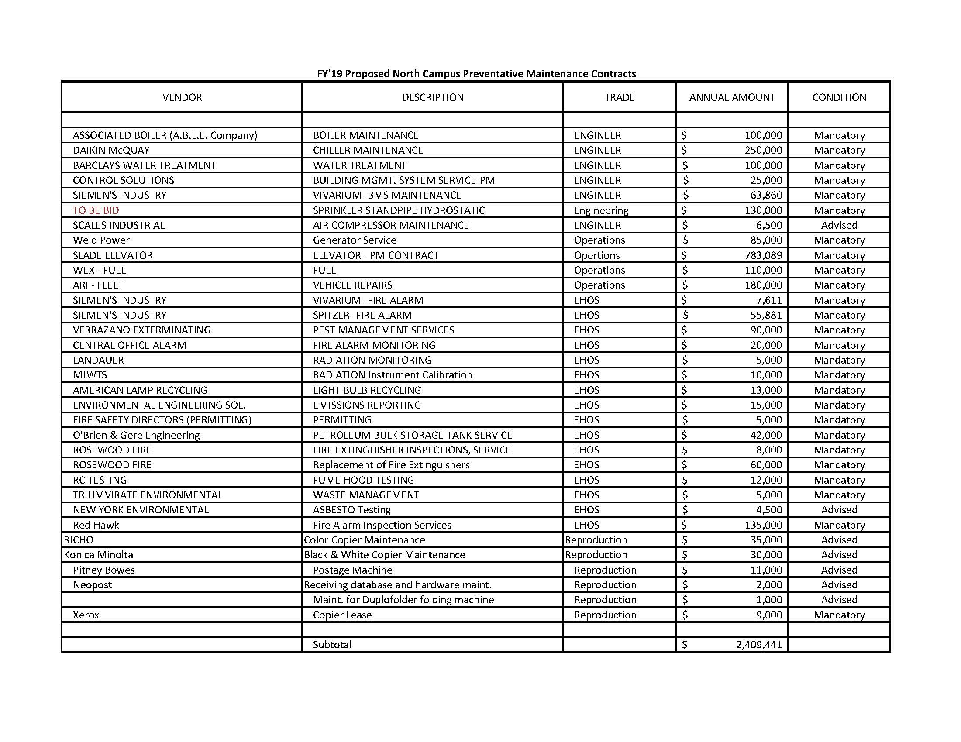

Table 5.2

North Campus OIT Preventative Maintenance Contracts

|  |  |  |
| --- | --- | --- |
|  |  |  |
| **Vendor** | **Description** | Yearly Cost |
|  | **Hardware** |  |
| Dell | Enterprise Backup Systems & Email sever | $ 67,251.00 |
| GIOIA P AMBRETTE INC | Voice Mail System | $ 16,533.00 |
| HP | Active Directory AD -Server | $ 9,469.00 |
| iSecure LLC: JZ | Procera Security Device | $ 5,966.00 |
| Lane Refrigeraton Co Inc. | AC Maintenance for PBX Switches | $ 12,000.00 |
| NEC Corpration of America | PBX Maintenance & monitor | $ 51,785.00 |
| Paetec | Phone Line T-1 - PRI for CDI | $ 66,891.00 |
| Vandis | Palo Alto Firewalls | $ 49,000.00 |
| Vandis | *InfoBlox DSN* | $ 6,500.00 |
| Virtuit Systems | Compellent-Storage | $ 38,000.00 |
| **Sub-total** |  | **$323,395** |
|  | **Software** |  |
| Apple | Apple Developer Program | $ 107.79 |
| Aurea Lyris Inc | Broadcast List-Serv | $ 5,000.00 |
| Dyntek Services Inc | Commvault Endpoint Backup | $ 15,941.00 |
| ExQuilla Addon | (1) ExQuilla email migragration | $75.00 |
| IBM | SPSS Statistics Standard | $ 6,000.00 |
| Parallels | Plesk Web Host | $ 315.00 |
| ProcessMaker Inc | ProcessMaker | $ 12,995.00 |
| SHI | EnCase Enterprise SMS | $ 3,597.00 |
| SHI | LiquidFiles -FTP Server | $ 1,419.98 |
| SHI | Patch Management | $ 22,965.00 |
| SHI | Kiwi Syslog Server | $ 202.39 |
| West Unified Comm Services | Blue Jeans video conferencing | $ 14,420.00 |
| **Sub-total** |  | **$83,038** |
| Grand Total |  | **$ 406,433.00** |

Table 6.1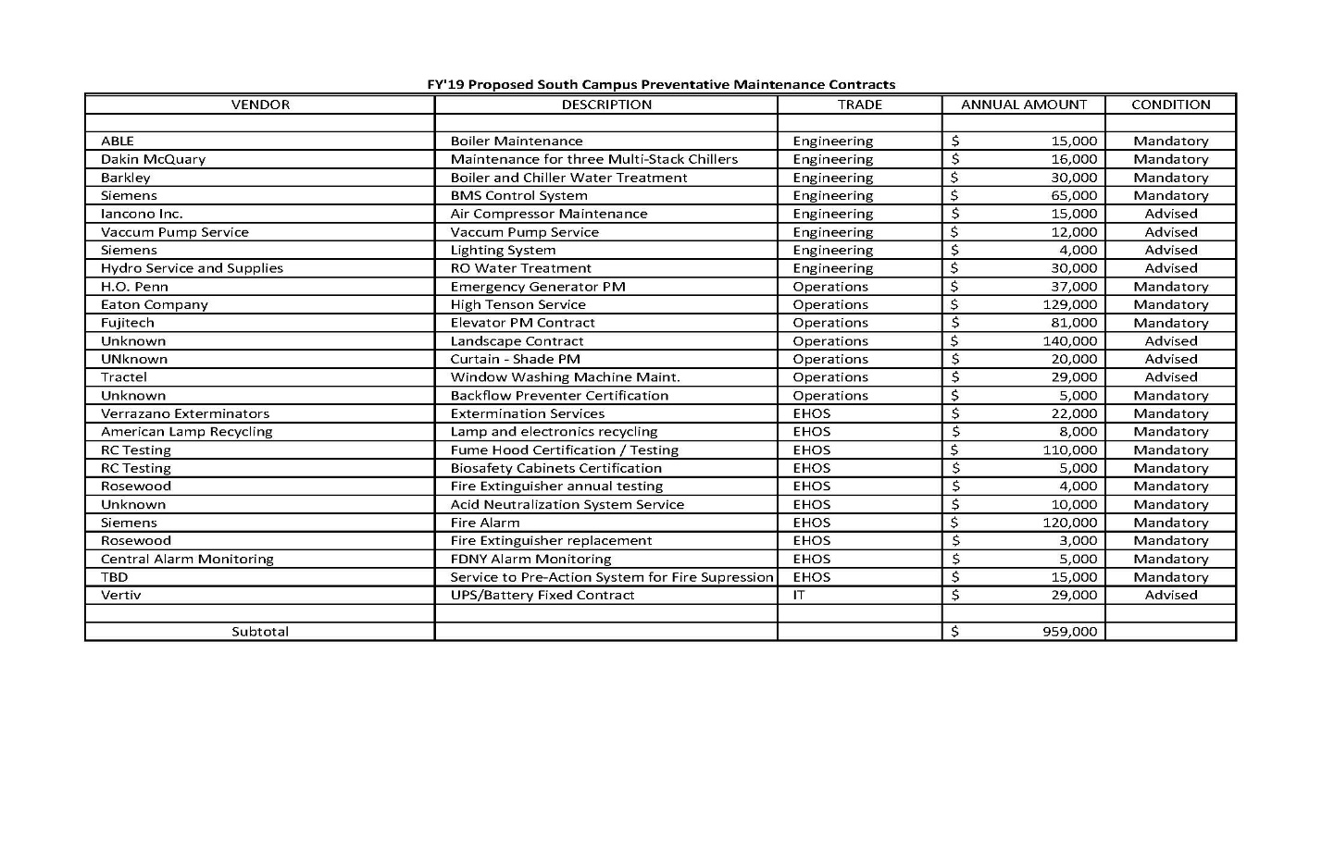

Table 6.2

South Campus OIT Preventative Maintenance Contracts

|  |  |  |
| --- | --- | --- |
| *OIT List* |  |  |
| **Vendor** | **Description** | Yearly Cost |
|  | **Hardware** |  |
| Dell | Blade servers for VM | $ 14,000.00 |
| Dell | Dell PowerEdgeM I/O Aggregator - | $ 1,955.00 |
| NetApp | Storage | $ 31,219.00 |
| Presidio/ went to QED Inc | APC /UPS) | $ 3,900.00 |
| SHI | F5: BIG-IP | $ 26,000.00 |
| Vandis | Infoblox -DNS | $ 13,000.00 |
| VirtuiT System | Liebert Vertic - UPS | $ 25,000.00 |
| Virtuit Systems | Compellent-Storage | $ 38,000.00 |
| **Sub-total** |  | **$ 153,074.00** |
|  | **Software** |  |
| Aruba | ClearPass, 7220 Controllers | $ 41,680.00 |
| Presidio | NetBrain Monitors | $ 25,136.00 |
| SHI | SolarWinds Network Performance | $ 9,000.00 |
| Vandis | Palo Alto Networks | $ 49,000.00 |
| **Sub-total** |  | **$ 124,816.00** |
| Grand Total |  | **$ 277,890.00** |

Research carries an extra burden to the maintenance needs of the campus. Again, prior to the Minor Repair Money and B&E funds being taken away, the committee has been told that the maintenance needs for the campus’ research community was well handled. For example, autoclave equipment or cold boxes used in many research laboratories across campus were covered by annual preventative maintenance contracts. Today, preventative maintenance contracts are not purchased by the science department nor any other department on-campus for the maintenance and repair of specialty equipment dedicated to the research community. The FIT Task Force understands the constraints of the Facilities and IT budgets, but at the same time holds strong belief that since the campus elected to attract research in the first instance that the campus now carries a responsibility to provide adequately maintained facilities in support of the research programs and research grants it oversees. To that end, the FIT Task Force believes that a percentage of the IDC funds, sometimes amounting to 61-percent of grant awards, be separated into a sinking fund account that can be used to support the maintenance of facilities and equipment needed to support the research for which the grants were intended. This conversation is seen as one that needs to occur soon.

From the above it can be inferred that the deferred maintenance of the campus infrastructure that has led to the current condition of equipment began or was accelerated in or around 2004 – 2006 when the Minor Repair Money and the B&E funding was taken from the campus, leaving all maintenance formerly undertaken with funds from those programs to the campus OTPS budget. One also needs to understand the spectrum of maintenance needs on campus, each with customers who hold widely different challenges and expectations in order for them to effectively do their jobs. In the end, quality maintenance is and will always be a function of resources in the form of personnel to undertake the work, budget to purchase the services and supplies and Administrative support to understand the complex and dynamic environment nature of the work and to help navigate the divide between customer service and maintenance support. Information on the OTPS budget and how that interplays with the preventative maintenance is shown in the following section.

**Facilities OTPS Budget:**

Table 7 illustrates the Other Than Personnel Services (OTPS) budget for the Department of Facilities Management for 2010 to 2018. From Table 7 one can see that the level of spending decreased by 33-percent at year 2012 and remained at this level for two years. 2014 showed a slight increase in spending and then remained constant at ±$3M through 2016. 2017 showed another increase and continued through 2018.

Table 7

|  |  |  |  |
| --- | --- | --- | --- |
| FY | OTPS Budget | OTPS Actual Expense | OTPS Unexpended |
|  |  |  |  |
| 2010 | unknown | $3,539,116 | - |
| 2011 | unknown | $3,540,169 | - |
| 2012 | unknown | $2,386,674 | - |
| 2013 | unknown | $2,352,915 | - |
| 2014 | $3,311,599 | $2,816,313 | $495,286 |
| 2015 | $4,065,044 | $3,041,671 | $1,023,373 |
| 2016 | $3,584,836 | $2,923,273 | $661,563 |
| 2017 | $4,386,991 | $3,649,203 | $737,788 |
| 2018 | $5,446,325 | $4,645,325 | $801,000 |
| Note: 2018 Actual OTPS Is Estimated | | |  |

Table 8 breaks-out the North Campus and South Campus budgets separately to illustrate the onset of the ASRC/CDI building which occurred in 2015/16. With the advent of the ASRC/CDI buildings the North Campus budget decreased by ±30-percent in comparison to the FY’14 budget and FY’10 and FY’11 expenditures.

**Table 8**

**OTPS Budget OTPS Actual Expenditure Difference**

**FY ’10 = unknown $3,539,116 -**

**FY ’11 = unknown $3,540,169 -**

**FY ’12 = unknown $2,386,674 -**

**FY ’13 = unknown $2,352,915 -**

**FY ‘14 = $3,311,599 $2,816,313 $495,286**

**FY ’15 (North Campus) = $2,936,732 $2,402,629 $534,103**

**FY ’15 (South Campus) = $1,128,312 $639,042 $489,269**

**FY ’16 (North Campus) = $1,519,107 $1,279,127 $239,980**

**FY ’16 (South Campus) = $2,065,729 $1,644,146 $421,583**

**FY ’17 (North Campus) = $2,007,464 $1,777,619 $229,845**

**FY ’17 (South Campus) = $2,379,527 $1,871,584 $507,943**

**FY ’18 (North Campus) = $2,031,713 $1,781,713 $250,000**

**FY ’18 (South Campus) = $3,414,612 $2,863,612 $551,000**

**Note: 2018 Actual OTPS Estimated**

Regarding the OTPS budget, one of the largest costs that is incurred is that of preventative maintenance contracts. Table 5x and Table 6x illustrate the preventative maintenance contracts for the North Campus and South Campus budgets respectively. From these tables the maintenance contracts have been separated into two categories, mandatory and advised. Mandatory preventative maintenance contracts are driven by regulatory or CUNY guidelines. Maintenance contracts identified as ‘Advised” are recommended for the operation of the campus. In total, the value of the preventative maintenance contracts is equal to $3,368,441. This represents 100% of the current OTPS actual expenditures shown in Table 5.

Table 9 includes a proposed four year OTPS budget for the Facilities Department. From Table 9 it is recommended that the OTPS budget for the Facilities Department be increased to ±$7.5M in FY ’19 with a 5-percent increase to FY’22. Personnel services are estimated based upon the proposed staffing plan shown in Table 2 as implemented over a 4-year period. The results of this budget will be that maintenance contracts needed to provide a continuity of operation on-campus will be in-place together with the resources (personnel and funding) necessary to repair out-of-service mechanical equipment, hire contractors needed for specialty maintenance, undertake in-house preventative maintenance programs, maintain the integrity and usefulness of maintenance equipment, expand the depth and skill-sets of the personnel in the Facilities Department to match the needs of the campus and elevate the overall quality of life for the campus community.

**Table 9**

|  |  |  |  |
| --- | --- | --- | --- |
| **CCNY Office of Facilities Management** | | | |
| **4-Year Budget Projection** | | | |
|  |  |  |  |
| **Period** | **Personnel Cost** | **OTPS** | **Total** |
|  |  |  |  |
| **Proposed FY'19 Budget** | **$15,802,445** | **$7,463,946** | **$23,266,391** |
|  |  |  |  |
| **Proposed FY’20 Budget** | **$17,098,623** | **$7,837,143** | **$24,935,766** |
|  |  |  |  |
| **Proposed FY’21 Budget** | **$18,319,999** | **$8,229,000** | **$26,548,999** |
|  |  |  |  |
| **Proposed FY’22 Budget** | **$20,126,080** | **$8,640,450** | **$28,766,530** |
|  |  |  |  |
| Note: Personnel cots do not include OT, Shift Differential, Temp Services or Holiday Pay | | | |

Form Table 7 and 8 one can see that approximately $750,000, or ±18-percent, remains in the budget at the end of the fiscal year. This results from a number of factors such as purchase orders not issued, invoices not paid in the fiscal year where the expense was incurred, services or supplies not received by the end of the fiscal year and contractual anomalies. Annually the Facilities Department processes approximately 400 purchase requisitions through the CUNYFirst system, which requires in-puts from both Facilities, CCNY Purchasing, CUNY Purchasing and NYS for a purchase order to be issued. Needless to say this process has been found not to be user-friendly and does cause a backlog of purchase requisitions for any point in time. For FY’16, FY’17 and FY’18 the average length of time for a purchase order to be issued once a Purchase Requisition was entered was equal to 72-days, 59-days and 69-days respectively. This data does not include purchase requisitions that could not be issued due to contractual issues.

Preventative maintenance contracts have a strong influence on the OTPS budget.  Drivers for preventative maintenance contracts are regulatory based, institutional based as mandated by CUNY and locally driven by the needs of the campus.  For FY’19 it is estimated that the Facilities preventative maintenance contracts for the North Campus will be equal to ±$2.4M and the South Campus equal to ±$0.96M for a total of ±$3.36M.  The OTPS budget is also driven by the level of annual routine and corrective maintenance that is needed on the campus together with the level of deferred maintenance that has transpired over the years and now needs to be addressed.  Simply put, the maintenance that is required for the campus boiler plants could easily reach $250,000 in a good year and 4x that in the event of a failure.  Next year the NAC Chiller Plant will need to start the 5-year overhauls for the three steam chillers.  Each of these overhauls will cost a minimum $100,000.  If possible the overhauls will be done over three consecutive years.  This is on and above the routine and corrective maintenance for the chiller plant which alone can be another $200,000.

Deferred maintenance holds different needs and shapes its own dimension on the OTPS budget.  For too many years the campus has been treading a fine line wherein primary lead equipment was not replaced but instead secondary or lag equipment was used with no back-up.  In 2018 the Facilities Department began correcting some of this deferred maintenance but more needs to follow for the next four years in order to keep critical systems operating with suitable back-up in-place to avoid catastrophic failures.  Along with the strategy for correcting the deferred maintenance is the need to build an adequately stocked spare parts inventory for critical mechanical equipment so that corrective maintenance can be initiated in a timely manner as opposed to waiting long lead times for equipment orders to be processed and filled.  Where possible we are being strategic with our spare part selections such that they will be able to be used in more than one application.

A strategic four (4) year budget and staffing plan will bring the following benefits to the campus community:

* The Planning Department to hire outside consultants as needed for projects that arise throughout the year;
* The Trades Department to purchase the level of supplies needed to support the maintenance workers, plumbers, electricians, carpenters, and lock smiths throughout the year;
* The Trades to be able to hire outside contractors to perform specialty work such as replacing the exterior control joints or repairing building roofs, both to eliminate water from intruding into buildings;
* The Department of Environmental Health and Occupational Safety to support the programs offered by the Grove School of Engineering, the Division of Science, the Center for Discovery and Innovation and all of the mechanical, chemical, research and teaching labs across the campus;
* The Engineering Division to be able to maintain and repair mechanical equipment throughout the campus, address failures, upgrade system technology, and maintain the second largest boiler plant in NYC; and,
* The Cleaning Division to be able to increase the level of cleanliness across all campus spaces which in-turn increases customer satisfaction and provides for a better quality of life on-campus.

Optimizing the use of the Facilities Budget each year needs to be a priority. Improvement initiatives that could help to increase the spend-down level are as follows:

* Increase the number of open market contracts available to the Facilities Department. This will reduce the number of purchase requisitions that the CCNY Purchasing Department needs to process and will allow products and services to be furnished in a more timely manner;
* Establish authorizations for the Facilities Department to purchase from the NYS OGS Contract through a portal termed NYS eMarketplace. This will allow the Facilities Department to purchase items that are available on the OGS site without the need to process additional purchase requisitions through the CUNYFirst system;
* Allocate a purchasing representative to the Facilities Department whose main focus is the processing of Facilities Purchase Requisitions and bidding of items and services for the Facilities Department.
* Set-up preventative maintenance contracts for a 5-year term so that they are in-place at the beginning of the fiscal year, as opposed to waiting 3-9 months for the contracts to be available to the Facilities Department.
* Develop metrics for how long purchase requisitions should remain in the CUNYFirst system without action;
* Establish a list of M/WBE and Veteran Owned Business for the Facilities Department where common items such as lumber supplies (which always has a long lead time) can be purchased more easily; and,
* Look for opportunities to join Purchasing Consortiums, such and E&I which the college is a member, to help streamline the purchase of goods and services.

**OIT Budget and OTPS**

Historically, OIT’s budget and OTPS has provided for Personnel Services and Operating Expenses (Other Than Personnel Services). Occasionally, OIT will receive funding outside of the normal budgeting channels, such as in FY ’17 when OIT received $527,650 as part of an online education grant awarded by CUNY to the Provost’s office. Additionally, budget allocation comes from both North and South campus funds. Table 10 represents the department expenditure budget for the past five years. Note: FY 2018 expenditure is still in progress. Also notice that personnel salaries in FY 2017 was higher than previous years due to the retro-active salary payment increase.

**Table 10**

**OIT 5-Year Historical Budget**

|  |  |  |  |  |  |
| --- | --- | --- | --- | --- | --- |
| **Allocation** | **FY 2014** | **FY 2015** | **FY 2016** | **FY 2017** | **FY 2018** |
| OIT | $3,492,563 | $3,810,505 | $4,056,836 | $4,966,275 | $5,802,475 |
| Online Education Grant |  |  |  | $527,650 |  |
| **Total** | **$3,492,563** | **$3,810,505** | **$4,056,836** | **$5,493,925** | **$5,802,475** |
| **Expenses** |  |  |  |  |  |
| **Salaries** |  |  |  |  |  |
| Tax-Levy (Temporary Service) | $925,567 | $614,865 | $470,751 | $548,456 | $568,619 |
| Personnel Services (Regular -PS) | $1,995,809 | $2,179,210 | $2,504,870 | $3,291,994 | $3,451,043 |
| **Total** | **$2,921,376** | **$2,794,075** | **$2,975,621** | **$3,840,450** | **$4,019,662** |
| **Other than Personnel Services (OTPS )** |  |  |  |  |  |
| Information Technology Service | $294,837 | $707,261 | $769,468 | $836,800 | $1,454,992 |
| Telecommunications | $276,350 | $309,169 | $311,747 | $289,025 | $327,821 |
| Online Education Grant |  |  |  | $527,650 |  |
| **Total** | **$571,187** | **$1,016,430** | **$1,081,215** | **$1,653,475** | **$1,782,813** |
|  |  |  |  |  |  |
| **Total Expenses** | **$3,492,563** | **$3,810,505** | **$4,056,836** | **$5,493,925** | **$5,802,475** |

Currently, OIT’s budget includes approximately $55,000 that is designated for equipment replacement. This amount covers very little in the way of replacements and is generally for IT departmental equipment. Occasionally, we will purchase equipment for a Division in emergency situations.

It is the FIT Working Group’s recommendation that the College consider a comprehensive equipment replacement plan. Keeping relatively current on the infrastructure hardware and classroom equipment will provide the services our faculty and students expect and position us to utilize the latest pedagogical practices.

Table 11 below shows the current state of much of our infrastructure equipment.

Table 11

Networking Equipment

|  |  |  |
| --- | --- | --- |
| **Device Types** | **# of Devices** | **# of Device at (EOL)** |
| Traffic Application | 1 | 1 |
| Cisco Routers | 4 |  |
| Network Firewalls | 4 |  |
| Cisco Switches | 291 | 177 |
| Wireless Access Points(AP) | 586 | 140 |
| **Grand Total** | **886** | **318** |

|  |  |  |  |  |
| --- | --- | --- | --- | --- |
|  |  |  |  |  |

Excluding the equipment located in the following buildings, ST (Steinman), SH (Shepard) and MR (Marshak) which are being replaced as part of a capital project, we have more than 100 additional switches that are operating at End of Life (EOF) today. These devices are no longer supported and in many cases parts are not available for them if they break. Operationally, they do not handle the demands of our faculty, students or staff. Network equipment typically has a lifespan of six to seven years. We recommend a rapid replacement of End of Life equipment with a future replacement schedule refreshing our network equipment every six to seven years.

Servers should be replaced every six to eight years. As you can see from Table 12, we have 25 servers that are at End of Life. Our demand for storage continues to grow and as we develop online content and move towards electronic record keeping, storage demand will increase significantly. Recently, through a CUNY online education grant, we purchased a new storage system for storing online content as well as other things. That system is in good shape as it is new but our storage system that stores email is at End of Life.

Table 12

OIT Servers and Storage Equipment

|  |  |  |
| --- | --- | --- |
| **Device Types** | **# of Devices** | **# of Device at (EOL)** |
| NetApp- (Controllers) | 2 |  |
| Compellent- (Controllers) | 4 |  |
| Physical Servers (VM hosts) | 57 | 25 |
| Enclosure (NetApp + Compellent) | 13 | 2 |
| Disk-drive | 89 | 24 |
| **Grand Total** | **165** | **51** |

The Telecommunications systems consists of a PBX phone system for North campus and a Voice over IP (VOIP) system for CDI. Table 13 shows CCNY telecommunications equipment that is end of life. The primary PBX that support the majority of CCNY will be End of Life in December 2018. From Table 13, the FIT Task Force recommends replacing this system by EOL to avoid phone disruption that could be very costly for the College.

Table 13

Telecommunications Systems

|  |  |  |
| --- | --- | --- |
| **Device Types** | **# of Devices** | **# of Device at (EOL)** |
| NEC PBX(Phone System) | 2 | 2 |
| NEC PBX Battery Backup | 2 | 2 |
| Telecom –main Air Conditioner AC) | 2 | 2 |
| Campus Emergency Phones(Talk-A-Phone) | 87 | 87 |
| **Grand Total** | **93** | **93** |

Equipment for teaching and learning includes lab and classroom computers and Audio Video Equipment. This technology is a major part of teaching and learning. Most of our AV equipment is so old that it requires VGA connectivity and does not support high definition video. Many of our PCs will not support software needed for instruction. The tables 14 and 15 below show the state of the AV and PC equipment.

Table 14

AV Equipment

Table 15

Equipment in CCNY Computer Labs

|  |  |  |  |  |  |
| --- | --- | --- | --- | --- | --- |
| **School/Division** | **Category** | | | | |
| **School of Architecture** | PC Desktop | **# of Devices/ (2003-2009)** | **# of Devices/ (2010-2013)** | **# of Devices / (2014-2018)** | **Total** |
| **School of Education** |  | **25** | **32** | **32** | **89** |
|  | PC Desktop |  |  |  |  |
|  | Laptop/Tablet | 1 |  | 80 |  |
|  | Apple Desktop |  | 5 |  |  |
|  | Apple Laptop |  | 8 | 12 |  |
|  | iPad/iPod | 20 |  |  |  |
|  |  |  | 49 |  |  |
| **Division of Science** |  | **21** | **62** | **92** | **175** |
|  | PC Desktop |  |  |  |  |
|  | Laptop/Tablet | 78 | 76 | 53 |  |
|  | Apple Desktop | 5 | 15 | 50 |  |
|  |  |  | 12 |  |  |
| **Grove School of Engineering** | PC Desktop | **83** | **103** | **103** | **289** |
| **Humanities and the Arts** |  | **48** | **174** | **271** | **493** |
|  | PC Desktop |  |  |  |  |
|  | Apple Desktop |  |  | 26 | 26 |
|  | Apple Laptop |  | 53 | 97 | 150 |
|  |  |  |  | 7 | 7 |
| **Colin Powell School** |  |  | **53** | **130** | **183** |
|  | PC Desktop |  |  |  |  |
| **CWE** |  |  | **36** | **57** | **93** |
|  | PC Desktop |  |  |  |  |
|  | Laptop/Tablet |  |  | 23 | 23 |
|  | Apple Desktop |  | 30 | 5 | 35 |
|  | Apple Laptop | 4 |  |  | 4 |
|  |  |  |  | 5 | 5 |
| **OIT Labs & Other Labs** |  | **4** | **30** | **33** | **67** |
|  | PC Desktop |  |  |  |  |
|  | Laptop/Tablet | 37 | 167 | 167 |  |
|  | Apple Desktop |  | 12 | 149 |  |
|  | Apple Laptop |  | 81 |  |  |
|  |  |  |  | 25 |  |
| **Student Affairs** |  | **37** | **260** | **341** | **638** |
|  | PC Desktop |  |  |  |  |
|  | Apple Desktop |  | 17 |  |  |
|  |  |  | 22 | 10 |  |
| **Seek Program** |  |  | **39** | **10** | **49** |
|  | PC Desktop |  |  |  |  |
| **Grand Total** |  |  | **12** | **20** | **32** |

1. **Research**

As with other universities, academic research at CCNY takes many different forms – involving anywhere from individuals to groups, in facilities ranging from single offices to large multiuser equipment installations. Clearly, these different research modes have markedly different requirements for facilities, IT and space resources on campus; STEM (Science, Technology, Engineering and Mathematics) research modes are typically more demanding on these resources than for other fields, given their integral use of large and specialized experimental and computational instrumentation with often complex infrastructure requirements.

Among campuses in the CUNY system, CCNY has traditionally been the leader in STEM research. According to the 2016 RF-CUNY Annual Report, of all of the 24 CUNY colleges, CCNY leads CUNY with over $51.7M in external funding[2]. CCNY research grants account for 30% of all CUNY research awards. This leadership position has been strengthened during the Decade of Science (2005-2015), City University’s commitment to advancing science at the highest levels by investing over $1 billion on the construction and modernization of science facilities. While this initiative has enhanced STEM operations across campuses, its greatest impact has been felt on the CCNY south campus with the addition of 215,000 NASF (400,000 GSF) of research space through the CCNY Center for Discovery and Innovation (CDI) and CUNY Advanced Science Research Center (ASRC). As a result, the percentage of research space on the CCNY campus increased from 11% in 2013 to 24% in 2016. Research space on the CCNY campus now accounts for 46% of all CUNY research space.

With these new research opportunities – especially, the starting of new research initiatives – comes the requirement for substantial long-term commitments to ensure the upkeep of specialized infrastructure needed for this work. In particular, such activity requires well-functioning physical and IT infrastructure for research to proceed in a timely and effective manner; indeed, such is explicitly or implicitly assumed to be in place for federal research grants.

Yet, a preliminary analysis of budget trends over the past 10 years indicate that the substantial increase in research infrastructure (+59% without ASRC, +124% with ASRC) has not been accompanied by a commensurate increase in resources for Facilities Management and OIT. When the two new buildings opened in 2015, the tax levy budgets of these two departments were at an all-time low (-19% and -43%, respectively, compared to five years earlier). Although the trend has been reversed in the past two years, current tax levy allocations have not yet caught up with the levels of 10 years ago despite substantial increases through two rounds of contractual salary increases.

We note that this decrease in tax levy spending for the facilities and OIT budgets has not been offset by increased spending from other sources, particularly indirect (“overhead”) funds from research grants. A cursory review of the past five years’ data shows that while external awards have generated a fairly constant amount of overhead since 2013 ($9M a year on average), Facilities and OIT received no significant funding from IDC during that period ($300K total in five years). Even more alarming, the share of IDC spending by academic units dropped from $5.1M in 2013 to $2.7M in 2017. We will incorporate a more thorough review of this important issue in our final report.

What are the appropriate levels of funding to insure the viability of the research infrastructure throughout the CCNY campus? This is what this committee will attempt to answer over the next three months.

Adequate resources for FIT, while a critical component of successful research, is only one of the areas most in need of improvement as far as their impact on the conduct of research. The committee has identified several other areas and will make recommendations for each of them:

* Transparency in use of indirect costs for academic research; establishing separate overhead budgets for FIT that will be earmarked for research infrastructure support;
* Better communication between FIT and researchers:
* implement ongoing feedback mechanisms to gauge customer satisfaction (e.g., forumCures)Identify physical space and IT needs specific to cutting-edge research (e.g, networking speeds and bandwidth);
* open, two-way discussions to determine cost sharing between university and faculty;
* Better communication and cooperation between CCNY and CUNY ASRC; and,
* Transparency in criteria applied to optimizing utilization of research space across campus.

1. **Space:**

The Physical spaces – rooms, gyms, labs, lecture halls, public spaces – we use to carry-out the work of the college is a silent but major part of our culture. The size, shape, furnishings and condition of our spaces determine directly and indirectly how well we function. And, the perceived condition of our facilities is taken as an indicator of our institutional health by students, faculty staff, donors and the public - prospective and current.

Facilities are also a major component of spending for such things as energy use, personnel deployment, and maintenance contracts for elevators and escalators, heating and cooling equipment.

The capital funding of the college, while separate from operational funding, is nevertheless closely related and must also be considered going forward.

Utilization

The “capacity” of the college can be measured in multiple ways including the amount and type of facilities available for the various uses such as instruction and research. The university collects data relevant to facilities capacity and there are means to determine from the data actual student and research capacities.

However, there are a number of intervening factors which can impact capacity, particularly student instructional capacity, including scheduling policies, use of technologies and instructional delivery means such as on-line courses.

Space Recommendations

Following are preliminary recommendations. Further collection and analysis of data will be required to prioritize and to add further detail.

Master Plan: Take steps to initiate a new campus Master Plan. The college’s last masterplan was issued 46 years ago making it ten years older than any other CUNY senior master plan and well beyond the average cross-university age of 18 years. The master planning process provides a number of opportunities for facilities and overall campus improvement as well as reconciliation and recognition of the college’s unique mix of academic activity.

Refurbish Cycle: Establish, budget-for, and carry-out regular cycles of finish, furnishings, and equipment refurbishment for spaces, particularly instructional, conference and public.

Design for Maintenance Reduction: Utilize materials and methods, and select furnishings and equipment to reduce maintenance costs and improve overall conditions. While initial costs might be higher, long-term maintenance costs can often be reduced by selection of more rugged finishes, materials and equipment. Simple design elements may also be employed to reduce maintenance and lengthen refurbish cycles.

Examine expedient (low cost) Space Improvement: Survey various types of spaces, particularly instructional, to determine opportunities for simple re-configuration and re-furnishing to expand capacity or improve utilization.

Examine capital-level (more extensive) Space Improvement: Survey instructional spaces to determine larger scale or more extensive opportunities for re-configuring space to adapt to changing needs in the Academic, Research and Public areas.

Data Sources

The university, in cooperation with each campus, maintains a comprehensive space and facility inventory (referred-to as the “Archibus” system) containing a wide range of information for every space in the university. Included for each space are physical attributes such as area, special equipment and services. In addition the type of space (classroom, lab, office, lounge, etc.) and its allocation (by division, department, etc) are recorded in a database which can be integrated with other university information sources such as course schedules, research activity and facilities management.

The Archibus system is used by the Research Foundation to collect grant information (A21). It is reported that, incorporating the room data from Archibus increased the total square footage reported as assigned to ‘research’, used for calculation of an indirect cost rate, resulting in an indirect cost increase of 26.9%. It is also reported that it boosted the total research square footage reported, resulting in a 37.9% increase in direct funding.

Several personnel in the CCNY Facilities Office are responsible for coordinating with the CUNY central space inventory group and are able to access CCNY data in a number of formats and report types. Also available is limited information about other CUNY campuses and the university in aggregate.

Information from the CCNY Scheduling Office, particularly when integrated with space data, is key to better understanding instructional capacity. Appendix C is an overview of the Archibus data available and selected reports for CCNY facilities.

1. **Modernization**

As the flagship of the City University of New York (CUNY) system, The City College of New York has a responsibility to provide up-to-date facilities and information technology services to our faculty and students. Furthermore, the maintenance of our physical facilities and information technology infrastructure are directly related to our ability to create an environment that fosters quality teaching, high morale and retention of quality faculty and students. In the past few years, administrative instability and severe budget constraints have been identified by faculty and students as primary barriers to classroom instruction and academic success.

This interim report opened with a discussion of the 2013/14 Faculty Council survey.[3] Here are some excerpts from the report, from a wide range of academic departments, which demonstrate the universal urgency of this issue:

1. “The physical state of the laboratory rooms and the furniture in there is dilapidated and almost dangerous in some cases. Second the equipment used in the laboratories are all old. All of this makes any effective teaching and training nearly impossible.”

-Department of Biology;

2. “Broken chairs in the lecture halls of Marshak seem to be a common problem. This is particularly bad in smaller lecture halls such as MR-1 where class size commonly approaches or surpasses the number of functional chairs. This also impacts the ability of the faculty to administer exams since students are practically on top of each other in these instances and are unable to spread out.”

-Department of Chemistry

3. “The EAS Department makes use of the Divisional computer classroom MR 044 for our computer-intensive courses. However, the computers in MR 044 are too slow to allow them to be used for many exercises involving remote sensing. Also, there are currently only about 15 computers in the room that will run the geophysics CD’s, used in EAS 565, without freezing.”

-Department of Earth and Atmospheric Sciences

1. “In addition, like everybody else in the NAC, we constantly operate in an environment of broken escalators, dirty windows, broken blinds, non-functioning wall clocks, antiquated and damaged classroom furniture, temperature extremes, dirty student bathrooms, heavy fire doors with malfunctioning (or broken) panic handles, etc.”

-Department of Economics and Business

1. “My panel of five external reviewers were shocked to discover the lack of instructional technology in our classrooms, and they noted that this deficiency has kept our composition pedagogy a couple of decades behind-the-times. Smart Boards would enable us to do amazing work in lower-division composition classes and the college would see an improvement in student writing as a result.”

-Department of English

1. “My concern about classrooms is simple: most classrooms are dirty, if not filthy. They are rarely vacuumed, garbage is everywhere, etc.”

-Department of French

1. “We are being encouraged by the administration to develop hybrid courses but have concerns about the viability of this push given the technology issues facing the college”

-Department of History

1. “Using Internet-housed info in classrooms is also severely hampered by no or slow Internet access in Shepard. It is frustrating to students and faculty alike. Using either the wifi on their laptops or the connection at the Instructor's station, students have been unable to download presentations from our online course platform. Note: these were NOT large files. Our new end-run has been to ask students to upload from home (or NAC) a day before class and bring material on a flash drive.”

-Department of Media and Communication Arts

1. “Instructors end up wasting time in class, trying to get equipment to work.”

-Department of Foreign Languages and Literature

1. “The carpeting in our classrooms is now 20 years old and in serious need of replacement because they are all filthy, ripped, and moldy.”

-Department of Music

1. “More generally we face the problem of inferior teaching conditions...”

-Department of Philosophy

Each of the survey comments above can be categorized under the heading of Modernization. In 2015 and 2016 a concerted effort was made to rehab classrooms and lecture halls with new furniture and finishes. During this time 1050 new tablet arm chairs were purchased, nine (9) classrooms were converted to smart rooms, nine (9) classrooms received upgrades to their IT/AV equipment, 37-rooms received new carpet, 30-rooms received new window treatment along with ceiling, wall, door and lighting repairs. Since that time no new projects have been undertaken with a focus on modernizing classrooms and lecture halls.

In addition to classrooms and lecture halls, the campus has over 300 teaching and research laboratories combined, four main libraries, >300 restrooms, ____ sf of corridors and 36 acres of hardscape that are all in varied conditions. Together the state of these facilities form impressionable imprints on the students, faculty and staff and in many ways influence their thinking, their attitudes and their achievements. The FIT Task Force finds that the no other sources of funds are available to implement and maintain a schedule for modernization of the campus classrooms, lecture halls, libraries, teaching laboratories, and other areas or facilities that directly influence a decision for a student to come to CCNY in the first place and are needed and necessary for faculty to teach and students to learn. Accordingly, the FIT Task Force finds that a program for modernization needs to be established and maintained to insure that classrooms, lecture halls, music rooms, arts and sciences laboratories, theatrical spaces, libraries and all student spaces will provide for spaces for excellence in teaching and learning.

1. **Conclusion:**

This Report represents an interim work product from the FIT Task Force. The report lays out many of the topics, observations and suggestions deliberated by the FIT Task Force to-date. It is the general consensus of the FIT Task Force that the discussions and recommendations presented in this Interim Report represents the scope of work that the FIT Task Force has been pursuing and illustrates, in large part, the format and breadth that will shape the Final Report. Formatting and stylistic edits will be addressed under the Final Report.

Endnotes

Appendix A

Cleaning Standards

Association of Physical Plant Administrators

And

APPA Custodial Staffing Guidelines

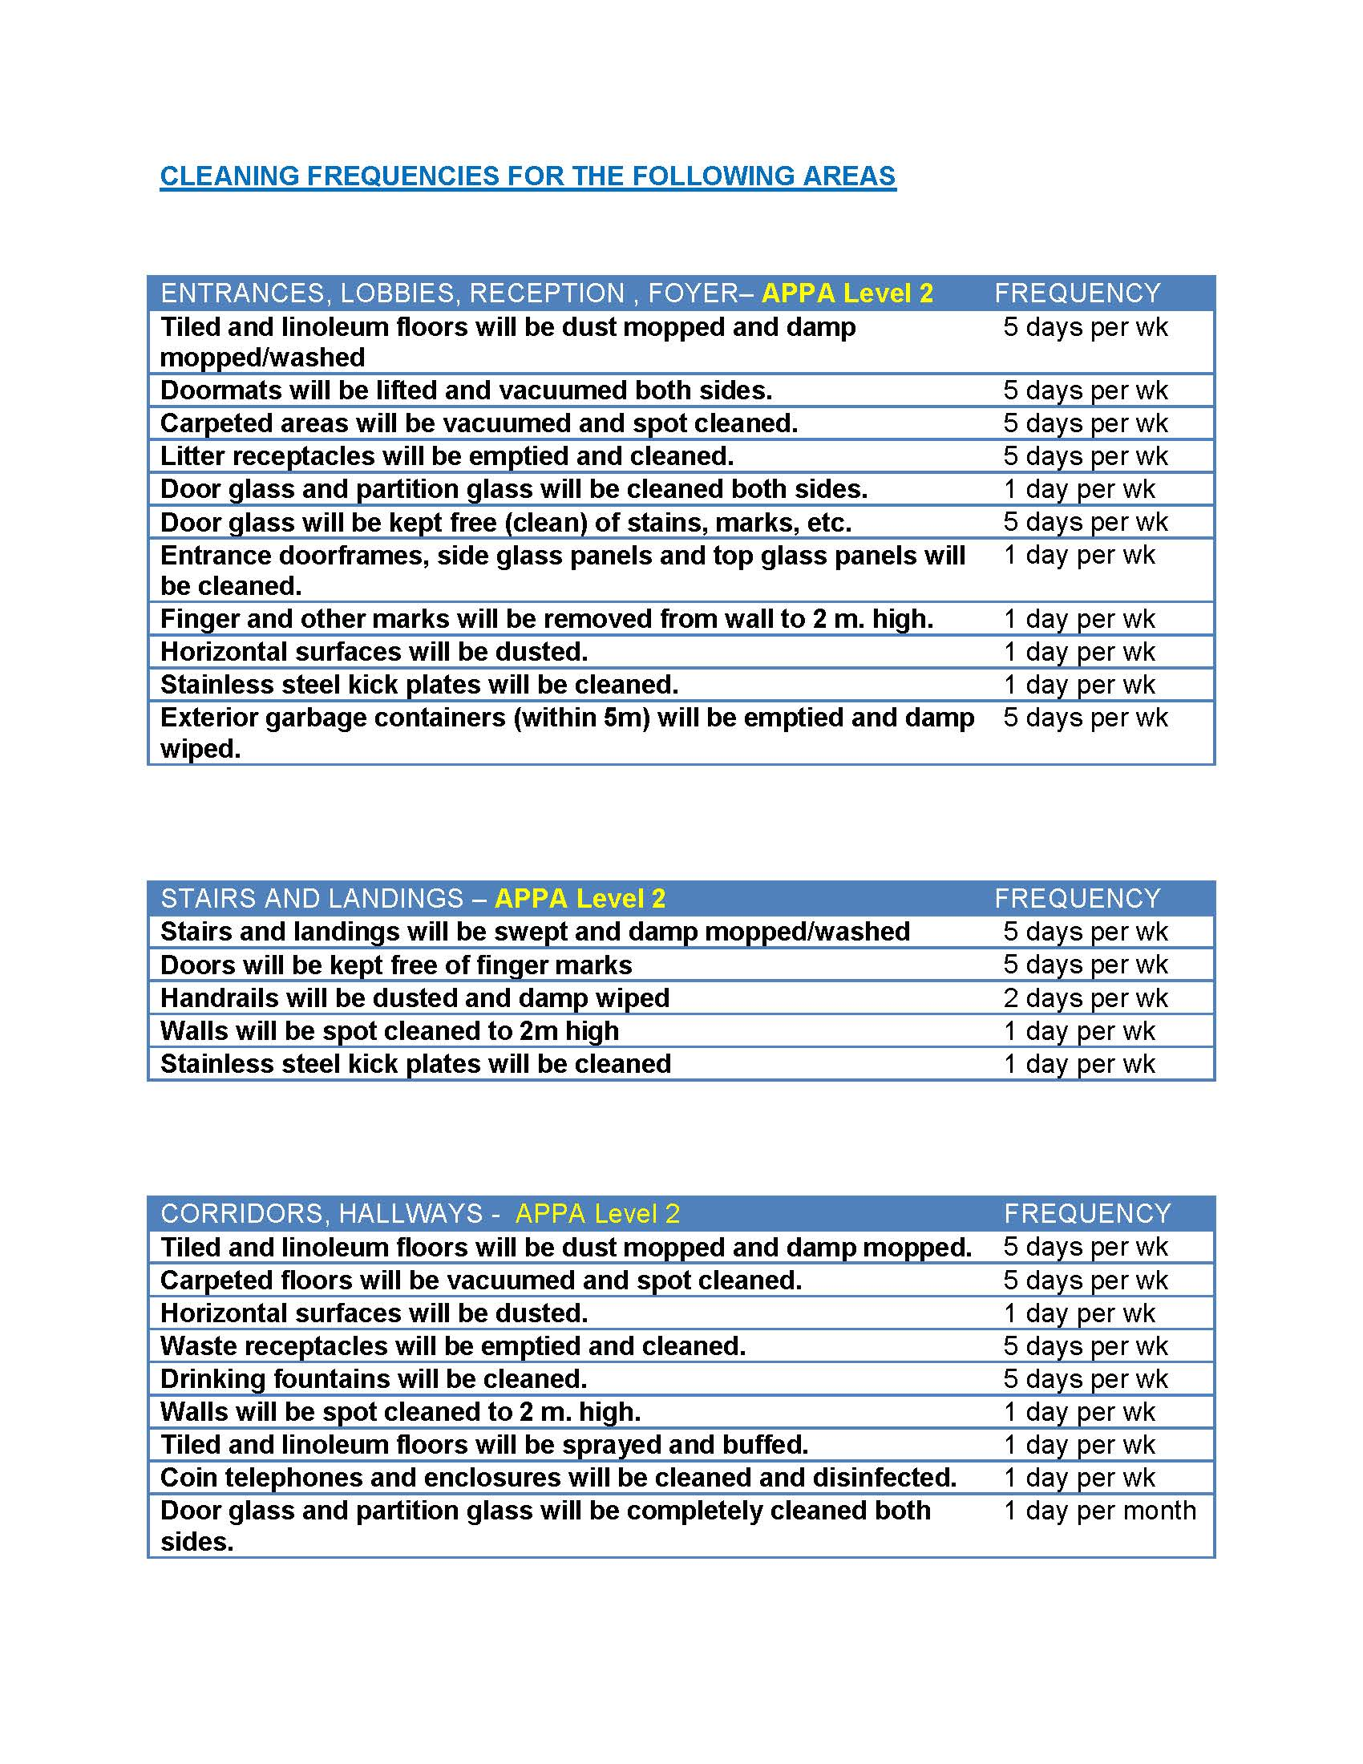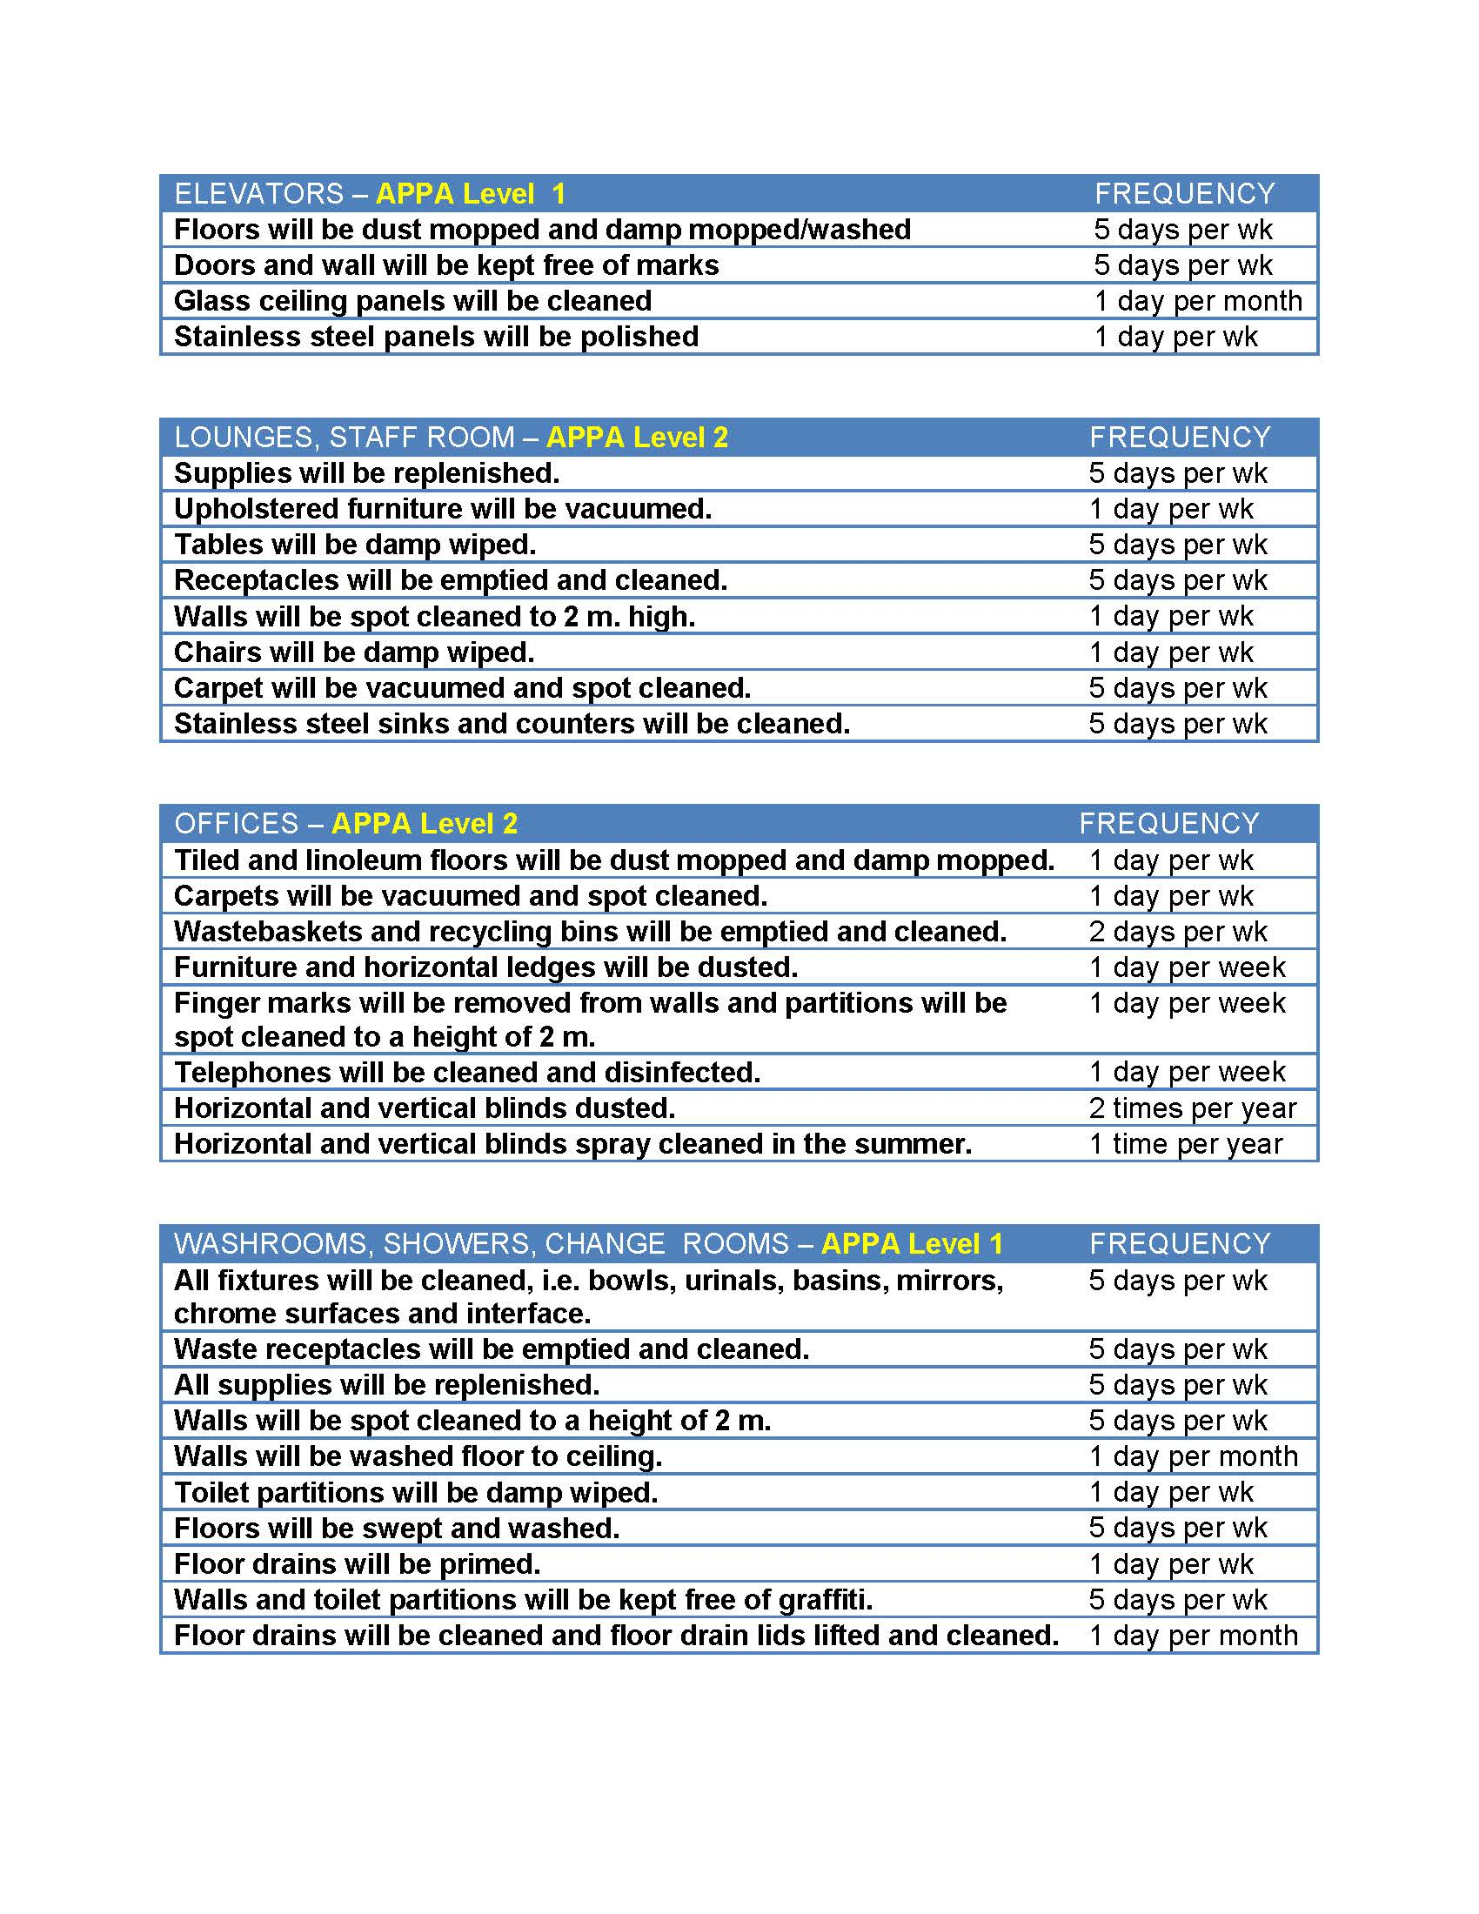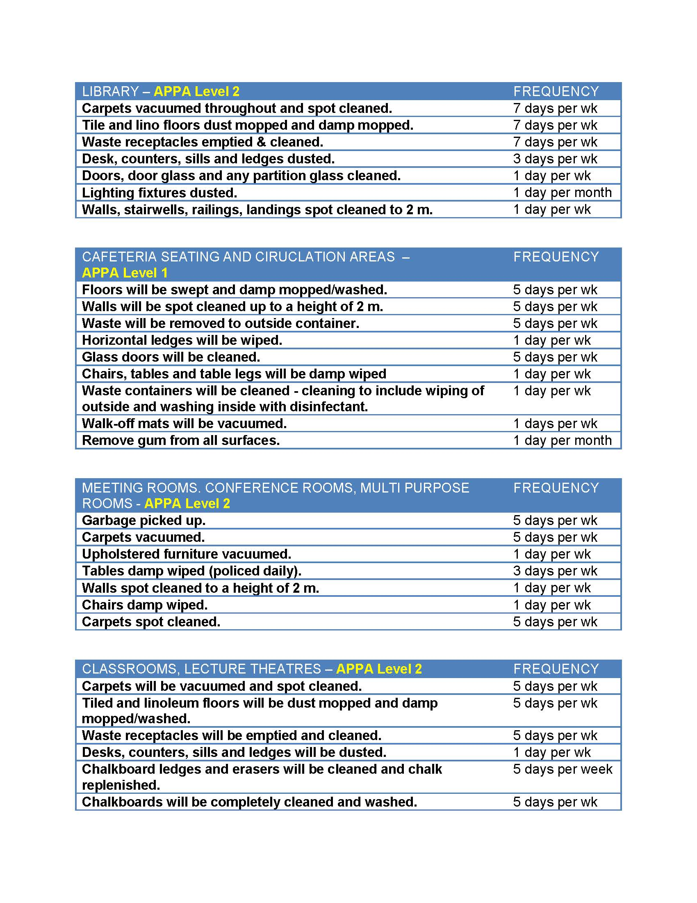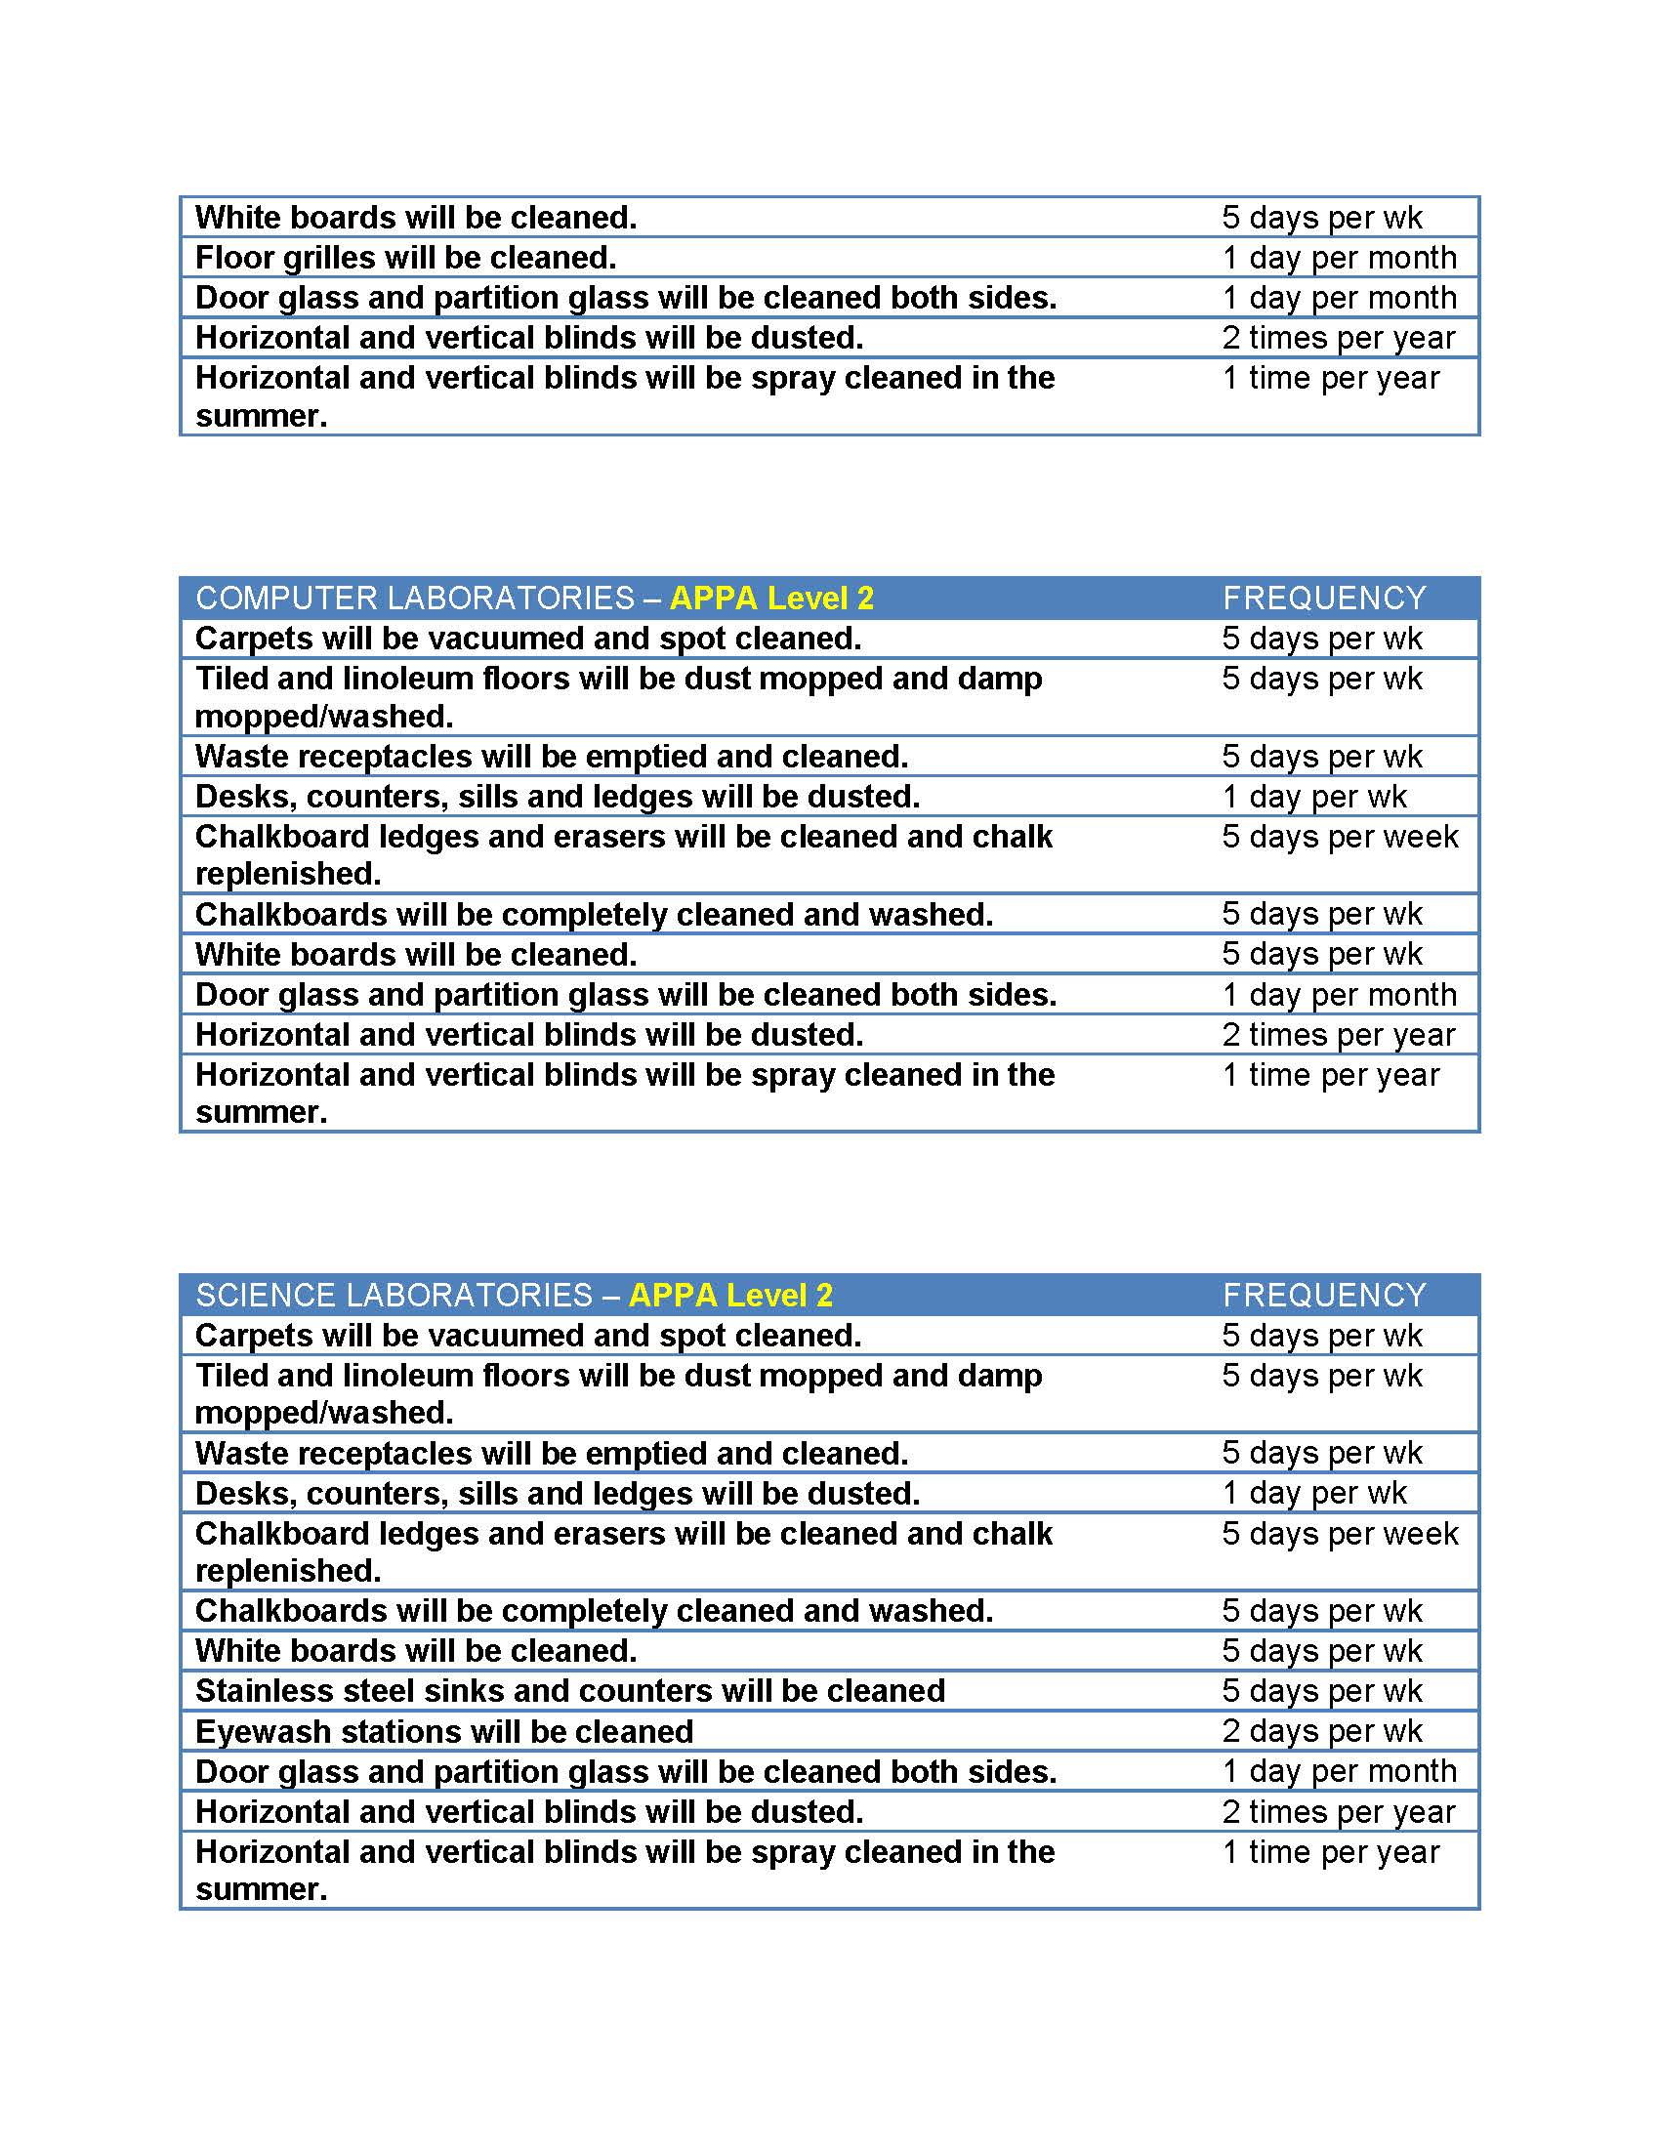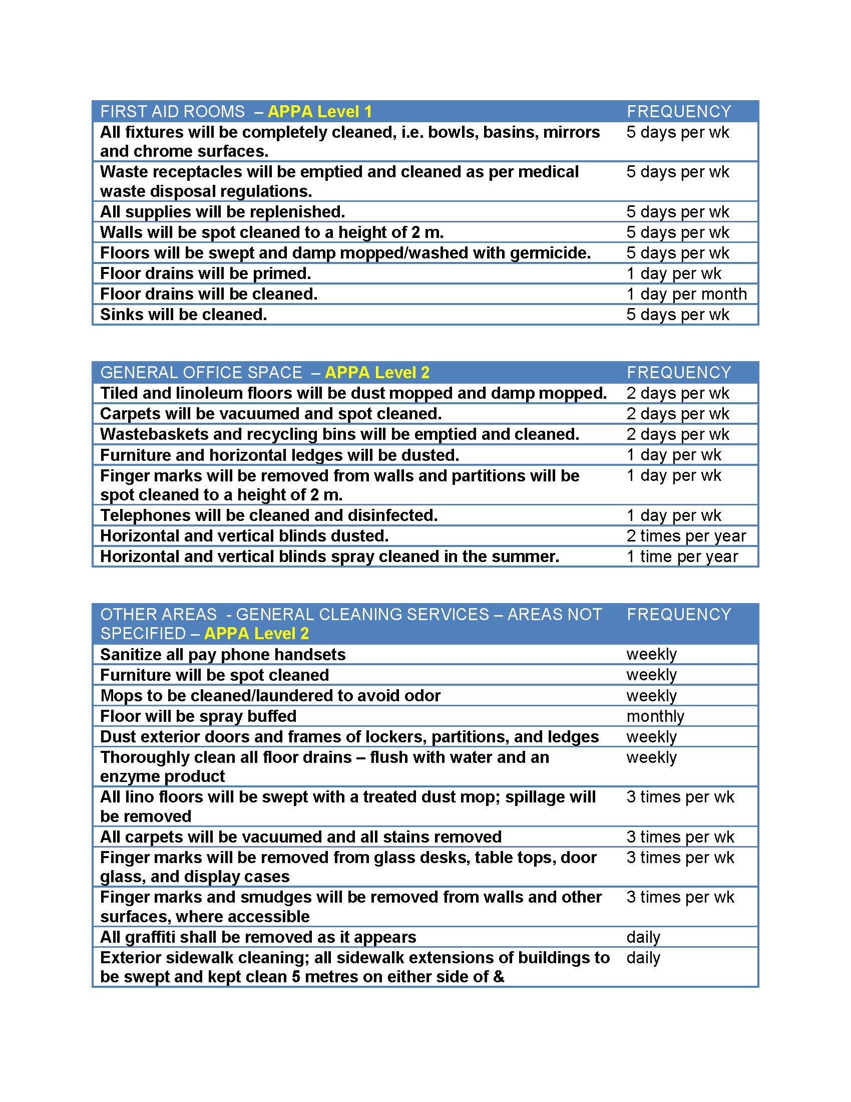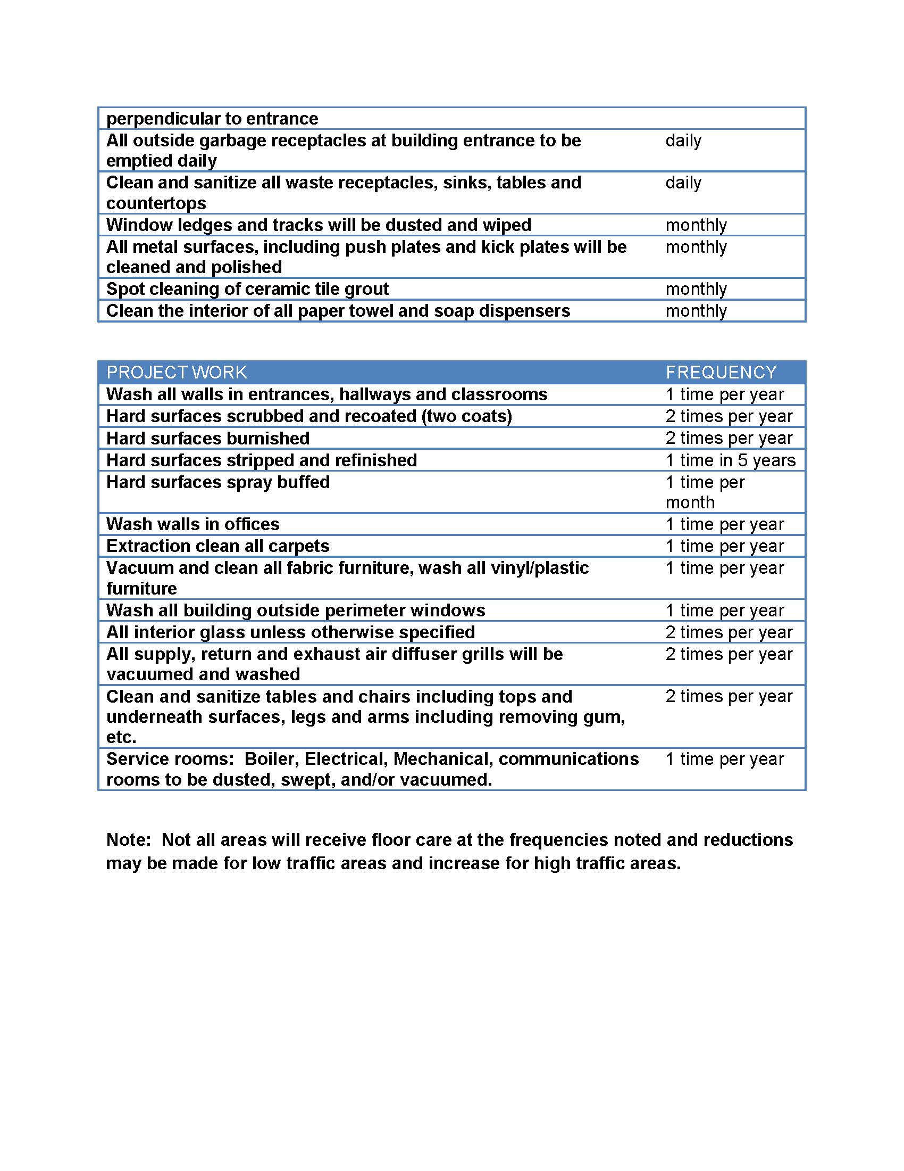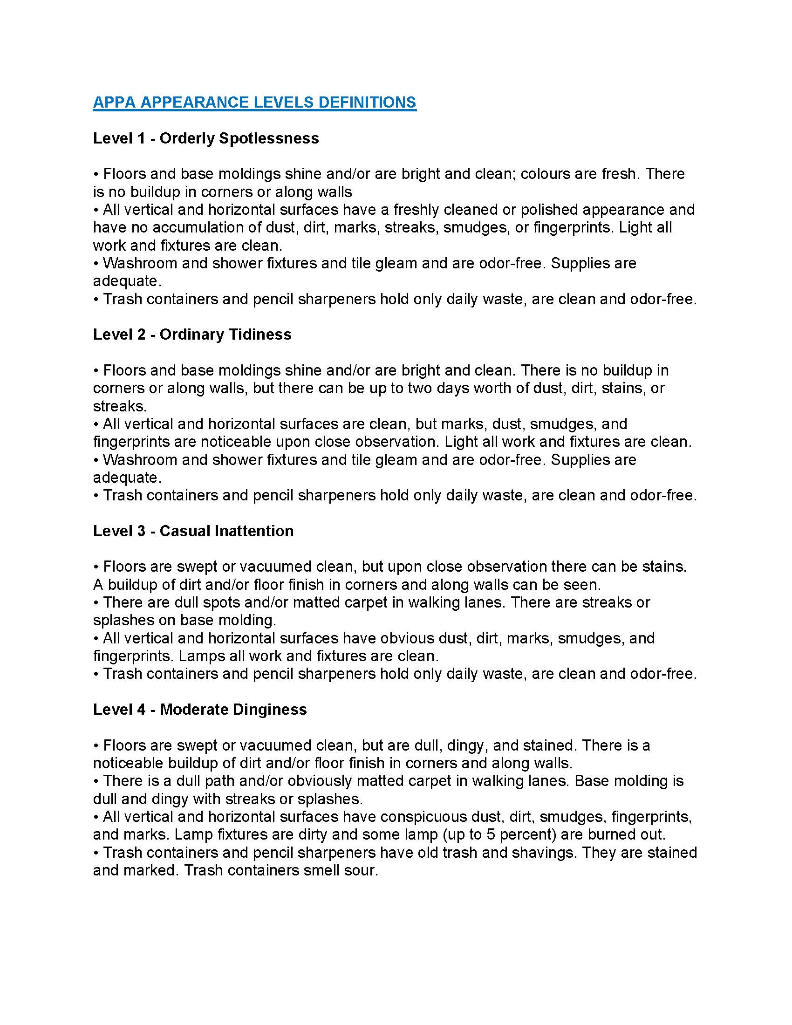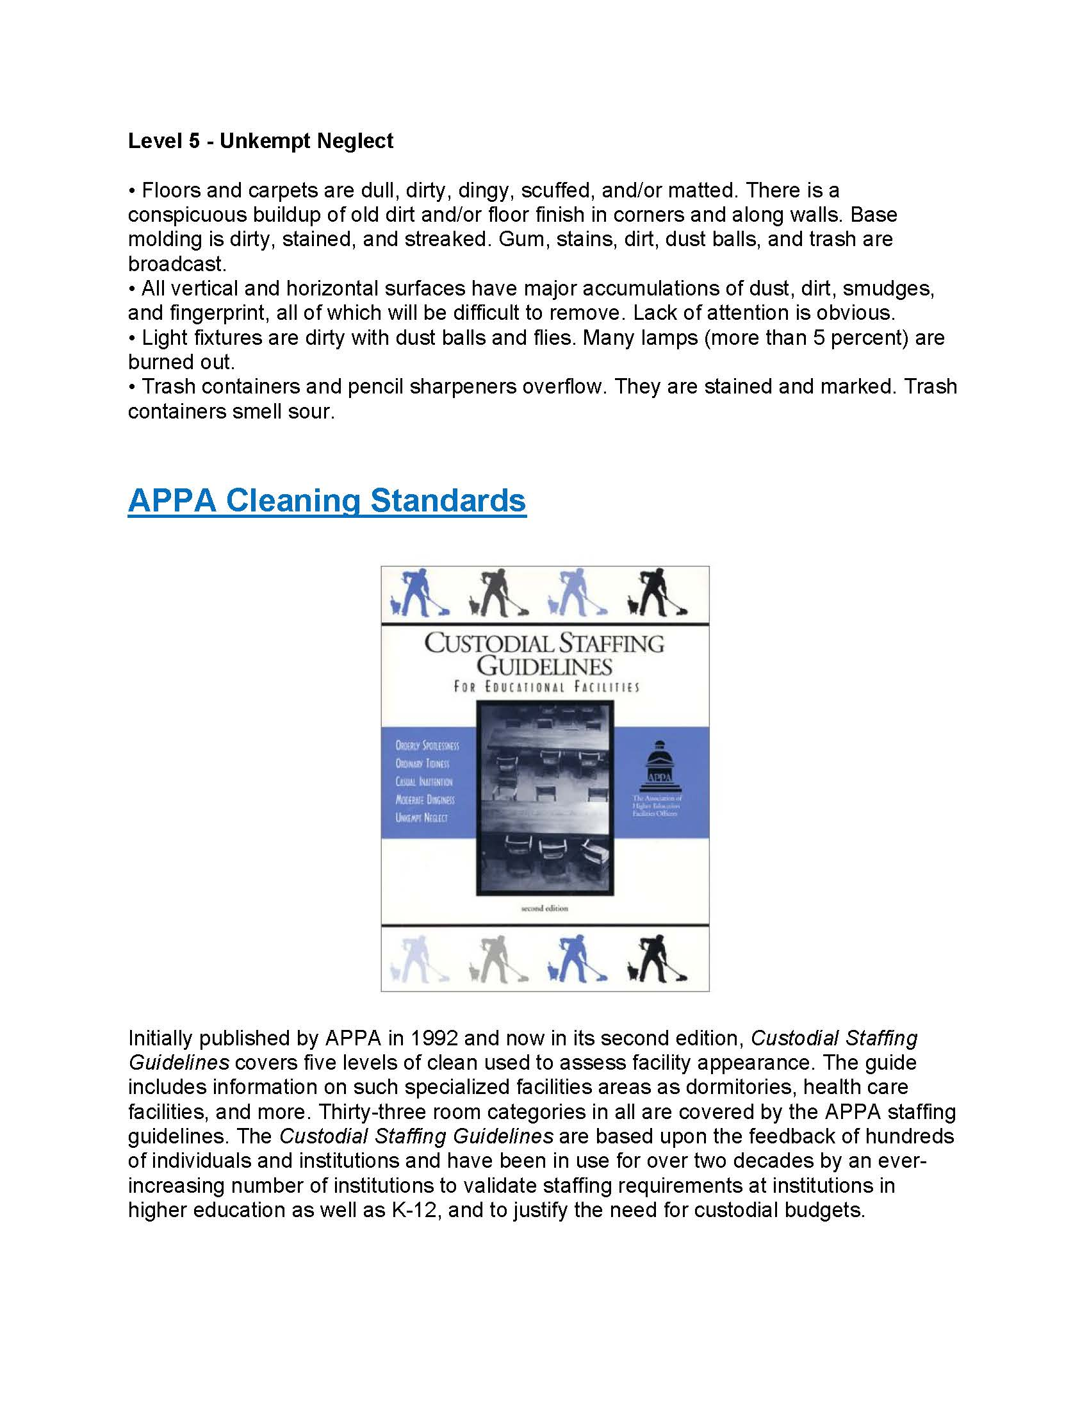

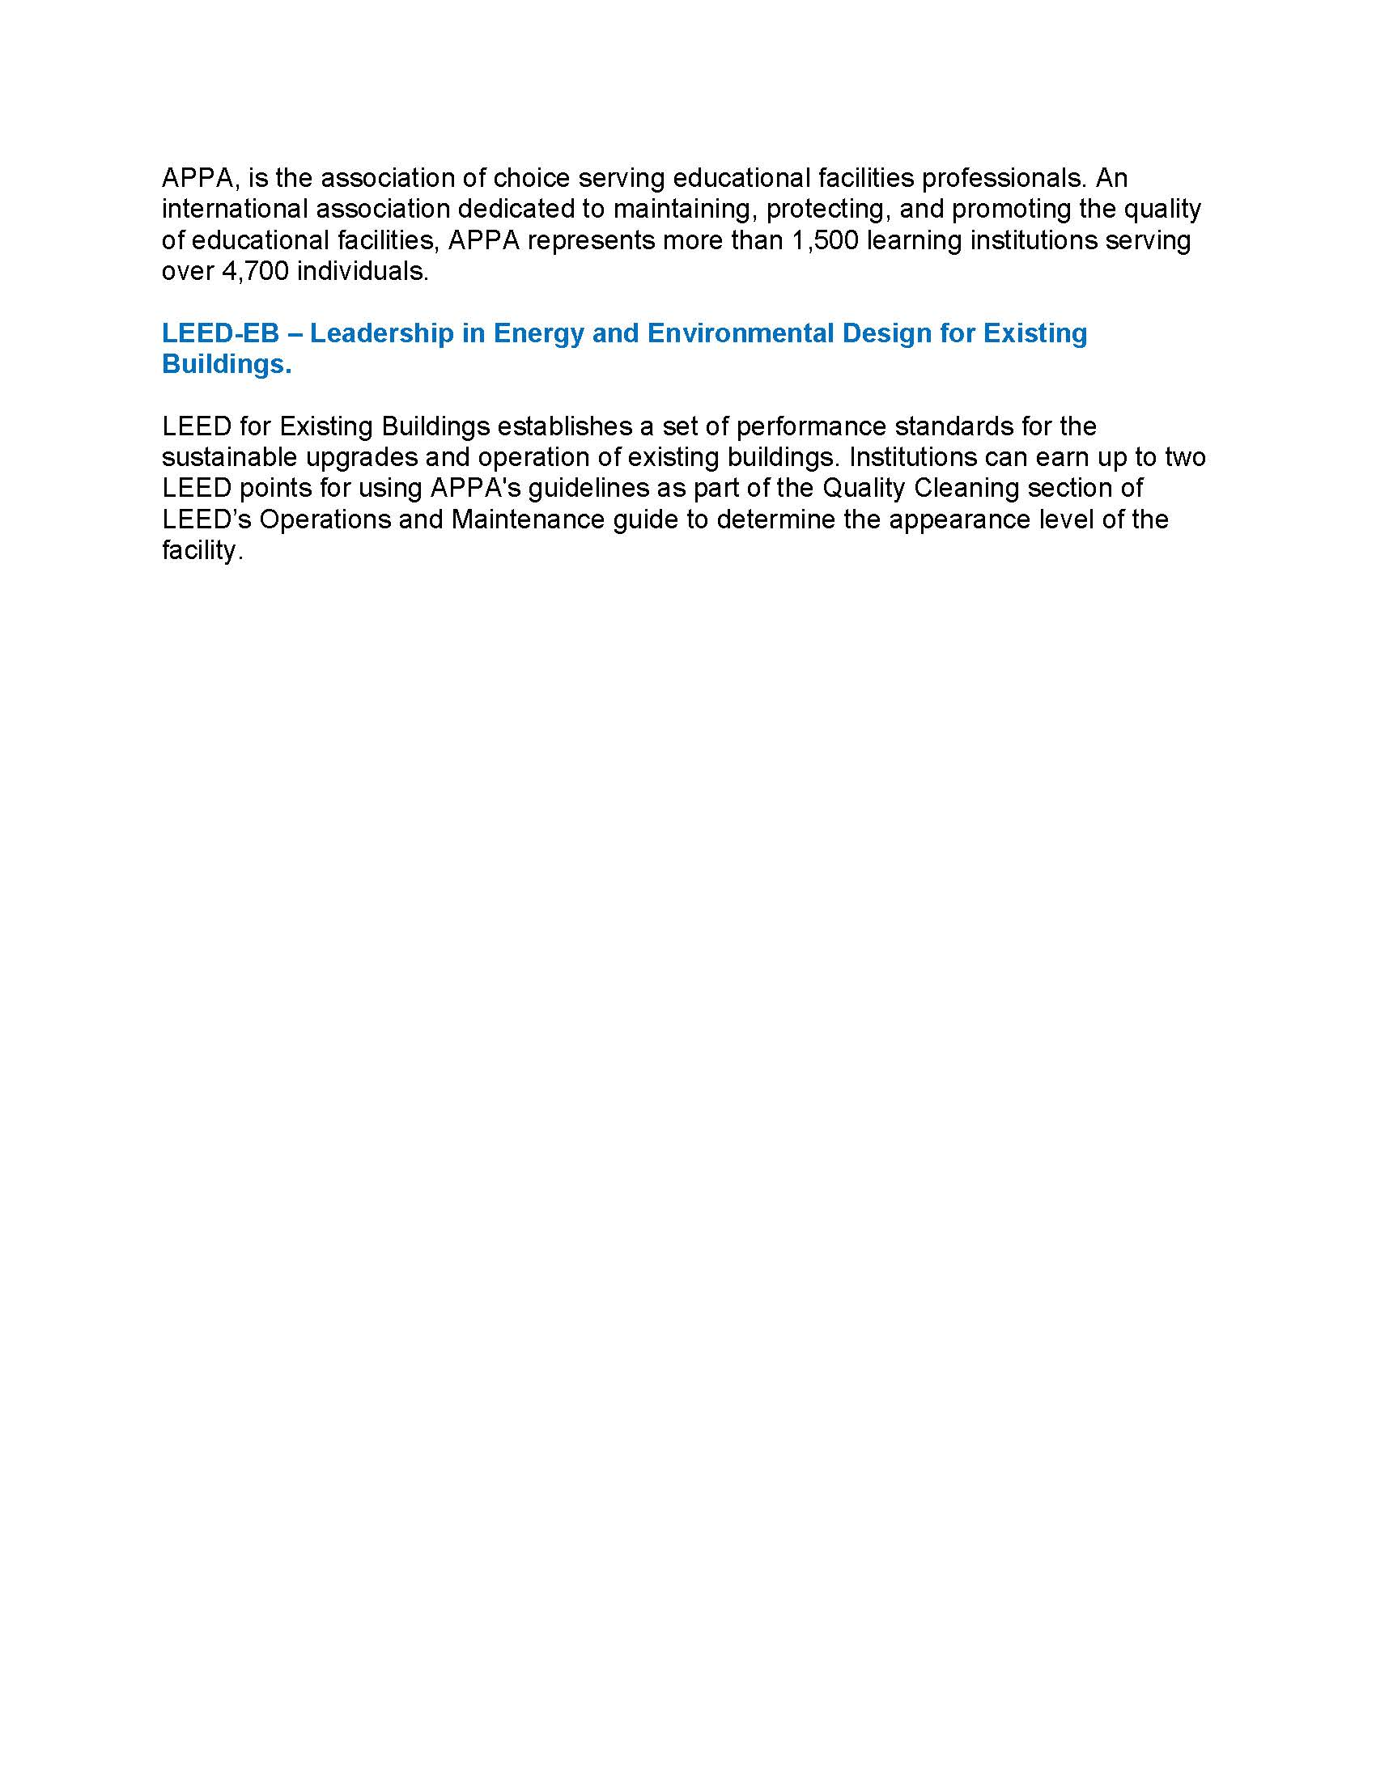

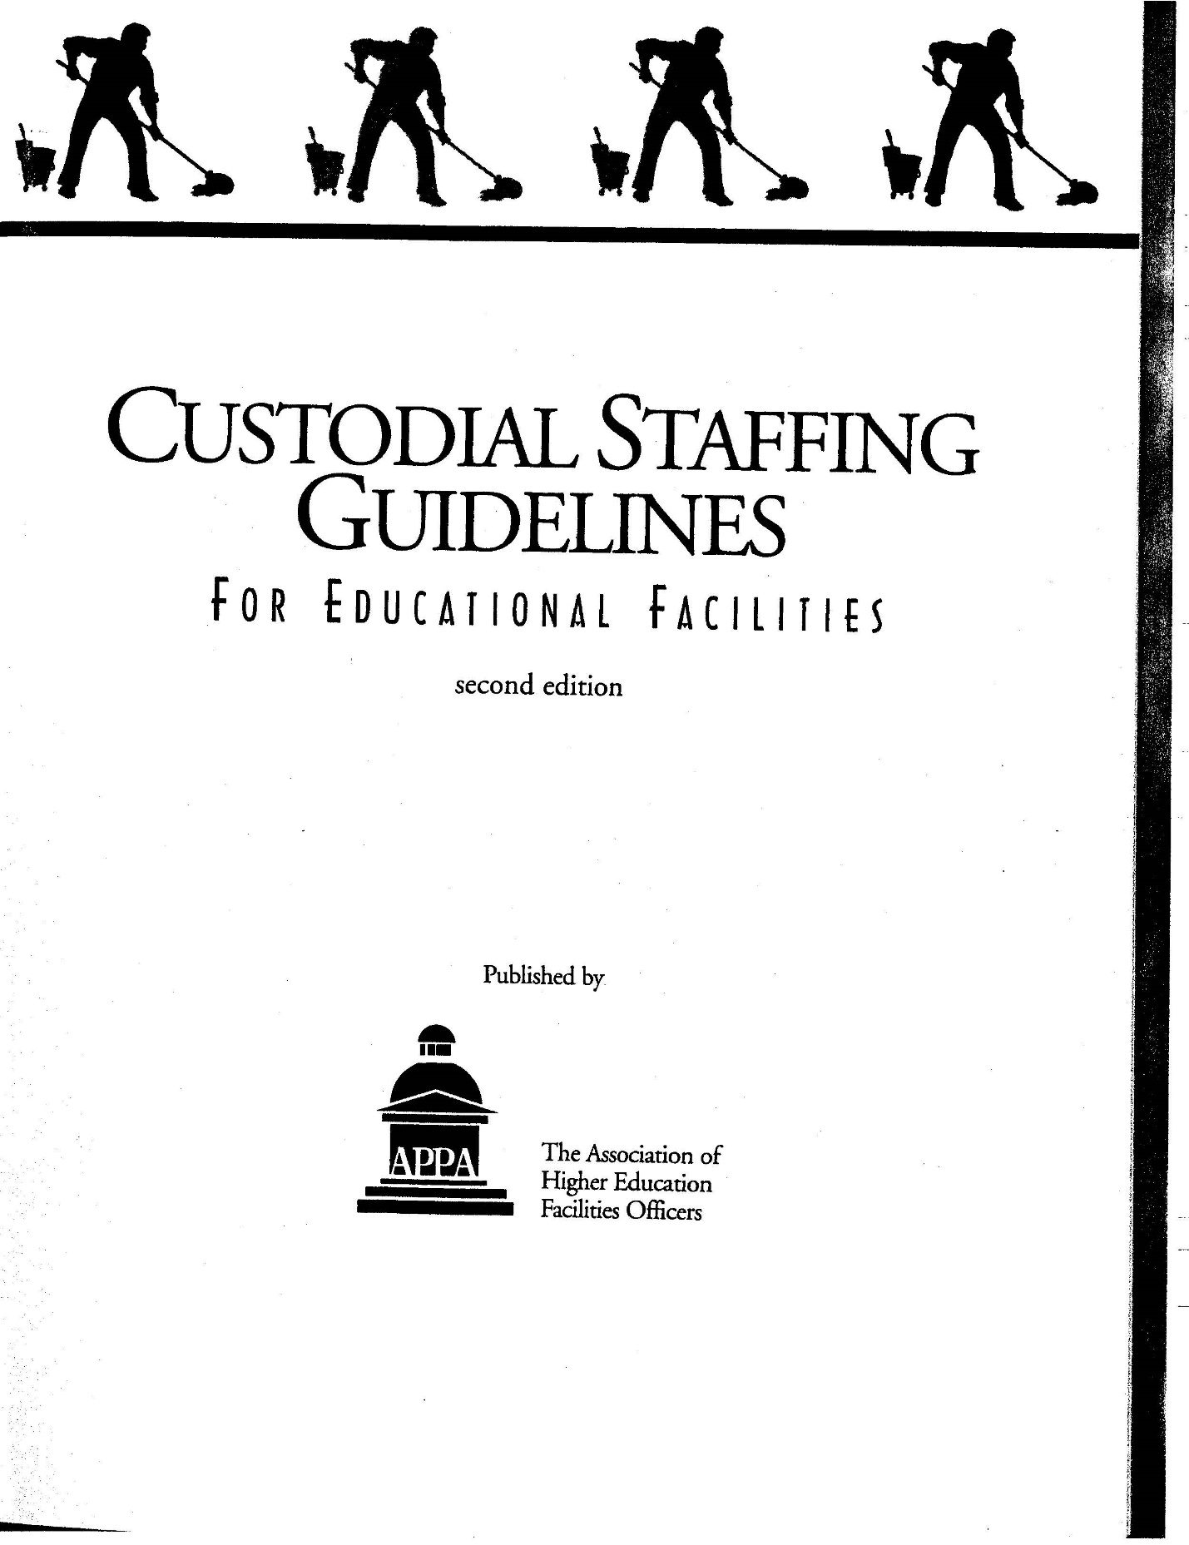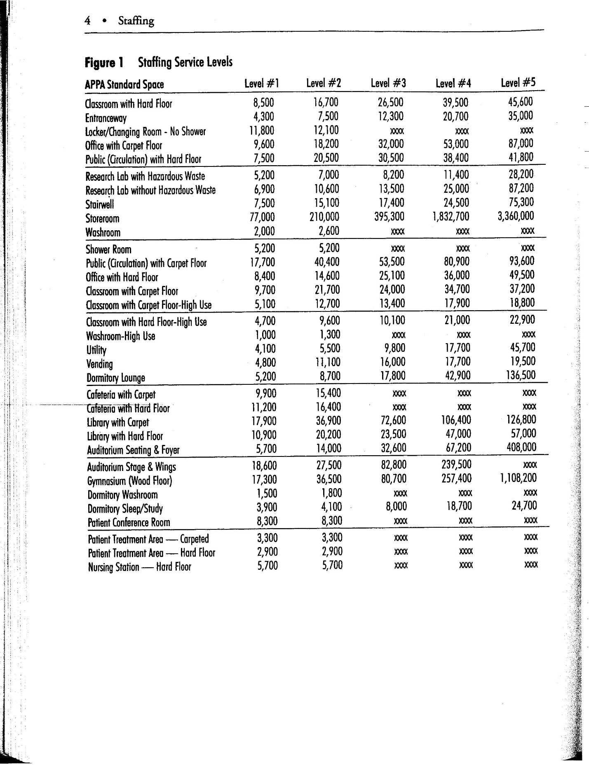

Appendix B

Oakland University Camous Cleaning

and

APPA’s 5-Levels of Cleanliness

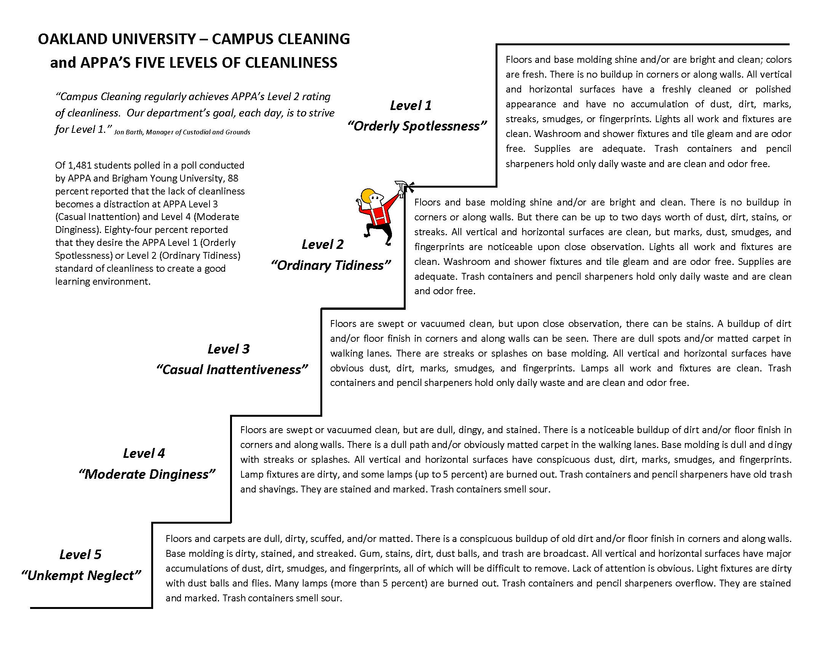

Appendix C

CCNY Archibus System

Space Inventory Data

CUNY SPACE DATA (Archibus)

**DATA ELEMENTS**

**Data available for each building, each floor, and each room**

|  |  |  |  |  |  |  |
| --- | --- | --- | --- | --- | --- | --- |
| **BUILDING INFORMATION** | **FLOOR INFORMATION** | **ROOM INFORMATION** | | **ROOM BY CATEGORY** | | **ROOM USES** |
| **Campus Id** | **Building Name** | | **Building Code** | | **Room Type** | **Room Use** |
| **Building Code** | **Floor Code** | | **Floor Code** | | **Description** | **Description** |
| **Building Name** | **Floor Name** | | **Room Id** | | **Type Count** | **Total Area** |
| **Address 1** | **Ext. Gross Area** | | **Room Name** | | **Average Area per Type** | **Room Use Count** |
| **Postal Code** | **Room Area** | | **Room Area** | | **Total Area** |  |
| **Block Number** |  | | **Room Category** | |  |  |
| **Lot Number** |  | | **Room Type** | |  |  |
| **DOB Bin Number** |  | | **Division Code** | |  |  |
| **Number of Floors** |  | | **Department Code** | |  |  |
| **Date Built** |  | | **Capacity** | |  |  |
| **Date of Rehab** |  | | **Room Use** | |  |  |
| **Building Use** |  | |  | |  |  |
| **Building Status** |  | |  | |  |  |
| **Owned By** |  | |  | |  |  |
| **Construction Type** |  | |  | |  |  |
| **Building Contact** |  | |  | |  |  |
| **Contact Phone** |  | |  | |  |  |
| **Contact Email** |  | |  | |  |  |
| **Ext. Gross Area** |  | |  | |  |  |
| **Int. Gross Area** |  | |  | |  |  |
| **Total Room Area** |  | |  | |  |  |
| **Total Occup. Area** |  | |  | |  |  |
| **Total Non-Occup. Area** |  | |  | |  |  |

CUNY SPACE DATA (Archibus)

**CITY COLLEGE SPACE BY INSTITUIONAL DIVISIONS**

**Total Room Area Data for all spaces by CCNY institutional division**

|  |  |  |  |
| --- | --- | --- | --- |
| **Division Code** | **Division Name** | **Business Unit** | **Room Area** |
| ARC | School of Architecture, Urban Design & Landscape Architecture | AA | 69,728 |
| ASRC | Advanced Science Research Center | ASRC | 99,255 |
| AWCS | Access, Wellness & Counseling Services | SA | 4,380 |
| COM | Communications | OP | 1,965 |
| CON | Controller | FA | 11,423 |
| EDU | School of Education | AA | 29,279 |
| EM | Enrollment Management | AA | 10,562 |
| ENG | Grove School of Engineering | AA | 201,241 |
| FAC | Facilities Management | CPFM | 58,104 |
| FIN | Finance & Administration | FA | 68,201 |
| HR | Human Resources | FA | 3,857 |
| HUM | Division of Humanities & The Arts | AA | 162,278 |
| ITCS | Information Technology & Computer Services | FA | 25,329 |
| LIB | Library | AA | 167,382 |
| MED | Sophie Davis School of Biomedical Education | AA | 64,909 |
| NNA | Non-Assignable | SUP | 1,051,982 |
| NON | Non-CUNY | OP | 71,777 |
| PRE | Office of the President | OP | 20,158 |
| PS | Public Safety | CPFM | 4,940 |
| SCI | Division of Science | AA | 354,176 |
| SLLD | Student Life & Leadership Development | SA | 8,709 |
| SOC | Colin L. Powell School for Civic and Global Leadership | AA | 60,490 |
| SS | Student Services | SA | 45,310 |
| UNA | Unassigned | SUP | 38,944 |
| VFA | VP of Finance & Administration | FA | 7,070 |
| VPAA | SVP for Academic Affairs | AA | 132,130 |
| VSA | VP for Student Affairs | SA | 69,279 |
|  |  |  |  |

CUNY SPACE DATA (Archibus)

**CITY COLLEGE SPACE BY ROOM TYPE**

**Total Room Area Data for all spaces by by CUNY standard room type.**

|  |  |  |  |  |  |
| --- | --- | --- | --- | --- | --- |
| **Room Type** | **Room Code** | **Description** | **Type Count** | **Average Area per Type** | **Total Area** |
| 050 | 000 | Inactive / Vacant | 43 | 516 | 22172 |
| 060 | 000 | Alterations or Conversions | 19 | 861 | 16355 |
| 070 | 000 | Unfinished Areas | 4 | 1377 | 5507 |
| 110 | 100 | Classroom | 146 | 758 | 110610 |
| 115 | 100 | Classroom Service | 52 | 45 | 2349 |
| 120 | 100 | Lecture Hall | 19 | 1697 | 32250 |
| 125 | 100 | Lecture Hall Service | 40 | 107 | 4277 |
| 130 | 100 | Seminar Room | 35 | 323 | 11309 |
| 135 | 100 | Seminar Room Service | 2 | 170 | 339 |
| 210 | 200 | Instructional Laboratory | 292 | 803 | 234406 |
| 215 | 200 | Instructional Laboratory Service | 245 | 182 | 44656 |
| 220 | 200 | Open Laboratory | 67 | 341 | 22814 |
| 225 | 200 | Open Laboratory Service | 21 | 130 | 2737 |
| 230 | 200 | Study Room / Work Laboratory | 0 | 0 | 0 |
| 235 | 200 | Study Room / Work Laboratory Service | 0 | 0 | 0 |
| 240 | 200 | Resource and Learning Center | 0 | 0 | 0 |
| 245 | 200 | Resource and Learning Center Service | 0 | 0 | 0 |
| 250 | 200 | Research Laboratory (Granted) | 381 | 605 | 230370 |
| 255 | 200 | Research Laboratory Service (Granted) | 380 | 214 | 81371 |
| 260 | 200 | Research Laboratory (Non-granted) | 2 | 645 | 1289 |
| 265 | 200 | Research Laboratory Service (Non-granted) | 0 | 0 | 0 |
| 310 | 300 | Administrative Office | 1157 | 188 | 217140 |
| 315 | 300 | Administrative Office Service | 624 | 157 | 97888 |
| 320 | 300 | Faculty Office | 512 | 132 | 67402 |
| 325 | 300 | Faculty Office Service | 88 | 114 | 10056 |
| 330 | 300 | Adjunct Faculty Office | 87 | 125 | 10838 |
| 335 | 300 | Adjunct Faculty Office Service | 6 | 121 | 727 |
| 340 | 300 | Student Office (Activity or Academic) | 56 | 174 | 9739 |
| 345 | 300 | Student Office Service (Activity or Academic) | 10 | 205 | 2048 |
| 350 | 300 | Conference Room | 126 | 311 | 39248 |
| 355 | 300 | Conference Room Service | 33 | 35 | 1170 |
| 360 | 300 | Research Office | 195 | 234 | 45654 |
| 365 | 300 | Research Office Service | 43 | 111 | 4757 |
| 370 | 300 | Telecommunication Conference Room | 0 | 0 | 0 |
| 375 | 300 | Telecommunication Conference Room Service | 0 | 0 | 0 |
| 410 | 400 | Study Space | 157 | 175 | 27497 |
| 420 | 400 | Stack | 13 | 5410 | 70327 |
| 430 | 400 | Open-Stack Study Room | 25 | 1465 | 36622 |
| 440 | 400 | Processing Room | 11 | 1473 | 16206 |
| 455 | 400 | Study Service | 43 | 455 | 19579 |
| 510 | 500 | Armory | 0 | 0 | 0 |
| 515 | 500 | Armory Service | 0 | 0 | 0 |
| 520 | 500 | Athletic / Physical Education | 8 | 6412 | 51292 |
| 523 | 500 | Athletic / Physical Education Spectator Seating | 1 | 811 | 811 |
| 525 | 500 | Athletic / Physical Education Service | 52 | 271 | 14101 |
| 530 | 500 | Media Production | 6 | 243 | 1456 |
| 535 | 500 | Media Production Service | 11 | 92 | 1016 |
| 540 | 500 | Clinic | 8 | 140 | 1120 |
| 545 | 500 | Clinic Service | 1 | 133 | 133 |
| 550 | 500 | Demonstration | 1 | 518 | 518 |
| 555 | 500 | Demonstration Service | 0 | 0 | 0 |
| 570 | 500 | Animal Facilities | 39 | 135 | 5246 |
| 575 | 500 | Animal Facilities Service | 75 | 216 | 16171 |
| 580 | 500 | Greenhouse | 0 | 0 | 0 |
| 585 | 500 | Greenhouse Service | 0 | 0 | 0 |
| 590 | 500 | Other Special-Use | 0 | 0 | 0 |
| 595 | 500 | Other Special-Use Service | 0 | 0 | 0 |
| 610 | 600 | Assembly | 13 | 3350 | 43556 |
| 615 | 600 | Assembly Service | 97 | 237 | 22993 |
| 620 | 600 | Exhibition | 3 | 1699 | 5096 |
| 625 | 600 | Exhibition Service | 1 | 381 | 381 |
| 630 | 600 | Food Facility | 16 | 1682 | 26905 |
| 635 | 600 | Food Facility Service | 28 | 496 | 13897 |
| 640 | 600 | Day Care | 4 | 395 | 1581 |
| 645 | 600 | Day Care Service | 11 | 54 | 599 |
| 650 | 600 | Lounge | 13 | 966 | 12564 |
| 655 | 600 | Lounge Service | 11 | 122 | 1339 |
| 660 | 600 | Merchandising | 8 | 783 | 6261 |
| 665 | 600 | Merchandising Service | 2 | 282 | 563 |
| 670 | 600 | Recreation | 2 | 3063 | 6125 |
| 675 | 600 | Recreation Service | 3 | 129 | 386 |
| 680 | 600 | Meeting Room | 1 | 47 | 47 |
| 685 | 600 | Meeting Room Service | 0 | 0 | 0 |
| 690 | 600 | Other General-Use | 0 | 0 | 0 |
| 695 | 600 | Other General-Use Service | 0 | 0 | 0 |
| 710 | 700 | Central Computer or Telecommunications | 8 | 1002 | 8016 |
| 715 | 700 | Central Computer or Telecommunications Service | 4 | 203 | 812 |
| 720 | 700 | Shop | 19 | 539 | 10247 |
| 725 | 700 | Shop Service | 56 | 210 | 11761 |
| 730 | 700 | Central Storage | 31 | 550 | 17058 |
| 735 | 700 | Central Storage Service | 36 | 119 | 4280 |
| 740 | 700 | Vehicle Storage | 18 | 205 | 3686 |
| 745 | 700 | Vehicle Storage Service | 1 | 38 | 38 |
| 750 | 700 | Central Service | 0 | 0 | 0 |
| 755 | 700 | Central Service Support | 0 | 0 | 0 |
| 760 | 700 | Hazardous Materials | 12 | 93 | 1112 |
| 765 | 700 | Hazardous Materials Service | 0 | 0 | 0 |
| 790 | 700 | Other Supporting | 0 | 0 | 0 |
| 795 | 700 | Other Supporting Service | 0 | 0 | 0 |
| 810 | 800 | Patient Bedroom | 0 | 0 | 0 |
| 815 | 800 | Patient Bedroom Service | 0 | 0 | 0 |
| 820 | 800 | Patient Bath | 0 | 0 | 0 |
| 825 | 800 | Patient Bath Service | 0 | 0 | 0 |
| 830 | 800 | Nurse Station | 0 | 0 | 0 |
| 835 | 800 | Nurse Station Service | 0 | 0 | 0 |
| 840 | 800 | Surgery | 0 | 0 | 0 |
| 845 | 800 | Surgery Service | 0 | 0 | 0 |
| 850 | 800 | Treatment / Examination Clinic | 0 | 0 | 0 |
| 855 | 800 | Treatment / Examination Clinic Service | 0 | 0 | 0 |
| 860 | 800 | Diagnostic Service Laboratory | 0 | 0 | 0 |
| 865 | 800 | Diagnostic Service Laboratory Service | 0 | 0 | 0 |
| 870 | 800 | Central Supplies | 0 | 0 | 0 |
| 910 | 900 | Sleep / Study without Toilet or Bath | 0 | 0 | 0 |
| 919 | 900 | Toilet or Bath | 0 | 0 | 0 |
| 920 | 900 | Sleep / Study with Toilet or Bath | 1 | 0 | 0 |
| 935 | 900 | Sleep / Study Service | 0 | 0 | 0 |
| 950 | 900 | Apartment | 0 | 0 | 0 |
| 955 | 900 | Apartment Service | 0 | 0 | 0 |
| 970 | 900 | House | 0 | 0 | 0 |
| M16 | MMM | Roof & Miscellaneous Structures (No Building Envelope) | 0 | 0 | 0 |
| P01 | PPP | Parking Structure | 0 | 0 | 0 |
| P02 | PPP | Parking Lot | 0 | 0 | 0 |
| CORRIDOR | SERV | Corridor | 0 | 0 | 0 |
| HALLWAY | SERV | Hallway | 0 | 0 | 0 |
| JANITOR | SERV | Janitor\Custodial Closet | 0 | 0 | 0 |
| LOBBY | SERV | Lobby | 0 | 0 | 0 |
| MECH | SERV | Mechanical Closet\Room | 0 | 0 | 0 |
| MEN | SERV | Mens Restroom | 0 | 0 | 0 |
| PRIMCIRC | SERV | Primary Circulation | 0 | 0 | 0 |
| SERVICE | SERV | Service Area | 0 | 0 | 0 |
| TELECOM | SERV | Telecom\Electrical Closet | 0 | 0 | 0 |
| WOMEN | SERV | Womens Restroom | 0 | 0 | 0 |
| ELEV | SERV | Elevator | 0 | 0 | 0 |
| PIPE | SERV | Pipes | 0 | 0 | 0 |
| SHAFT | SERV | Shaft, Duct | 0 | 0 | 0 |
| STAIR | SERV | Stairs | 0 | 0 | 0 |
| VERT | VERT | Vertical Penetration | 0 | 0 | 0 |
| W01 | WWW | Bridge / Tunnel | 5 | 1127 | 5637 |
| W02 | WWW | Elevator | 340 | 75 | 25526 |
| W03 | WWW | Escalator | 11 | 648 | 7125 |
| W04 | WWW | Loading Dock | 8 | 1071 | 8565 |
| W05 | WWW | Lobby | 146 | 502 | 73236 |
| W06 | WWW | Public Corridor | 503 | 714 | 359066 |
| W07 | WWW | Stairway | 515 | 216 | 110990 |
| X01 | XXX | Custodial Supply Closet | 123 | 56 | 6893 |
| X02 | XXX | Janitor Room | 23 | 93 | 2130 |
| X03 | XXX | Public Rest Room | 300 | 144 | 43343 |
| X04 | XXX | Trash Room | 1 | 1148 | 1148 |
| Y01 | YYY | Central Utility Plant | 2 | 13225 | 26450 |
| Y02 | YYY | Fuel Room | 1 | 583 | 583 |
| Y03 | YYY | Shaft | 823 | 108 | 88697 |
| Y04 | YYY | Utility / Mechanical Space | 749 | 391 | 292593 |
|  |  |  |  |  |  |
|  |  |  |  |  |  |

CUNY SPACE DATA (Archibus)

**ROOM CATEGORIES**

**List of room category codes**

|  |  |
| --- | --- |
| **Room Category** | **Description** |
| 000 | Unclassified Facilities |
| 100 | Classroom Facilities |
| 200 | Laboratory Facilities |
| 300 | Office Facilities |
| 400 | Study Facilities |
| 500 | Special-Use Facilities |
| 600 | General-Use Facilities |
| 700 | Supporting Faiclities |
| 800 | Health Care Facilities |
| 900 | Residential Facilities |
| MMM | Roof & Miscellaneous Structures |
| PPP | Parking |
| SERV | Service Area Rooms |
| VERT | Vertical Penetration |
| WWW | Circulation Area |
| XXX | Building Service Area |
| YYY | Mechanical Area |

CUNY SPACE DATA (Archibus)

**CCNY BUILDINGS**

**List of all CCNY buildings with bldg. code designation**

|  |  |
| --- | --- |
| **Building Code** | **Building Name** |
| CCNY-25 | 25 Broadway |
| CCNY-AB | Howard E. Administration Building |
| CCNY-AD | Aaron Davis |
| CCNY-AH | Alumni House |
| CCNY-AR | Outdoor Athletic & Recreation |
| CCNY-AS | ASRC |
| CCNY-BH | Baskerville |
| CCNY-CC | Schiff House |
| CCNY-CG | Compton-Goethals Hall |
| CCNY-DI | Center for Discovery and Innovation |
| CCNY-HR | Harris Hall |
| CCNY-MH | Mott Hall - D.O.E. |
| CCNY-MS | Marshak Hall |
| CCNY-NA | North Academic Center |
| CCNY-OC | Off Campus |
| CCNY-SA | Spitzer |
| CCNY-SB | Structural Biology Center |
| CCNY-SE | Storehouse |
| CCNY-SH | Shepard Hall |
| CCNY-ST | Steinman Hall |
| CCNY-TW | The Towers at CCNY |
| CCNY-V | Vivarium |
| CCNY-WG | Wingate Hall |

1. https://www.oakland.edu/Assets/upload/docs/Facilities/OU-Campus-Cleaning-and-APPA%27s-Five-Levels-for-Cleanliness1.pdf
2. We distinguish between awards in general, which are not necessarily sponsoring research activities (e.g., curriculum development) and research grants. CCNY awards represent only 12% of CUNY-wide awards compared to 30% for research grants.
3. Citations from 2014/14 Faculty Council Survey