# Catherine Monk, Ph.D.

Parenting Begins before Birth: Maternal Prenatal Mental Health Matters for Women and their Future Children

✹

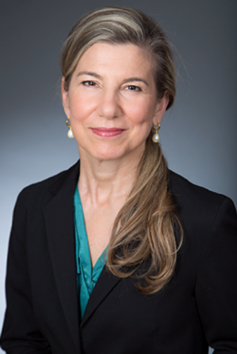

# SHEPARD HALL RM 107

TUESday 4 DECEMBER, 2018 at 1:00-2:30PM

Clinical Psychology @ City College 2018-2019 Colloquia series

4TH ANNUAL RESEARCH & SCHOLARSHIP DAY KEYNOTE SPEAKER