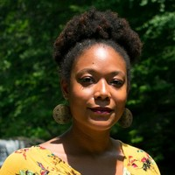

Back to Natural: A Documentary Film is a groundbreaking, 68-minute documentary film that takes a shocking and emotional look at the intersection of hair, politics, and identity in Black communities. This documentary is a powerful, thought provoking, call for healing that takes a grass roots approach to exploring the globalized policing of natural black hair. Filmed in New York City, Paris, And Cape Town, this documentary explores universal aspects of the Black experience and the "New" Natural Hair movement. Join us on this journey of discovery and enlightenment while celebrating our history and natural styles that are taking the world by storm.

# Gillian Scott-Ward, PhD.

BACK TO NATURAL: A DOCUMENTARY FILM

✹

TUES 9 OCT, 2018 at 11:30 AM-12:50 PM

# SHEPARD HALL RM 107

## TALK ABSTRACT

✹

Clinical Psychology @ City College 2018-2019 Colloquia series