CLINICAL PSYCHOLOGY @ CITY COLLEGE 2017-2018 COLLOQUIA SERIES

Silvia L. Mazzula, PhD, LPC

MENTAL HEALTH AND JUSTICE:

AN UNTOLD STORY

\*

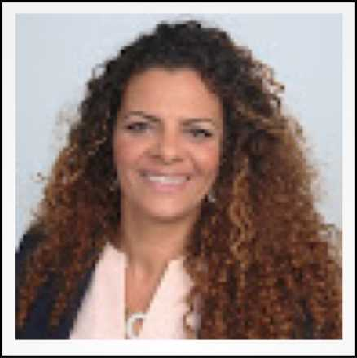

TUESDAY 10 OCTOBER, 2017 AT 11:30 AM-12:50PM

SHEPARD HALL RM 107

\*

TALK ABSTRACT

An expert on racial cultural psychological processes. Dr. Mazzula will speak on the intersections of race, migration, culture and mental health. Through the eyes of an underrepresented scholar. Dr. Mazzula shares the development of a research agenda and recommendations for moving beyond complacent to committed social justice research, scholarship and practice.