**Thinking Plural**

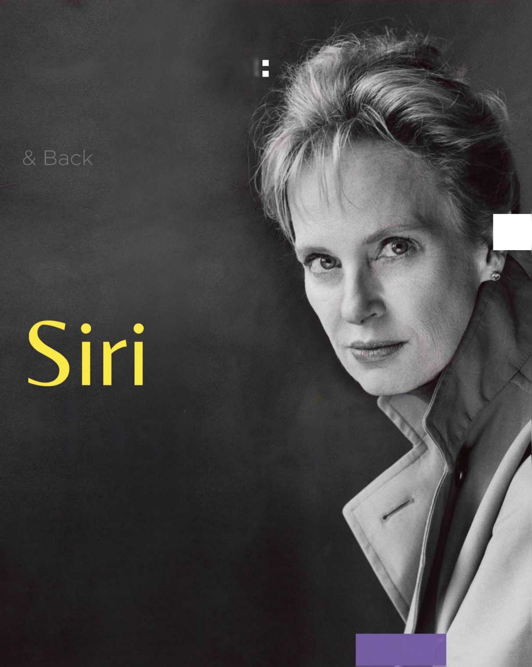

Travels Between Literature to Science

Tuesday

February 13, 2018

5.00-6.30 pm Location: TBA

H ustvedt

Siri Hustvedt is a novelist and essayist who has authored six novels as well as several books of essays and works of non-fiction. Her most recent book is the essay collection A Woman Looking at Men Looking at Women (2016). Other works include The Blazing World (2014), which was longlisted for the 2014 Man Booker Prize and won the 2015 Los Angeles Times Book Prize for Fiction. In this talk Hustvedt will address her long-standing interest in the relations between the humanities and the sciences. This is a theme she has returned to in many of her writings, including her book The Shaking Woman or A History of My Nerves (2010), which explores intersections among philosophy, psychoanalysis, and neuroscience.

CCNY

The Rifkind Center for the Humanities and the Arts

