Welcome to City College*

Our Mission
Since its founding in 1847, The City College of New York (CCNY) has been true to its legacy of access, opportunity, and transformation. CCNY is as diverse, dynamic, and boldly visionary as the city itself. CCNY advances knowledge and critical thinking, and fosters research, creativity, and innovation across academic, artistic, and professional disciplines. As a public institution with public purpose, CCNY produces citizens who make an impact on the cultural, social, and economic vitality of New York, the nation, and the world.

CCNY Green
CCNY is committed to becoming a sustainable campus and lowering its carbon footprint. We are adapting the way we teach, learn, conduct research and operate as an institution in order to reduce our greenhouse gas emissions. We ensure campus sustainability by fostering environmentally sound habits and behaviors across the campus while engaging the Harlem community. CCNY will carry out this mission by exercising leadership in education and research, always mindful of our urban setting and the needs of the richly diverse population that we serve. View our profile with the Association for the Advancement of Sustainability in Higher Education.

Our Vision
City College stands at the intersection of its historical past and promise for a vibrant future. Building on its strong foundation of unleashing potential, a City College education integrates knowledge with experience to nurture scholars, professionals, and leaders who are ready to meet the challenges of our contemporary society. CCNY will attract students who have a tenacious desire to learn, lead, and contribute to the greater good of society on their path to a successful future. CCNY graduates will be committed to supporting access to opportunity and mentorship for future generations of learners.

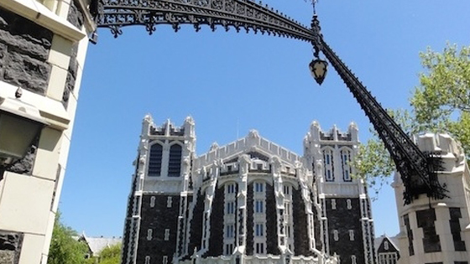

City College of New York Fast Facts Fall 2016 Student Demographics [02.23.2017]

Age | Undergraduates | Masters | PhDs | Total
19 | 1608 | 0 | 0 | 1608
20-22 | 4570 | 133 | 0 | 4703
23-24 | 1591 | 386 | 1 | 1978
25-29 | 1759 | 990 | 34 | 2783
30-44 | 1026 | 812 | 47 | 1885
45 & Over | 282 | 241 | 1 | 524
Under 19 | 2675 | 0 | 0 | 2675
Total | 13511 | 2562 | 83 | 16156

References
- https://www.ccny.cuny.edu/
- https://www.ccny.cuny.edu/about/mission
- https://www.ccny.cuny.edu/sites/default/files/2016_Fast_Facts_02.23.2017.pdf

* Please note the content from this document was found on the CCNY website and was only used for this training purposes on how to convert Word Documents to accessible PDFs.

